Questions in relation to GA Analysis Work Form
Table in Note 5
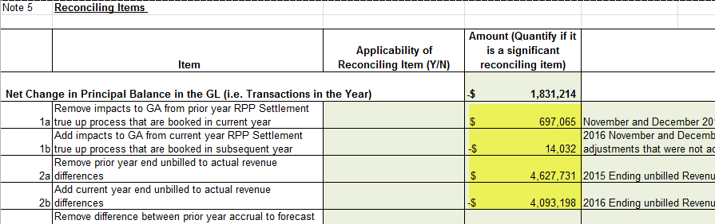

- 1a and 1b:

- In booking expense journal entries for Charge Type 1142 (formerly 142), and Charge Type 148 from the IESO invoice, please confirm which of the following approach is used:
- Charge Type 1142 is booked into Account 1588. Charge Type 148 is pro-rated based on RPP/non-RPP consumption and then booked into Account 1588 and 1589, respectively
- Charge Type 148 is booked into Account 1589. The portion of Charge Type 1142 equalling RPP-HOEP for RPP consumption is booked into Account 1588. The portion of Charge Type 1142 equalling GA RPP is credited into Account 1589.
- Another approach. Please explain this approach in detail.
  - Charge type 1142 (previously 142) on the IESO invoice relates to the final RPP settlement and TOU/RPP settlement true-ups between what was submitted on the 4th business day of the month and the actual billings. This amount is coded to a balance sheet clearing account as the entries to accrue these items has already occurred prior to the IESO invoice posting. RPP final settlement never affected 1588 as this was a pass through to the customer – whatever we billed the customer we recovered from the IESO the following month. The TOU/RPP settlement is accrued to 1588 at the time of the true up calculation. Line 148 is pro-rated based on RPP/non-RPP consumption to 4705 and 4707 and then booked into Account 1588 and 1589, respectively

- With regards to the Dec. 31 balance in Account 1589,
  - Please indicate whether the following items that flow into the account is based on estimates/accruals or actuals at year end.
  - If there are reconciling items #1a, 1b in the GA Analysis Workform or if there are any proposed adjustments to Account 1589 in the DVA Continuity Schedule for the true up impacts, please quantify the adjustment that relate to each of the following items.
- Revenues (i.e. is unbilled revenues trued up)
  - Unbilled revenue is accrued for the appropriate month based on actual billing occurring in the subsequent month(s). There are no reconciling items in the GA workform related to unbilled revenue.
  - Item 7 represents the variance between the loss factor used for billing and the calculated actual loss factor for the year.
- Expenses - GA non-RPP (Charge Type 148) with respect to the quantum dollar amount and RPP/non-RPP pro-ration percentages
  - Reconciling items 1a and 1b on the GA workform are true-ups related to the split between RPP and non-RPP.
  - Item 1a is related to the prior year (2015), which was actually booked in 2016.
  - Item 1b represent the final true-up for 2016 and is quite small as the majority of the true-up was accrued in 2016. This small amount has been booked in the 2017 financial records but has been reflected in the DVA continuity schedule submitted with the application.
  - Item 8 represents and adjusted required between account 1588 and 1589.
- Credit of GA RPP (Charge Type 142) if the approach under IR 1b is used
  - Not applicable

- 2a and 2b: Please note that in these two cells, the difference between unbilled and actual billed should be entered (not the total unbilled). Please provide the total unbilled amounts at the end of 2015 and 2016, and the actual billed amounts corresponding to the unbilled amounts. Please update the work form if needed.
  - BPI uses the actual billing information in order to accrue unbilled revenue in the appropriate month in order to ensure a good cut-off. Therefore, there is no variance between the accrual and the actual. BPI has adjusted the amounts in 2a and 2b to reflect this
  - Please note that in the process of investigating the remaining variance BPI has made some adjustments to the consumption data in tab for note 4.

