Questions in relation to GA Analysis Work Form
Table in Note 5
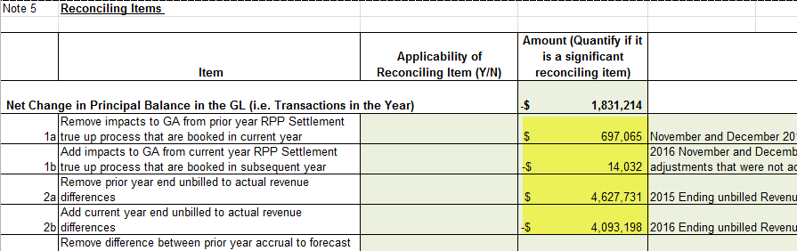

- 1a and 1b:

- In booking expense journal entries for Charge Type 1142 (formerly 142), and Charge Type 148 from the IESO invoice, please confirm which of the following approach is used:
- Charge Type 1142 is booked into Account 1588. Charge Type 148 is pro-rated based on RPP/non-RPP consumption and then booked into Account 1588 and 1589, respectively
- Charge Type 148 is booked into Account 1589. The portion of Charge Type 1142 equalling RPP-HOEP for RPP consumption is booked into Account 1588. The portion of Charge Type 1142 equalling GA RPP is credited into Account 1589.
- Another approach. Please explain this approach in detail.

- With regards to the Dec. 31 balance in Account 1589,
  - Please indicate whether the following items that flow into the account is based on estimates/accruals or actuals at year end.
  - If there are reconciling items #1a, 1b in the GA Analysis Workform or if there are any proposed adjustments to Account 1589 in the DVA Continuity Schedule for the true up impacts, please quantify the adjustment that relate to each of the following items.
- Revenues (i.e. is unbilled revenues trued up)
- Expenses - GA non-RPP (Charge Type 148) with respect to the quantum dollar amount and RPP/non-RPP pro-ration percentages
- Credit of GA RPP (Charge Type 142) if the approach under IR 1b is used

- 2a and 2b: Please note that in these two cells, the difference between unbilled and actual billed should be entered (not the total unbilled). Please provide the total unbilled amounts at the end of 2015 and 2016, and the actual billed amounts corresponding to the unbilled amounts. Please update the work form if needed.

