**Brantford Power Inc.**

**2018 Price Cap IR Application (EB-2017-0028)**

**Staff Questions**

**September 26, 2017**

**Question #1**

**Ref: IRM Model Tab 3: Account 1588 RSVA Power – 2015 OEB-approved interest disposition**

On tab 3 of the 2018 IRM model, Brantford Power entered a debit balance of $53,320 in Account 1588 Power as the OEB-approved interest disposition amount in 2015. As per the Decision and Rate Order issued for Brantford Power’s 2015 IRM application, EB-2014-0187, the interest balance that was approved for disposition in 2015 was a credit balance of $53,310.

1. Please confirm whether or not this amount should be corrected to a credit balance of $53,310 in the continuity schedule in the IRM model. If not, please provide explanation for the discrepancy noted above.

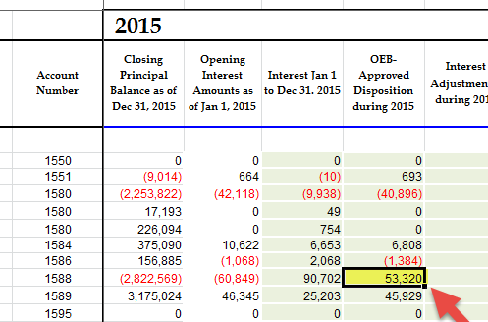

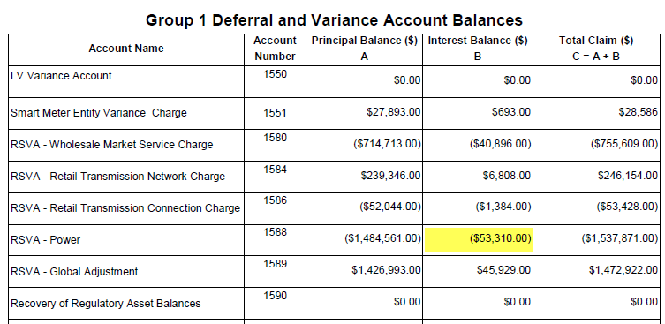

**Question #2**

**Ref: IRM Model Tab 3: Entries for 2016 RPP Settlement True-up Claims**

In the continuity schedule of the IRM model, Brantford Power included a debit adjustment amount of $14,408 in account 1588 – RSVA Power for the year of 2016.

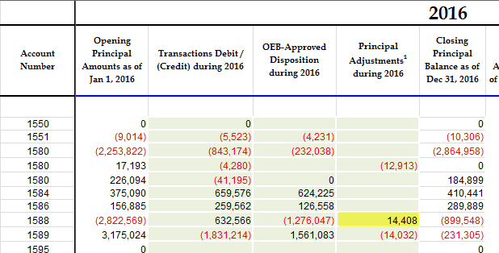

With regards to the Dec. 31 balance in Account 1588:

* 1. Please indicate whether the following items that flow into the account are based on estimates/accruals or actuals at year end.
  2. If there are any proposed adjustments to Account 1588 in the DVA Continuity Schedule for the impacts of RPP settlement true up, please quantify the adjustment that relate to each of the following items.

1. Revenues (i.e. is unbilled revenues trued up)
2. Expenses - Commodity (Charge Type 101)
3. Expenses - GA RPP (Charge Type 148) with respect to the quantum dollar amount and RPP/non-RPP pro-ration percentages

**Question #3**

**Ref: IRM Model Tab 3: Required adjustment amount of $451,461 between Account 1588 and Account 1589**

As a result of discussion with OEB staff and further investigation, Brantford Power has determined and notified OEB staff that an adjustment is required to the continuity schedule. This adjustment, in amount of $451,461, is to correctly capture 2016 GA variance amounts associated with RPP customers in Account 158. OEB staff has updated the IRM model accordingly to include this adjustment (screenshot below).

As noted in Brantford Power’s responses to OEB staff questions (part 2) in relation to the GA analysis work form, this adjustment is required in order to correct an error in the consumption data received from third party smart meter data provider. Brantford Power is working to confirm that no other impacts from this issue exist.

1. Please confirm whether or not there is any other impacts from this issue.

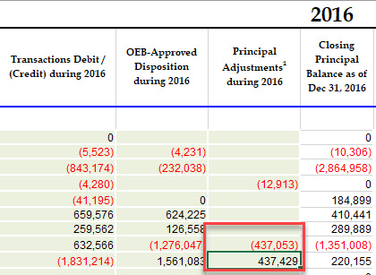

**Question #4**

**Ref: IRM Model Tab 3: Disposition of 1595 (2016)**

As per indicated in tab 3, the account 1595 balance is not to be disposed until a year after the rate rider has expired and that balance has been audited. Brantford Power’s DVA (2016) rate rider expired as of December 31, 2016. One year after the rate rider has expired would be December 31, 2017. Therefore, Brantford Power will need to wait until the associated balance in account 1595 (2016) is audited in the 2017 year-end audit, to dispose of the balance in account 1595 (2016). The earliest rate application in which this account can be disposed of would be the 2019 rate application.

1. Please confirm that Brantford Power will not propose to dispose of the balance in account 1595 (2016). OEB staff will update the IRM model.

**Question #5**

**Ref: GA Allocation to Transition Customers and CBR Class B Allocation to Transition Customers; IRM Model Tab 6.1a and Tab 6.2a**

In Tab 6.1a and 6.2a, the IRM model calculates the customer-specific total GA/CBR Class B Allocation for each transition customer. It also calculates the monthly equal payment if the distributor is going to settle the amount through 12 monthly adjustments to bills.

1. Please confirm whether Brantford Power will settle the GA/CBR Class B amounts to the transition customers through 12 monthly equal payments OR through one-time payments. (As noted in Chapter 3 Filing Requirements, the general expectation is to settle the amount through 12 equal adjustments to bills.)

**Question #6**

**Ref: IRM Model Tab 12 & Tab 13: RTSR**

In tab 11 of the IRM model, Brantford Power entered the Line and Transformation Connection Service Rate of its host distributor into the Line Connection Service Rate line (row 52). Accordingly, in tab 12, the Units Billed and Amount data for Connection should also be entered in the Line Connection section, so that the cost in 2017 (tab 13) and 2018 (tab 14) in relation to host distributor’s Connection charge can be calculated properly.

1. OEB staff has update Tab 12 as described above. Please review the updated model and confirm the change.

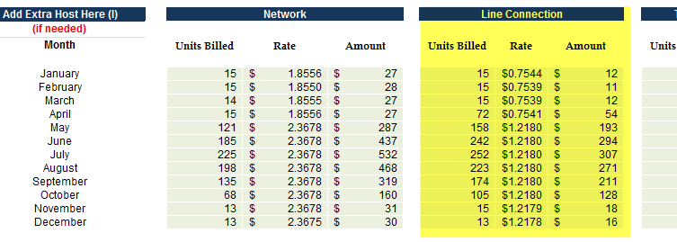

**Questions in relation to LRAMVA**

Brantford is applying for disposition of a debit balance of $220,381 in the LRAMVA account. This amount consists of $218,022 in lost revenues from new CDM program savings in 2015, persisting savings from 2011 to 2014 in 2015 and carrying charges, as well as $2,360 from projected interest to 2017.

**Question #7**

**Ref: Tab 5 of LRAMVA work form**

a) Please confirm the actual year of savings embedded into the 2013 load forecast, at the time of rebasing in 2013.

b) Please discuss the appropriateness of claiming 2011 persisting savings into 2015.

**Question #8**

**Ref: Tab 5 of LRAMVA work form**

In 2015, 53 kW of monthly demand savings from the Loblaw Pilot was verified by the IESO. In the 2015 work form, the monthly multiplier applied to these program savings was 0. As a result, Brantford has not claimed savings from this CDM pilot program in the 2015 LRAMVA.

a) Please confirm whether or not the monthly multiplier for the Loblaw Pilot in 2015 should in fact be 0.

b) If not, please provide the appropriate monthly multiplier to claim demand savings for this pilot program. Please also provide rationale for the multiplier provided.

**Question #9**

If Brantford has made any changes to the LRAMVA work form as a result of its responses to interrogatories, please file an updated LRAMVA work form.

**Updates made to IRM Model**

1. The RRRP charge in the Current OEB-Approved section of the Bill Impact tab has been updated to $ 0.0003.
2. The Continuity Schedule has been updated to include the adjustment amounts in account 1588 and 1589 in 2016, as per a letter filed by Brantford Power on September 25, 2017.