St. Thomas Energy Inc.
OEB Staff Questions
EB-2017-0074

St. Thomas Energy Inc.
EB-2017-0074

Staff Question-1
Ref: Cell C63 from Tab 3. Continuity Schedule has been reproduced below.
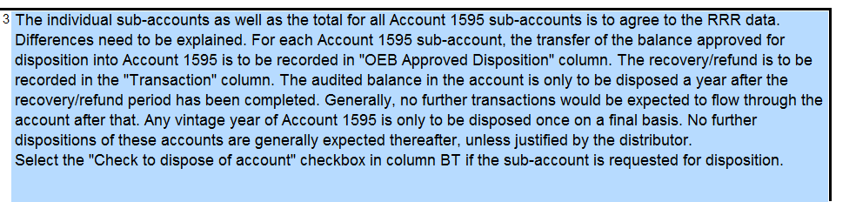
Ref: A Portion of the Tab 3 Continuity Schedule has been reproduced below.
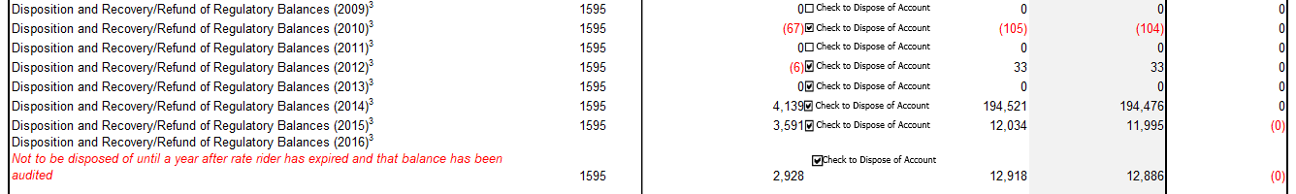
St. Thomas Energy is requesting disposition of account 1595-2010 credit balance of $105, account 1595-2012 debit balance of $33, account 1595-2014 credit balance $194,521, account 1595-2015 debit balance $12,034 and account 1595-2016 debit balance $12,918

- Please confirm whether St. Thomas Energy has requested disposition of these sub accounts previously.
- When did the rate rider relating to each IRM cease?
- What audited financial statements did St. Thomas base these dispositions on previously and what does each balance pertain to?

Staff Question-2
Ref: A portion of Tab 3. Continuity Schedule is reproduced below.
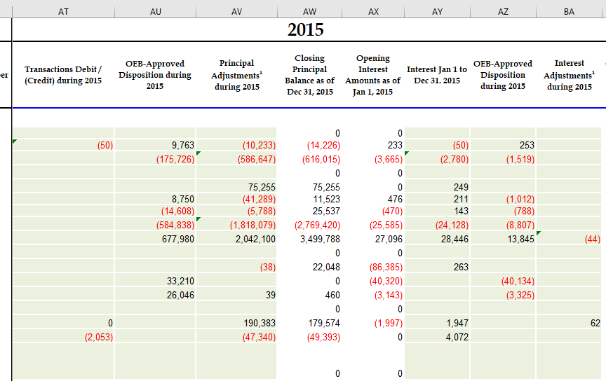

- OEB staff notes that there are no unexplained variances with RRR. Please explain each of the adjustments in column AV and BA.
- Please confirm these are not adjustments to previously disposed of balances.
- Please explain why column AT transaction column is not filled out.

Staff Question-3
Ref: St. Thomas Decision EB-2016-0104
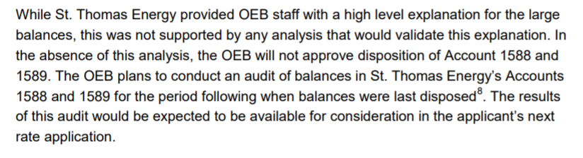
As the OEB has not conducted an audit of St. Thomas’s Accounts 1588 and 1589 yet, please explain the rationale for requesting disposition of Accounts Group 1 accounts before the audit has been completed.

