Waterloo North Hydro Inc.
OEB Staff Questions
EB-2017-0080

Waterloo North Hydro Inc.
EB-2017-0080

Staff Question-1
Ref: Cell C63 from Tab 3. Continuity Schedule has been reproduced below.
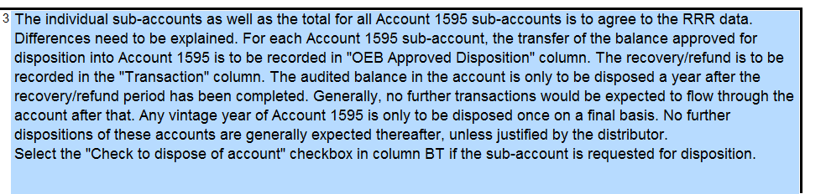
Waterloo North is requesting Disposition of accounts 1595-2014 credit balance $1,485 and 1595-2015 debit balance $128,677.
- Please confirm whether Waterloo North has requested disposition of these sub-accounts previously.
- When did the rate rider relating to the 2014 and 2015 IRM OEB decisions cease?
- What audited financial statements did Waterloo North base these dispositions on previously and what does the credit balance of $1,485 and debit balance of $128,677 pertain to?

Staff Question-2
Ref: A portion of Tab 3. Continuity Schedule is reproduced below.
Ref: Managers Summary Page 8 “Waterloo North Hydro did not make any adjustments to deferral and variance account balances that were previously approved by the Board on a final basis.”

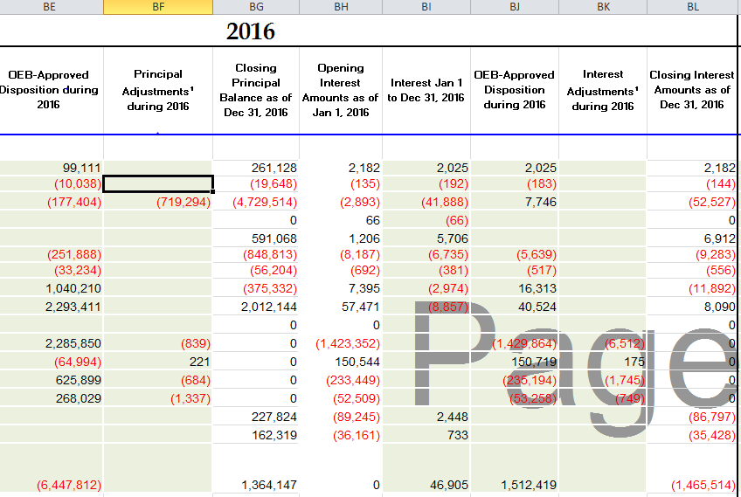
- OEB staff notes that the OEB approved amounts for disposition in Waterloo North Hydro’s 2017 (EB-2016-0109) reconcile with the 2015 balances in the continuity schedule. Please explain each of the adjustments in column BF and BK.
- Please confirm these are not adjustments to previously disposed of balances.

Staff Question-3
Ref: Managers Summary Page 6
Ref: A portion of Tab 4.Billing Det for Def-Var has been reproduced below.

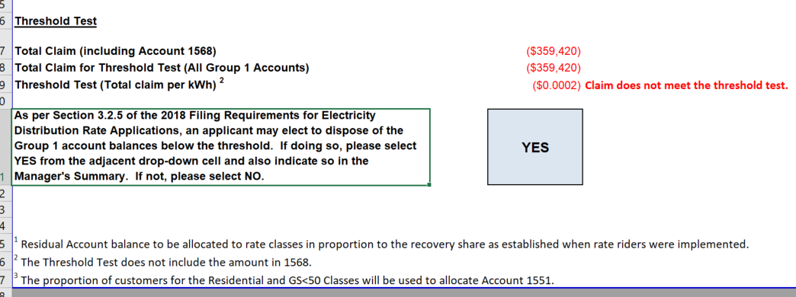
On page 6 Waterloo North Hydro states “Waterloo North Hydro has exceeded the disposition threshold of $.001/kWh of its Group 1 Account Deferral and Variance Account Balances as reflected in Sheet 4 of its 2018 Rate Generator Model.” On Tab 4.Billing Det. For Def-Var of the rate generator model it appears NOT to have exceeded the threshold, see screen shot above.
- Please confirm Waterloo North Hydro has not exceeded the threshold of $.001/kWh.
- Please confirm Waterloo North Hydro still intends to request disposition of its Group 1 balances.

