Waterloo North Hydro Inc.
OEB Staff Questions
EB-2017-0080

Waterloo North Hydro Inc.
EB-2017-0080

Staff Question-1
Ref: Cell C63 from Tab 3. Continuity Schedule has been reproduced below.
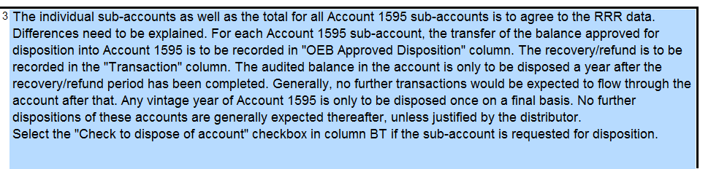
Waterloo North is requesting Disposition of accounts 1595-2014 credit balance $1,485 and 1595-2015 debit balance $128,677.
- Please confirm whether Waterloo North has requested disposition of these sub-accounts previously.
Waterloo North Hydro (WNH) previously claimed the 1595-2014 balance on the 2017 IRM. 1595-2015 had not yet been claimed because it had not been 1 full year from audited statements. On Jan.1/16 WNH changed from a May filer to a January filer and therefore we shouldn’t be behind a year going forward.
- When did the rate rider relating to the 2014 and 2015 IRM OEB decisions cease?
1595-2014 ceased on April 30, 2015. 1595-2015 ceased on April 30, 2016.
- What audited financial statements did Waterloo North base these dispositions on previously and what does the credit balance of $1,485 and debit balance of $128,677 pertain to?
WNH was adjusted on these balances on its December 31, 2016 financial statements. The remaining principal and interest balance on the 2014 amount is for the remaining activity in 2017. The 2015 balance has previously not been claimed so the full amount is for principal and interest.

Staff Question-2
Ref: A portion of Tab 3. Continuity Schedule is reproduced below.
Ref: Managers Summary Page 8 “Waterloo North Hydro did not make any adjustments to deferral and variance account balances that were previously approved by the Board on a final basis.”

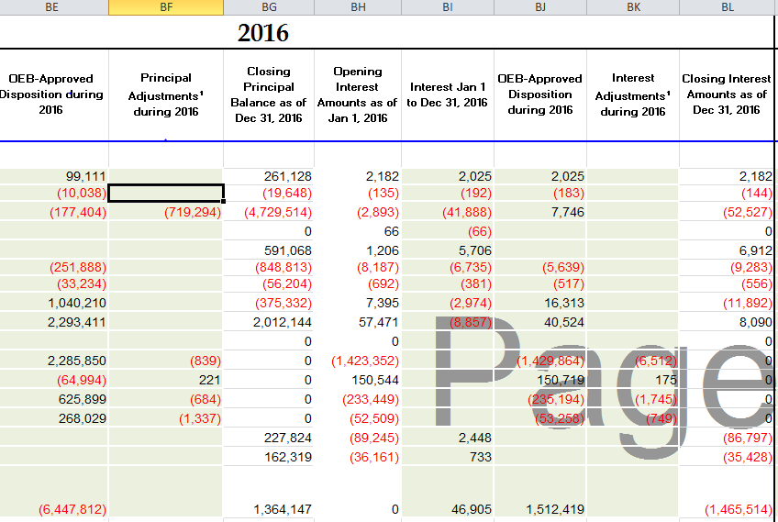
- OEB staff notes that the OEB approved amounts for disposition in Waterloo North Hydro’s 2017 (EB-2016-0109) reconcile with the 2015 balances in the continuity schedule. Please explain each of the adjustments in column BF and BK.
Please see the response that was included in the IR’s for the 2017 IRM that was accepted.
“In 2016 Cost of Service Rate Filing estimates were made for carrying charges to the end of 2015 since the application was filed May 1, 2015. As of December 31, 2015 for accounting purposes the ‘actual’ balances were recorded. As of January 1, 2016 all balances from the Cost of Service were adjusted to approved balances. This resulted in some variances between estimated and actual which were included in this application in column BK.” The amount of these adjustments total ($2,639) in column BF and ($8,831) in column BK. An additional adjustment is noted in column BF ($719,294) this was for an IESO Adjustment Account Surplus Disbursement. The accounting treatment required that this be posted through the WMS account.
- Please confirm these are not adjustments to previously disposed of balances.
As noted above the treatment for the COS balances had to be eliminated in the 2017 IRM so there are no adjustments to previously disposed balances.

Staff Question-3
Ref: Managers Summary Page 6
Ref: A portion of Tab 4.Billing Det for Def-Var has been reproduced below.

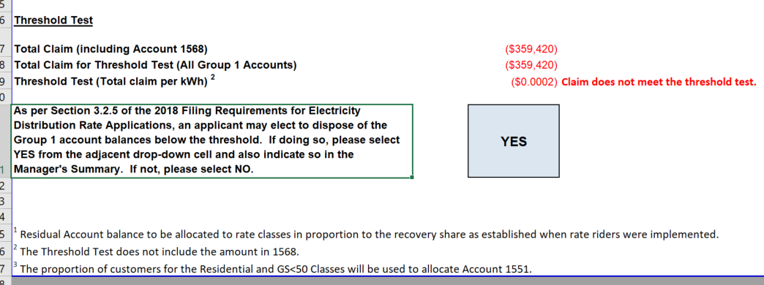
On page 6 Waterloo North Hydro states “Waterloo North Hydro has exceeded the disposition threshold of $.001/kWh of its Group 1 Account Deferral and Variance Account Balances as reflected in Sheet 4 of its 2018 Rate Generator Model.” On Tab 4.Billing Det. For Def-Var of the rate generator model it appears NOT to have exceeded the threshold, see screen shot above.
- Please confirm Waterloo North Hydro has not exceeded the threshold of $.001/kWh.
WNH confirms that it has not exceeded the threshold.
- Please confirm Waterloo North Hydro still intends to request disposition of its Group 1 balances.
WNH still wishes to dispose of these balances.

4. WNH would like to note that through the PEG process there was an error in the inputs and with the correction we are still in Group 3. This has been discussed with the OEB. WNH was told to identify this through the IRM review process. Please contact us if you would like further details on this.

