St. Thomas Energy Inc.

OEB Staff Questions

EB-2017-0074

**St. Thomas Energy Inc.**

**EB-2017-0074**

**Staff Question-1**

Ref: Cell C63 from Tab 3. Continuity Schedule has been reproduced below.

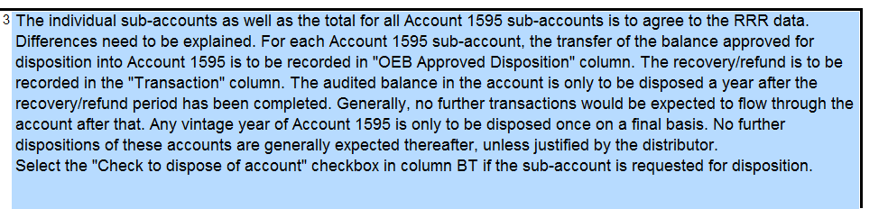

Ref: A Portion of the Tab 3 Continuity Schedule has been reproduced below.

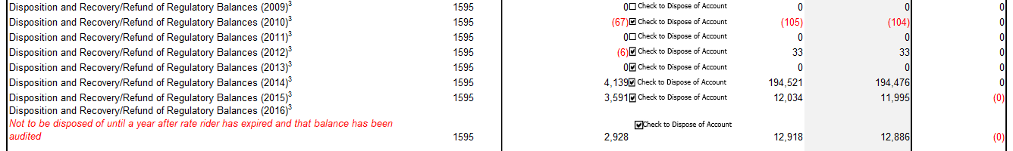

St. Thomas Energy is requesting disposition of account 1595-2010 credit balance of $105, account 1595-2012 debit balance of $33, account 1595-2014 credit balance $194,521, account 1595-2015 debit balance $12,034 and account 1595-2016 debit balance $12,918

1. Please confirm whether St. Thomas Energy has requested disposition of these sub accounts previously.
2. When did the rate rider relating to each IRM cease?
3. What audited financial statements did St. Thomas base these dispositions on previously and what does each balance pertain to?

**STEI Response**

1. These sub accounts relate to the disposition of previous Board-approved rate riders (see table in part b below). STEI requested Group 1 account disposition in its 2017 IRM EB-2016-0104 Application, however, the balances did not meet the OEB’s materiality threshold at that time. As such, the Group 1 account balance were not disposed in that Application.
2. The table below summarizes when each IRM rate rider ceased:



1. The table below summarizes rate rider activity and the residual account balances from the OEB approved Decision and Rate Orders and the amounts collected/ refunded to customers.



The above noted table also illustrates the annual audited financial statements of the original approved OEB disposition and subsequent collections/ refunds.

The “Disposition and Recovery/Refund of Regulatory Balances 2014” rate rider was billed over a 12 month period from May 1, 2014 to April 30, 2015. In reviewing the residual balance for this rate rider, it is clear that the residual of $194,521 (debit) is disproportionate to the original disposal balance of $342,907 (credit). A breakdown of the residual balance by rate class is shown in the table below:



The original approved OEB disposition per EB-2013-0171 was a customer (refund) balance in the amount of $342,907 (credit), the residual balance is $194,521 (debit) which is due from customers. This is mainly attributed to the under collection of the GS>50 rate class.

It is evident that the primary residual balance components of the 2014 rate rider are an under collection in the GS>50 kW rate class, net of smaller over-payments (refunds) in the residential time of use, and GS<50 rate classes.

Upon further examination of the GS>50kW rate class there were significant changes in the billing determinates and volumetric usage in the base year used to calculate the 2014 rate riders as compared to the actual usage from May 1, 2014 to April 30, 2015. As noted in STEI’s 2015 COS Application EB-2014-0013, a large GS>50kW customer “Timken” closed its manufacturing operations in 2013 which resulted in decreased consumption and revenues. Additionally, there were material changes in the number of GS>50kW customers as previously reported in STEI’s Reporting and Record Keeping Requirements (“RRR”). The table below summarizes the changes between the 2012 fiscal year and 2014 fiscal year:



The remaining balances in accounts 1595-2010 credit balance of $105, account 1595-2012 debit balance of $33, account 1595-2015 debit balance $12,034 and account 1595-2016 debit balance $12,918 are due to small residual balances based on typical volumetric billing determinant variances (e.g. number of customers and usage).”

**Staff Question-2**

Ref: A portion of Tab 3. Continuity Schedule is reproduced below.

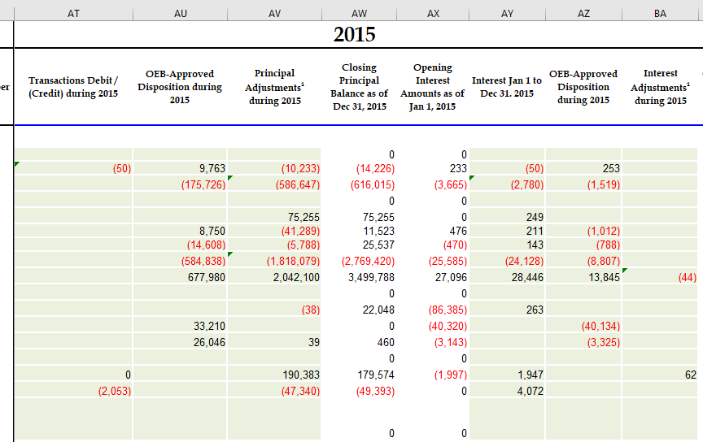

1. OEB staff notes that there are no unexplained variances with RRR. Please explain each of the adjustments in column AV and BA.
2. Please confirm these are not adjustments to previously disposed of balances.
3. Please explain why column AT transaction column is not filled out.

**STEI Response**

1. STEI has updated the 2015 continuity schedule to agree to the 2017 IRM Application EB-2016-0104. The 2015 balances were inadvertently recorded in the wrong columns.
2. STEI confirms that no adjustments were made to the previously disposed of balances.
3. As noted above, please refer to the revised 2015 continuity schedule.

**Staff Question-3**

Ref: St. Thomas Decision EB-2016-0104

As the OEB has not conducted an audit of St. Thomas’s Accounts 1588 and 1589 yet, please explain the rationale for requesting disposition of Accounts Group 1 accounts before the audit has been completed. 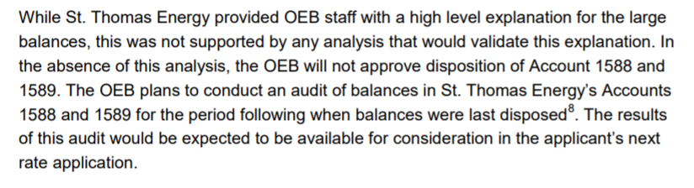

**STEI Response**

As indicated above in STEI’s EB-2016-0104 Decision and Rate Order the OEB noted: *“The results of this audit would be expected to be available for consideration in the applicant’s next rate application”.* As a result of this, STEI was optimistic that the DVA audit would be completed before the 2018 IRM Decision and Rate Order Application EB-2017-0074. As such, STEI requested the disposition of its Group 1 account balances.

The OEB’s DVA audit on STEI’s 2015 and 2016 1588 and 1589 Accounts is currently on-going. If the audit is not completed at the time the final Decision and Rate Order is made on STEI’s EB-2017-0074 Application STEI understands that the disposition of the Group 1 account balances will be deferred until the audit has been completed.