Brantford Power Inc.
2018 Price Cap IR Application (EB-2017-0028)
Follow-up Questions
October 18, 2017
Question #1
Ref: IRM Model Tab 3: Account 1588 RSVA Power – 2015 OEB-approved interest disposition
On tab 3 of the 2018 IRM model, Brantford Power entered a debit balance of $53,320 in Account 1588 Power as the OEB-approved interest disposition amount in 2015. As per the Decision and Rate Order issued for Brantford Power’s 2015 IRM application, EB-2014-0187, the interest balance that was approved for disposition in 2015 was a credit balance of $53,310.
- Please confirm whether or not this amount should be corrected to a credit balance of $53,310 in the continuity schedule in the IRM model. If not, please provide explanation for the discrepancy noted above.
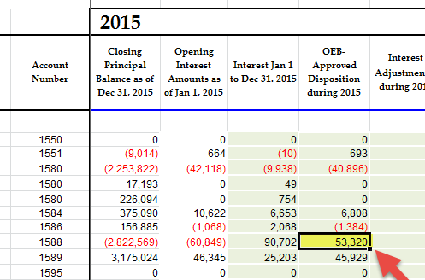
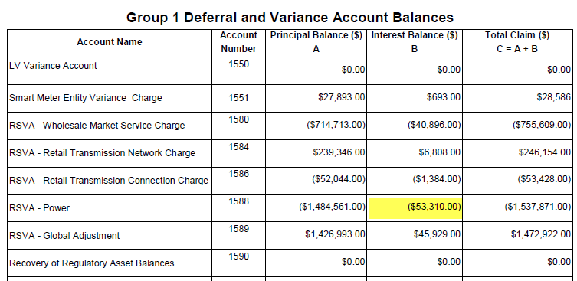
BPI Response:
BPI confirms that the amount approved for disposition in 2018 for interest in 1588-RSVA Power was a credit balance. However, BPI has determined that there is an offsetting adjustment required to the entry in column “Interest Adjustments during 2015”, of ($15,928) which brings the ending balance to the same ending interest balance total of ($23,467) for 2015.
BPI requests that board staff make a further adjustment to the continuity as below:
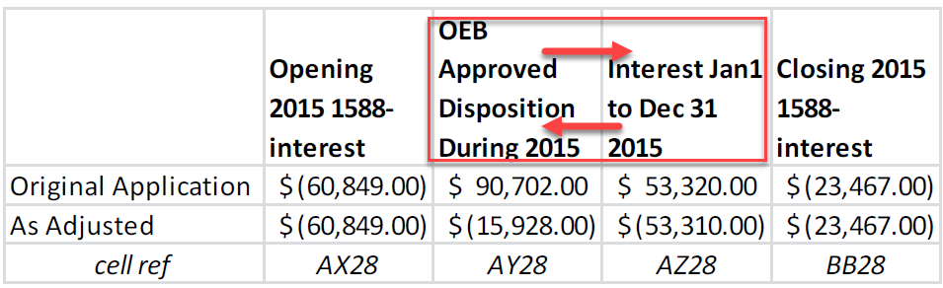
OEB Staff:
- In the above table the Brantford Power provided, please confirm the title of the column with cell reference AY28 should be “Interest Jan 1 to Dec 31 2015” (i.e. the interest transaction column in the continuity schedule); and the title of the column with cell reference AZ28 should be “OEB Approved Disposition During 2015”.
- Please confirm the credit balance of $15,928 (the as adjusted amount in Brantford Power’s request) is the actual interest calculated for Account 1588 in 2015.
Question #2
Ref: IRM Model Tab 3: Entries for 2016 RPP Settlement True-up Claims
In the continuity schedule of the IRM model, Brantford Power included a debit adjustment amount of $14,408 in account 1588 – RSVA Power for the year of 2016.
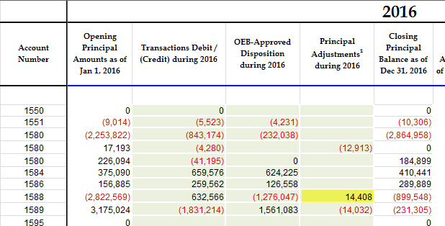
With regards to the Dec. 31 balance in Account 1588:
  - Please indicate whether the following items that flow into the account are based on estimates/accruals or actuals at year end.

  - If there are any proposed adjustments to Account 1588 in the DVA Continuity Schedule for the impacts of RPP settlement true up, please quantify the adjustment that relate to each of the following items.
- Revenues (i.e. is unbilled revenues trued up)
- Expenses - Commodity (Charge Type 101)
- Expenses - GA RPP (Charge Type 148) with respect to the quantum dollar amount and RPP/non-RPP pro-ration percentages
BPI Response:
a) BPI’s accounting treatment with respect to the following items that flow into account 1588 is as follows:
i. Revenues are recorded based on actual billings with accruals for unbilled revenue made monthly. The unbilled revenue accrual is based on actual billings occurring in the subsequent months. Since some bills straddle months the unbilled accrual is based on the number of days in each month the bill covers.
ii. Expenses – Commodity (Charge Type 101) – Amounts are accrued to the appropriate period based on actual IESO invoices.
iii. Expenses - GA RPP (Charge Type 148) –GA for RPP customers is accrued in the appropriate period based on actual invoices from the IESO. The RPP portion is recorded based on an estimated percentage of RPP consumption vs non-RPP consumption. Subsequently, the GA for RPP customers is trued up based on actual billed consumption (taking into consideration the accrual for unbilled revenue at the end of the period).
b) The proposed adjustments to Account 1588 in the DVA Continuity Schedule for the impacts of RPP settlement true up, $14,408 is related to expenses- GA RPP (charge type 148).
OEB Staff:
Brantford Power indicates that the $14K adjustment to Accounts 1588 and 1589 it made in the DVA Continuity Schedule for 2016 relates to the true-up of RPP Settlements.
  - Adjustments are required for all elements of RPP Settlement where estimated values were used. Please confirm that this adjustment trues up each of the components below for the relevant months:
    - Revenues,
    - Commodity Expenses (Charge Type 101),
    - GA RPP Expenses (Charge Type 148) with respect to the quantum dollar amount, and
    - GA RPP/non-RPP with respect to the pro-ration percentages,
    - RPP Settlement (Charge Type 1142) based on the actuals for items noted above in i. to iv.
  - If part a. confirmed, please quantify each of the components of the $14K RPP Settlement true up adjustment made to accounts 1588 and 1589 as of December 2016, for relevant months where settlement hadn’t been trued-up with the IESO, by end of year.
  - If part a. not confirmed, please update RPP settlement true up adjustments to accounts 1588 and 1589 and quantify each of the components of the RPP Settlement true up adjustment to be made to accounts 1588 and 1589 as of December 2016, for relevant months where settlement hadn’t been trued-up with the IESO, by end of year.

Question #3
Ref: IRM Model Tab 3: Required adjustment amount of $451,461 between Account 1588 and Account 1589
As a result of discussion with OEB staff and further investigation, Brantford Power has determined and notified OEB staff that an adjustment is required to the continuity schedule. This adjustment, in amount of $451,461, is to correctly capture 2016 GA variance amounts associated with RPP customers in Account 158. OEB staff has updated the IRM model accordingly to include this adjustment (screenshot below).
As noted in Brantford Power’s responses to OEB staff questions (part 2) in relation to the GA analysis work form, this adjustment is required in order to correct an error in the consumption data received from third party smart meter data provider. Brantford Power is working to confirm that no other impacts from this issue exist.
- Please confirm whether or not there is any other impacts from this issue.
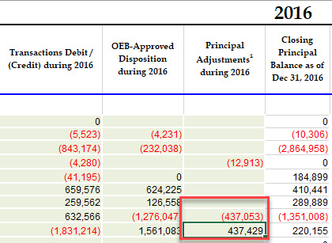
BPI Response:
a) BPI continues to work to determine whether other impacts related to this issue exist. BPI requires input from third party service providers in order to make this determination with confidence and is not able to confirm at this time.
BPI has performed some further analysis to fine tune the amount associated with RPP customers, and determined the adjustment amount should be as set out below:
Previous adjustment of $451,460.53 has been refined to $436,388.50. BPI requests that OEB staff update the adjustment to the following amounts:
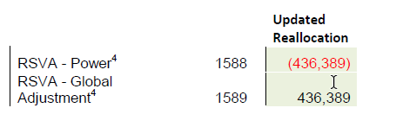
BPI expects the updated continuity schedule to show the following:
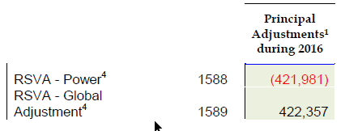
OEB Staff:
In the above response, Brantford Power required OEB staff to revise the adjustment amount in account 1588 and account 1589 from $451,460.53 to $436,388.50. Brantford Power also noted that it continues to work to determine whether other impacts related to the issue exist.
Please confirm whether or not the balances in account 1588 and account 1589 could be further affected (updated) as a result of Brantford Power’s ongoing investigation and analysis on the issue. If yes, is Brantford Power going to withdraw its request for disposition of its Group 1 DVA accounts until it can make determination with confidence on the impacts to account 1588 and account 1589?

