Orillia Power Distribution Corporation
EB-2017-0264
Staff Questions
January 18, 2018
Question #1
Ref: IRM Model Tab 1: Rate-setting Method; Rate Year in which Group 1 accounts were last cleared
- Orillia Power selected “Annual IR Index” as the rate-setting method in tab 1 of the IRM model. OEB staff noted that Orillia Power filed its previous rate applications (2015 to 2017) under the Price Cap IR methodology. Please confirm the rate setting method of Orillia Power’s 2018 application.
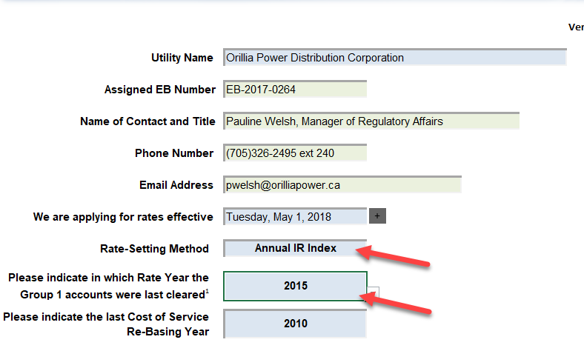
- In the Decision and Rate Order issued for Orillia Power’s 2017 rates (EB-2016-0321), the Group 1 DVA accounts balances as of December 31, 2015 were disposed of. Therefore, the rate year associated with this disposition should be 2017. In tab 1 of the 2018 IRM model, Orillia Power selected 2015 as the rate year in which the Group 1 accounts were last cleared. Please confirm if the rate year should be corrected to 2017.
Question #2
Ref: IRM Model Tab 3: Adjustments in Account 1595 (2012) and Account 1595 (2014); 2017 OEB-approved disposition in Account 1595 (2012)
- In tab 3 continuity schedule of the IRM model, Orillia Power reported adjustment amounts in 2016 in account 1595 (2012) and account 1595 (2014). Please provide explanations for these adjustments (as highlighted in the screenshot below in both principal and interest).
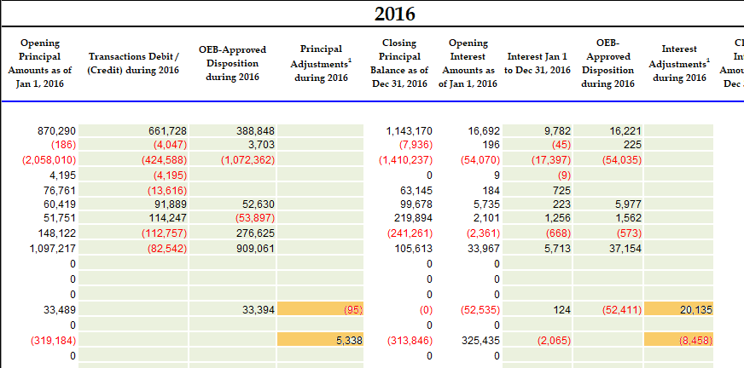
- As per the Decision and Rate Order issued for Orillia Power’s 2017 rates, the interest disposition during 2017 in account 1595 (2012) should be a debit amount of $20,064. In the continuity schedule in Orillia Power’s 2018 IRM model, the disposition amount mentioned above was reported as a debit amount of $20,040. Please provide explanation for the discrepancy ($24).

Question #3
Ref: Account 1588 Power
Ref: 2018 Rate Generator Model – Tab 3 Continuity Schedule
With regards to the amount being requested for disposition of USoA 1588 account balance as at Dec. 31, 2016, all components that flow into Account 1588 (i to iv in table below) should be all based on actuals at year end. Please complete the following table to:
- Indicate whether the component is based on estimates or actuals at year end, and
- Quantify the adjustment pertaining to each component that is trued-up from estimate to actual
 | Component | Estimate or Actual? | Notes/Comments | Quantify True Up Adjustment $ Amount
i | Revenues (i.e. is an unbilled revenue true-up adjustment reflected in the balances being requested for disposition?)
ii | Expenses – Commodity: Charge Type 101 (i.e. is expense based on IESO invoice at year end)
iii | Expenses - GA RPP: Charge Type 148 with respect to the quantum dollar amount (i.e. is expense based on IESO invoice at year end)
iv | Expenses - GA RPP: Charge Type 148 with respect to the RPP/non-RPP kWh volume proportions.
v | RPP Settlement: Charge Type 142 including any data used for determining the RPP/HOEP/RPP GA components of the charge type

- For each item in the table above, please confirm that the 2018 Rate Generator Model Tab 3 Continuity Schedule for 2016 have been adjusted for settlement true-ups where settlement was originally based on estimate and trued up to actuals subsequent to 2016.

Question #4
Ref: Follow up questions on GA Analysis
- Please indicate which GA rate Orillia Power uses for the unbilled revenue.
- On page 14 of the application, it states that “Orillia Power completes a true-up and reconciles the estimates of RPP and non-RPP consumption to actuals on a monthly basis. Orillia Power bills on a calendar month basis and uses actual billing data in the following month to true-up estimates used in the preliminary settlement process.”
- Does Orillia Power use the actual billing data in the following month to record unbilled revenue?
- Please explain the time lag of the RPP Settlement True-up, i.e. when would the October, November and December true-ups be reflected in the G/L.

- In its response to GA question #5 part iii, Orillia Power notes that “RPP/Non-RPP proration percentages are determined after final annual reconciliation of IESO Form 1598 is completed”.
  - When was the final annual reconciliation for 2016 completed and reflected in the G/L?
  - What is the dollar amount of the 2016 annual reconciliation? Has Orillia Power reflected the true-up adjustment for 2016 in the 2016 year-end balance?
  - Has Orillia power updated their RPP Settlement true-up procedures consistent with the OEB May 23, 2017 letter regarding the Guidance on the Disposition of Accounts 1588 and 1589?
  - Please describe the final annual reconciliation process.
  - Please explain what the difference is between this annual reconciliation true-up and the monthly true-up that is completed by Orillia Power.

Note, the following in all references in OEB Staff questions relating to amounts booked to account 1588. Amounts are not booked directly to account USoA 1588 relating to power purchase and sale transactions, but are rather booked to the cost of power USoA 4705 Power Purchased. However, account 1588 is impacted the same way as accounts 4705 is for cost of power transactions, and the same way as the Energy Sales accounts are for revenue transactions.

