Questions in relation to GA Analysis Work Form
- Table in note 4.
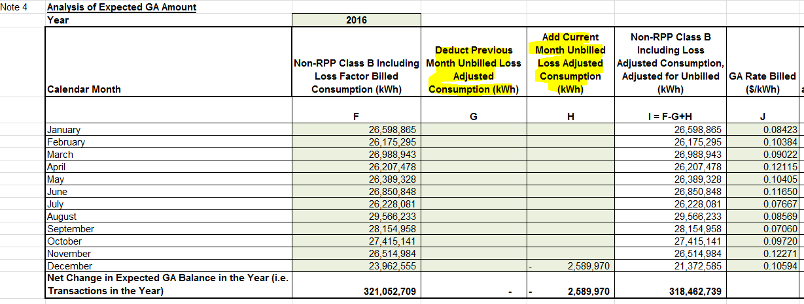
- Please confirm that the Non-RPP Class B kWh amounts entered in column F below represent the kWh that was billed in each Month.

Response: The amounts included in column F are the Non-RPP Class B kWh used in the month versus billed in the month. As Festival did not, at the time, book unbilled revenue each month, the VR account was prepared utilizing the IESO invoice charge for non-RPP class B and the actual GA price to determine the actual kWh utilized in the month – and then this quantity was used to compare the price differential on GA actual vs. the 1st estimate which Festival bills off of to come up with the total dollar variance.

- Please enter the unbilled kWh for previous month and current month in column G and H.

Response: see response above

- After the table is updated, please calculate the value of “F59/D26” in the work form and compare this value to the total loss factor of Festival, 1.0291. If there is a significant difference, please provide explanation.
Based on the data provided this would be 1.032.

- Table in Note 5
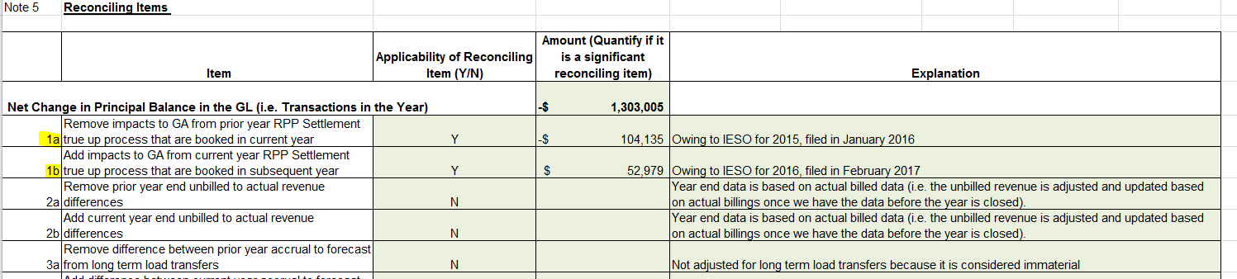

  - In booking expense journal entries for Charge Type 1142 (formerly 142), and Charge Type 148 from the IESO invoice, please confirm which of the following approach is used:
    - Charge Type 1142 is booked into Account 1588. Charge Type 148 is pro-rated based on RPP/non-RPP consumption and then booked into Account 1588 and 1589, respectively
    - Charge Type 148 is booked into Account 1589. The portion of Charge Type 1142 equalling RPP-HOEP for RPP consumption is booked into Account 1588. The portion of Charge Type 1142 equalling GA RPP is credited into Account 1589.
    - Another approach. Please explain this approach in detail.

Response: Festival follows another approach. Please review the OEB audit report dated June 5, 2017. Specifically, 1.2.3 finding and 1.2.4 response by Festival. As part of the audit, Festival has committed to revising several processes including this process, but notes that the annual adjustment calculated for 2016 was determined to be immaterial and as such no adjustment was made in 2016.

  - With regards to the Dec. 31 balance in Account 1589, please indicate whether the following items that flow into the account is based on estimates/accruals or actuals at year end:
    - Revenues (i.e. is unbilled revenues trued up)
    - If there are reconciling items #1a, 1b in the GA Analysis Work form or if there are any proposed adjustments to account 1589 in the DVA Continuity Schedule for the true up impacts, please quantify the adjustment that relate to each of the following items.
      - Expenses - GA non-RPP (Charge Type 148) with respect to the quantum dollar amount
      - Expenses - GA non-RPP (Charge type 148) with respect to RPP/non-RPP pro-ration percentages
      - Credit of GA RPP (Charge Type 142) if the approach under IR 1b is used
Response:
Festival books a preliminary balance in 1589 using an unbilled revenue estimate for December 31, and then once all December consumption has been billed, utilizing the February billing stats information – Festival trues up the unbilled revenue amount to the actual unbilled revenue for December based on billing stats.
Festival has included an adjustment in the GA work form (1a - -$104,135 and 1b - $52,979). These adjustments represent 2015 true ups filed with the IESO in 2016 and 2016 true ups filed with the IESO in 2017.
In the continuity schedule included in the rate generator model Festival has included an adjustment of $52,979 representing the amount owing to the IESO for 2016 which was filed in February 2017.
All of these adjustments would be a combination of 1 & 2 in your question above.

