Festival – Staff LRAMVA Questions
Staff-1
Ref: Application, pages 7-8
LRAMVA Work Form, Tab 1, Table 1-b
For the 2016 LRAMVA balance:
- In Festival Hydro’s LRAMVA application, it is seeking approval of a debit balance of $205,628 effective January 1, 2018. In the LRAMVA work form submitted by Festival Hydro, a debit balance of $334,903 has been calculated. Please confirm the amount being claimed.

- Please confirm that the 2016 LRAMVA is based on final IESO verified savings results.

- At page 8 of the application, Festival has confirmed that an adjustment of $140,032 was included for approval effective January 1, 2018.
- Please confirm whether or not the adjustment is included in the 2016 LRAMVA balance via completion of Tab 5 of the LRAMVA work form.
- If not, please clarify how the adjustment is included in the total claim.

- In Tab 1 of the LRAMVA work form, please clarify what the adjustment of $346.08 relates to and why this amount is included in the 2016 LRAMVA balance. In particular, please explain what cells H69 and I69 in Tab 1 of the LRAMVA work form pertain to.

- Can Festival please confirm why it is appropriate to include the adjustment of $346.08 in Tab 1 of the LRAMVA work form? In your response, please confirm that there are no retroactive claims being made to the current filed LRAMVA amount. Staff notes that Festival has been approved of lost revenues up to 2015 CDM programs in the last IRM rates application.
- If Festival believes it is appropriate to claim this adjustment of $346.08, please clarify whether there is another way the “adjustment” can be recovered without affecting the LRAMVA work form? In Staff’s view, it appears to be inappropriate that the LRAMVA work form is capturing adjustments due to timing differences in the entry in the GL and the amount in carrying charges from 2016 to 2017. Please confirm.

- At page 8 of the application, projected interest of $2,210 is requested to be approved in the 2016 LRAMVA claim.
- Please confirm whether $2,210 in carrying charges is proposed to be claimed as part of the LRAMVA disposition.
- Please confirm the period of the interest amounts collected on this amount and the interest rate used.
- Please confirm the carrying charges amount for the 2016 year in the LRAMVA, with the 2011-2015 amounts removed from Table 1-b of the LRAMVA work form. Please revise Tab 6 as appropriate.
For the 2014 amount added to the LRAMVA total:
- At page 8 of the application, it shows that a remaining balance of $10,335 from 2014 is requested to be claimed.
- Please discuss how a remaining balance from 2014 is created and why it is proposed to be recovered in account 1568 with the 2016 LRAMVA disposition.

- As noted in Tab 1 of the LRAMVA work form, amounts that are previously approved should not be included in the form. Please discuss the appropriateness of including the 2011 to 2015 LRAMVA amounts in Table 1-b of the LRAMVA work form.

Staff-2 (revised)
Ref: 2015 COS Appendix 2-I (excel)
LRAMVA Work Form, Tabs 2 and 5
Pre-amble

In the 2015 COS Appendix 2-I, a manual adjustment of 4,960,075 kWh and an LRAMVA threshold of 4,320,150 kWh were approved in 2015. In the LRAMVA work form, it appears that forecast savings were based on the manual adjustment rather than the approved LRAMVA threshold.

In the 2018 application, Festival notes that the 2015 COS load forecast reflects the full impact of 2011-2014 results. In Appendix 2-I in the 2015 COS, it shows that 2011 to 2013 impacts were fully incorporated in the 2014 load forecast. On pages 99 and 100 of 104 of Festival’s Settlement Agreement, it appears as if 2011-2014 persisting program savings have been embedded in 2015 rates.

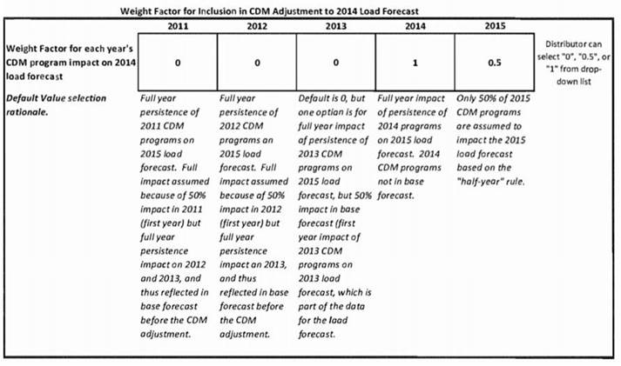
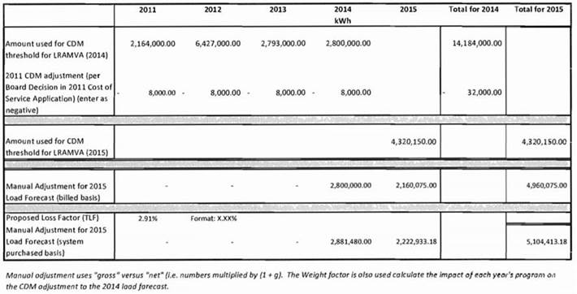

In the LRAMVA work form, Festival has proposed to claim the persistence of savings from 2011 to 2014 in 2016. Given what is shown in Appendix 2-I, it appears to Staff that the persisting savings from 2011 to 2013 CDM programs in 2016 have been included in the 2015 load forecast, and should not be included in the LRAMVA.
- Please confirm that the threshold of 4,320,150 kWh should be used. If Festival agrees a change is required, please update Tab 2 as appropriate. Please provide a reference source of the breakdown of the LRAMVA threshold used.
- Based on the tables in the Settlement Agreement and Appendix 2-I, it is not clear to Staff what actual years of savings were included in the 2015 load forecast and what forecast years of savings were used in the 2015 manual adjustment (and related LRAMVA threshold). Please confirm whether 2011 to 2013 persisting savings, or in fact 2011 to 2014 persisting savings, have been captured in the 2015 load forecast. If Festival agrees that there are some historical persistence of these savings captured in the 2015 load forecast, please consider the following:

  - In Tab 5, Table 5-b, please confirm the appropriateness of removing the persisting lost revenues from 2011 to 2013 in 2016 (rows 382 to 384)
  - In Tab 5, Table 5-b, please confirm whether the persistence of 2014 savings should be excluded in 2016 (row 385)

- In Table 2-a of the LRAMVA work form, it appears that 5,068 kWh of the LRAMVA threshold is not associated with a rate class. Please confirm accuracy of the rate class breakdown of the LRAMVA threshold noted in Tab 2, Table 2-a of the LRAMVA work form.
- Please confirm the updated 2016 amount in Tabs 1 and 5 of the LRAMVA work form.

Staff-3
Ref: LRAMVA Work Form, Tabs 4 and 5
Please discuss the methodology to calculate the rate class allocation by sector and program. In particular, please discuss the inputs and outputs of the formula used to calculate the rate class allocation percentages in Tabs 4 and 5.

Staff-4
- Please provide a table confirming the LRAMVA amount requested for disposition in 2016 by year, rate class and rate rider.
- If Festival Hydro has made any changes to the LRAMVA work form as a result of its responses to interrogatories, please file an updated LRAMVA work form.

