Responses to Board staff questions in relation to GA Analysis Work Form

- Table in Note 5
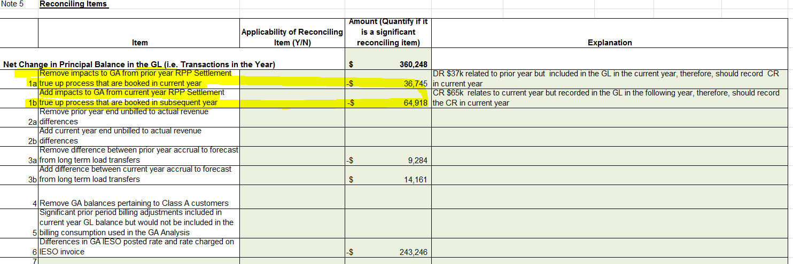

- 1a and 1b:

  - In booking expense journal entries for Charge Type 1142 (formerly 142), and Charge Type 148 from the IESO invoice, please confirm which of the following approach is used:
    - Charge Type 1142 is booked into Account 1588. Charge Type 148 is pro-rated based on RPP/non-RPP consumption and then booked into Account 1588 and 1589, respectively
    - Charge Type 148 is booked into Account 1589. The portion of Charge Type 1142 equalling RPP-HOEP for RPP consumption is booked into Account 1588. The portion of Charge Type 1142 equalling GA RPP is credited into Account 1589.
    - Another approach. Please explain this approach in detail.

Response:

Oakville Hydro confirms that it books charge type 148 in the Global Adjustment variance account (account 1589) and then credits the portion of charge type 1142 equalling the GA RPP into account 1589 as set out in approach (b).

  - With regards to the Dec. 31 balance in Account 1589, please indicate whether the following items that flow into the account is based on estimates/accruals or actuals at year end:
    - Revenues (i.e. is unbilled revenues trued up)

Response:

At year-end, Oakville Hydro records revenue on an accrual basis. Therefore, the balance in account 1589 as at December 31 is based upon estimates/accruals. Unbilled revenues are not trued up to actual revenues.

    - If there are reconciling items #1a, 1b in the GA Analysis Workform or if there are any proposed adjustments to account 1589 in the DVA Continuity Schedule for the true up impacts, please quantify the adjustment that relate to each of the following items.
      - Expenses - GA non-RPP (Charge Type 148) with respect to the quantum dollar amount
      - Expenses - GA non-RPP (Charge type 148) with respect to RPP/non-RPP pro-ration percentages
      - Credit of GA RPP (Charge Type 142) if the approach under IR 1b is used

Response:
The credit of $36,475 and $64,918 in reconciling items 1(a) and 1(b) respectively, relate to the credit of GA RPP (Charge Type 1142) under IR approach 1 (b).

- Item 6: Please provide supporting details to explain the ($243,246) adjustment.
Response:
In 2016, a short-term load transfer in one of the transformer stations serving Oakville Hydro resulted in incorrect metered consumption during the load transfer period. As a result, Oakville Hydro was overbilled for electricity charges by the IESO.

The adjustment of $243,246 in the Global Adjustment Work Form represents the amount of the overbilling, estimated at the time, that was recorded in the Global Adjustment variance account as at December 31, 2016. This issue was fully resolved through the settlement process in 2017.
Given that this issue has been resolved, the $243,246 will not be reflected in the variance account balance as at December 31, 2017. Oakville Hydro also notes that, since it is not requesting disposition of its 2016 variance account balances, this amount will not affect its customers.

