Proposed Amendments to the Distribution System Code

London Hydro’s Comments

Summary of London Hydro’s Review

London Hydro has reviewed the proposed amendments to the OEB’s Distribution System Code and notes the following observations on a high level. Specific details to support our observations follow each proposed amendment.

- London Hydro echo’s the EDA comments on these amendments.

- London Hydro is concerned that generalized inputting of the word “shall” in place of “may” can be inferred as requiring all connections, contributions and expansions be handled in the same manner. London Hydro has exercised over the years the application of connections, contributions and expansions and in support of efficiency and materiality introduced threshold tests or limits. London Hydro would recommend that distributors should have the ability to set a minimum threshold befitting their experiences.

More specifically London Hydro is concerned that this simple wording change could lead to unnecessary disagreements with customers and/or the OEB audit or compliance staff syntactic interpretation of requirements. London Hydro would suggest that through years of experience with customers, OEB Compliance and OEB Audit interactions, much of the disagreements on application of OEB code has been the result of the syntactic application of specific words or phrases used in the code. Too often it is specific words that become contentious; eroding what may have been the original spirit and intent of the application.

London Hydro wishes to avoid this and therefore suggests the OEB remove the wording “shall” in favour of more liberal terminology. The OEB may wish to consider inputting “shall, within reason,” as an alternative.

- London Hydro is concerned with the minimal reference to “basic connection charge”. London Hydro would suggest that such simple wording could lead to unnecessary disagreements with customers and/or the OEB audit or compliance staff syntactic interpretation of requirements. London Hydro would suggest that a more definitive description be applied to accentuate the need for some level of variability in application.

- London Hydro is concerned with the minimal reference to “distributor-owned asset”. London Hydro would suggest that such simple wording could lead to unnecessary disagreements with customers and/or the OEB audit or compliance staff syntactic interpretation of requirements. London Hydro would suggest that a more definitive description be applied to accentuate the need for some level of materiality application.
London Hydro’s Comments to Each Proposed DSC Amendment

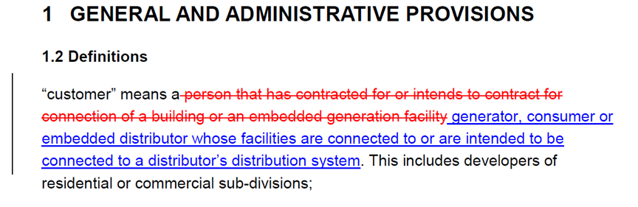

London Hydro’s Response:

London Hydro would suggest that a reference be included in the customer definition for consideration of previous bypass customers returning to the electricity grid. This would reinforce the requirement for such customers to be treated as if they were new customers and be subject to and responsible for all upgraded connection requirements that may not have been in place when they exited the grid.

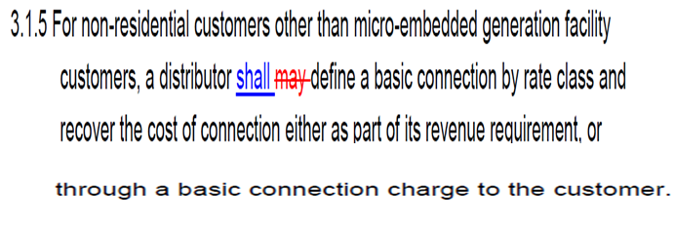
London Hydro’s Response:

London Hydro does not agree in principle to the replacement of the word “may” to “shall” in this instance. London Hydro is concerned that this simple wording change could lead to unnecessary disagreements with customers and/or the OEB audit or compliance staff syntactic interpretation of requirements. London Hydro currently applies basic connection charges based on various non-residential service types, given the multiple options for connection variations required within the limited defined non-residential rate classes. London Hydro would suggest that if such wording change is to be considered that more concentration be placed on the definition of “basic connection charge” to avoid conflict of syntactic interpretation.
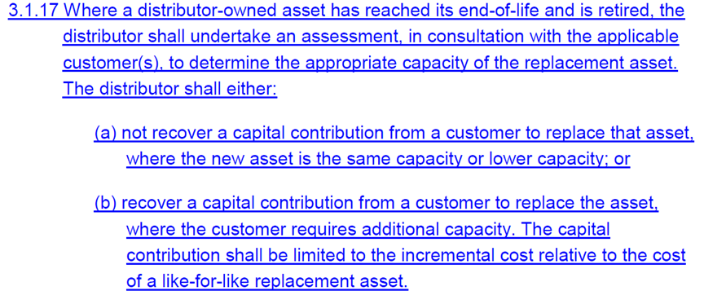
London Hydro’s Response:

London Hydro is concerned with the minimal reference to “distritributor-owned asset”. London Hydro would suggest that such simple wording could lead to unnecessary disagreements with customers and/or the OEB audit or compliance staff syntactic interpretation of requirements. London Hydro would suggest that a more definitive description be applied to accentuate the need for some level of materiality application. Possible suggestions could be the inclusion of the word “material” in the phrase wherein material could be defined as the distributors COS materiality.

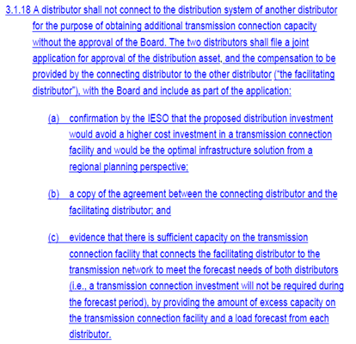
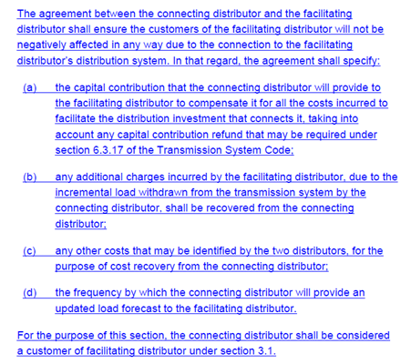
London Hydro’s Response:

London Hydro would echo the EDA comments on this amendment.

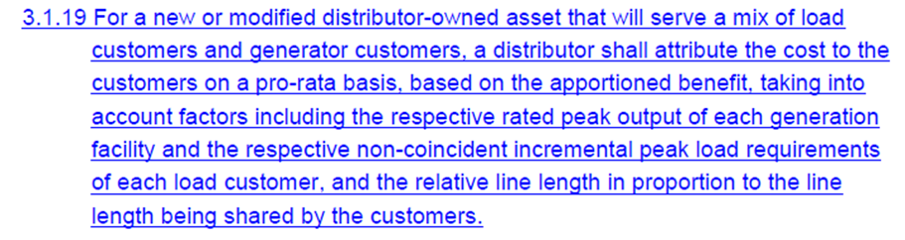
London Hydro’s Response:

London Hydro is again concerned with the minimal reference to “distributor-owned asset”. London Hydro would suggest that such simple wording could lead to unnecessary disagreements with customers and/or the OEB audit or compliance staff syntactic interpretation of requirements. London Hydro would suggest that a more definitive description be applied to accentuate the need for some level of materiality application.

Further London Hydro would suggest that the wording of this requirement as is is not comprehendible. London Hydro’s initial interpretation is that this is a cost allocation directive for a cost of service application. If this is the intent then London Hydro would question it’s placement within the DSC.

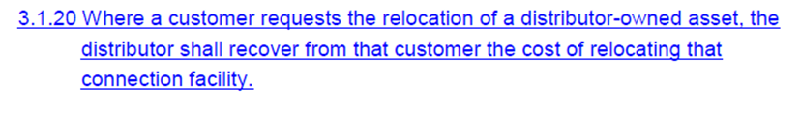
London Hydro’s Response:

London Hydro is again concerned with the minimal reference to “distributor-owned asset”. London Hydro would suggest that such simple wording could lead to unnecessary disagreements with customers and/or the OEB audit or compliance staff syntactic interpretation of requirements. London Hydro would suggest that a more definitive description be applied to accentuate the need for some level of materiality application.

London Hydro does not agree in principle to the use of the word “shall” in this instance. London Hydro is concerned that this simple wording could lead to unnecessary disagreements with customers and/or the OEB audit or compliance staff syntactic interpretation of requirements. London Hydro currently exercises recovery of costs for relocation of assets as a result of customer requests. In the case of municipal road work London Hydro is compelled to only recover 50% of costs incurred in accordance with “Public Service Works on Highways Act" R.S.O. 1990, CHAPTER P.49. In other circumstance London Hydro may exercise its own discretion as to the circumstances for amount to be recovered.

London Hydro would suggest that the word “shall” be replaced by “may” or “shall, within reason”.

London Hydro’s Response:

London Hydro has no concerns with this amendment.
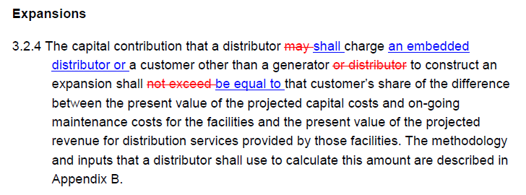
London Hydro’s Response:

London Hydro does not agree in principle to the replacement of the word “may” to “shall” in this instance. Also London Hydro does not agree in principle to the replacement of the words “not exceed” to “be equal to” in this amendment. London Hydro is concerned that these simple wording changes could lead to unnecessary disagreements with customers and/or the OEB audit or compliance staff syntactic interpretation of requirements. London Hydro has exercised the application of this code with consideration for balancing the materiality of recovery to the administrative burden in exercising this clause. London Hydro understands the OEB’s desire to have all LDCs exercise this directive. However London Hydro would suggest alternative wording be constructed as to not restrict efficiency of application.

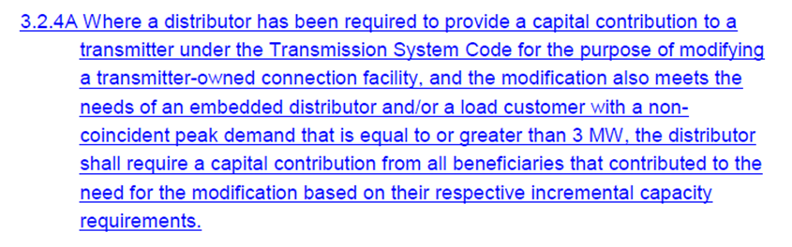
London Hydro’s Response:

London Hydro would echo the EDA comments on this amendment.

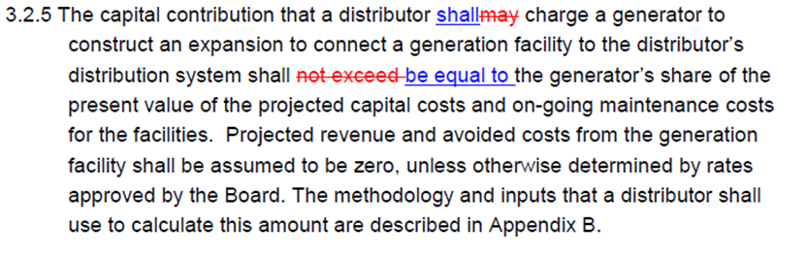
London Hydro’s Response:

London Hydro does not agree in principle to the replacement of the word “may” to “shall” in this instance. Also London Hydro does not agree in principle to the replacement of the words “not exceed” to “be equal to” in this amendment. London Hydro is concerned that these simple wording changes could lead to unnecessary disagreements with customers and/or the OEB audit or compliance staff syntactic interpretation of requirements. London Hydro has exercised the application of this code with consideration for balancing the materiality of recovery to the administrative burden in exercising this clause. London Hydro understands the OEB’s desire to have all LDCs exercise this directive. However London Hydro would suggest alternative wording be constructed as to not restrict efficiency of application.

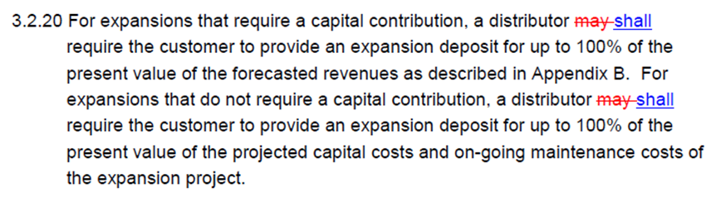
London Hydro’s Response:

London Hydro does not agree in principle to the replacement of the word “may” to “shall” in this instance. London Hydro is concerned that these simple wording changes could lead to unnecessary disagreements with customers and/or the OEB audit or compliance staff syntactic interpretation of requirements. London Hydro has exercised the application of this code with consideration for balancing the materiality of recovery to the administrative burden in exercising this clause. London Hydro understands the OEB’s desire to have all LDCs exercise this directive. However London Hydro would suggest alternative wording be constructed as to not restrict efficiency of application.

Currently, London Hydro does not require all expansion projects to pay an expansion deposit. Our policy is that if the capital cost of the expansion exceeds $100K, the customer will be required to pay the capital contribution requirement and an expansion deposit. If the capital cost of the expansion is less than $100K, the customer is required to pay their capital contributions only.

Expansions that cost less than $100K are typically smaller projects with less projected load/lots. In our experiences these types of projects connect their projected load/lots within the first 1 to 2 years.
With potentially hundreds of projects being active at any one time over the 5 year window, the administrative burden and costs maintaining these deposit records and performing monthly interest calculations on these projects would be substantial.

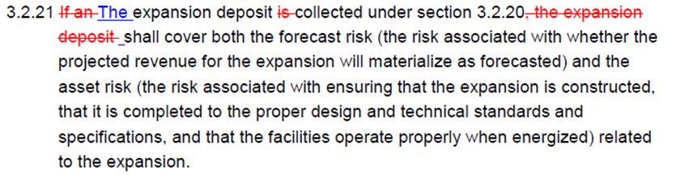

London Hydro’s Response:

The expansion deposit is held to mitigate the risk that the projected revenue will not materialize within the customer connection horizon. However, with expansion projects that cost less than $100K, the projected revenue is typically low so London Hydro does not feel that there is significant risk that these revenues will not materialize. And, it would be extremely uncommon for the revenue on these small projects to not materialize within the 5 year review period.

In addition to collecting a deposit for riskier projects, we also apply a conservative forecast on all projects that employs actual historical experience. This process helps to offset the revenue risk to London Hydro.

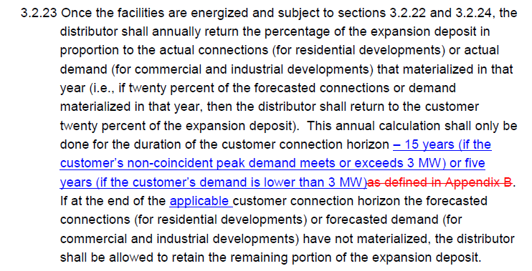
London Hydro’s Response:

London Hydro would echo the EDA comments on this amendment.

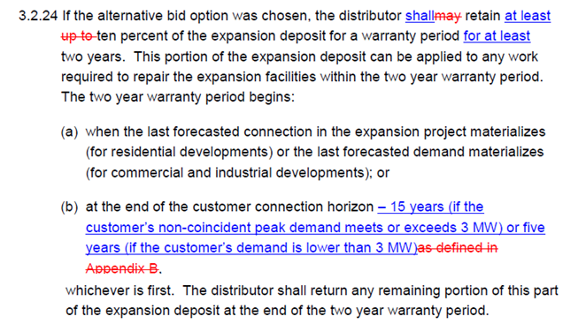
London Hydro’s Response:

London Hydro does not agree in principle to the replacement of the word “may” to “shall” in this instance. London Hydro is concerned that these simple wording changes could lead to unnecessary disagreements with customers and/or the OEB audit or compliance staff syntactic interpretation of requirements. London Hydro would suggest that the OEB give consideration for balancing the materiality of recovery to the administrative burden in exercising this clause. London Hydro understands the OEB’s desire to have all LDCs exercise this directive. However London Hydro would suggest alternative wording be constructed as to not restrict efficiency of application.

London Hydro would also suggest that there may be a conflict in wording in the fifth sentence with respect to the warranty period.

London Hydro would echo the EDA comments on this amendment with respect to customer.

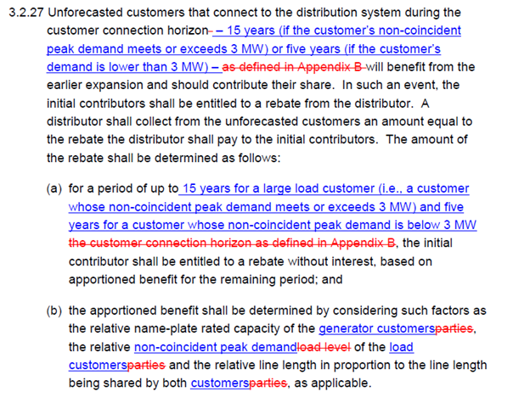
London Hydro’s Response:

London Hydro would echo the EDA comments on this amendment.

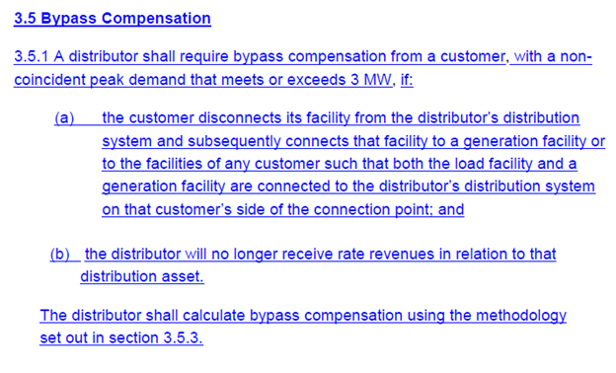
London Hydro’s Response:

London Hydro would echo the EDA comments on this amendment.

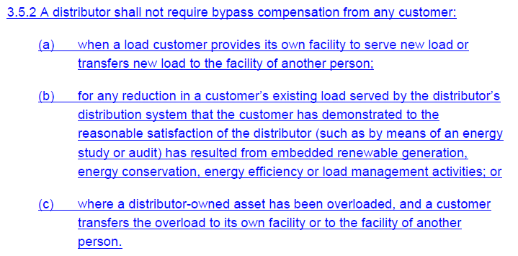
London Hydro’s Response:

London Hydro would echo the EDA comments on this amendment.

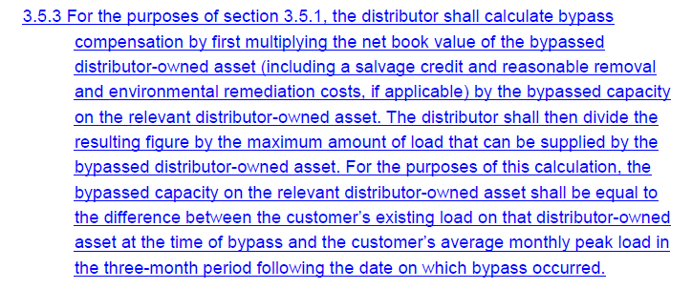
London Hydro’s Response:

London Hydro would echo the EDA comments on this amendment.

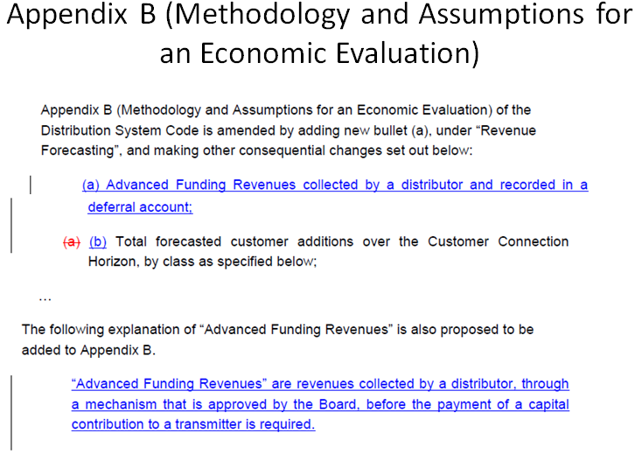
London Hydro’s Response:

London Hydro would echo the EDA comments on this amendment.

