Lakeland Power Distribution
OEB Staff Questions
EB-2017-0058

Lakeland Power Distribution Ltd.
EB-2017-0058

Parry Sound Service Territory
Staff Question-1
- With regards to the Dec. 31, 2016 balance in Account 1588, all components that flow into Account 1588 (i to iv in table below) should be all based on actuals at year end. Please complete the following table to a) indicate whether the component is based on estimates or actuals at year end and b) quantify the adjustment pertaining to each component that is trued up from estimate to actual
 | Component | a) Estimate or Actual | Notes/Comments | b) Quantify True Up Adjustment
i | Revenues (i.e. is unbilled revenues trued up by year end)
Ii | Expenses – Commodity: Charge Type 101 (i.e. is expense based on IESO invoice at year end)
ijj | Expenses - GA RPP: Charge Type 148 with respect to the quantum dollar amount (i.e. is expense based on IESO invoice at year end)
iv | Expenses - GA RPP: Charge Type 148 with respect and RPP/non-RPP pro-ration percentages
v | RPP Settlement: Charge Type 142 including any data used for determining the RPP/HOEP/RPP GA components of the charge type

Staff Question-2
No adjustment pertaining to impacts of RPP settlement true-up is proposed for Account 1588 or Account 1589, please explain why not.
Staff Question-3
Ref: A portion of Tab 3. Continuity Schedule is reproduced below.
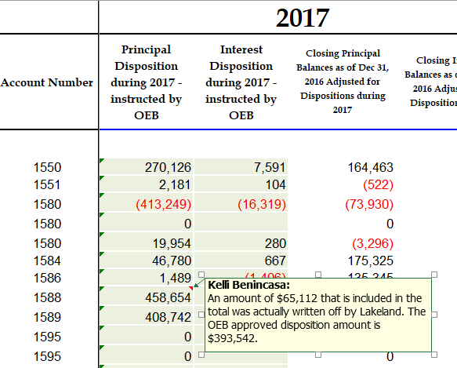
- Please confirm the OEB approved (EB-2016-0090) disposition amount for account 1588 is actually $393,542, not $458,654.
- The OEB acknowledges there is no adjustment column for the 2017 rate year in the continuity schedule. Please confirm for the 2018 rate year the amount of $65,112 will be in the 2017 adjustments column.

Lakeland Service Territory
Staff Question-1
- With regards to the Dec. 31, 2016 balance in Account 1588, all components that flow into Account 1588 (i to iv in table below) should be all based on actuals at year end. Please complete the following table to a) indicate whether the component is based on estimates or actuals at year end and b) quantify the adjustment pertaining to each component that is trued up from estimate to actual
 | Component | a) Estimate or Actual | Notes/Comments | b) Quantify True Up Adjustment
i | Revenues (i.e. is unbilled revenues trued up by year end)
Ii | Expenses – Commodity: Charge Type 101 (i.e. is expense based on IESO invoice at year end)
ijj | Expenses - GA RPP: Charge Type 148 with respect to the quantum dollar amount (i.e. is expense based on IESO invoice at year end)
iv | Expenses - GA RPP: Charge Type 148 with respect and RPP/non-RPP pro-ration percentages
v | RPP Settlement: Charge Type 142 including any data used for determining the RPP/HOEP/RPP GA components of the charge type

Staff Question-2
No adjustment pertaining to impacts of RPP settlement true-up is proposed for Account 1588 or Account 1589, please explain why not.

