Atikokan Hydro Inc. (Atikokan Hydro)
2018 IRM Application
EB-2017-0026
Application Analysis
December 22, 2017
Question #1
Ref: A portion of Sheet 8 “STS – Tax Change” is reproduced below.

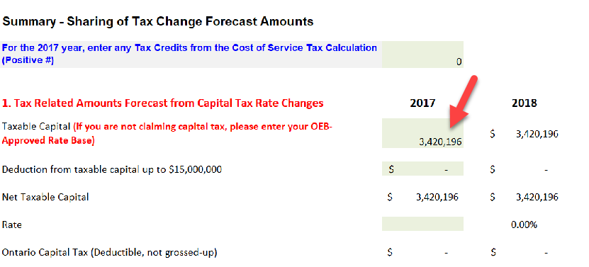

- OEB staff has been unable to confirm the amount entered in for “Taxable Capital” with the OEB approved amount from Atikokan Hydro’s 2013 cost of service Revenue Requirement Work Form (EB-2014-0055). Please provide evidence supporting this amount. If this amount is entered in error, OEB staff will make any necessary updates to the model.

Updates to IRM Model made by OEB staff

- Tab RTSR has been updated to reflect the new UTR
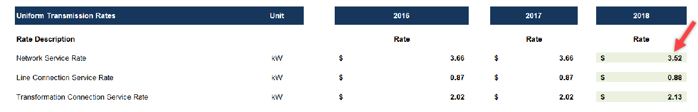

- Tab 16 has been updated to reflect the inflation factor of 1.2%
