EB-2017-0049

Ontario Energy Board

IN THE MATTER OF the Ontario Energy Board Act, 1998, S.O. 1998, c. 15, Sch. B, as amended;

AND IN THE MATTER OF the Application by Hydro One Networks Inc.’s for 2018-2022 Distribution Rates.

Interrogatories of

Energy Probe Research Foundation

January 24, 2018

A. GENERAL

1. Has Hydro One responded appropriately to all relevant OEB directions from previous proceedings?
2. Has Hydro One adequately responded to the customer concerns expressed in the Community Meetings held for this application?

IR #1
Reference: Exhibit A, tab 3, schedule 1, page 15

Preamble: Energy Probe is curious about the timing of Hydro One’s three investment plans and the customer engagement activities. It appears that, even though customers repeatedly stressed that bill increases were their number on concern – more than improved reliability – the first plan recommended by the utility’s asset managers called for a 7.1% rate increase in 2018 and 3.8% average annual rate increases over the term of the application.

- Did Hydro One’s asset managers make that request before the customer engagement surveys were completed? What were the time frames – i.e. when were the customer surveys completed versus the investment plans?
- How does Hydro One distribute its customer engagement surveys and findings to its asset managers? Are all asset managers required to review the findings before making recommendations?

3. Is the overall increase in the distribution revenue requirement from 2018 to 2022 reasonable?

IR#2
Reference: Exhibit E1, Tab 1, Schedule 2, Page 2, Table 1

Please explain the large variance in Regulated Revenues between 2016 Actual and 2016 Approved.

4. Are the rate and bill impacts in each customer class in each year in the 2018 to 2022 period reasonable?

IR #3

Please file the bill impacts on the various rate classes if the Board were to approve Hydro One’s application as is, with an effective date of January 2019. Energy Probe is most interested in seeing the bill impacts in 2019 that will include a rate rider for the collection of 2018 rates. Please do not include any bill mitigation measures or Fair Hydro Plan rebates.

For R2 customers, please do include the recent increase to the Rural or Remote Rate Protection program.

IR #4
Reference: Exhibit C1, tab 1, schedule 5, page 7-8

Has Hydro One’s forecast of LEAP spending changed as a result of the recently passed Fair Hydro Plan?

5. Are Hydro One’s proposed rate impact mitigation measures appropriate and do any of the proposed rate increases require rate smoothing or mitigation beyond what Hydro One has proposed?
6. Does Hydro One’s First Nation and Métis Strategy sufficiently address the unique rights and concerns of Indigenous customers with respect to Hydro One’s distribution service?

B. CUSTOM APPLICATION

7. Is Hydro One’s proposed Custom Incentive Rate Methodology, using a Revenue Cap Index, consistent with the OEB’s Rate Handbook?

IR #5
Reference: Exhibit A, tab 3, schedule 2, page 3

- Please confirm that the methodology used to establish inflation figures was for Price Cap IR, not Revenue Cap, as Hydro One is proposing.
- Is Hydro One aware of different inflation methodologies being used for Price Cap applications, as opposed to Revenue Cap?

IR #6
Reference: Exhibit A, tab 3, Schedule 1, page 6 and Exhibit A, Tab 3, Sch 2, page 2

Hydro One lists a number of advantages of its proposed Revenue Cap IR model over a Price Cap IR Model.
- Is "a Price Cap IR model" that Hydro One refers to the 4GRIM Price Cap IR model used by other electricity distributors in Ontario?
- Is this a comprehensive list of advantages? If not what are other advantages?
- Are there any disadvantages of the proposed Revenue Cap IR model over a Price Cap IR Model?
- Please file all presentations, reports, memos and e-mails that were given to Hydro One senior management to obtain their approval to use the proposed Revenue Cap IR model in the EB-2017-0049 OEB application.

8. Is the proposed industry-specific inflation factor, and the proposed custom productivity factor, appropriate?
9. Are the values for the proposed custom capital factor appropriate?

IR #7
Reference: Exhibit A, tab 3, schedule 2, page 6

Please explain how Hydro One will ensure that its proposed capital factor does not over-recover the cost of capital expenditures.

10. Are the program-based cost, productivity and benchmarking studies filed by Hydro One appropriate?

IR #8
Reference: Exhibit A, tab 3, schedule 1, page 22, Table 6

Are the productivity savings in Table 6 cumulative or incremental? For example, is Hydro One proposing an additional $70.5 million in productivity savings in 2019 or is it proposing an additional $7.3 million in savings from the $63.2 million of savings achieved in 2018?

IR #9
Reference: Exhibit A, tab 3, schedule 1, page 22, Table 6

Preamble: In Hydro One’s previous distribution rate application – EB-2013-0416, 2015-2019 rates – the utility estimated that it would achieve more than $100 million annually in productivity savings between 2015 and 2019. When the test year, 2014, was included, those savings amounted to more than $728 million in savings.

- Can Hydro One provide an update on the forecasted savings from its previous rate application?
- Are those productivity savings included in this application?
- Are the savings detailed in Hydro One’s current application in addition to those laid out in the previous rate application?

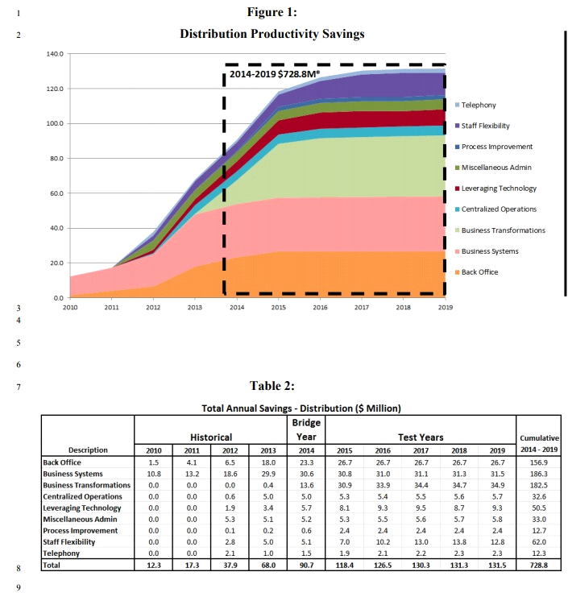

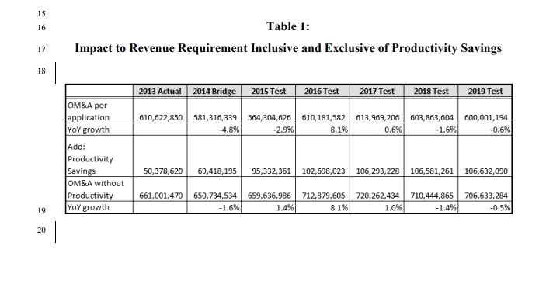
IR #10
Reference: Exhibit A, tab 3, Schedule 1, page 22, Table 6

Please explain how Hydro One plans to track actual productivity savings against its forecast of productivity savings, and how it plans to differentiate between productivity savings and cost savings in future years.

IR #11
Reference: Exhibit A, Tab 3, Schedule 2, page 10

- Please explain the method Hydro One proposes to use in tracking “verifiable productivity gains” during the Custom IR term.
- Please provide a numerical example using hypothetical numbers.

11. Are the results of the studies sufficient to guide Hydro One’s plans to achieve the desired outcomes to the benefit of ratepayers?
12. Do these studies align with each other and with Hydro One’s overall custom IR Plan?
13. Are the annual updates proposed by Hydro One appropriate?
14. Is Hydro One’s proposed integration of the Acquired Utilities in 2021 appropriate?

IR #12
Reference: Exhibit A, tab 7, schedule 1, page 1-11

Please provide service area savings for the acquired utilities for 2017.

15. Is the proposed Earnings/Sharing mechanism appropriate?
16. Are the proposed Z-factors and Off-Ramps appropriate?

C. OUTCOMES, SCORECARD AND INCENTIVES

17. Does the application adequately incorporate and reflect the four outcomes identified in the Rate Handbook: customer focus, operational effectiveness, public policy responsiveness, and financial performance?

IR #13
Reference: Exhibit A, tab 3, schedule 2, page 10

- How does Hydro One propose to verify in-service capital additions that result from productivity savings?
- Will Hydro One provide evidence for all in-service addition variances that result from productivity savings as opposed to underspending for organizational reasons?
- When will Hydro One provide that evidence? At the end of the term or annually?

IR #14
Reference: Exhibit A, tab 3, Schedule 1, page 8

Please explain the reasoning that Hydro One used in its proposal that the capital-in-service variance account track the cumulative difference over the Term between actual in-service and OEB approved capital additions for any in-service additions that are 98% or lower than the OEB approved level. Specifically why was the 98% level selected?

IR #15
Reference: Exhibit C1, tab 1, schedule 1, page 7

Please provide net bad debt levels from 2013 to 2017.

18. Are the metrics in the proposed additional scorecard measures appropriate and do they adequately reflect appropriate outcomes?

IR #16
Reference: Exhibit A, tab 3, schedule 1, page 11

- Why has Hydro One not considered a metric for cost per megawatt hour (MWh) delivered?
- Can Hydro One provide that figure for 2010-2016?

IR #17
Reference: Exhibit A, tab 3, schedule 1, page 16, Table 4

Please update Table 4 using 2013-2016 data, as well as 2010-2016 data

IR #18

Reference: Exhibit A, tab 5, schedule 1, page 8

- Given Hydro One’s vast reach and the different rate classes based on density, can Hydro One provide these scorecards for the different rate classes (UR, R1 and R2)?
- Please update these figures with 2016 and 2017 (if possible) results.

IR #19
Reference: Exhibit A, tab 5, schedule 1, page 35-37

Please provide SAIFI and SAIDI figures by rate class (UR, R1 and R2).

IR #20
Reference: Exhibit A, tab 5, schedule 1, page 39-41

Please provide cost control figures by rate class (UR, R1 and R2).
IR #21

Reference: Exhibit B1-1-1, DSP Section 3.6, page 6

How many customers have signed up to Hydro One’s pre-determined threshold program?

19. Are the proposals for performance monitoring and reporting adequate and do the outcomes adequately reflect customer expectations?

IR #22
Reference: Exhibit A, tab 5, schedule 1, page 5, Table 2

Can Hydro One break down these results by residential rate class (UR, R1 and R2)?

20. Does the application promote and incent appropriate outcomes for existing and future customers including factors such as cost control, system reliability, service quality, and bill impacts?
21. Does the application adequately account for productivity gains in its forecasts and adequately include expectations for gains relative to external benchmarks?
22. Has the applicant adequately demonstrated its ability and commitment to manage within the revenue requirement proposed over the course of the custom incentive rate plan term?

IR #23
Reference: Exhibit C1, tab 1, schedule 2, page 4

- Please provide an estimate to how much work was deferred (in nominal dollar amounts) in 2015 in order to address problems with the customer information system.
- What projects in particular were deferred as a result of problems with the customer information system and have they been addressed since?

IR#24
Reference: Exhibit A, tab 3, Schedule 1, pages 14 to 18

Hydro One deferred to future years previously planned 2018 capital spending on wood pole replacements, station refurbishments, component replacements, system capability reinforcement, information technology and facilities and real estate in moving from Plan B to Plan B Modified.

- Please provide a list of capital spending that was deferred showing the amount in each category and the subsequent year(s) that the capital spending has been deferred to.
- Please file all presentations and reports that were given to senior management in support of the deferral.

IR #25
Reference: Exhibit A, tab 3, Schedule 1, page 26, Table 9

Does the caption “Plan” indicate an OEB approved spending plan. If it does, please provide reference to OEB approval. Note 1 indicates that there were no Board approved capital expenditure budgets for 2013 and 2014 but the table shows Plan numbers. Please explain the source of those numbers and provide actual expenditures for those years.

IR #26
Reference: Exhibit C1, tab 1, schedule 2, page 17

Please explain why the “Line Maintenance” programs are repeatedly underspent.

IR #27
Reference: Exhibit C1, tab 1, schedule 5, page 3

Please provide an updated cost of Call Center Operations now that Hydro One has agreed to end the Inergi contract (as stated at the most recent conference).

IR #28
Reference: Exhibit C1, Tab 1, Schedule 7, Page 15

Considering that Hydro One will no longer be outsourcing certain customer care activities as disclosed at the presentation of the application on December 22, please explain why there is an increase in the forecast of outsourcing costs in 2018.

IR #29
Reference: Exhibit C1, Tab 5, Schedule 1

Based on the statements made at the Presentation of the application on December 22, Hydro One is reviewing its customer care outsourcing arrangements.
- Please explain the nature of the review and any decisions that were made as a result of the review.
- Please file any reports or presentations that were given to senior management to assist them in their decision on changes in outsourcing.

IR #30
Reference: Exhibit C1, Tab 4, Schedule 1, Page 15

Please file the 2015 Time Study mentioned in the Black & Veatch report.

D. DISTRIBUTION SYSTEM PLAN

23. Was the customer consultation adequate and does the Distribution System Plan adequately address customer needs and preferences?

IR #31
Reference: Exhibit B1-1-1, DSP Section 1.3

Please list ten most significant changes that Hydro One has made to the DSP as a result of consultations with its customers and provide detail explanations.

24. Does Hydro One’s investment planning process consider appropriate planning criteria? Does it adequately address the condition of distribution assets, service quality and system reliability?

IR #32
Reference: Exhibit B-1-1, DSP Section 1.1, Page 3

- Was the Ontario Ministry of Energy consulted or informed of Plan A and Plan B alternatives in the process of reaching the decision on the DSP?
- Please file all documents including reports and presentations that Hydro One gave to the Ministry of Energy regarding Plan A and Plan B alternatives.

IR #33
Reference: Exhibit B1-1-1, DSP Section 1.6, page 2

Hydro One says it is considering whether to reduce its capitalization policy from $2 million to $500k.

- Has Hydro One formally reduced its capitalization policy?
- Please provide any documents, memos or internal studies related to Hydro One’s decision to either reduce its capitalization policy or keep it at its current level.

IR #34
Reference: Exhibit B1-1-1, DSP Section 1.4, page 21-27

Please breakdown the reliability data – SAIDA, SAIFI and CAIDI by rate class (UR, RI and R2).

25. Does the Distribution System Plan adequately reflect productivity gains, benefit sharing and benchmarking?

IR #35
Reference: Exhibit B1-1-1, DSP Section 1.1, page 17, Table 4 and Exhibit B1-1-1, DSP Section 1.5, page 2-3, Table 17

Are the savings listed in Table 4 cumulative or incremental?

IR #36
Reference: Exhibit B1-1-1, DSP Section 2.1, page 27, Table 34

Preamble: Energy Probe is curious on how Hydro One came up with these weightings.

- Please explain Hydro One’s methodology for these weightings.
- Please provide any documents, memos or studies related to how Hydro One established these weightings.

IR #37
Reference: Exhibit B1-1-1, DSP Section 2.3, page 75

- Since 2010, how many buildings has Hydro One deemed surplus?
- What was the value of those sales by year?

IR #38
Reference: Exhibit B1-1-1, DSP Section 2.1, page 30

Please provide any variance proposals for projects with a budget of more than $1 million.

IR #39
Reference: Exhibit B1-1-1, DSP Section 3.6, page 5

- Given Hydro One’s numerous references to its aging fleet of poles, why did the company underspend in that category in both 2015 and 2016? Please provide a detailed response.
- Is Hydro One on track to meet its pole replacement budget in 2017? Please explain any variance.

IR #40
Reference: Exhibit B1-1-1, DSP Section 3.6, page 7

Please breakdown the $23 million by spending category. For example, how much was spent on the Web Redesign?

IR #41
Reference: Exhibit B1, Tab 2, Schedule 1, page 3

Preamble: Hydro One states that it is increasing its submarine cable maintenance programs to “meet challenges as a result of receding water levels in the Great Lakes…”

Data from the NOAA Great Lakes Environmental Research Laboratory suggest that water levels have increased in recent years.

Can Hydro One provide evidence that water levels in the Great Lakes are continuing to recede and what the direct cost of receding water levels is to the utility?

See data here:

https://www.glerl.noaa.gov//data/dashboard/GLD_HTML5.html

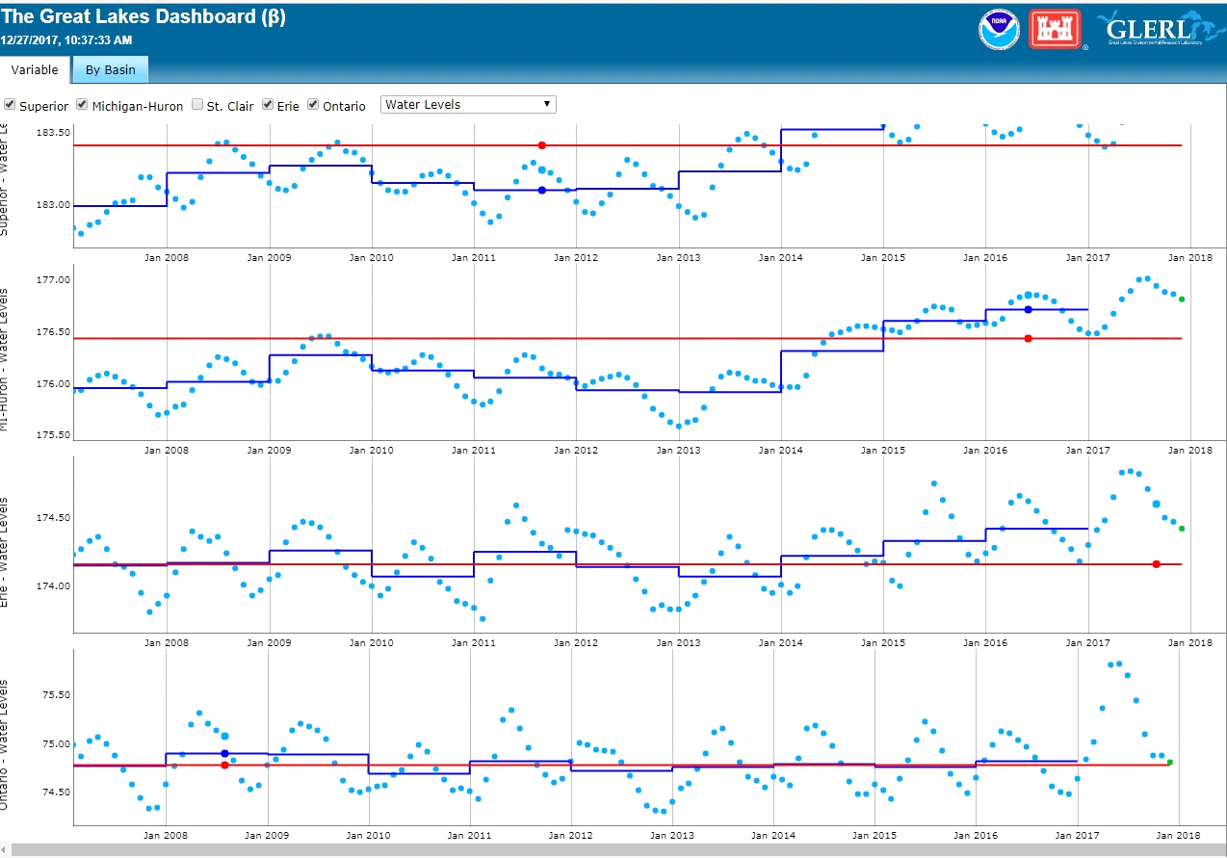

IR #42
Reference: Exhibit B1-1-1, DSP Section 1.4, Page 3, Table 8

Are the cost metrics in Table 8 adjusted for inflation? Please explain why or why not.

IR #43
Reference: Exhibit B1-1-1, DSP Section 1.4, Page 7

As Hydro One has indicated a number of metrics are sensitive to changes in the scope of work. Please explain how Hydro One will prevent reduction in the scope of work over time to maintain consistent reporting of actual metrics.

IR #44
Reference: Exhibit B1-1-1, DSP Section 1.4, Page 13

Hydro One proposes to cease reporting metrics on the number of replaced poles and the number of pole top transformers with PCB Oil. Will Hydro One still track these numbers for other purposes and, if required, make them available to the OEB in the future?

IR #45
Reference: Exhibit B1-1-1, Section 1.4, Attachment 1, Page 1

How will Hydro One ensure that there is no confusion between savings and avoided costs?

IR #46
Reference: Exhibit B1-1-1, Section 1.4, Attachment 1, Page 3

Hydro One indicates that each line of business is accountable for developing a productivity strategy including targets and forecasts for the business planning period. Have these productivity strategies been developed? If they have, please file them. If not please explain why not and indicate when the productivity strategies are expected to be completed.

IR #47
Reference: Exhibit B1-1-1, Section 1.5, DSP Section 1.5, Page 8

The list of changes that Supply Chain has made such as Bundling/Volume Discounts are long standing established practices in industry. Why is Hydro One only now implementing these changes?

IR #48
Reference: Exhibit B1-1-1, Section 1.5, DSP Section 1.5, Page 12

Hydro One states that “to date, 138 servers and 38 databases have been decommissioned, with plans to decommission an additional 67 servers and three databases by early 2017. This has
reduced Hydro One’s monthly server and database fees.”
- Were these assets owned or leased by Hydro One?
- If they were owned what was the net book value of the decommissioned assets?
- What were the costs of decommissioning and what account were they charged to?
- What was the reduction in Hydro One’s monthly server and database fees?

IR #49
Reference: Exhibit B1-1-1, DSP Section 1.6, Page 21

Please confirm that a reduction in IT capitalization threshold will reduce OM&A expense and increase rate base and depreciation expense. If that is the case, please provide an estimate of this proposal on revenue requirement.

IR #50
Reference: Exhibit B1-1-1, DSP Section 3.2, Page 1, Table 54

- Were there any changes in categories of capital expenditures between 2013 and 2017?
- Why is System OM&A shown in a table of capital expenditures?
- Please explain the reasons for the large variances shown in the System Service category for 2015, 2016 and 2017.
- Please explain the reason for the large variance shown in the General Plant Category for 2017.

IR #51
Reference: Exhibit B-1-1, DSP Section 3.8

Pease file approved business cases for the following programs. If approved business cases do not exist, please file documents that were used in obtaining senior management approvals for these programs.
- SA-01 Joint Use and Line Relocations Program
- SA-02 Metering Infrastructure Sustainment Program,
- SA-03 Meter Infrastructure Expansion Program
- SA-04 New Load Connections, Upgrades, Cancellations and Metering
- SA-05 Distributed Generation Connections
- SR-06 Distribution Station Refurbishment
- SR-07 Distribution Lines Trouble Call and Storm Damage Response Program
- SR-13 Life Cycle Optimization & Operational Efficiency Projects
- SR-14 Advanced Meter Infrastructure Hardware Refresh
- SS-02 System Upgrades Driven by Load Growth
- SS-05 Distribution System Modifications
- GP-01 Transport & Work Equipment
- GP-02 Real Estate Field Facilities Capital
- GP-18 Integrated System Operating Centre

26. Does the Distribution System Plan address the trade-offs between capital and OM&A spending over the course of the plan period?
27. Has the distribution System Plan adequately addressed government mandated obligations over the planning period?

IR #52
Reference: Exhibit C1, Tab 1, Schedule 4, page 18

What is Hydro One’s approximate total investment in Smart Grid since EB-2009-0096?
- What are the metrics that Hydro One uses to manage its annual investment in Smart Grid?
- How does Hydro One track the effectiveness of its annual Smart Grid investment?

28. Has Hydro One appropriately incorporated Regional Planning in its Distribution System Plan?
29. Are the proposed capital expenditures resulting from the Distribution System Plan appropriate, and have they been adequately planned and paced?
30. Are the proposed capital expenditures for System Renewal, System Service, System Access and General Plant appropriately based on the Distribution System Plan?
31. Are the methodologies used to allocate Common Corporate capital expenditures to the distribution business appropriate?
32. Are the methodologies used to determine the distribution Overhead Capitalization Rate for 2018 and onward appropriate?

E. RATE BASE & COST OF CAPITAL

33. Are the amounts proposed for the rate base from 2018 to 2022 appropriate?

IR #53
Reference: Exhibit D1, Tab 1, Schedule 1, Page 3, Table 3

- Please explain the reason for the significantly higher 2016 actual retirements amount.
- Please explain the reason for the growth in Provincial Funded Assets from 2014 to 2017.

34. Are the inputs used to determine the working capital component of the rate base and the methodology used appropriate?
35. Is the proposed capital structure appropriate?
36. Are the proposed timing and methodology for determining the return on equity and short-term debt prior to the effective date of rate implementation appropriate?
37. Is the forecast of long term debt for 2018 and further years appropriate?

IR #54
Reference: Exhibit D1, Tab 2, Schedule 1, Page 5, Table 1

Please confirm that Table 1 is incorrect and that Short Term Debt is “Deemed”, not Long Term Debt.

F. OPERATIONS MAINTENANCE & ADMINISTRATION COSTS

38. Are the proposed OM&A spending levels for Sustainment, Development, Operations, Customer Care, Common Corporate and Property Taxes and Rights Payments, appropriate, including consideration of factors considered in the Distribution System Plan?
39. Do the proposed OM&A expenditures include the consideration of factors such as system reliability, service quality, asset condition, cost benchmarking, bill impact and customer preferences?
40. Are the proposed 2018 human resources related costs (wages, salaries, benefits, incentive payments, labour productivity and pension costs) including employee levels, appropriate (excluding executive compensation)?

IR #55
Reference: Exhibit B1-1-1, DSP Section 1.4, page 3

What percentage of Short-Term Incentive Plan (STIP) and Long-Term Incentive Plan (LTIP) payments are based on scorecard-based performance?

IR #56
Reference: Exhibit C1, Tab 2, Schedule 1, Pages 22 and 23

Have 2017 STIP and LTIP compensation payments been determined? If they have what percentages of employees in each eligible group received the maximum payment, above average payment, average payment, and below average payment?

IR #57
Reference: Exhibit B1-1-1, DSP Section 1.4, page 6-9

Please breakdown the Operational Effectiveness measures by rate class (UR, R1 and R2)? The measures we are most interested in are: Pole Replacement, Vegetation Management, OM&A per Customer and OM&A expense per km of Line.

IR #58

Reference: Exhibit A, Tab 3, Schedule 1, page 31

Please explain why “higher than forecast spending on trouble calls” would increase rate base. Is response to trouble calls treated as capital or OM&A? Please explain.

41. Has Hydro One demonstrated improvements in presenting its compensation costs and showing efficiency and value for dollar associated with its compensation costs (excluding executive compensation)?

IR #59
Reference: Exhibit C1, tab 1, schedule 5, page 10, table 9

Please update these figures with the most recent information and provide data back to 2010.

IR #60
Reference: Exhibit C1, tab 5, schedule 1, page 5, table 1

Please provide the most recent figures for 2017.

IR #61
Reference: Exhibit C1, Tab 2, Schedule 1, Page 30

Does Hydro One have study or a report that has examined the advantages and disadvantages of using its own casual construction labour for construction projects instead of contracting out construction work? If there is such a study or a report, please file it.

IR #62
Reference: Exhibit C1, tab 2, Schedule 1, Attachment 6, Table 1

Please add the following lines to Table 1:

a) Hydro One total FTEs (all categories of employees)
b) Total compensation (all categories including incentive payments) per FTE
c). Percent change in total compensation per FTE from previous year

42. Is the updated executive compensation information filed by Hydro One in the distribution proceeding on December 21, 2017 consistent with the OEB’s findings on executive compensation in the EB-2016-0160 Transmission Decision?
43. Are the methodologies used to allocate Common Corporate Costs and Other OM&A costs to the distribution business for 2018 and further years appropriate?

G. REVENUE REQUIREMENT

44. Is Hydro One’s proposed depreciation expense for 2018 and further years appropriate?

IR #63
Reference: Exhibit C1, Tab 6, Schedule 1, Page 4

- Please confirm that increased capitalized depreciation of transport and work equipment increases rate base.

- Please confirm that in the pole replacement program, since the cost of removal is treated as depreciation expense and included in accumulated depreciation, the removal of poles has no impact on rate base.

IR #64
Reference: Exhibit C1, Tab 6, Schedule 1, Attachment 1, Page 15

Please explain the reason for the recommended negative accrual rates for certain assets, specifically generators, land-depreciable, and communication equipment. Does this mean that if current depreciation rates are continued as proposed, ratepayers would be charged for depreciation expense on fully depreciated assets?

45. Are the proposed other revenues for 2018 – 2022 appropriate?

H. LOAD AND REVENUE FORECAST

46. Is the load forecast methodology including the forecast of CDM savings appropriate?

IR #65
Reference: Exhibit H1, Tab 5, Schedule 1, page 3

Will Hydro One’s capital spending program – and the updating of many of its assets – have any impact on its Total Loss Factors? Please provide any documents, memos or evidence that discuss the impact that the utility’s capital spending program will have on Total Loss Factors.

47. Are the customer and load forecasts a reasonable reflection of the energy and demand requirements for 2018 – 2022?
48. Has the load forecast appropriately accounted for the addition of the Acquired Utilities’ customers in 2021?

I. COST ALLOCATION AND RATE DESIGN

49. Are the inputs to the cost allocation model appropriate and are costs appropriately allocated?
50. Are the proposed billing determinants appropriate?
51. Are the revenue-to-cost ratios for all rate classes over the 2018 – 2022 period appropriate?

IR #66
Reference: Exhibit H1, Tab 1, Schedule 1, page 9, Tables 5-7

Please re-create these charts, but put all residential rate classes (UR, R1, R2 and Seasonal) at a revenue-to-cost ratio of 100%.

IR #67
Reference: Exhibit H1, Tab 1, Schedule 2, page 1-5

Please explain Hydro One’s reasoning for allowing the revenue-to-cost ratio for the UR and R1 rate classes to get worse (increase from 2018 levels to 2022)?

IR #68
Reference: Exhibit H1, Tab 4, Schedule 1, page 2, Table 1

Please refile this table, but hold all residential rate classes at a revenue-to-cost ratio of between 95% to 105%.

IR #69
Reference: Exhibit H1, Tab 1, Schedule 1, Page 8

Please explain why the revenue-to-cost ratios of some rate classes which are above 1.0 in 2017 are increasing in the subsequent years? Is not the objective to have rate all classes as close to 1.0 by the end of the period?

52. Are the proposed fixed and variable charges for all rate classes over the 2018 – 2022 period, appropriate, including implementation of the OEB’s residential rate design?
53. Are the proposed Retail Transmission Service Rates appropriate?
54. Are the proposed specific service charges for miscellaneous services over the 2018 – 2022 period reasonable?
55. Are the proposed line losses over the 2018 – 2022 period appropriate?
56. Do the costs allocated to acquired utilities appropriately reflect the OEB’s decisions in related Hydro One acquisition proceedings?

J. DEFERRAL/VARIANCE ACCOUNTS

57. Are the proposed amounts, disposition and continuance of Hydro One’s existing deferral and variance accounts appropriate?

IR #70
Reference: Exhibit A, tab 3, schedule 1, page 2

- Please update the amount of money in deferral accounts that Hydro One is proposing to clear over 2018-2022
- Please provide how much money Hydro One would have to “back collect” in 2019-2022 if the Board were to approve Hydro One’s application as is and with an effective date of January, 2019.
- Is Hydro One proposing to collect the difference between interim 2018 rates and approved rates over four years (2019-2022)? What is the bill impact of collecting that money over two-years, compared to four years?

IR #71
Reference: Exhibit A, tab 3, schedule 1, page 35, Table 16

Please update the deferral account balances at the end of 2017 if they are materially different.

IR #72
Reference: Exhibit F1, Tab 2, Schedule 1, page 1

Given that a decision on Hydro One’s distribution rates application isn’t likely until January 2019, is Hydro One still proposing to recover the deferral accounts over 2019-2022?

58. Are the proposed new deferral and variance accounts appropriate?
59. Is the proposal to discontinue several deferral and variance accounts appropriate?

