**Orillia Power Distribution Corporation**

**EB-2017-0264**

**Responses to Staff Questions**

**January 25, 2018**

**Question #1**

**Ref: IRM Model Tab 1: Rate-setting Method; Rate Year in which Group 1 accounts were last cleared**

1. Orillia Power selected “Annual IR Index” as the rate-setting method in tab 1 of the IRM model. OEB staff noted that Orillia Power filed its previous rate applications (2015 to 2017) under the Price Cap IR methodology. Please confirm the rate setting method of Orillia Power’s 2018 application.

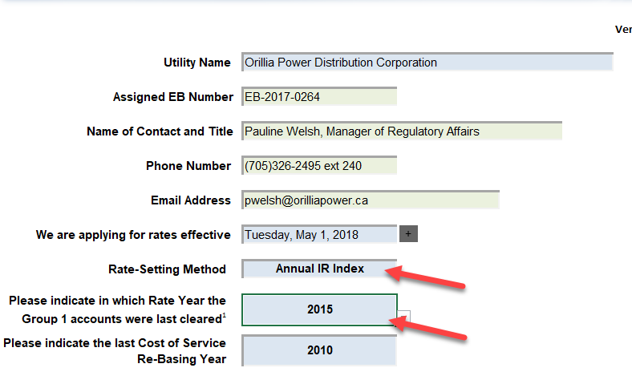

Reply:

In the Board letter dated July 5, 2016, Orillia Power was placed on the list of distributors whose rates will be scheduled for the 2018 rate year. This was the fourth year that Orillia Power sought a deferral to file a cost of service rate application. In paragraph four, the letter states:

*“In the absence of a 2018 cost of service rate application from Orillia Power, the OEB will apply the Annual IR Index method.”*

Accordingly, Orillia Power confirms that the rate-setting method for this application is Annual IR Index.

1. In the Decision and Rate Order issued for Orillia Power’s 2017 rates (EB-2016-0321), the Group 1 DVA accounts balances as of December 31, 2015 were disposed of. Therefore, the rate year associated with this disposition should be 2017. In tab 1 of the 2018 IRM model, Orillia Power selected 2015 as the rate year in which the Group 1 accounts were last cleared. Please confirm if the rate year should be corrected to 2017.

Reply:

Orillia Power confirms that the rate year should be corrected to 2017.

**Question #2**

**Ref: IRM Model Tab 3: Adjustments in Account 1595 (2012) and Account 1595 (2014); 2017 OEB-approved disposition in Account 1595 (2012)**

1. In tab 3 continuity schedule of the IRM model, Orillia Power reported adjustment amounts in 2016 in account 1595 (2012) and account 1595 (2014). Please provide explanations for these adjustments (as highlighted in the screenshot below in both principal and interest).

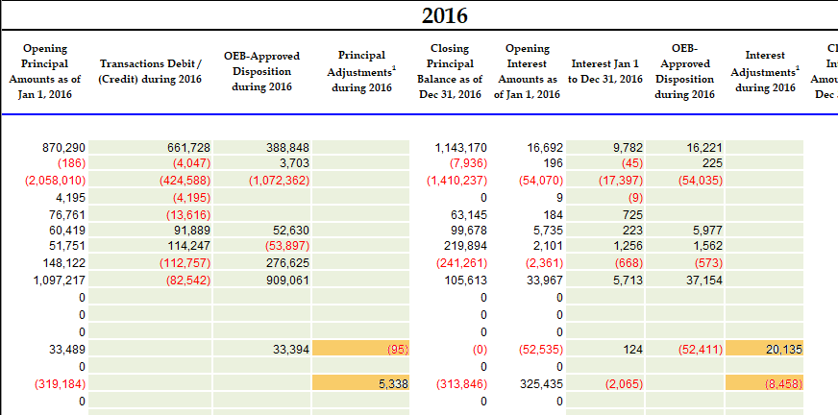

Reply:

In tab 3. Continuity Schedule, the principal adjustment of $95 in column BF represents the write-off of small amounts recovered through bills cancelled and reissued post sunset date for the related rate riders. The interest adjustment of $20,135 in column BK represents the residual balance of $20,159 in Account 1563 Deferred PILs Contra Account at December 31, 2015 moved to Account 1595 in 2016 as explained on page 14 of Orillia_APPL_2017 IRM_Revised Manager Summary_20161114[1] net of a small difference of approximately $24 related to a formula error in cell BQ33 of Orillia Power_Rate Model 2017_20170330. As shown in the table below, the approved rate rider was based on $20,136.

A further adjustment in tab 3. Continuity Schedule, column BF, for Account 1595(2014) represents the full recovery of the principal amount plus partial recovery of $5,338 of approved carrying charges. The adjustment is column BK of $8,458 consists of the $5,338 plus carrying charges of $3,120 on approved balances further written off in OPDC customers’ favour.



1. As per the Decision and Rate Order issued for Orillia Power’s 2017 rates, the interest disposition during 2017 in account 1595 (2012) should be a debit amount of $20,064. In the continuity schedule in Orillia Power’s 2018 IRM model, the disposition amount mentioned above was reported as a debit amount of $20,040. Please provide explanation for the discrepancy ($24).

Reply:

In the 2017 IRM Model, tab 3. Continuity Schedule, projected interest from Jan 1, 2016 to Apr 30, 2017 on Dec 31-15 balance for account 1595 (2012) should have been zero. This is same issue noted in a) above. After correction, the debit amount that was approved is $20,040.

**Question #3**

**Ref: Account 1588 Power[2]**

**Ref: 2018 Rate Generator Model – Tab 3 Continuity Schedule**

With regards to the amount being requested for disposition of USoA 1588 account balance as at Dec. 31, 2016, all components that flow into Account 1588 (i to iv in table below) should be all based on actuals at year end. Please complete the following table to:

1. Indicate whether the component is based on estimates or actuals at year end, and
2. Quantify the adjustment pertaining to each component that is trued-up from estimate to actual

|  |  |  |  |  |
| --- | --- | --- | --- | --- |
|  | **Component** | **Estimate or Actual?** | **Notes/Comments** | **Quantify True Up Adjustment $ Amount** |
| i | Revenues (i.e. is an unbilled revenue true-up adjustment reflected in the balances being requested for disposition?) | Actual | Dec unbilled revenues are booked after billing for Dec usage is completed in the following Jan; no true up needed |  |
| ii | Expenses – Commodity: Charge Type 101 (i.e. is expense based on IESO invoice at year end) | Actual | Expense is based on IESO invoice for Dec. |  |
| iii | Expenses - GA RPP: Charge Type 148 with respect to the quantum dollar amount (i.e. is expense based on IESO invoice at year end) | Actual | Expense is based on IESO invoice for Dec. |  |
| iv | Expenses - GA RPP: Charge Type 148 with respect to the RPP/non-RPP kWh volume proportions. | Actual | RPP/Non-RPP proration percentages are updated monthly with each reconciliation of IESO Form 1598. |  |
| v | RPP Settlement: Charge Type 142 including any data used for determining the RPP/HOEP/RPP GA components of the charge type | Actual | RPP/Non-RPP proration percentages are updated as actual billing and GA pricing become available as part of monthly reconciliations as well as an annual reasonableness test for the GA balance in Account 1589. | In 2016, a final true up adjustment of $45,500 to Account 1588. |

1. For each item in the table above, please confirm that the 2018 Rate Generator Model Tab 3 Continuity Schedule for 2016 have been adjusted for settlement true-ups where settlement was originally based on estimate and trued up to actuals subsequent to 2016.

Reply:

Orillia Power confirms that the 2018 Rate Generator Model Tab 3 Continuity Schedule for 2016 has been adjusted for settlement true-ups where settlement was originally based on estimate and trued-up to actuals subsequent to 2016.

**Question #4**

**Ref: Follow up questions on GA Analysis**

1. Please indicate which GA rate Orillia Power uses for the unbilled revenue.

Reply:

Orillia Power uses the IESO’s 1st GA estimate for unbilled revenue.

1. On page 14 of the application, it states that “Orillia Power completes a true-up and reconciles the estimates of RPP and non-RPP consumption to actuals on a monthly basis. Orillia Power bills on a calendar month basis and uses actual billing data in the following month to true-up estimates used in the preliminary settlement process.”
2. Does Orillia Power use the actual billing data in the following month to record unbilled revenue?

Reply:

Yes, Orillia Power uses actual billing data in the month following year end to calculate and record unbilled revenue.

1. Please explain the time lag of the RPP Settlement True-up, i.e. when would the October, November and December true-ups be reflected in the G/L.

Reply:

True-ups are reflected in the G/L in the month following the initial RPP Settlement with the exception of December which is trued-up before the fiscal books are closed. The October true-up is reflected in the G/L in November; November and December true-ups are reflected in the G/L in December.

1. In its response to GA question #5 part iii, Orillia Power notes that “RPP/Non-RPP proration percentages are determined after **final annual reconciliation** of IESO Form 1598 is completed”.
   1. When was the final annual reconciliation for 2016 completed and reflected in the G/L?

Reply:

The final annual reconciliation for 2016 was completed and reflected in the G/L in December 2016.

* 1. What is the dollar amount of the 2016 annual reconciliation? Has Orillia Power reflected the true-up adjustment for 2016 in the 2016 year-end balance?

Reply:

The dollar amount of the 2016 annual reconciliation was $45,500 and was reflected in the 2016 year-end balance.

* 1. Has Orillia power updated their RPP Settlement true-up procedures consistent with the OEB May 23, 2017 letter regarding the Guidance on the Disposition of Accounts 1588 and 1589?

Reply:

Orillia Power has updated its RPP Settlement true-up procedures to ensure consistency with the OEB May 23, 2017 letter.

* 1. Please describe the final annual reconciliation process.

Reply:

The final annual reconciliation process for RPP Settlement is part of Orillia Power’s year-end audit processes and includes verification of billed statistics for both RPP Tier and RPP TOU consumers and regulated prices reflected in G/L balances. An annual reasonableness test of the GA balance in Account 1589 is prepared using actual billing data and final GA prices. Orillia Power determines whether a final true up adjustment is required, and if so determined, an entry is prepared to be reflected in December before the fiscal books are closed. Orillia Power also completes a high-level review of the monthly claims and adjustments and the impact on annual cost of power that is reflected in the 2016 audited financial statements.

* 1. Please explain what the difference is between this annual reconciliation true-up and the monthly true-up that is completed by Orillia Power.

Reply:

The annual reconciliation is a high-level review that reflects audited sale of power and cost of power transactions adjusted for unbilled. The monthly true-up is tied to actual data as it becomes available. The following is a brief description of Orillia Power’s monthly true-up methodology applied separately to RPP Tier and RPP TOU settlement.

RPP TOU Settlement Monthly Reconciliation:

Bottom up kWh approach using billing statistics – one-month delay in settlement with the IESO e.g. Jan-17 billed usage is settled on the Feb-17 Form 1598 workbook. Actual billed kWh multiplied by WAP plus final GA prices for the bill period is compared to the actual RPP amount billed. No correction or true up is generally required once billed usage is settled.

RPP TOU settlement is prepared on an accrual basis using the best estimate of unbilled kWh and 2nd estimate GA prices. The following month, actual billed usage is settled as described above and the accrued amounts are reversed.

RPP TOU Settlement Monthly Reconciliation:

Top down kWh approach – captures all kWh purchased including embedded generation delivered, reduced by non-designated non-interval usage, interval usage, RPP TOU usage, adjusted for unaccounted energy if material. Designated interval usage is included in this reconciliation.

This method involves several estimates based on unbilled data (previous month billed data, if unbilled is not available) in the initial claim. Estimates used are updated as actual billing data becomes available. The true-up is usually completed the following month, always within 3 months of the claim month. True-up amounts, if required, are included in the following claim month.

1. Orillia_APPL_2017 IRM_Revised Manager Summary_20161114, page 14, paragraph 3.
2. Note, the following in all references in OEB Staff questions relating to amounts booked to account 1588. Amounts are not booked directly to account USoA 1588 relating to power purchase and sale transactions, but are rather booked to the cost of power USoA 4705 Power Purchased. However, account 1588 is impacted the same way as accounts 4705 is for cost of power transactions, and the same way as the Energy Sales accounts are for revenue transactions.