Collus PowerStream Corp.
OEB Staff Questions
EB-2017-0034

Collus PowerStream Corp.
EB-2017-0034

Staff Question-1
RE: Tab 4 of the LRAMVA Work Form
In Tables 4-a to 4-d, the 2011 to 2014 savings entered into the work form do not appear to have any adjustments applied to the savings claimed.
- Please confirm whether or not the 2011 to 2014 savings include adjustments.
- If yes, please confirm whether the adjustments to savings have been applied to the year it relates to. For example, an adjustment related to the 2012 year for a particular program should be applied against the savings verified in 2012.
- Please confirm whether the 2011 to 2014 savings and adjustments can be entered in separate rows from Tables 4-a to 4-d. If yes, please file a revised version of the work form.

Staff Question-2
RE: Tab 3-a of the LRAMVA Work Form
- Please provide supporting tables in Tab 3-a of the LRAMVA work form that indicate the allocation of CDM savings to the Collus’ customer classes by year and program. Please ensure that the rate class allocation percentages are consistent with the rate class allocators used in Tabs 4 and 5.

- Please discuss how the savings were allocated to Collus’ customer classes. In particular, please discuss how the savings have been allocated between the GS<50 kW and GS>50 kW classes for the retrofit program, and the rationale for the changes from 2011 to 2015.

Staff Question-3
Please file an excel copy of LDC’s 2014 and 2015 Final CDM Annual Report, and the 2011-2015 Persistence Savings Report issued by the IESO.

Staff Question-4
If Collus has made any changes to the LRAMVA work form as a result of its responses to interrogatories, please file an updated LRAMVA work form.

Staff Question-5
Reference: Tab 3. Continuity Schedule
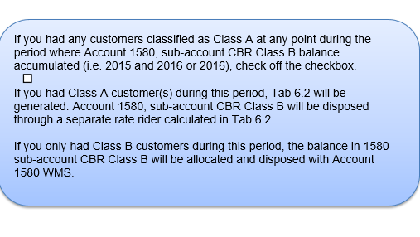
Collus did not indicate on Tab 3. Continuity Schedule that they had any Class A customers during the period where account 1580, sub account CBR Class B balance accumulated yet on the Tab 6. Class A consumption data, Collus has indicated they had Class A consumption. Please explain why Collus has not indicated they had Class A customers during the period the CBR balances accumulated. If this was just an oversight please update the rate generator model.

Staff Question-6
Reference: Tab 6. Class A Consumption
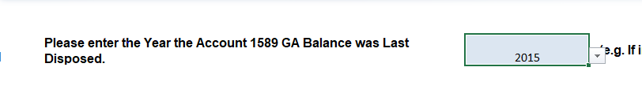
Collus has indicated the last year of disposition was 2015 for the GA balance on Tab 6. Class A Consumption. The last time Collus disposed of the GA balance was in the 2015 EDR process, which would have been the GA balance as at December 31, 2013. Please update the model to indicate year 2013 and fill out the additional Class A customer information required.

Staff Question-7
Reference: Tab 3. Continuity Schedule
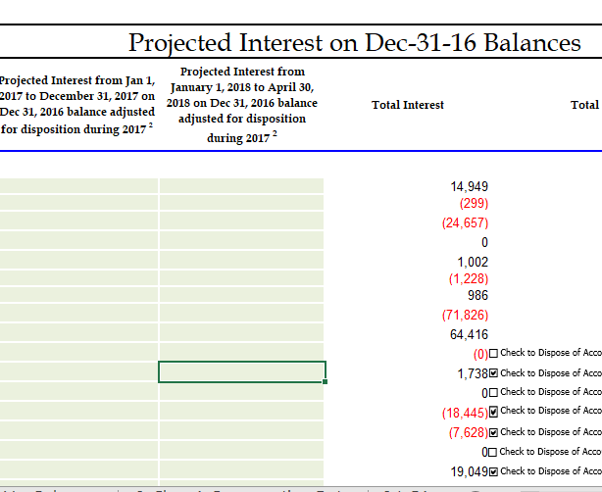
Please explain why Collus has not filled out the interest columns on Tab 3. Continuity Schedule. If this is just an oversight please update the rate generator model provided.

Staff Question-8
Ref: Tab 3 Continuity Schedule
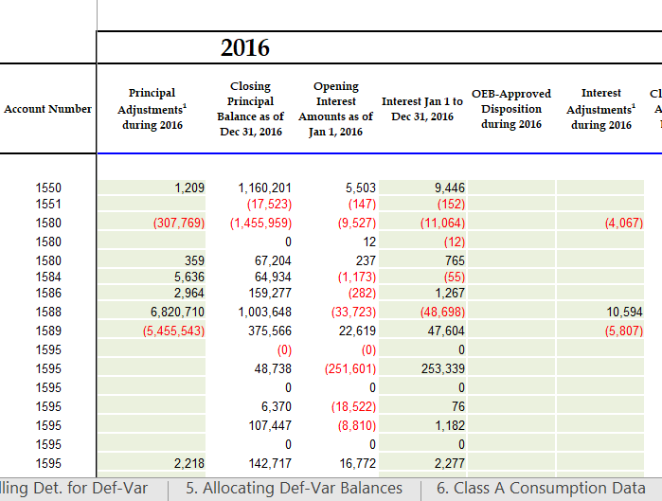

Please explain the adjustments to accounts 1550, 1580, 1584, 1586 and 1595.

