**Staff IR-1**

**Ref: Cell C53 from Tab 3. Continuity Schedule has been reproduced below.**

Per Appendix A of the *Chapter 3 Filing Requirements for Electricity Distribution Rate Applications for 2018 Rate Applications,* “Any vintage Account 1595 Sub-Account is to be disposed only once, on a final basis. No further dispositions of these accounts are expected thereafter unless justified by the distributor”.

Ref: A Portion of the Tab 3 Continuity Schedule has been reproduced below.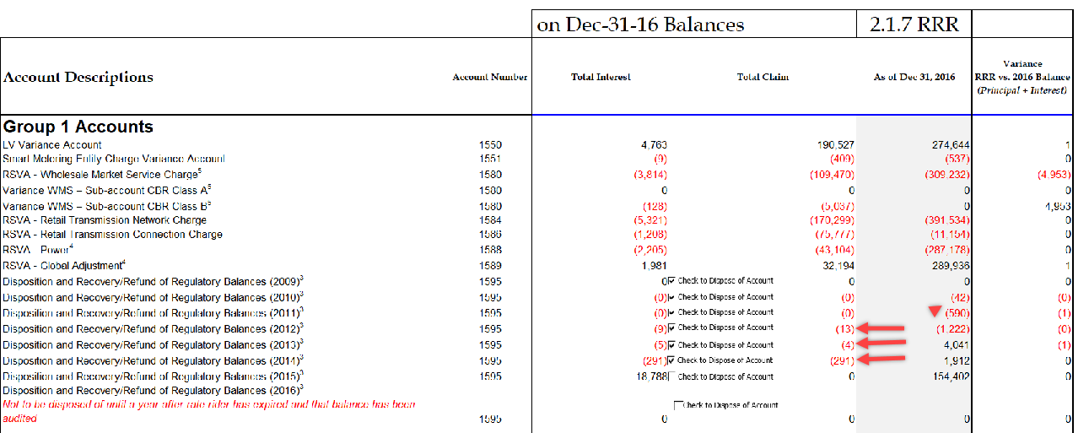

Rideau St. Lawrence Distribution is requesting disposition of account 1595-2012 credit balance of $13, account 1595-2013 credit balance of $4 and account 1595-2014 credit balance $291.

1. Please confirm whether Rideau St. Lawrence Distribution has requested disposition of these sub accounts previously.
2. When did the rate rider relating to each IRM cease?
3. What audited financial statements did Rideau St. Lawrence Distribution base these dispositions on previously and what does each balance pertain to?

Please explain why these amounts have not been written off.

Response:

1. **Rideau St. Lawrence Distribution (“RSL”) confirms that it requested disposition of these sub accounts in the 2016 Cost of Service Application (EB-2015-0100).**
2. **Account 1595-2012 ceased in 2013. Account 1595-2013 ceased in 2014. Account 1595-2014 ceased in 2015.**
3. **The disposition for accounts 1595-2013 and 1595-2014 requested in the 2016 Cost of Service was based on the 2015 audited financial statement and the amount disposed of was the 2015 balance.**
4. **The residual balances in account 1595-2012 after the last disposition were carrying charges for months from June 2016 to May 2017 since 2016 disposition was implemented in July 2017 not in May 2016 as approved in the 2016 COS.**

**The small balance of $5 in account 1595-2013 was written off in June 2017. The Continuity Schedule has been updated with this change.**

**The balance in account 1595-2014 was from an adjustment for 2015 long term load transfer made in 2016. 2015 long term load transfer (LTLT) revenue that was recorded in 1595-2014 in 2015 was based on estimated usage instructed by Hydro One. In April 2016 Hydro One provided RSL with 2015 actual usage. An adjustment for the variance between actual and accrued amounts was made accordingly.**

**Staff IR-2**

**Ref: Retail Transmission Service Rates**

OEB staff notes that the balance of Rideau St. Lawrence’s USoA account 1584 is significant. The balance being requested for disposition is ($170,299), this balance is for the principal and interest transactions in 2016 plus forecasted interest to April 30, 2018.

1. Please complete the following tables and reconcile the principal portion of USoA account 1584 of ($164,977) and provide an explanation for magnitude of the account balance.





**Response:**

**Please see the following table for account 1584 reconciliation.**

**RSL is subject to significant changes in the balance of 1584. RSL has an alternate feed, meaning that power is delivered to the bulk of our customers from two transmission stations (Morrisburg and Brockville). The primary power source for RSL is Morrisburg.**

**There are events, typically initiated by Hydro One, where all power is sourced from Brockville, with the flow from Morrisburg stopped. This causes a “double kW demand peak” which results in significantly higher bills from Hydro One. These events are not predictable. There are years where one or two events occur, and other years where are more. It creates a timing issue, where costs and revenue are out of allignment. Large 1584 balances can result from this issue.**

**RSL expects this timing issue to improve, as Hydro One has agreed to stop billing the LDC for double peaks that are the result of their own projects.**



**Staff IR-3**

**Ref: Tab 10 “RTSR Current Rates”**

OEB staff is unable to reconcile the “Non-Loss Adjusted Metered kWh” and “Non-Loss Adjusted Metered kW” for GS 50 to 4,999 kW Service Classification with the reported amounts in Rideau St. Lawrence Distribution’s 2.1.5 RRR.

1. If Rideau St. Lawrence Distribution believes the figures entered are correct, please provide an explanation for these discrepancies.
2. If Rideau St. Lawrence Distribution believes these figures needs adjustments, please confirm and OEB staff will update the model with the figures as found in the RRR.

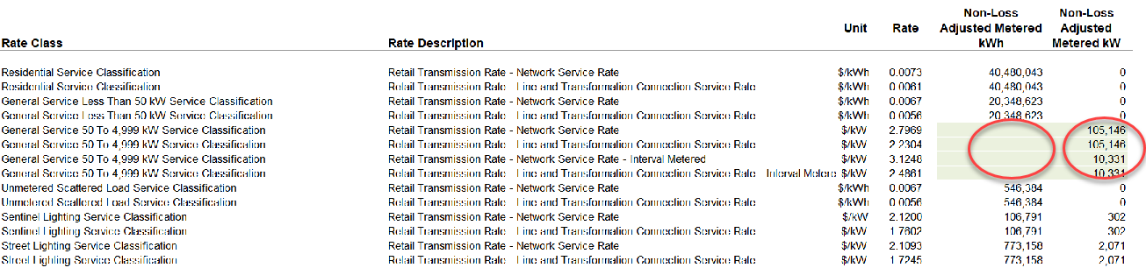

**Response:**

1. **RSL confirms that the Non-Loss Adjusted Metered kW for GS 50 to 4,999 kW is consistent with 2.1.5 RRR data. The Non-Loss Adjusted Metered kWh was omitted in the original submission by error. The reconciliation is shown in the following table.**
2. **RSL requests that OEB staff update the model with the kWhs shown in the following table.**



**Staff IR-4**

**Ref: Tab 3 “Continuity Schedule”: RRR 2.2.1 – account 1580 Sub-account CBR Class B**

It is noted that Rideau St. Lawrence Distribution filed a zero balance in RRR 2.1.7 account 1580 CBR Class B. Rideau St. Lawrence filed a balance in the 2018 Rate Generator Model in the DVA Continuity Schedule for account 1580 WMS – Sub-account CBR Class B correctly, but did not report a balance in RRR 2.1.7 under control account 1580. Please update the RRR 2.1.7 for 2016 to reflect the correct amount for account 1580 CBR Class B and notify OEB staff when the revision is made.

**Response:**

**RSL has filed a request to update RRR 2.1.7 to add the sub-account balance for 1580 CBR Class B.**

**Staff IR-5**

**Ref: RSVA 1588 & 1589**

**GA Analysis Workform**

**IRM Rate Generator DVA Continuity Schedule**

1. What is Rideau St. Lawrence Distribution process for calculating and recording the various components of RPP settlement true-up amounts?
2. What is the timing of when the steps in the process are completed?
3. What is the date of the IESO invoice where the December 2016 RPP settlement true-up amount was reflected? Were the accounting books kept open long enough to reflect this adjustment in the year end balances?

**Response:**

1. **On a monthly basis, RSL calculates an RPP variance. RPP billings for the calendar month are compared with the energy and GA costs embedded in the bills. RSL reports the monthly variance to the IESO in form 1598. With the receipt of the monthly IESO invoice, RSL splits the GA cost between RPP and non-RPP consumption by calculating the kWh percentage of each customer class. The overall percentage is applied to the GA cost for the split. A monthly journal entry is created to shift the non-RPP cost from account 4705 to account 4707. As part of the year-end process, an overall RPP true-up is done once billings have been completed for consumption from the prior year. Any variance is reported to the IESO with form 1598.**
2. **The monthly IESO reporting is completed by in the first few days of the month. The journal entries to record the IESO costs and the split between RPP and non-RPP costs are recorded monthly. The overall, final true-up is done in late February, when the last of the billings related to the prior year are completed. The final true-up is reported to the IESO in March for inclusion in the February invoice. The true-up is accrued as part of the year end, and reversed in the new year.**
3. **The December 2016 RPP settlement was reflected on the IESO invoice dated March 14, 2017. The books were kept open to record the transaction.**

**Staff IR-6**

**Ref: December 21, 2017 Response to OEB Staff Question 4)**

**GA Analysis Workform**

**IRM Rate Generator DVA Continuity Schedule**

Rideau St. Lawrence Distribution indicates that an adjustment was made between accounts 1588 and 1589 for $47,286 relating to a portion of the RPP Settlement true-up relating to the RPP/Non-RPP split.

With respect to the debit adjustment to account 1588 of $47,286, what are Rideau St. Lawrence Distribution plans to settle this amount with the IESO? Does Rideau St. Lawrence Distribution expect to recover this amount from the IESO or customers? Is a credit adjustment in the DVA Continuity Schedule required for account 1588 to eliminate this amount from 1588? Please explain your reasons why.

**Response:**

**The adjustment noted in the question is a correction. The settlement with the IESO for the RPP true-up was correct. RSL missed making a journal entry in 2016 which was part of the split between RPP and non-RPP costs. The required adjustment was not discovered until the preparation of the IRM application.**

**Staff IR-7**

**Ref: December 21, 2017 Response to OEB Staff Question 5) a)**

**GA Analysis Workform**

Rideau St. Lawrence Distribution indicates that Column F includes both billed and unbilled data for each month from its billing system. Please provide the calculations to support the quantities included in Column F breaking out loss adjusted billed volumes and unbilled volumes.

**Response:**

**Please see the following table.**



**Staff IR-8**

**Ref: December 21, 2017 Response to OEB Staff Question 5) b)**

**GA Analysis Workform**

Rideau St. Lawrence Distribution provided a high level calculation for the ($47,286) adjustment to account 1589. Please describe the methodology and the data used to determine the volumes of monthly consumption for RPP and non-RPP customers in order to determine the pro-ration of the Global Adjustment attributable to the RPP/Non-RPP customer groups.

**Response:**

**Each month, a set of reports is generated from our Billing software. The first report shows all of the GA that is associated with the bills produced. Even though the customers who are billed for RPP do not have GA on the bills, the software tracks the amount of GA dollars and kWh that would have otherwise been on the bills. The second report produced shows the GA dollars and kWh that are automatically reversed (not billed) for RPP customers. The data from these two reports is entered into a spreadsheet. The result is a split, by customer category, of kWh for RPP and non-RPP customers. The total percentage of non-RPP is used to split the overall GA cost and apply it to account 4707/1589.**

**Staff IR-9**

**Digger Truck Cost Recovery Treatment**

1. **Ref: Manager’s Summary/pp. 14-16  
   *Report of the Board: New Policy Options for the Funding of Capital Investments: The Advanced Capital Module (EB-2014-0219)*, September 18, 2014/ p. 15**

In the Report of the Board: New Policy Options for the Funding of Capital Investments: The Advanced Capital Module (EB-2014-0219), September 18, 2014, on page 15, the OEB identifies a “means test” as a requirement for ICM eligibility in any year:

**4.1.4 The Adoption of a Means Test**

The Board is of the view that establishing a means test would be prudent in qualifying distributors for incremental capital funding. Any distributor approved for an ACM in its most recent cost of service application must file its most recent calculation of its regulated return (RRR 2.1.5.6) at the time of the applicable Price Cap IR application in which funding for the project, and recovery through rate riders, would commence. **If the regulated return exceeds 300 basis points above the deemed return on equity embedded in the distributor’s rates, the funding for any incremental capital project will not be allowed.** Therefore, any approvals provided for an ACM in a cost of service application will be subject to the distributor passing the means test in order to receive its funding during the IR term. The same means test shall also apply going forward for new projects proposed as ICMs during the Price Cap IR term. [Emphasis in original]

Rideau St. Lawrence Distribution has not provided such information in its manager’s summary under consideration of the proposed incremental capital investment.

Please provide complete information, showing calculations and source data, with respect to the regulated ROE for the last year for which actual data is available.

**Response:**

**The last year for which ROE is available is 2016. RSL’s ROE for 2016 was 1.03%, compared with the deemed rate of 9.12% from the 2012 Cost of Service rate application EB-2011-0274.**

**In the 2016 Cost of Service rate application EB-2015-0100, RSL’s deemed ROE was set at 8.78%. Based on forecasted 2017 results, RSL’s ROE for 2017 is expected to be 2.5%.**

**The lack of funding for this vehicle is placing a burden on RSL. RSL has been paying interest on the loan since mid-2016 for the initial loan, and has been paying principal and interest on the entire loan since mid-2017. The lack of funding is having a negative impact on cash flows.**

**The following information is from RRR 2.1.5.6 for 2016 results:**

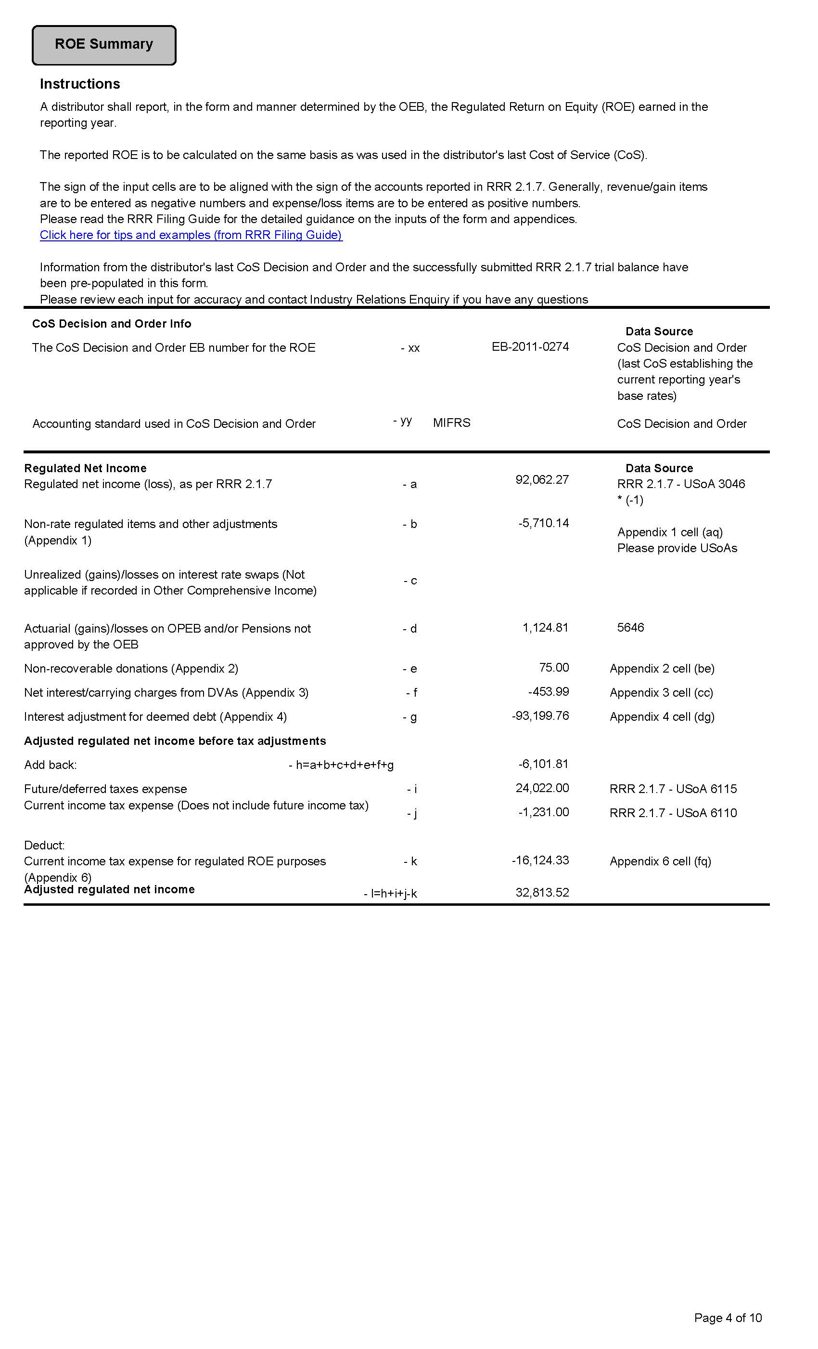

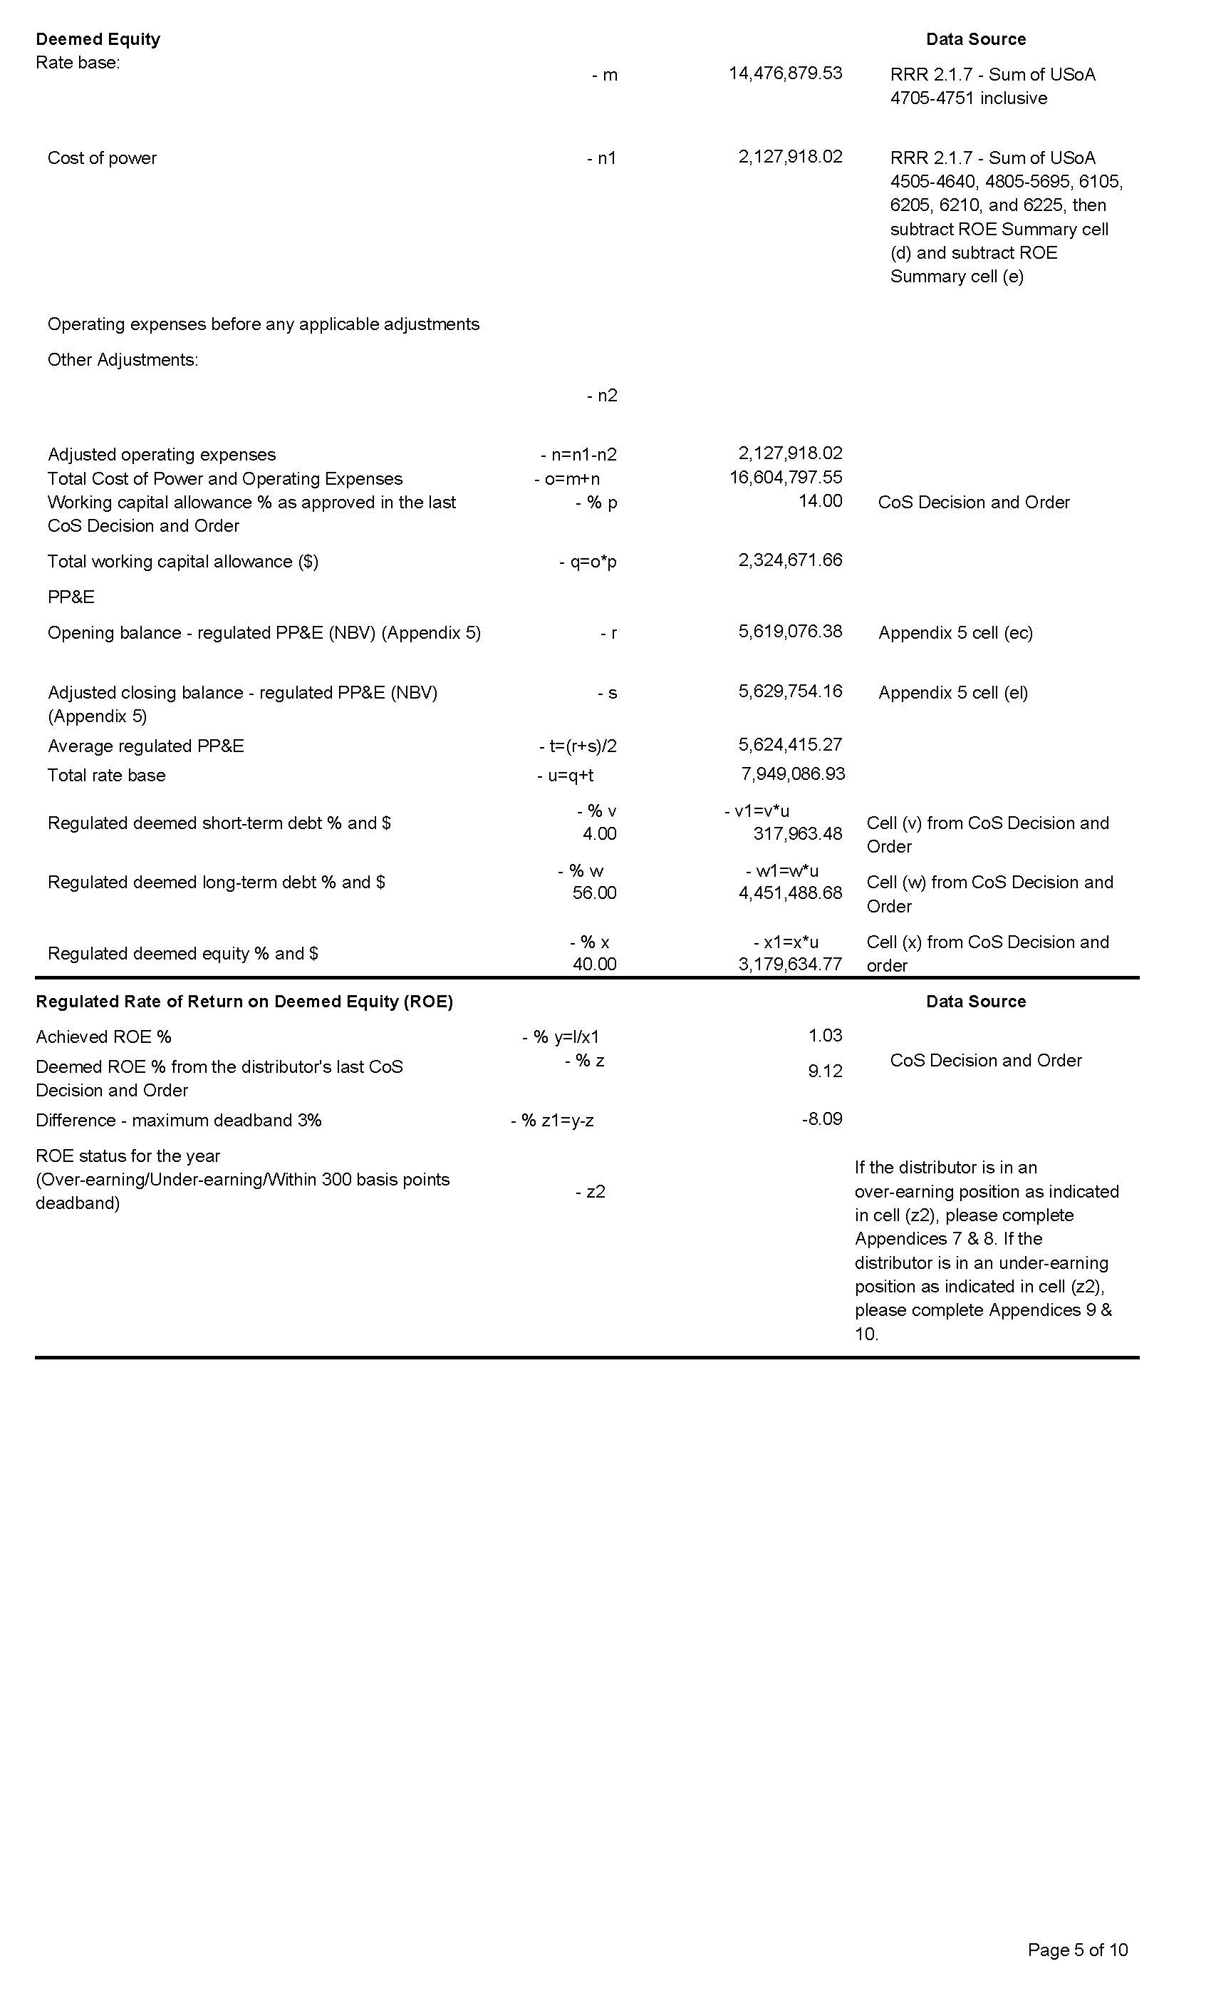

1. **Ref: Manager’s Summary/page 15**

Rideau St. Lawrence Distribution notes that the digger truck was acquired in April 2017 on page 15 of its manager’s summary.

1. Please confirm that, for financial reporting purposes, the digger truck will be accounted for as an asset of Rideau St. Lawrence Distribution in the 2017 fiscal calendar year.
2. As proposed, Rideau St. Lawrence Distribution is seeking an incremental capital treatment and rate rider as if the digger truck becomes “used and useful” (i.e., in service) in 2018. Is Rideau St. Lawrence Distribution proposing that, for regulatory accounting purposes, the digger truck is listed as an asset that enters service during 2018?
3. If the answer to b) is “Yes”, then please explain the rationale for having a temporal (time-based) disconnect between the treatment of the digger truck for financial accounting and regulatory accounting purposes.
4. If the answer to b) is “No”, please provide an explanation.

**Response:**

1. **RSL confirms that, for financial reporting purposes, the digger truck will be accounted for as an asset in 2017.**
2. **No.**
3. **N/A**
4. **The digger truck was received in 2017. However the OEB restricted RSL from seeking incremental capital treatment in 2017, due to the ruling in the EB-2015-0100 Decision which prohibited RSL from submitting an IRM application for rates effective May 1, 2017.**
5. **Ref: Manager’s Summary/page 15  
   Decision and Rate Order EB-2015-0100/pages 4-5 and Settlement Proposal/page 23/Section 2.3**

Rideau St. Lawrence Distribution states that “[d]ue to the late delivery, Rideau St. Lawrence Distribution was not able to include this asset in the rate base of the 2016 Cost of Service rate application, EB-2015-0100. As this purchase is a material amount to Rideau St. Lawrence Distribution, representing almost a full year of capital spending in one asset, Rideau St. Lawrence Distribution is applying for incremental capital funding for this truck.”

In its Decision and Rate Order EB-2015-0100, issued June 15, 2017, the OEB stated:

**3.2 Test Year**

The Application was filed on October 21, 2016 pursuant to the Filing Requirements for Electricity Distribution Rate Applications - 2015 Edition for 2016 Rate Applications (filing requirements). Given that the Application was filed after the OEB’s August 2015 deadline for 2016 rates’ applications, the OEB received the application as a “late filing”. However, unlike with the OEB’s current edition of the filing requirements, the 2015 edition (for 2016 rates) did not require a late filing applicant to convert its application to the subsequent year. (Under the 2016 edition of the filing requirements (for 2017 rates) this conversion would now be required.)

Through the Settlement Proposal, the parties requested that the OEB approve a 2016 test year with the resulting rates effective in 2017.

The parties to the settlement agreed that it was appropriate to use 2016 as a test year. The Settlement Proposal indicated that despite the late filing, the OEB did not require Rideau St. Lawrence Distribution to revise or amend its Application. As well, comprehensive forecasts for a 2017 test year had not been filed. OEB staff submitted that a 2016 test year would be acceptable as it would be consistent with the edition of the filing requirements applicable to the Application.

**Findings**

The OEB finds that it is appropriate to use 2016 as the test year with rates effective in 2017 in this case. [Decision and Rate Order EB-2015-0100, June 15, 2017, pp. 4-5]

Section 2.3 of the Settlement Proposal states:

***2.3:*** *Is it appropriate to use 2016 as the test year when rates are effective June 1, 2017?*

**Complete Settlement:** The Application was filed based on the OEB’s 2015 Filing Requirements for 2016 rate setting. The Application was filed on October 21, 2016. The OEB did not require RSL to revise or amend its Application.

For the purposes of settling all of the issues in this proceeding, the Parties agree that it is appropriate to use 2016 as the test year. The Application, the Interrogatory Responses, and this Settlement Proposal are all based on 2016 test year data. RSL has not provided comprehensive forecasts for a 2017 test year.

In addition, RSL has been informed by counsel that it erred when identifying an “effective date” of January 1, 2017 in its original Application. RSL intended to propose an “implementation date” of January 1, 2017 while maintaining an effective date of May 1, 2016. RSL does not intend to move to a January 1 effective date for rates.

The effective and implementation date for 2016 rates as agreed upon in this settlement is in issue 5.2.

**Evidence:**

*Application:* Exhibit 1, Tab 6, Schedule 2.

*IRRs:* 1-Staff-1; 1-VECC-4.

*Appendices to this Settlement Proposal:* None.

*Settlement Models:* None.

**Supporting Parties:** All

[Settlement Proposal, page 23, filed May 11, 2017, included as Schedule A of Decision and Rate Order EB-2015-0100]

1. Please confirm that the digger truck was acquired by Rideau St. Lawrence Distribution prior to the Settlement Proposal being completed by the parties.
2. If Rideau St. Lawrence Distribution confirms the response in a), and while respecting the confidentiality of the settlement process in EB-2015-0100, please explain why Rideau St. Lawrence considered that the rate base and revenue requirement based on a 2016 test year would be suitable for it to fund 2017 capital expenditures and operating expenses when it knew that it had the material capital addition of the digger truck in 2017.

**Response:**

1. **The digger truck was delivered prior to the Settlement Proposal being completed.**
2. **The above referenced application, evidence, settlement and decision established rates on a cost of service basis for a 2016 test year.**

**At no point was RSL asked to consider, or required to provide evidence in respect of, what would be suitable to fund 2017 capital expenditures and operating expenses. 2017 costs are not a relevant consideration in a 2016 test year application. With very few exceptions, normalization of costs over several years is not permitted within a single test year cost of service application.**

**The truck was removed from the 2016 test year, as it had not been received by the end of 2016.**

**As with any material capital expenditure which occurs after the 2016 test year, RSL would have to utilize the Board’s ICM to fund material capital expenditures that occur in IRM years beyond the test year.**

1. **Ref: *Report of the Board on New Policy Options for the Funding of Capital Investments: The Advanced Capital Module* (EB-2014-0219)/page 25**

On page 25 of the *Report of the Board on New Policy Options for the Funding of Capital Investments: The Advanced Capital Module* (EB-2014-0219), issued September 18, 2014, the OEB states:

In the Price Cap IR application for the year in which the capital project(s) will go into service and the applicant is seeking to commence recovery through rate riders, the distributor should provide updated, current information with respect to the above [costs, need and prudence] for any approved ACMs for any material changes from what was reflected in the DSP.

In the case of an ICM proposal for recovery of an unanticipated capital project, or for a project for which a distributor did not have sufficient information at the time of the cost of service application, this will be the first time that the distributor is providing such evidence. Therefore full and complete details of the project(s) must be filed, as is the current ICM policy and practice.

The condition that cost recovery begins with the year that the asset enters service is consistent with the cost recovery through rates treatment of capital additions under tradition cost of service regulation.

Rideau St. Lawrence Distribution is proposing incremental capital funding treatment as part of its 2018 Price Cap IR application for a capital addition acquired and entering service in 2017 (i.e., not the Price Cap IR test year). Please explain how Rideau St. Lawrence Distribution’s proposal is compliant with the OEB’s policy and practice with respect to incremental capital funding.

**Response:**

**RSL would have preferred to have applied for ICM funding in 2017.**

**However, in EB-2015-0100 the OEB made a determination that: “The OEB finds that Rideau St. Lawrence Distribution should file its next IRM application for May 1, 2018 rates as this Decision and Order is issued in the 2017 rate year.”**

**This decision of the OEB meant that RSL was not able to submit an IRM or ICM application for May 1, 2017 rates.**

**This is a unique circumstance. By virtue of the EB-2015-0100 Decision, RSL was not permitted by the OEB to apply for ICM in the year the truck went into service.**

**For this reason, a limited exception to the OEB’s typical policy is appropriate. RSL has applied for ICM funding as soon as it was able to.**

1. **Ref: Capital Module ACM/ICM Spreadsheet**

Rideau St. Lawrence Distribution has filed a completed Capital Module spreadsheet documenting the calculation of the incremental revenue requirement and the rate riders to recover this based on the digger truck as if it was a capital expenditure and addition in 2018.

OEB staff note that the model does not work appropriately due to the special circumstances of Rideau St. Lawrence Distribution. For example, the growth factor is based on an assessment of 2017 Board-approved relative to 2016 Actuals. However, the 2017 Board-approved load forecast is actually a 2016 test year load forecast. As noted in section 3.1 of the Settlement Proposal in EB-2015-0100, the load forecast agreed to used 2016 actual customer and connection counts. There is therefore no information on normal customer and connection annual growth as the 2016 actual and 2017 Board-approved customers and connections are exactly the same. It is not clear how the kWh and kW demand vary between the 2016 actuals and 2017 Board-approved amounts, although OEB staff suspects that CDM and weather-actual versus weather-normalized comparisons may be the main drivers.

OEB staff also views that, if allowance for recovery of the digger truck is to be considered, its addition to rate base in 2017 as actually occurred should be the starting point. Per the Settlement Proposal accepted by the OEB in its Decision and Rate Order EB-2015-0100, the parties to the Settlement Proposal agreed that the rates established to recover the 2016 test year revenue requirement based on the settled 2016 load forecast were sufficient for Rideau St. Lawrence Distribution to fund its capital expenditures and operations in 2017. If any recovery is required for 2018 and going forward, it should be based on the opening net book value as of January 1, 2018.

OEB staff have populated a Capital Funding Module based on the following:

1. Growth is based on 2016/17 Board-approved load forecast relative to 2015 actuals. 2015 actuals were taken from the load forecast data filed in EB-2015-0100.
2. Projected capital expenditures for each year from 2016 onwards were taken from EB-2015-0100, with the forecasts for 2017 and onwards were per Rideau St. Lawrence Distribution, Distribution System Plan and Appendix 2-AB as filed in the Settlement Proposal attached to the Decision and Rate Order EB-2015-0100. For 2018, the opening NBV of the digger truck on January 1, 2017 (i.e. the 2017 GBV of $379,015 less the half-year depreciation in 2017) is added to the 2018 capex.
3. Depreciation from 2018 onwards is allowed at the full year amount of $47,377.

Other changes were made to adjust labels to reflect this possible treatment. Changes are highlighted in yellow and with comments documenting the changes in each cell. These are summarized in the following table:

|  |  |  |
| --- | --- | --- |
| Sheet | Cell(s) | Description |
| 1. Information Sheet | F34, F38 | Numerator Year should be 2016 (last CoS test year). Assume 2015 is most recent year of actuals (other than 2016 = cannot use same year for numerator and denominator) |
| F48, F49 | Overrode formulae. Numerator is 2017 (= 2016) CoS test year load forecast, and denominator is 2015 actuals, both at current (2017) approved rates, for deriving the growth (“g”) factor. |
| ‘7. Growth Factor – DEN CALC | G14 | Corrected label. Current (2017) rates are used. Growth is determined based on changes in customers and demand, with no changes in rates (rate changes captured through Price Cap Index) |
| ‘9. Threshold Test | E13 | Corrected label |
| 10b. Proposed ACM ICM Projects | C15-G15 | Year labels corrected. |
| C16-G16 | Entered capex for years as approved in Decision and Rate Order EB-2015-0100 and from Appendix 2-AB of Proposed Settlement, with the following changes:   1. 2017 is the $464,288 as approved for the 2016 test year; and 2. 2018 capex is calculated as the 2018 capex per 2-AB plus the January 1, 2018 opening NBV of the digger truck.   Capex aligned with correct years. No forecasted capex for 2021, as RSL is expected to rebase for that year per Decision and Rate Order EB-2015-0100. |
| C24 | Opening capex for digger truck in 2017 |
| D24 | Opening NBV of digger truck on January 1, 2018, calculated as 2017 GBV less half-year depreciation in 2017. |
| E61 | No change in value, but assume full-year depreciation based on initial GBV of digger truck over 8 year expected useful life. |

1. Please examine the data inputs and adjustments. Provide (or advise) of any corrections that Rideau St. Lawrence Distribution considers suitable, with explanation.
2. Please provide Rideau St. Lawrence Distribution’s views on the appropriateness of this approach for recovery of the digger truck from January 1, 2018 until Rideau St. Lawrence Distribution next rebases or the digger truck becomes fully depreciated (by June 30, 2025).

**Response:**

1. **RSL believes that the model originally submitted with the application is appropriate.**
2. **RSL understands and appreciates that the circumstances surrounding our 2016 Cost of Service rate application, the 2018 IRM application, and the ICM are unusual. It is important to note that RSL was not permitted to submit a 2017 IRM, and this is the reason why the ICM was not submitted for 2017. RSL believes that it is more appropriate to treat the addition of the truck as if it had happened in 2018, rather than penalize RSL with no cost recovery for 2017.**
3. **Ref: Capital Module ACM/ICM Spreadsheet**

As filed in the original application, Rideau St. Lawrence Distribution has proposed rate riders that are fully fixed monthly charges for all six of its customer classes. Except for the Residential customer class, where distribution costs are recovered solely through fixed monthly charges, costs (revenue requirements) can be recovered through either fixed charges, volumetric charges, or a combination of these.

With respect to Rideau St. Lawrence Distribution’s original proposal, and the ACM model as revised by OEB staff for Interrogatory 5 above, the following table summarizes four scenarios:

* Rideau St. Lawrence Distribution’s proposal as filed on September 25, 2017, with recovery solely through fixed monthly rate riders
* Rideau St. Lawrence Distribution’s proposal, but with recovery through a combination of monthly and volumetric rates, except for the Residential class
* Capital Module as revised by OEB staff per Interrogatory 5 above, with recovery solely through fixed monthly rate riders
* Capital Module as revised by OEB staff per Interrogatory 5 above, with recovery through a combination of monthly and volumetric rates, except for the Residential class.



1. Please explain why Rideau St. Lawrence Distribution proposed recovery for the digger truck solely through fixed monthly charges for all customer classes.
2. Considering the responses to OEB staff Interrogatory 5 and the above table, please provide Rideau St. Lawrence Distribution’s views on whether costs should be recovered through a fixed charge or through a combination of fixed and variable charges, based on cost causality for the allocated class revenue requirement.

**Response:**

1. **RSL chose fixed monthly charges for all customer classes. Fixed monthly charges are consistent and predictable for customers. RSL has a customer count that changes very little from year to year. The use of a fixed monthly charge increases revenue certainty, and avoids potential under or over collection.**
2. **As discussed in a), RSL believes that a flat, predictable charge is appropriate. The digger truck is used to install poles which benefit all customer classes. As there is no apparent cost causality that would favour one customer class over another, RSL believes that all classes should share the cost.**

**Staff IR-10**

**Ref: Tabs 1 and 8 of LRAMVA work form**

In the application, Rideau St. Lawrence Distribution is requesting approval of a debit balance of $41,135 in lost revenues associated with new CDM program savings in 2015, persisting savings from 2011 to 2014 in 2015, and carrying charges of $1,357.

In the LRAMVA work form, Table 1-b of Tab 1 shows that interest of $681 is claimed up to the period of December 31, 2016. However, as Rideau St. Lawrence indicates in the application, $1,357 of interest is requested to be approved up to April 30, 2018.

1. Please update Table 1-b of the LRAMVA work form accordingly to ensure that the total carrying charges are consistent in both the LRAMVA work form and application.

**Response:**

1. **Table 1-b of Tab 1 of the LRAMVA work form has been updated.**

**Staff IR-11**

**Ref: Application, page 8 of 48**

**Tabs 1 and 8 of LRAMVA work form**

Included in the LRAMVA claim is $2,929.43 in savings related to a street lighting project in 2014. These savings were not included in the final approved amount in 2014, but are requested to be claimed in 2018 rates.

Rideau St. Lawrence Distribution has not claimed the persistence of 2014 street lighting savings (South Dundas project) in 2015.

1. Please discuss why Rideau St. Lawrence Distribution included $2,929.43 in the LRAMVA disposition and whether Rideau St. Lawrence Distribution agrees that the savings should be removed since, as noted in the Chapter 3 Filing Guidelines, adjustments to final approved amounts related to a previous LRAMVA disposition cannot be made.
2. If Rideau St. Lawrence Distribution agrees with not including $2,929.43, please remove the savings in cell G61 of Tab 1.
3. Please discuss whether Rideau St. Lawrence Distribution has received information from the IESO related to the persistence of street lighting savings in future years and whether Rideau St. Lawrence Distribution has considered claiming the persistence of 2014 street lighting savings (South Dundas project) in 2015.
4. If Rideau St. Lawrence Distribution would like to claim the persistence of 2014 street lighting savings in 2015, but did not receive information from the IESO, please provide assumptions related to future year’s persistence of the 2014 streetlight project.

**Response:**

1. **RSL, upon review, has decided to remove this item.**
2. **The savings have been removed.**
3. **RSL has not received information from the IESO about persistence of street lighting savings. RSL has claimed persistence for 2015 for the South Dundas street light project. The persistence is reflected in the decreased monthly demand billed to the customer in 2015. For South Dundas, the reduction is 906 kW. For Cardinal, the reduction is 137 kW.**

**Staff IR-12**

**Ref: Tabs 1 and 3 of LRAMVA work form**

Tab 3 of the LRAMVA work form allows distributors to input distribution rates used in the LRAMVA calculation. In row 39 of Tab 3, it appears that the distribution rate for the street lighting class was converted to an energy charge, $/kWh, to be consistent with Rideau St. Lawrence Distribution’s billing system. As noted in Rideau St. Lawrence Distribution’s tariffs, it appears that the volumetric rates for the streetlighting class are expressed in $/kW.

1. Please confirm whether the streetlighting rates are charged on a $/kW basis.
2. Please confirm whether Rideau St. Lawrence Distribution has correctly calculated savings for the two streetlighting projects.

**Response:**

1. **Street lighting is billed on a $/kW basis.**
2. **The savings have been calculated correctly. There was an error in selecting kWh as the billing basis, but the rate used was the correct kW rate.**

**Staff IR-13**

**Ref: Tabs 4 and 5 of LRAMVA work form**

Actual program savings are allocated to their respective rate classes to be compared against forecast savings by rate class. In the LRAMVA work form, rate class allocation percentages are provided by LDCs with supporting documentation and rationale for its proposal.

1. Please discuss the rate class allocation of the business retrofit program in 2014 and 2015, as compared to prior years from 2011 to 2013.

**Response:**

1. **RSL received LRAMVA reports from Burman Energy which summarizes the savings from the IESO, and groups the savings by customer class and project category. Burman reviews the known projects, and determines the customer class. Based on the relative percentages of the savings for the classes, Burman applies those percentages to the total retrofit savings as reported by the IESO. As RSL reviewed the allocations, it was found that street light savings were included in the original allocations to GS<50 and GS 50-4,999 classes. The street light savings allocation have been removed.**

**Staff IR-14**

**Ref: Tab 8 of LRAMVA work form**

Rideau St. Lawrence Distribution has included billing information on the pre- and post-installation of two street lighting projects (South Dundas and Cardinal).

1. Please describe the nature of the two street lighting projects that Rideau St. Lawrence Distribution has engaged in, including support received from the IESO, if any, with respect to the implementation of these two projects.
2. Please discuss whether Rideau St. Lawrence Distribution has relied on the OEB approved street lighting load profile to calculate savings for the pre and post installation of LED streetlights. If not, please discuss how monthly street lighting savings were calculated for both projects.
3. Please confirm whether or not the lost revenue amounts on both street lighting projects are net savings. Please confirm whether an adjustment for free ridership has been applied.

**Response:**

1. **The street light projects both involved the replacement of high-pressure sodium (“HPS”) street lights with light-emitting diode (“LED”) lights. The two municipalities replaced all of the street light bulbs in their towns and villages. The IESO provided funding to the municipalities related to the project savings.**
2. **RSL has relied on the OEB approved street lighting profile to calculate the savings.**
3. **The street lighting savings have been adjusted to reflect the net reduction in kW billings.**

**Staff IR-15**

Please file an excel copy of Rideau St. Lawrence Distribution’s 2015 Final CDM Annual Report, and the 2011-2015 Persistence Savings Report issued by the IESO.

**Response:**

**A copy of the 2015 Final CDM Annual report is being submitted. The 2011-2015 Persistence Savings Reports were filed on September 25, 2017.**

**Staff IR-16**

If Rideau St. Lawrence Distribution has made any changes to the LRAMVA work form as a result of its responses to interrogatories, please file an updated LRAMVA work form.

**Response:**

**An updated LRAMVA work form is being submitted.**