Staff Question-1
References: GA Analysis Workform – Reconciliation items 1a and 1b
2018 Rate Generator Model – Tab 3 Continuity Schedule
In booking expense journal entries for Charge Type 1142 (formerly 142), and Charge Type 148 from the IESO invoice, please confirm which of the following approaches is used:
- Charge Type 1142 is booked into Account 1588. Charge Type 148 is pro-rated based on RPP/non-RPP consumption and then booked into Account 1588 and 1589, respectively.
- Charge Type 1142 is booked into Account 1588. In relation to Charge Type 148, the non-RPP quantities multiplied by the GA rate is booked to account 1589 and the remainder of Charge Type 148 is booked to account 1588.
- Charge Type 148 is booked into Account 1589. The portion of Charge Type 1142 equalling RPP-HOEP for RPP consumption is booked into Account 1588. The portion of Charge Type 1142 equalling GA RPP is credited into Account 1589.
- If another approach is used, please explain in detail.

Staff Question-2
References: GA Analysis Workform – Reconciliation items 1a and 1b
2018 Rate Generator Model – Tab 3 Continuity Schedule
With regards to the amount being requested for disposition of USoA 1589 account balance as at Dec. 31, 2014, Dec. 31, 2015, and Dec. 31, 2016, all components that flow into Account 1589 (i to iv in table below) should be based on actuals in the 2018 Rate Generator Model – Tab 3 Continuity. Please complete the following table to:
  - Indicate whether each of the components are based on estimates or actuals at year end, and
  - Quantify the adjustment amount pertaining to each component that is trued-up from estimate to actual.
 | Component | Estimate or Actual | Notes/Comments | Quantify True Up Adjustment $ Amount
i | Revenue (i.e. is an unbilled revenue true-up adjustment reflected in the balances being requested for disposition?)
ii | Expenses - GA non-RPP: Charge Type 148 with respect to the quantum dollar amount (i.e. is expense based on IESO invoice at year end)
iii | Expenses - GA non-RPP: Charge Type 148 with respect to the RPP/non-RPP kWh volume proportions.
iv | Credit of GA RPP: Charge Type 142 if the approach under Staff Question 1c is used

  - For each item in the table above, please confirm that the GA Analysis Workform for 2016 and the 2018 Rate Generator Model Tab 3 Continuity Schedule for 2016 have been adjusted for settlement true-ups where settlement was originally based on estimate and trued up to actuals subsequent to 2016.

Staff Question-3
References: 2018 Rate Generator Model – Tab 3 Continuity Schedule
With regards to the amount being requested for disposition of USoA 1588 account balance as at Dec. 31, 2016, all components that flow into Account 1588 (i to iv in table below) should be all based on actuals at year end. Please complete the following table to:
- Indicate whether the component is based on estimates or actuals at year end, and
- Quantify the adjustment pertaining to each component that is trued-up from estimate to actual
 | Component | Estimate or Actual? | Notes/Comments | Quantify True Up Adjustment $ Amount
i | Revenues (i.e. is an unbilled revenue true-up adjustment reflected in the balances being requested for disposition?)
ii | Expenses – Commodity: Charge Type 101 (i.e. is expense based on IESO invoice at year end)
ijj | Expenses - GA RPP: Charge Type 148 with respect to the quantum dollar amount (i.e. is expense based on IESO invoice at year end)
iv | Expenses - GA RPP: Charge Type 148 with respect to the RPP/non-RPP kWh volume proportions.
v | RPP Settlement: Charge Type 142 including any data used for determining the RPP/HOEP/RPP GA components of the charge type

- For each item in the table above, please confirm that the 2018 Rate Generator Model Tab 3 Continuity Schedule for 2016 has been adjusted for settlement true-ups where settlement was originally based on estimate and trued up to actuals subsequent to 2016.

Staff Question-4
Reference: GA Analysis Workform – Analysis of expected GA Amount
- Please confirm whether customers are billed on a calendar month basis. If not, on what basis are non-RPP Class B customers billed?
- Please confirm that the Non-RPP Class B kWh amounts entered in column F below represent the actual kWh that was consumed by non-RPP Class B customers for each month.

Staff Question-5
Reference: GA Analysis Workform – Consumption Data Excluding for Loss Factor – Box E
GA Analysis Workform – Analysis of Expected GA Amount
- In 2016, the calculated value from the GA Analysis Tab for “F59/D26” = 1.05822 and Collus Powerstream’s OEB approved total loss factor is 1.0710. Please reconcile this difference and provide an explanation for why the calculated loss factor differs from the OEB approved total loss factor.
Staff Question-6
Reference: GA Analysis Workforms 2014-2016 – Reconciling Items 2a/2b:
a) Is there a true up adjustment for the 2013 year-end for the difference between estimated unbilled revenue and actual unbilled revenue in 1589, recorded in the 2014 general ledger? If so, please provide the dollar amount of the 2013 year-end estimated unbilled revenue and the actual unbilled revenue.
b) The 2014 GA Analysis Workform has an entry of $430,336 under reconciling item 2b. Please provide the amount of the estimated unbilled revenue in 1589 for the 2014 year-end and the actual amount of unbilled revenue billed in 2015.
c) The 2015 GA Analysis Workform has an entry of ($148,515) under reconciliation item 2a to remove the impact of the estimated versus actual unbilled amounts from the prior year, however, the amount entered under reconciliation item 2b in the 2014 GA Analysis Workform is reported as $430,336. Please explain this discrepancy.
d) Please explain what the ($148,515) entry under reconciliation item 2a in the 2015 GA Analysis Workform is comprised of and which period it pertains to?
e) The 2016 GA Analysis Workform has no entries for reconciliation items 2a and 2b, whereas 2014 and 2015 had reconciliation items 2b or 2a, respectively. Please confirm whether or not all of the years should have both reconciliation items 2a and 2b.
Staff Question-7
Reference: GA Analysis Workforms 2014-2016 – Reconciling Item 7
Table 7.1 in Collus PowerStream’s Application appears to have been populated with cumulative adjustments from 2014 to 2016; however, the GA Analysis Workform has been populated with reconciliation item 7 for each year from 2014 to 2016 separately. Please provide a detailed analysis for each column in table 7.1 of the Application by year and by component and provide an explanation for each component for each year.
Staff Question-8
Reference: Collus PowerStream’s response to OEB Staff Question 8 from January 30, 2018
The below is an excerpt from Collus PowerStream’s response to OEB Staff Question 8 sent on January 30, 2018:
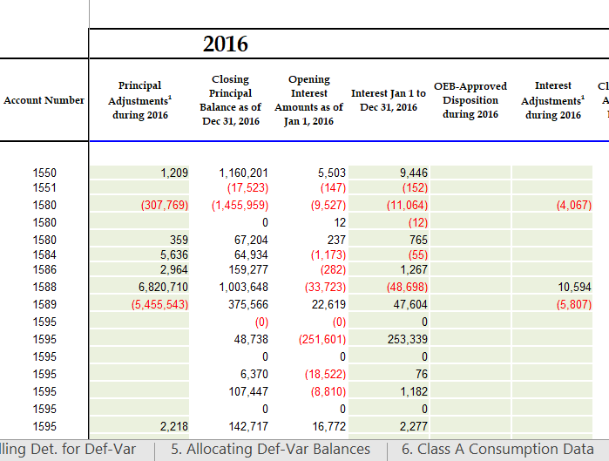
Please explain the adjustments to accounts 1550, 1580, 1584, 1586 and 1595.
CPS Response: The changes in accounts are due to the special purpose global adjustment audit (audit report included in original submission) as well as a newly identified billing error. Please refer to attachment: “OEB Letter Re Billing Error - Collus Powerstream” for a detailed explanation of the billing issue.
Account | Global Adjustment | Billing Error | Total | Interest Charges
1550 |  | 1,209 | 1,209
1580 | (316,005) | 8,236 | (307,769) | (4,067)
1580 |  | 359 | 359
1584 |  | 5,636 | 5,636
1586 |  | 2,964 | 2,964
1588 | 6,676,336 | 144,373 | 6,820,710 | 10,594
1589 | (5,459,541) | 3,998 | (5,455,543) | (5,807)
1595 |  | 2,218 | 2,218

The table below (“Schedule B”) is an excerpt from the Collus PowerStream’s January 19th, 2018 letter to the OEB (“OEB Letter Re Billing Error – Collus Powerstream”):
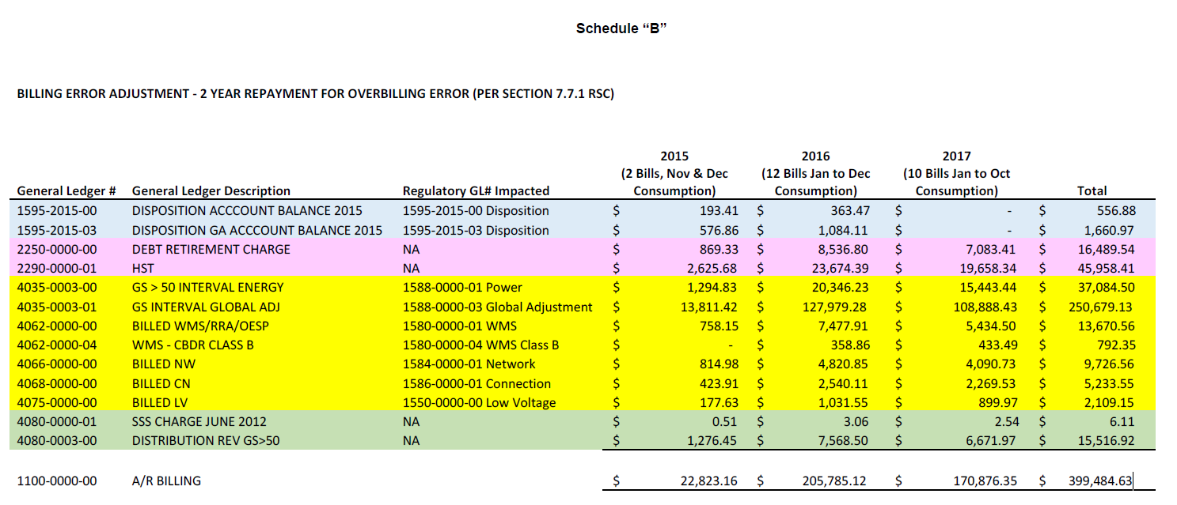
OEB Staff notes that the total impact as of December 31, 2016 of the billing error to accounts 1588-Cost of Power and 1589-Global Adjustment is $21,641.06 ($1,294.83 + $20,346.23) and $141,790.70 ($13,811.42 + $127,979.28), respectively, according to Schedule B in the OEB Letter Re Billing Error – Collus Powerstream. However, the table provided in Collus PowerStream’s response to OEB Staff Question 8 from January 30th, 2018 shows the total impact from the billing error to accounts 1588-Cost of Power and 1589-Global Adjustment as $144,373 and $3,998, respectively.
Please explain the discrepancy between the figures reported in “Schedule B” and the figures reported in Collus PowerStream’s response to the OEB’s Question 8 from January 30, 2018.
Staff Question-9
Reference: Principal adjustments in 2016 continuity schedule in the 2018 Rate Generator Model
The dollar amount in the 2016 principal adjustments column in the 2018 Rate Generator Model for account 1588 – RSVA Power, totals $6,820,710, comprised of the following formula:
=6676336.44+20346.23+1294.83+124791.18+13001.39-15527.66+467.38
The dollar amount in the 2016 principal adjustments column in the 2018 Rate Generator Model for account 1589 – RSVA Global Adjustment, totals ($5,455,543), comprised of the following formula:
=-5459540.71+127979.28+13811.42-124791.18-13001.39
Please prepare:
a) An analysis of each of the amounts for accounts 1588 and 1589, by year, in the principal adjustments column for 2016 from the Tab 3. Continuity Schedule in the 2018 Rate Generator Model.
b) A detailed reconciliation by component of the analysis in part a) of this question to the analysis requested in Staff Question-7.
c) Please explain why Collus PowerStream finds it necessary to include the impact of the billing error in the 2016 principal adjustments column, rather than including it as part of its principal transactions during the year that the error is recorded in the general ledger.

Note, the following in all references in OEB Staff questions relating to amounts booked to accounts 1588 and 1589. Amounts are not booked directly to accounts USoA 1588 and 1589 relating to power purchase and sale transactions, but are rather booked to the cost of power USoA 4705 Power Purchased/4707 Charges - Global Adjustment and the respective Energy Sales USoA accounts, respectively. However, accounts 1588 and 1589 are impacted the same way as accounts 4705/4707 are for cost of power transactions, and the same way as the Energy Sales accounts are for revenue transactions.

