**Greater Sudbury Hydro Inc. Price Cap IR Application (EB-2017-0042)**

**OEB Staff Questions**

**OEB Staff Question #1**

**References: 2018 IRM Rate Generator Model, Tab 3 Continuity Schedule**

The amounts reported in the 2018 IRM Rate Generator Model in the DVA continuity schedule for 2015 for accounts 1588 and 1589 differ from what was reported in the 2017 IRM Rate Generator Model in the DVA continuity schedule for 2015 for accounts 1588 and 1589.

Table 1 - 2017 IRM Rate Generator Model – Tab 3 Continuity Schedule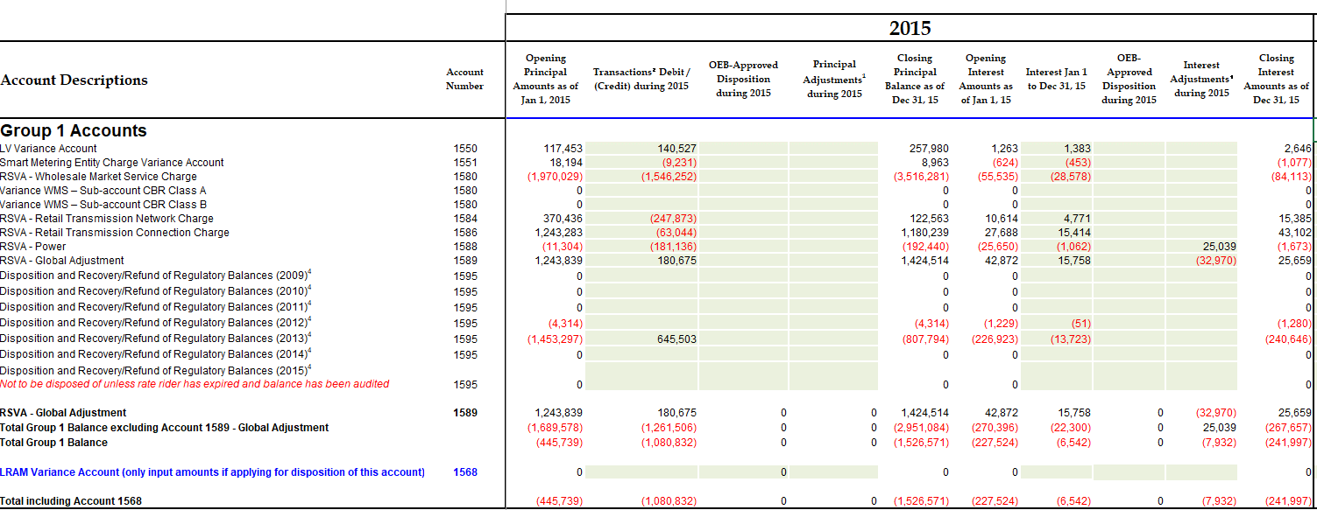

Table 2 - 2018 IRM Rate Generator Model – Tab 3 Continuity Schedule

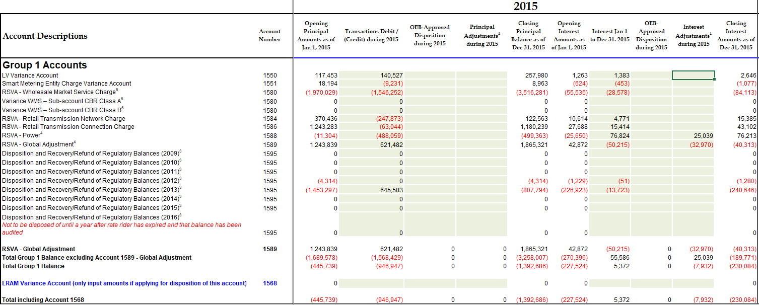

Information extracted from the 2017 IRM Rate Generator Model from Tab 3 Continuity Schedule summarizes the principal transactions for 2015.

Table 3 – 2015 Principal Transactions from 2017 IRM Rate Generator Model



Information extracted from the 2018 IRM Rate Generator Model from Tab 3 Continuity Schedule summarizes the principal transactions for 2015 and 2016.

Table 4 – 2015 and 2016 Principal Transactions from 2018 IRM Rate Generator Model



Updating Table 4 above based on 2015 transactions from the 2017 IRM Rate Generator Yields the following table

Table 5 – Updated 2015 and 2016 Principal Transactions from 2018 IRM Rate Generator



1. Table 5 above calculates different total principal balances for accounts 1588 and 1589 than what Greater Sudbury Hydro filed in its application. Please comment on the table above and explain why the amounts Greater Sudbury Hydro filed are different? OEB Staff notes that the starting point for the DVA continuity schedule for the 2015 principal amounts populated in the 2018 IRM Rate Generator Model must be the same as the 2015 information populated in the DVA continuity schedule from the 2017 IRM Rate Generator Model. Meaning that the balances previously approved for disposition cannot be changed. Please update the DVA continuity schedule in the 2018 IRM Rate Generator Model as needed and explain the components of each adjustment made.

**David Chisholm:** As part of the 2017 IRM rate filing (EB-2016-0072), Sudbury Hydro calculated and included an adjustment that pertained to 2015 year-end balances for 1588 and 1589. This was reflected in the 2015 balance/transactions for that IRM rate filing, and in the balances disposed of. In the 2018 submission, our intent was to show the principal and interest balances so that they agreed to the original RRR filing/OEB trial balance for 2015, and to show the adjustments for 2015 when they actually flowed through our general ledger (in 2016). The year-end balances for 2016 in the 2018 IRM model (for 1588/1589) are unchanged regardless of which year those adjustments are shown in the model – this is simply a presentation difference. I have revised the 2018 IRM model to reflect the presentation you are expecting, and have submitted that via RESS.

1. Question 1 refers to discrepancies to total principal balances for accounts 1588 and 1589. Please perform the same analysis for carrying charges and provide completed tables 3, 4 and 5 and then comment on the third table for carrying charges and explain why the amounts Greater Sudbury Hydro filed are different? OEB Staff notes that the starting point for the DVA continuity schedule for carrying charges populated in the 2018 IRM Rate Generator Model must be the same as the 2015 information populated in the DVA continuity schedule from the 2017 IRM Rate Generator Model. Meaning that the balances previously approved for disposition cannot be changed. Please update the DVA continuity schedule in the 2018 IRM Rate Generator Model as needed and explain the components of each adjustment made.

**David Chisholm:** Same as part 1 above, the initial submission of the 2018 IRM model has 2015 interest balances that matched our annual RRR submission and OEB trial balance for that year. The disposed-of 2015 carrying charges were calculated for the year after consideration of principal adjustments to 1588 and 1589.

However, in looking closely at the interest calculation for 1588 and 1589, I have discovered an issue with our internal continuity spreadsheet for 2016 year-end, which caused an incorrect final year-end adjusting entry to the interest in account 1589 (pertaining to 2016 & therefore not yet disposed of). The adjustment required is to debit the 1589 Global Adjustment deferral interest account by $65,972.66. For the purpose of maintaining an accurate balance continuity I have recorded the transaction in our 2017 general ledger and reflected it as an adjustment in the “Interest Adjustments during 2016” column. In the revised 2018 IRM model, the “Variance in RRR vs. 2016 Balance” column now has a variance of $65,973 which is this adjustment.

Please see the following table to support the adjusted carrying charges for 1589 ($65,973 interest adjustment less ($56,699) existing transactions equals $9,274 total carrying charges) :



We have revised the 2018 IRM model to reflect the presentation you are expecting, and have submitted that via RESS.

1. Please update application as applicable depending on any adjustments to group 1 accounts as a result of changes relating to questions 1 and 2.

**David Chisholm:** As discussed above, principal balances are now re-classed and the updated IRM model reflects this. An adjustment has been booked to interest pertaining to 1589 and the updated model reflects this also.

Sudbury Hydro has verified and can confirm that all other carrying charge amounts reported in the 2018 IRM model are accurate.

**OEB Staff Question #2**

**References: 2018 Rate Generator Model – Tab 3 Continuity Schedule**

With regards to the amount being requested for disposition of USoA 1588 account balance as **at Dec. 31, 2015 and Dec. 31, 2016**, all components that flow into Account 1588 (i to iv in table below) should be all based on actuals at year end. Please complete the following table for 2015 and 2016 to:

1. Indicate whether the component is based on estimates or actuals at year end, and
2. Quantify the adjustment pertaining to each component that is trued-up from estimate to actual

**David Chisholm:** Just to clarify – Sudbury Hydro is not requesting disposition of Group 1 DVA balances in the 2018 IRM.

|  |  |  |  |  |
| --- | --- | --- | --- | --- |
|  | **Component** | **Estimate or Actual?** | **Notes/Comments** | **Quantify True Up Adjustment $ Amount** |
| i | Revenues (i.e. is an unbilled revenue true-up adjustment reflected in the balances being requested for disposition?) | Actual | Sudbury Hydro’s year-end process allows us to capture all billings subsequent to year-end that pertained to the fiscal year. An unbilled revenue true-up adjustment is recorded, and that accrual is actual billings. | Actual #’s Used, no True Up |
| ii | Expenses – Commodity: Charge Type 101 (i.e. is expense based on IESO invoice at year end) | Actual | An accrual is booked that captures actual commodity billings that are paid subsequent to year-end. | Actual #’s Used, no True Up |
| iii | Expenses - GA RPP: Charge Type 148 with respect to the quantum dollar amount (i.e. is expense based on IESO invoice at year end) | Actual | Sudbury Hydro has exhausted significant effort in the past two years in revamping its RPP true up process. The GA attributed to RPP customers is based on actual charges. | Actual #’s Used, no True Up |
| iv | Expenses - GA RPP: Charge Type 148 with respect to the RPP/non-RPP kWh volume proportions. | Actual | Sudbury Hydro has exhausted significant effort in the past two years in revamping its RPP true up process. The kWh split for RPP/non-RPP is based on actual billings for the year. | Actual #’s Used, no True Up |
| v | RPP Settlement: Charge Type 142 including any data used for determining the RPP/HOEP/RPP GA components of the charge type | Actual | Sudbury Hydro has exhausted significant effort in the past two years in revamping its RPP true up process. Data inputs to the process are queried from our actual billings for the month | Actual #’s Used, no True Up |

**David Chisholm:** Actuals are used at year-end, however throughout the year it is necessary to submit an estimate for IESO RPP settlement purposes, and true up this submission quarterly. At year-end Sudbury Hydro’s general ledger does not reflect estimates. Actuals are recorded in the general ledger after all billings for the fiscal year have occurred.

1. For each item in the table above, please confirm that the 2018 Rate Generator Model Tab 3 Continuity Schedule for 2015 and 2016 has been adjusted for settlement true-ups where settlement was originally based on estimate and trued up to actuals subsequent to 2015 and 2016.

**David Chisholm:** The true-up adjustments are booked subsequent to year-end (mid February), but they are adjusted in the fiscal year prior to finalization. Therefore the continuity balances reflect the final actual amounts with no further true-up necessary.