ENWIN Utilities Ltd. (ENWIN Utilities)
2018 IRM Application
EB-2017-0037
Application Analysis
February 1, 2018

Question #1
Reference: Account 1595 (2014) Mgr summary Tables 4, 5 & 6, pgs 9-10

With respect to Table 4 on page 9 in the Managers Summary, it is stated in explaining the differential of $241,150 that this can be attributed to Large Use, Large Use -3TS and Residential customers.
- A breakdown of this amount between the three referenced customer classes is provided. Please reconcile the actual annualized volumes for each class to the volumes used to determine the rate riders and also provide an explanation for the volume variance for each of those classes.

- Please provide similar explanations for the affected customer classes in Tables 5 and 6.

- Please reconcile the amount that is being requested for disposition back to Tables 4, 5 and 6 and ensure that the actual amounts attributable to each customer class are completed and balance back to the recoveries recorded in the general ledger.

RESPONSE
Tables 4, 5 and 6 identified the significant contributors to the outstanding balance in the sub account 1595 (2014). Other rate classes contributed small amounts to the outstanding balance, accounting for the remaining difference between the closing balance and the totals in Tables 4, 5 and 6. The closing principal balance for sub-account 1595 (2014) is $1,497,787. The customer classes identified in Tables 4, 5 and 6 account for $1,197,037 of the total.
The volumetric numbers used to determine the 2014 rate riders were based on 2013 consumption and demand data. The volumetric numbers used to identify the significant contributors to the outstanding balance are from the disposition period. The “Rate Rider for Deferral/Variance Account Disposition including WMP” and “Rate Rider for Deferral/Variance Account Disposition excluding WMP” disposition period was August 1, 2014 until July 31, 2015. The “Rate Rider for Global Adjustment Account Disposition applicable only for Non-RPP, non-WMP Customers” disposition period was August 1, 2014 until April 30, 2016.
Generally, reductions in load can be attributed to a cooler summer in 2014 and customer driven conservation. The Government of Canada’s Top 10 Weather Stories for 2014 states: “For Windsor, which typically leads the East with the warmest summers, it was the coldest July in 22 years. In southern Ontario, July and August were the second coldest two months in 55 years of records.”
The variance in annualized volumes from Table 4 which includes WMP, shown below as Table IR-1A, indicates a reduction of 8% in Residential consumption, 33% reduction in Large Use – Regular and a 12% reduction in Large Use – 3TS.
Table IR-1A
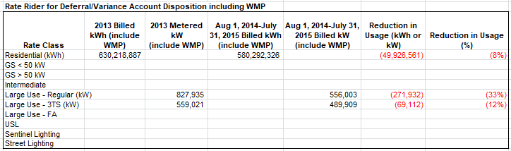
The variance in annualized volumes from Table 5 which excludes WMP, shown below as Table IR-1B, indicates a reduction of 8% in Residential consumption and a 19% reduction in Large Use – 3TS.

Table IR-1B
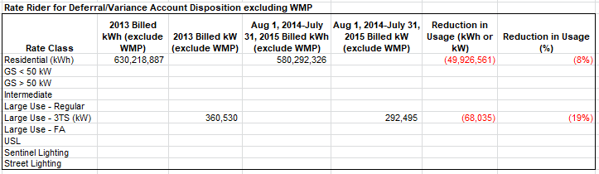
The variance in annualized volumes from Table 6 which is only non-RPP and excludes WMP, shown below as Table IR-1C, indicates a reduction of 44% in Residential consumption, 2% reduction in GS >50 kW, 55% reduction in Large Use – Regular and a 46% reduction in Large Use – 3TS.
From 2013 to 2015, there was a 26% reduction in the number of non-RPP residential customers (enrolled with a retailer). This disposition period was for a 21 month period [August 1, 2014 until April 30, 2016], but only included one summer period, ENWIN is a summer peaking utility which may account for some of the variances. An additional item reflected in the reduction of usage, the non-RPP kW used to calculate this rate rider in the original 2014 rate application (EB-2014-0156) incorrectly included WMP, resulting in the original rate riders being understated for the Large Use – Regular and Large Use – 3TS rate classes. ENWIN has confirmed the customers in Large Use – Regular and Large Use – 3TS rate classes are exactly the same customers in 2018 as in existed in 2013.
Table IR-1C
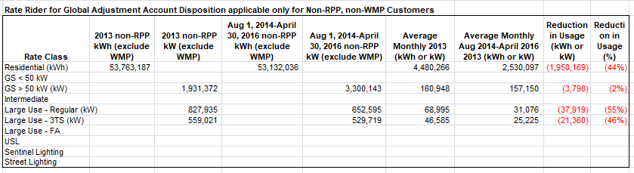
ENWIN has confirmed the balances of sub-account 1595 (2014) are completed and balance back to the recoveries recorded in the general ledger.
Question #2
Reference: IRM Model – Tab 3 “Continuity Schedule”

With respect to the continuity schedule provided in the IRM Model, please complete for the year 2014, the two columns headed “Transactions Debit / (Credit) during 2014” and “OEB-Approved Disposition during 2014”.

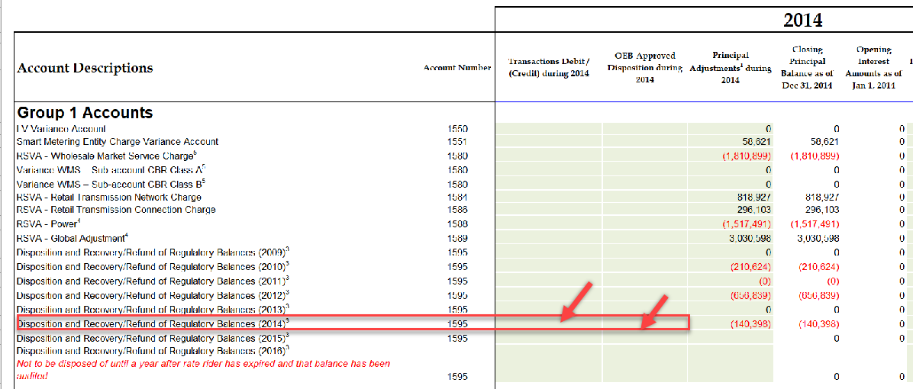
RESPONSE
ENWIN has updated the 1595 Continuity Schedule for the 2014 year to reflect the ‘Transaction Debit/Credit during 2014’ detail as well as the ‘OEB Approved Disposition during 2014’. There is no change to the account balance requested for disposition in the present application.
Question #3
Reference: IRM Model – Tab 3 “Continuity Schedule”
On Tab 3 of the IRM model, ENWIN Utilities reported balances ($1,497,922) in account 1595 under 2015 Board-Approved Disposition during 2015. Please provide explanation for this balance.

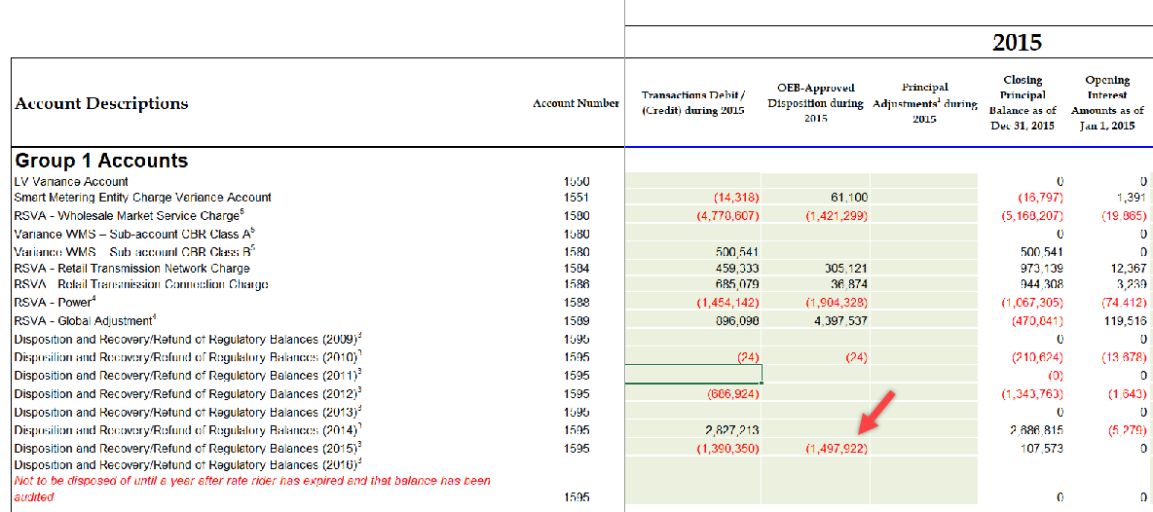
RESPONSE
The balance of ($1,497,922) represents the disposition of Group 1 deferral and variance account balances for the period ending 2013, approved in 2015. A copy of the approved account balances for disposition from the Decision and Order of EB-2014-0069 is provided below which includes the details for the balance. The balance and interest is added as OEB-Approved Disposition during 2015, the interest columns are used for calculated interest.
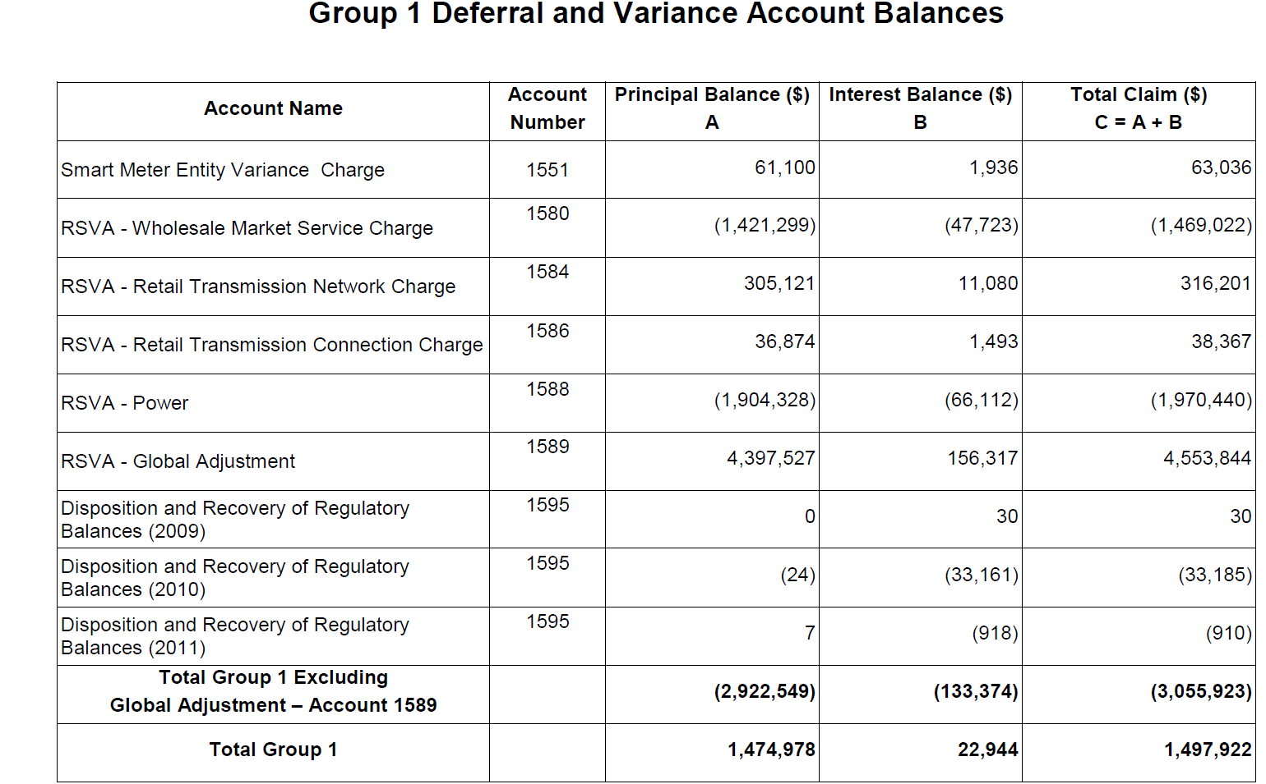

Question #4
Reference: Gross Billing, Retail Transmission Rate Determination, page 13

In its Managers Summary, ENWIN Utilities requested that a note be added on the final approved Tariff of Rates and Charges to each customer class to the Retail Transmission Rate – Line and Transformation Connection Service Rate in order to provide for gross load billing related to Eligible Load Displacement Generation.

- Please provide a detailed explanation of ENWIN Utilities’ reasons for proposing gross load billing related to Eligible Load Displacement Generation including the rate impacts if any on this proposal on the affected customer groups, as well as any effects on any other customers.

- Please state the specific OEB policies on which this request is based.

- In prior years how has ENWIN Utilities billed load displacement generators for – Line and Transformation Connection Service.

- Please state whether ENWIN Utilities has discussed this proposed change with the affected customers and if so what the results of this discussion were. If not, please explain why.

- Please provide further explanation regarding the wording that ENWIN Utilities is proposing for the note.

- Is ENWIN Utilities planning to incur additional expenses related to this proposal and billing purposes, and if so, please provide the amount.

RESPONSE
- ENWIN’s proposal for gross load billing of Retail Transmission Rate - Line and Transformation Connection charges related to Eligible Load Displacement Generation (“LDG”) is due to Hydro One informing ENWIN they would be applying these charges to eligible LDG in ENWIN’s service territory. In the absence of a Gross Billing of Retail Transmission Rate - Line and Transformation Connection, the rest of ENWIN’s customer classes are subsidizing the gross load billing transmission costs for the one pending LDG customer and any future LDG customers in ENWIN’s service territory.

From the Manager’s Summary:
On November 16, 2016 through a Detailed Technical Connection Assessment report, Hydro One Networks Inc. (“Hydro One”) informed ENWIN that gross load billing of Transmission Line and Transformation Connection service charges would apply to ENWIN due to the presence of an LDG customer with installed capacity above the threshold of 2 MW of renewable generation and 1 MW for non-renewable generation, as outlined in the Rate Order for 2016 Uniform Electricity Transmission Rates (EB-2015-0313), “The Customer shall install metering facilities in accordance with the IESO Rules as Gross Load Billing (GLB) would be applicable to the LDG facility as per Ontario Transmission Rate Schedule” . On an annual basis, the IESO will determine and charge to ENWIN the gross load billing of Transmission Line and Connection Service charges which apply specifically to the generation activities of our one pending LDG customer (and any future LDG customers with capacity above the specified threshold for renewable and non-renewable generation) in ENWIN’s distribution system.

In the absence of a Gross Billing of Retail Transmission Rate - Line and Transformation Connection, the rest of ENWIN’s customer classes are subsidizing the gross load billing transmission costs for the one pending LDG customer and any future LDG customers in ENWIN’s service territory. It is unreasonable for all other classes to pay the costs directly related to a specific customer, in this case an LDG customer, while the LDG customer benefits through savings. ENWIN suggests the costs associated to a specific customer/class should be recovered by that specific customer/class.

- The OEB approved Gross Load Billing in a Hydro One Networks Inc. (“Hydro One”) rate proceeding RP-1999-0044. At line 3.2.39 of the Decision with Reasons of that proceeding, it states “The Board therefore finds that for load customers with new embedded generation that charges for Line and Transformation Connection service should be based on gross load billing”. The Board further found in that proceeding that “new embedded generation under 1 MW serving existing load should be exempt from gross load billing” (Hydro One’s proposal, with the Board accepting said proposal at section 3.2.44). Hydro One went on to define Existing Embedded Generation as “embedded generation for which required approvals were obtained before October 30, 1998” (at section 3.3.1), and the Board agreeing with Hydro One’s proposal, that “load supplied by the existing embedded generation, as that term was defined in the application, should continue to be billed on a net load basis” (at section 3.3.3). Additional OEB references related to this request would be the Decision and Rate Order for 2017 Uniform Transmission Rates (EB-2017-0280), and the 2016 Decision and Order for Entegrus (EB-2015-0061).

- In prior years, ENWIN has not had any Eligible Load Displacement Generation.

- ENWIN has discussed this proposed charge with potential customers and the potential customers are continuing forward with their proposed LDG. The requirement pertaining to the ENWIN GS 50 - 4,999 kW customer with an LDG which imminently will be put into service which is referenced in this application was clearly established in writing by Hydro One Networks Inc. in their connection impact assessment document entitled “Detailed Technical Connection Assessment; Project ID 31,600, Revision 2, dated November 16, 2016”, an excerpt of which is provided, below.

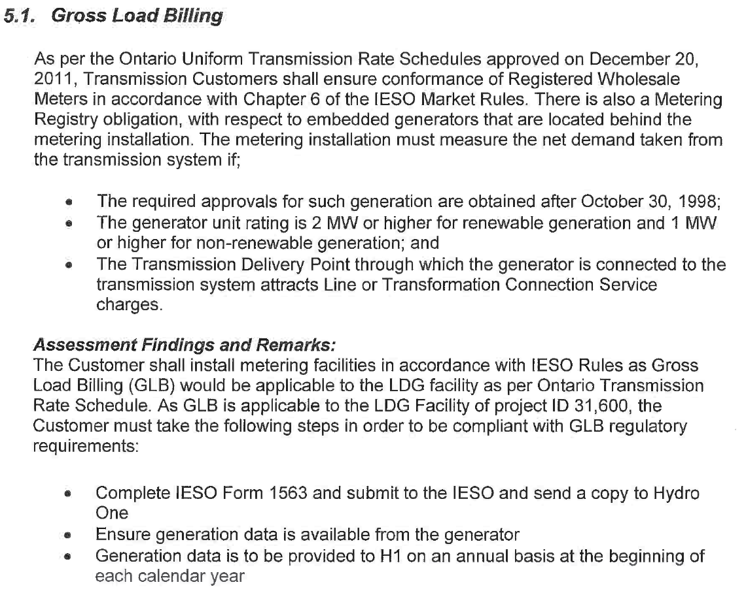

- ENWIN’s proposed language for the note is consistent with the language the OEB approved in the Decision and Rate Order for 2017 Uniform Transmission Rates (EB-2017-0280) as well as the Decision and Order for Entegrus (EB-2015-0061).

- This proposal and related billing has been handled by internal ENWIN staff, no external expenses are planned.

Question #5
References: GA Analysis Workform – Reconciliation items 1a and 1b
2018 Rate Generator Model – Tab 3 Continuity Schedule
In booking expense journal entries for Charge Type 1142 (formerly 142), and Charge Type 148 from the IESO invoice, please confirm which of the following approaches is used:
- Charge Type 1142 is booked into Account 1588. Charge Type 148 is pro-rated based on RPP/non-RPP consumption and then booked into Account 1588 and 1589, respectively.
- Charge Type 1142 is booked into Account 1588. In relation to Charge Type 148, the non-RPP quantities multiplied by the GA rate is booked to account 1589 and the remainder of Charge Type 148 is booked to account 1588.
- Charge Type 148 is booked into Account 1589. The portion of Charge Type 1142 equalling RPP-HOEP for RPP consumption is booked into Account 1588. The portion of Charge Type 1142 equalling GA RPP is credited into Account 1589.
- If another approach is used, please explain in detail.

RESPONSE
ENWIN Utilities Ltd. follows the approach explained in part a) Charge Type 1142 is booked into Account 1588. Charge Type 148 is pro-rated based on RPP/non-RPP consumption and then booked into Account 1588 and 1589, respectively.
Question #6
References: GA Analysis Workform – Reconciliation items 1a and 1b
2018 Rate Generator Model – Tab 3 Continuity Schedule
With regards to the amount being requested for disposition of USoA 1589 account balance as at Dec. 31, 2016, all components that flow into Account 1589 (i to iv in table below) should be based on actuals in the 2018 Rate Generator Model – Tab 3 Continuity. Please complete the following table to:
  - Indicate whether each of the components are based on estimates or actuals at year end, and
  - Quantify the adjustment amount pertaining to each component that is trued-up from estimate to actual.
 | Component | Estimate or Actual | Notes/Comments | Quantify True Up Adjustment $ Amount
i | Revenue (i.e. is an unbilled revenue true-up adjustment reflected in the balances being requested for disposition?)
ii | Expenses - GA non-RPP: Charge Type 148 with respect to the quantum dollar amount (i.e. is expense based on IESO invoice at year end)
iii | Expenses - GA non-RPP: Charge Type 148 with respect to the RPP/non-RPP kWh volume proportions.
iv | Credit of GA RPP: Charge Type 142 if the approach under Staff Question 1c is used
  - For each item in the table above, please confirm that the GA Analysis Workform for 2016 and the 2018 Rate Generator Model Tab 3 Continuity Schedule for 2016 have been adjusted for settlement true-ups where settlement was originally based on estimate and trued up to actuals subsequent to 2016.
RESPONSE
- and b)
 | Component | Estimate or Actual | Notes/Comments | Quantify True Up Adjustment $ Amount
i | Revenue (i.e. is an unbilled revenue true-up adjustment reflected in the balances being requested for disposition?) | Actual | Final unbilled revenue for December is confirmed in February of the following year, and backdated into December to ensure the year end number reflects actual. The unbilled amount is reversed in January when the customer is billed. | 0
ii | Expenses - GA non-RPP: Charge Type 148 with respect to the quantum dollar amount (i.e. is expense based on IESO invoice at year end) | Actual | The January dated IESO invoice pertains to December usage. All line items on that invoice are backdated into December except HST 900, 950 and 9980 Smart Metering Charge. Based on this approach the total dollars are correct, however the segregation between RPP/non-RPP is not finalized until the next step (see iii). | 0
iii | Expenses - GA non-RPP: Charge Type 148 with respect to the RPP/non-RPP kWh volume proportions. | Estimate | The amount in charge type 148 was based on the IESO January invoice. No true-up was entered in the general ledger for 2016. An adjustment was made in the 2018 IRM Rate Generator Model –Tab 3 under Principal Adjustments during 2016 which converted the estimate to actual. The offset to this true up is in account 1588. | (1,641,011)
iv | Credit of GA RPP: Charge Type 142 if the approach under Staff Question 1c is used |  | ENWIN believes this pertains to Staff Question 5c, not 1c. ENWIN does not use the 5c.approach.

c) ENWIN confirms the 2018 Rate Generator Model and the GA Analysis Workform have been adjusted for settlement true-ups where settlement was originally based on estimate and trued up to actuals subsequent to 2016. The updated models are included as Appendix A – 2018 Rate Generator Model IR and Appendix B – GA Analysis Workform IR.
Question #7
References: 2018 Rate Generator Model – Tab 3 Continuity Schedule

With regards to the amount being requested for disposition of USoA 1588 account balance as at Dec. 31, 2016, all components that flow into Account 1588 (i to iv in table below) should be all based on actuals at year end. Please complete the following table to:

- Indicate whether the component is based on estimates or actuals at year end, and
- Quantify the adjustment pertaining to each component that is trued-up from estimate to actual
 | Component | Estimate or Actual? | Notes/Comments | Quantify True Up Adjustment $ Amount
i | Revenues (i.e. is an unbilled revenue true-up adjustment reflected in the balances being requested for disposition?)
ii | Expenses – Commodity: Charge Type 101 (i.e. is expense based on IESO invoice at year end)
iii | Expenses - GA RPP: Charge Type 148 with respect to the quantum dollar amount (i.e. is expense based on IESO invoice at year end)
iv | Expenses - GA RPP: Charge Type 148 with respect to the RPP/non-RPP kWh volume proportions.
v | RPP Settlement: Charge Type 142 including any data used for determining the RPP/HOEP/RPP GA components of the charge type

- For each item in the table above, please confirm that the 2018 Rate Generator Model Tab 3 Continuity Schedule for 2016 have been adjusted for settlement true-ups where settlement was originally based on estimate and trued up to actuals subsequent to 2016.
RESPONSE
a) and b)
 | Component | Estimate or Actual? | Notes/Comments | Quantify True Up Adjustment $ Amount
i | Revenues (i.e. is an unbilled revenue true-up adjustment reflected in the balances being requested for disposition?) | Actual | Final unbilled revenue for December is confirmed in February of the following year, and backdated into December to ensure the year end number reflects actual. The unbilled amount is reversed in January when the customer is billed. | 0
ii | Expenses – Commodity: Charge Type 101 (i.e. is expense based on IESO invoice at year end) | Actual | The January dated IESO invoice pertains to December usage. All line items on that invoice are backdated into December except HST 900, 950 and 9980 Smart Metering Charge. | 0
iii | Expenses - GA RPP: Charge Type 148 with respect to the quantum dollar amount (i.e. is expense based on IESO invoice at year end) | Actual | The January dated IESO invoice pertains to December usage. All line items on that invoice are backdated into December except HST 900, 950 and 9980 Smart Metering Charge. Based on this approach the total dollars are correct, however the segregation between RPP/non-RPP is not finalized until the next step (see iv). | 0
iv | Expenses - GA RPP: Charge Type 148 with respect to the RPP/non-RPP kWh volume proportions. | Estimate | The amount in charge type 148 was based on the IESO January invoice. No true-up was entered in the general ledger for 2016. This is reflected in the 2018 IRM Rate Generator Model –Tab 3 under Principal Adjustments during 2016. The offset to this true up to actual is in account 1589. | 1,641,011
v | RPP Settlement: Charge Type 142 including any data used for determining the RPP/HOEP/RPP GA components of the charge type | Estimate | The true up amount for Type 142 is included in the GA true up in item iv above. | Included in item iv

c) ENWIN confirms that the 2018 Rate Generator Model Tab 3 Continuity Schedule for 2016 have been adjusted for settlement true-ups where settlement was originally based on estimate and trued up to actuals subsequent to 2016.
Question #8
Reference: GA Analysis Workform – Analysis of expected GA Amount
- Please confirm whether customers are billed on a calendar month basis. If not, on what basis are non-RPP Class B customers billed?

- Please confirm that the Non-RPP Class B kWh amounts entered in column F below represent the actual kWh that was consumed by non-RPP Class B customers for each month.

RESPONSE
- Non-RPP Class B customers are billed using monthly cycle billing, the billing cycle may span more than one load month.

- The Non-RPP Class B kWh amounts entered in column F of the GA Analysis Workform represent the actual kWh consumed by non-RPP Class B customers for each month.

Question #9
Reference: GA Analysis Workform – Analysis of expected GA Amount
In the GA Analysis Workform, under Note 5 Reconciling Items:
- Please confirm that the amount of $1,001,263 represents the net of all transactions in account 1589 relating to the differences between purchases and sales with respect to Non-RPP Class A charges from the IESO and Sales to Non-RPP Class A customers? If not please adjust the DVA Continuity Schedule accordingly.
- Please explain why there is a balance in the general ledger pertaining to Non-RPP Class A customers at year-end and what it is composed of since Class A Customers are billed based on actual GA costs, it is expected that account 1589 has the sum of zero net transaction pertaining to Class A customers.
- Please confirm if the amount of $1,001,263 has been excluded from the requested disposition amount of account 1589 in the DVA Continuity Schedule. If not, please adjust the balance being requested for disposition accordingly.
RESPONSE
The $1,001,263 balance does not represent a balance in the general ledger. It is presented as a separate reconciling item for the GA Analysis Workform.
The original submission attempted to isolate unbilled revenue differences excluding any Class A balances. The $1,001,263 consisted of two elements, the first was the difference between the opening and closing Class A balances within the unbilled revenue and the second was a rebilling issue for a Class A customer in 2016. Upon further investigation the $680,562 unbilled revenue accrual in December 2016 is for a Class A customer and should not be included as part of the disposition. As a result, the DVA Continuity Schedule was amended to exclude the $680,562 in account 1589 for 2016.
The updated models are included as Appendix A – 2018 Rate Generator Model IR and Appendix B – GA Analysis Workform IR.
The changes to the Account 1589 balance results in a change to the allocation to ENWIN’s customers that transitioned between Class A and Class B in 2016.
Customer | Updated Customer Specific GA Allocation During the Period They Were a Class B Customer | Monthly Equal Payments
Customer 1 | ($114,252) | ($9,521)
Customer 2 | ($76,982) | ($6,415)
Customer 3 | ($67,947) | ($5,662)
Total | ($259,181) | ($21,598)
Question #10
Reference: GA Analysis Workform – Analysis of expected GA Amount
In the GA Analysis Workform, under Note 5 Reconciling Items:
- Please provide the accrued cost of power dollar amounts and the actual cost of power dollar amounts for items 1a and 1b and explain how those amounts were determined.
- Please provide the accrued unbilled revenue dollar amounts and the actual revenue dollar amounts for items 2a and 2b and explain how those amounts were determined.
- Please explain if the amount of ($1,468,808) from line 2b is included in the 2016 proposed balance for disposition. If not, please include this amount in the proposed balance for disposition.

RESPONSE
- Consistent with the responses provided for Question #6 and #7, ENWIN backdates the total GA accrual into the appropriate period based on subsequent IESO invoicing and details. ENWIN did not however retroactively adjust the RPP/non RPP allocation but rather uses an estimate and adjusts when actuals are realized.

The balance of $1,727,054 in line 1a consists of an estimate for the cost of power of $5,937,365 offset by the actual cost of power $7,664,419 for the December 2015 period. The balance of ($1,641,011) in line 1b consists of an estimate for the cost of power of $5,870,168 offset by the actual cost of power of $7,511,179 for December 2016 period.

Beginning in 2017, account balances pertaining to 1588 and 1589 will be trued-up per the OEB guidance on the disposition of these accounts from the letter dated May 23, 2017.

- The balance of $1,547,618 in line 2a consists of accrued unbilled revenue of $8,124,711 and actual revenue of $9,672,329. The balance of ($1,468,808) in line 2b consists of accrued unbilled Global Adjustment revenue of $7,913,830 and actual Global Adjustment revenue $9,382,638.

- The amount of ($1,468,808) from line 2b is included in the proposed balance for disposition in the updated continuity schedule, attached hereto in Appendix A.
Question #11
Reference: Tab 2 of LRAMVA work form
ENWIN Utilities is requesting approval of a debit balance of $3,444,625 in lost revenues associated with CDM program savings from 2011 to 2016, and carrying charges up to the end of 2016. In the application, no CDM forecast savings applied as a comparator against actual savings between 2011 and 2016.
- Please confirm that ENWIN Utilities did not have a CDM manual adjustment and LRAMVA threshold approved as part of its last cost of service application in 2009.
- Please confirm that ENWIN Utilities did not have CDM manual adjustments and LRAMVA threshold approved as part of its subsequent annual index rate applications.

RESPONSE
- ENWIN did not have a CDM manual adjustment and LRAMVA threshold approved as part of its last Cost of Service application.

- ENWIN did not have a CDM manual adjustment and LRAMVA threshold approved as part of its subsequent annual index rate applications.

Question #12
Reference: Tab 5 of LRAMVA work form

As part of the 2016 lost revenue amounts, ENWIN Utilities proposed to claim 12 months of demand savings for a Building Optimization Pilot program implemented. Please discuss the rationale for claiming 12 months of demand savings from the Building Optimization Pilot program in 2016.

RESPONSE
Retrocommissioning (RCx) is a methodical approach to assess and correct existing building operations and procedures to improve the energy performance of a building. Buildings are typically commissioned when they are first put into service with the primary focus that all systems are functional. Over time, operational, structural, procedural and maintenance changes may result in buildings being out of tune and although still functioning, they may not be balanced to ensure performance in an optimal energy efficient state. ENWIN’s Building Optimization Pilot (BOP) program, which uses the RCx approach, was developed to explore the no-cost/low-cost energy savings associated with buildings that are not operating as designed, or to current operational requirements.
The BOP program focused on providing participants with incentives (RCx technical assessment services and financial incentives for corrective actions) that helped them identify and implement electricity savings solutions through RCx activities within their buildings. The RCx technical assessment targeted all energy consuming equipment within the participant’s buildings, and was not specific to HVAC (space cooling) equipment. Given that the demand savings attributed to the BOP program are not specific to space cooling, ENWIN multiplied said savings over a 12 month period as specified in the Board’s updated policy for the LRAM calculation (EB-2016-0182 – Updated Policy for the Lost Revenue Adjustment Mechanism Calculation: Lost Revenue and Peak Demand Savings from Conservation and Demand Management Programs).
From the OEB's report "Updated Policy for the Lost Revenue Adjustment Mechanism Calculation: Lost Revenues and Peak Demand Savings from Conservation and Demand Management Programs":

"The IESO indicated that the demand savings from energy efficiency programs shown in the Final CDM Results should generally be multiplied by twelve (12) months to represent the demand savings the distributor has experienced over the entire year (see Table 1)."

"The OEB agrees with the suggested approach for calculating lost revenues related to peak demand savings from energy efficiency programs as outlined above. The information provided by the IESO should be relied upon by distributors when calculating the applicable peak demand (kW) savings and resulting lost revenues from energy efficiency programs delivered to demand-billed customers."

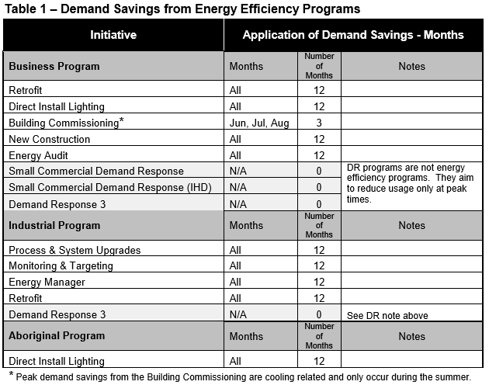
Question #13

If ENWIN Utilities has made any changes to the LRAMVA work form as a result of its responses to interrogatories, please file an updated LRAMVA work form.

RESPONSE
No changes were required to the LRAMVA work form as a result of the interrogatories.

At Note 3 of the 2017 ONTARIO UNIFORM TRANSMISSION RATE SCHEDULES, Terms and Conditions, it states “3. The Billing Demand for Line and Transformation Connection Services is defined as the Non-Coincident Peak demand (MW) in any hour of the month. The customer demand in any hour is the sum of (a) the loss-adjusted demand supplied from the transmission system plus (b) the demand that is supplied by an embedded generator unit for which the required government approvals are obtained after October 30, 1998 and which have installed capacity of 2MW or more for renewable generation and 1 MW or higher for non-renewable generation, on the demand supplied by the incremental capacity associated with a refurbishment approved after October 30, 1998, to a generator unit that existed on or prior to October 30, 1998.. The term renewable generation refers to a facility that generates electricity from the following sources: wind, solar, Biomass, Bio- oil, Bio-gas, landfill gas, or water. The demand supplied by embedded generation will not be adjusted for losses.”
Note, the following in all references in OEB Staff questions relating to amounts booked to accounts 1588 and 1589. Amounts are not booked directly to accounts USoA 1588 and 1589 relating to power purchase and sale transactions, but are rather booked to the cost of power USoA 4705 Power Purchased/4707 Charges - Global Adjustment and the respective Energy Sales USoA accounts, respectively. However, accounts 1588 and 1589 are impacted the same way as accounts 4705/4707 are for cost of power transactions, and the same way as the Energy Sales accounts are for revenue transactions.
OEB letter titled, Guidance on Disposition of Accounts 1588 and 1589.

