Ontario Energy Board
Commission de l’énergie de l’Ontario

OEB STAFF summary of community MEETING
Eb-2017-0039

Essex Powerlines Corporation
Application for 2018 Rates

Feburary 8, 2018

TABLE OF CONTENTS
1 INTRODUCTION 1
2 the PROCESS 2
3 Summary of the Meeting 3
4 Communications after the oeb community meeting 5
SCHEDULE A 6
SCHEDULE B 17

INTRODUCTION
Essex Powerlines Corporation (Essex Powerlines) filed a completed cost of service application with the Ontario Energy Board (OEB) on August 28, 2017 seeking approval for changes to the rates that Essex Powerlines charges for electricity distribution, to be effective May 1, 2018. For a typical residential customer beginning May 1, 2018, the proposed increase is $0.90 per month.
A Notice of Hearing was issued on December 6, 2017.
Further to the Notice of Hearing, the OEB hosted a community meeting on January 18, 2017 in Essex, Ontario regarding Essex Powerlines’ 2018 application.
This is an OEB staff report summarizing the outcomes of this community meeting. This report will be placed on the public record of the OEB hearing of this application along with copies of any written presentations made at the meeting. This report includes a summary of comments, questions and concerns raised during the community meeting by customers who attended the meeting. This summary is intended to capture the range of perspectives that were shared, rather than to provide a verbatim transcript of the meeting.
Customers are also able to submit individual written letters of comment with the OEB, either during a community meeting or any other time during the course of the OEB’s review of an application. The OEB places written letters of comment on the public record of the specific proceeding. All comments must be submitted to the OEB before the decision-makers in that case begin to consider their decision on the application. In making its decision, the OEB considers everything on the public record, including all comments when determining whether to grant the requests made by Essex Powerlines in this application.

the PROCESS
The OEB convenes community meetings in the service territories of local distribution companies that have applied to the OEB to change their rates through a cost of service proceeding.
Community meetings are part of the OEB’s process of reviewing a rate application. The OEB has established a Consumer Engagement Framework to ensure that the perspectives of customers served by rate-regulated entities are considered in the OEB’s decision-making process.
Community meetings are hosted by OEB staff who inform customers about the role of the OEB in rate-setting and the processes involved. OEB representatives explain the various ways that customers can become involved in the adjudicative process. A copy of OEB staff’s presentation is attached to this report as Schedule A.
To assist customers in better understanding the application, the utility makes a presentation explaining its proposals for capital, operations and other spending that result in the requested rate change. A copy of Essex Powerlines’ presentation is attached to this report as Schedule B.
Customers and municipal officials are also invited to make presentations outlining their thoughts on the utility’s proposals.
Following the presentations, customers have the opportunity to ask questions of the OEB and the utility about the application and the regulatory process. The issues raised by customers in the community meetings are documented and assist OEB staff in reviewing the application, asking interrogatories and making submissions to the OEB panel hearing and deciding the application. Any verbal comments provided to OEB staff at the community meeting are summarized in this report with no attribution.
In addition to providing verbal comments to OEB staff, customers attending the meetings may express their concerns directly to the OEB by providing individual comments (with attribution) by filling in a hard copy comment form, which is then submitted to the OEB by OEB staff.

Summary of the Meeting
The OEB’s community meeting for Essex Powerlines was held at the Essex Centre Sports Complex in Essex, Ontario on January 18, 2018 from 6:00 p.m. to 8:30 p.m. Approximately nine people attended the meeting to hear presentations from the OEB and Essex Powerlines. Four of which were staff from Enwin Utilities’, a neighboring utility. OEB and Essex Powerlines staff were available to speak with attendees before the meeting began. OEB and Essex Powerlines representatives responded to questions from attendees during and following the presentations.
The following OEB staff and Essex Powerlines representatives attended the meeting:
OEB Staff
Lynn Ramsay, Senior Advisor, Community Relations and Outreach
James Sidlofsky, Counsel, Legal Services
Donald Lau, Project Advisor, Major Applications

Essex Powerlines
Raymond Tracey, President & CEO
Joe Barile, General Manager
Lindsay Thiessen, Manager of Regulatory Accounting
Chris Carr, Customer Service Supervisor
Max Picco, Manager of Accounting
Monica Dupuis, Billing Supervisor
Brandon Chartier, Facility Operations & Risk Mitigation Supervisor
Dan Charron, Operations Manager
Mark Alzner, Engineering & Asset Manager
Kristopher Taylor, Director of Corporate Strategy

Ken Antaya, Board Chair and Mayor, Town of LaSalle
Bill Wark, Board Member

The OEB and Essex Powerlines presented at the meeting. There were no customer presentations.

Meeting participants asked about the difference between the regulated and unregulated companies under Essex Powerlines’ holding corporation, and specifically wanted to know how the ratepayer benefits from the unregulated companies and where the profits from those companies go. There were also questions on Essex Powerlines’ presentation regarding the conversion to a single voltage distribution system and who provides the power at that voltage. Participants also asked if Essex Powerlines is obligated to purchase power from the Independent Energy System Operator or whether there were other possible sources.

Communications after the oeb community meeting

Two letters of comment were received after the meeting from customers concerned about the requested rate increase. One customer also noted that the size and complexity of Essex Powerlines’ application makes it difficult for consumers to provide meaningful feedback and suggested that the rationale for the request be provided in a summary document.

SCHEDULE A
Ontario Energy Board Presentation
Essex Powerlines Corporation
EB-2017-0039
February 8, 2018

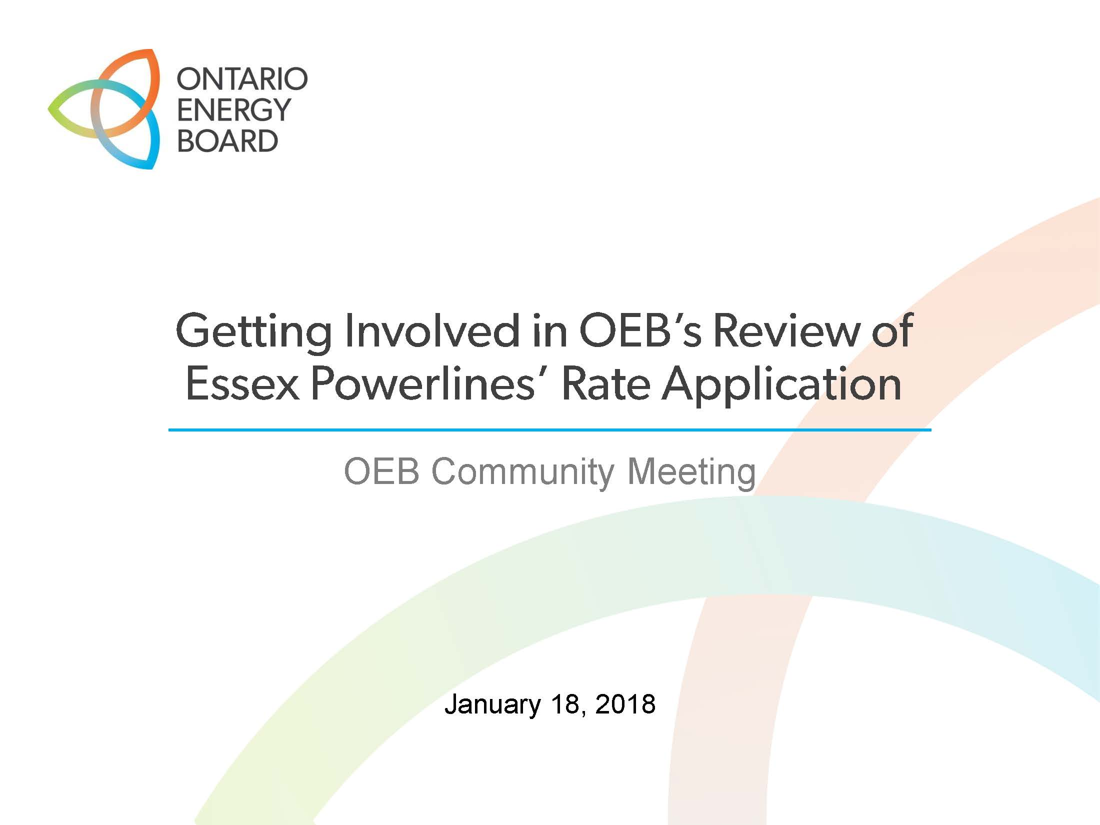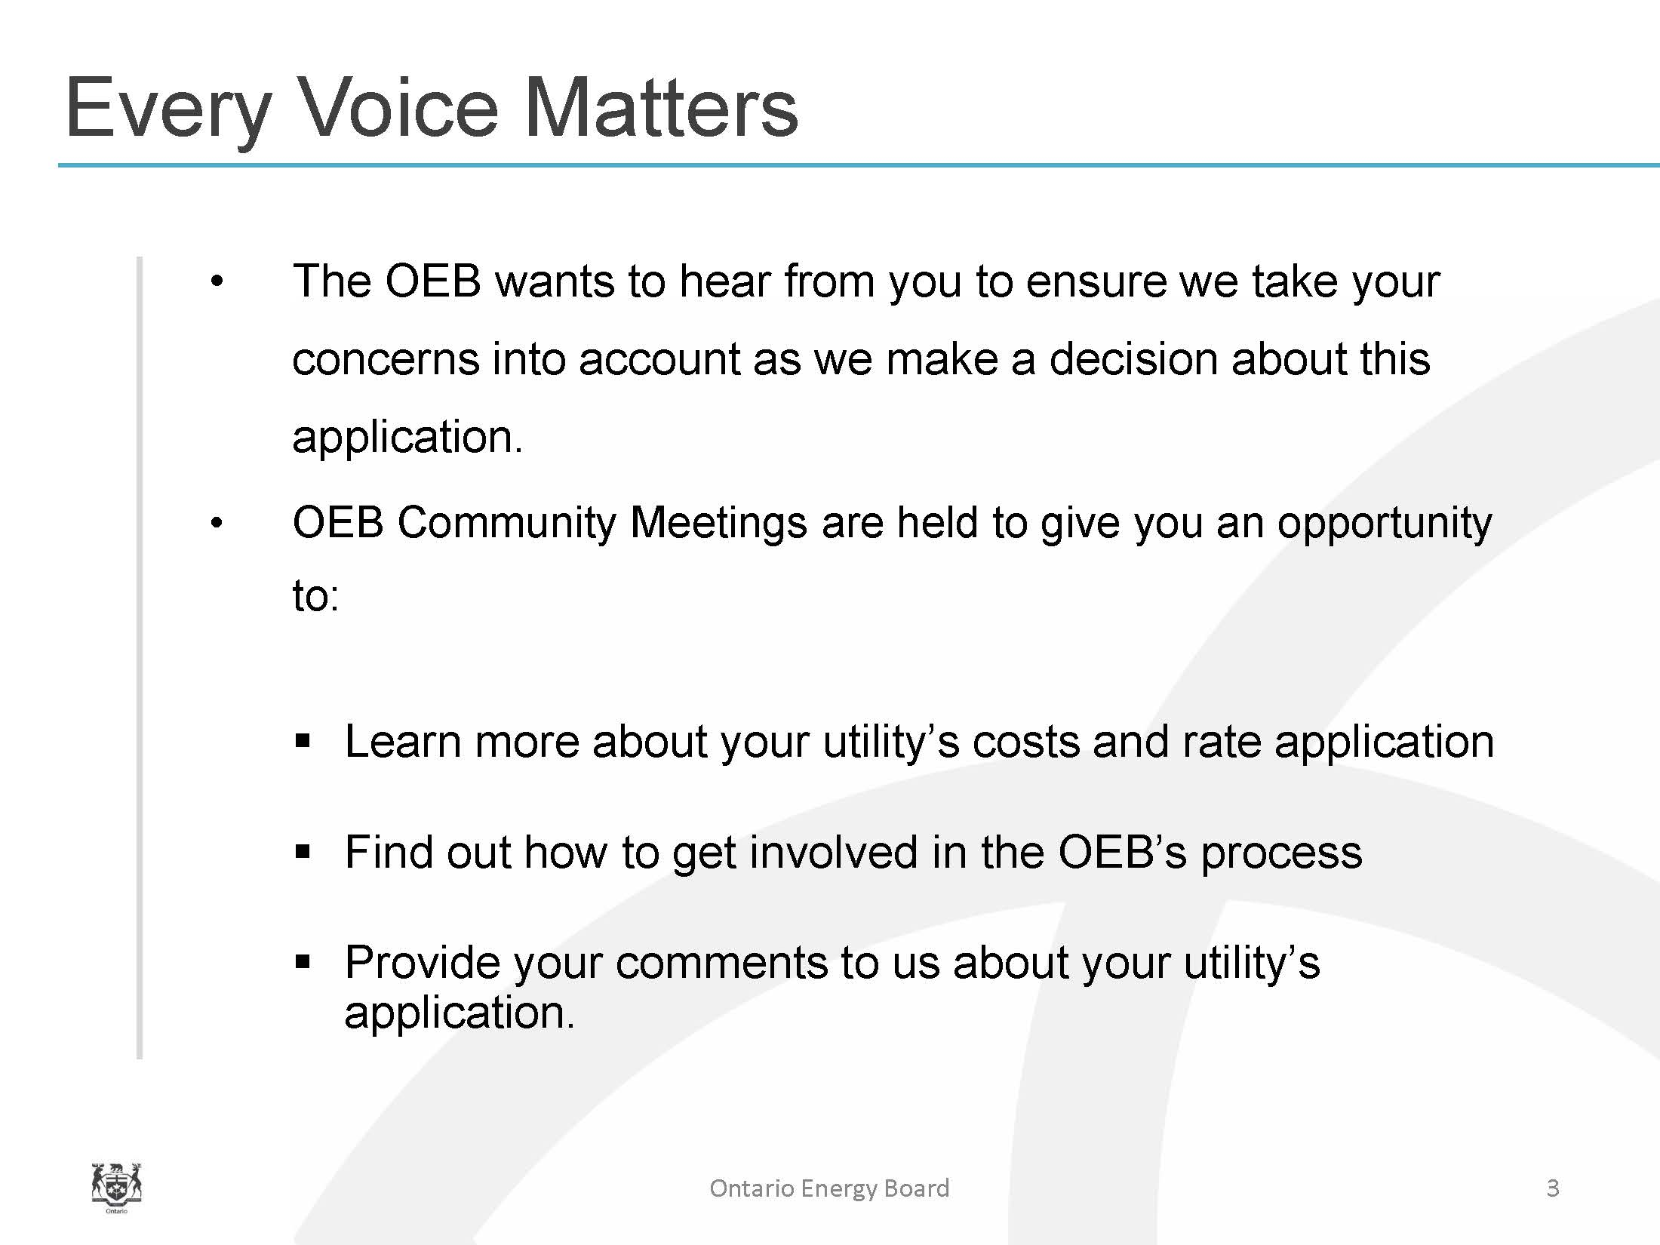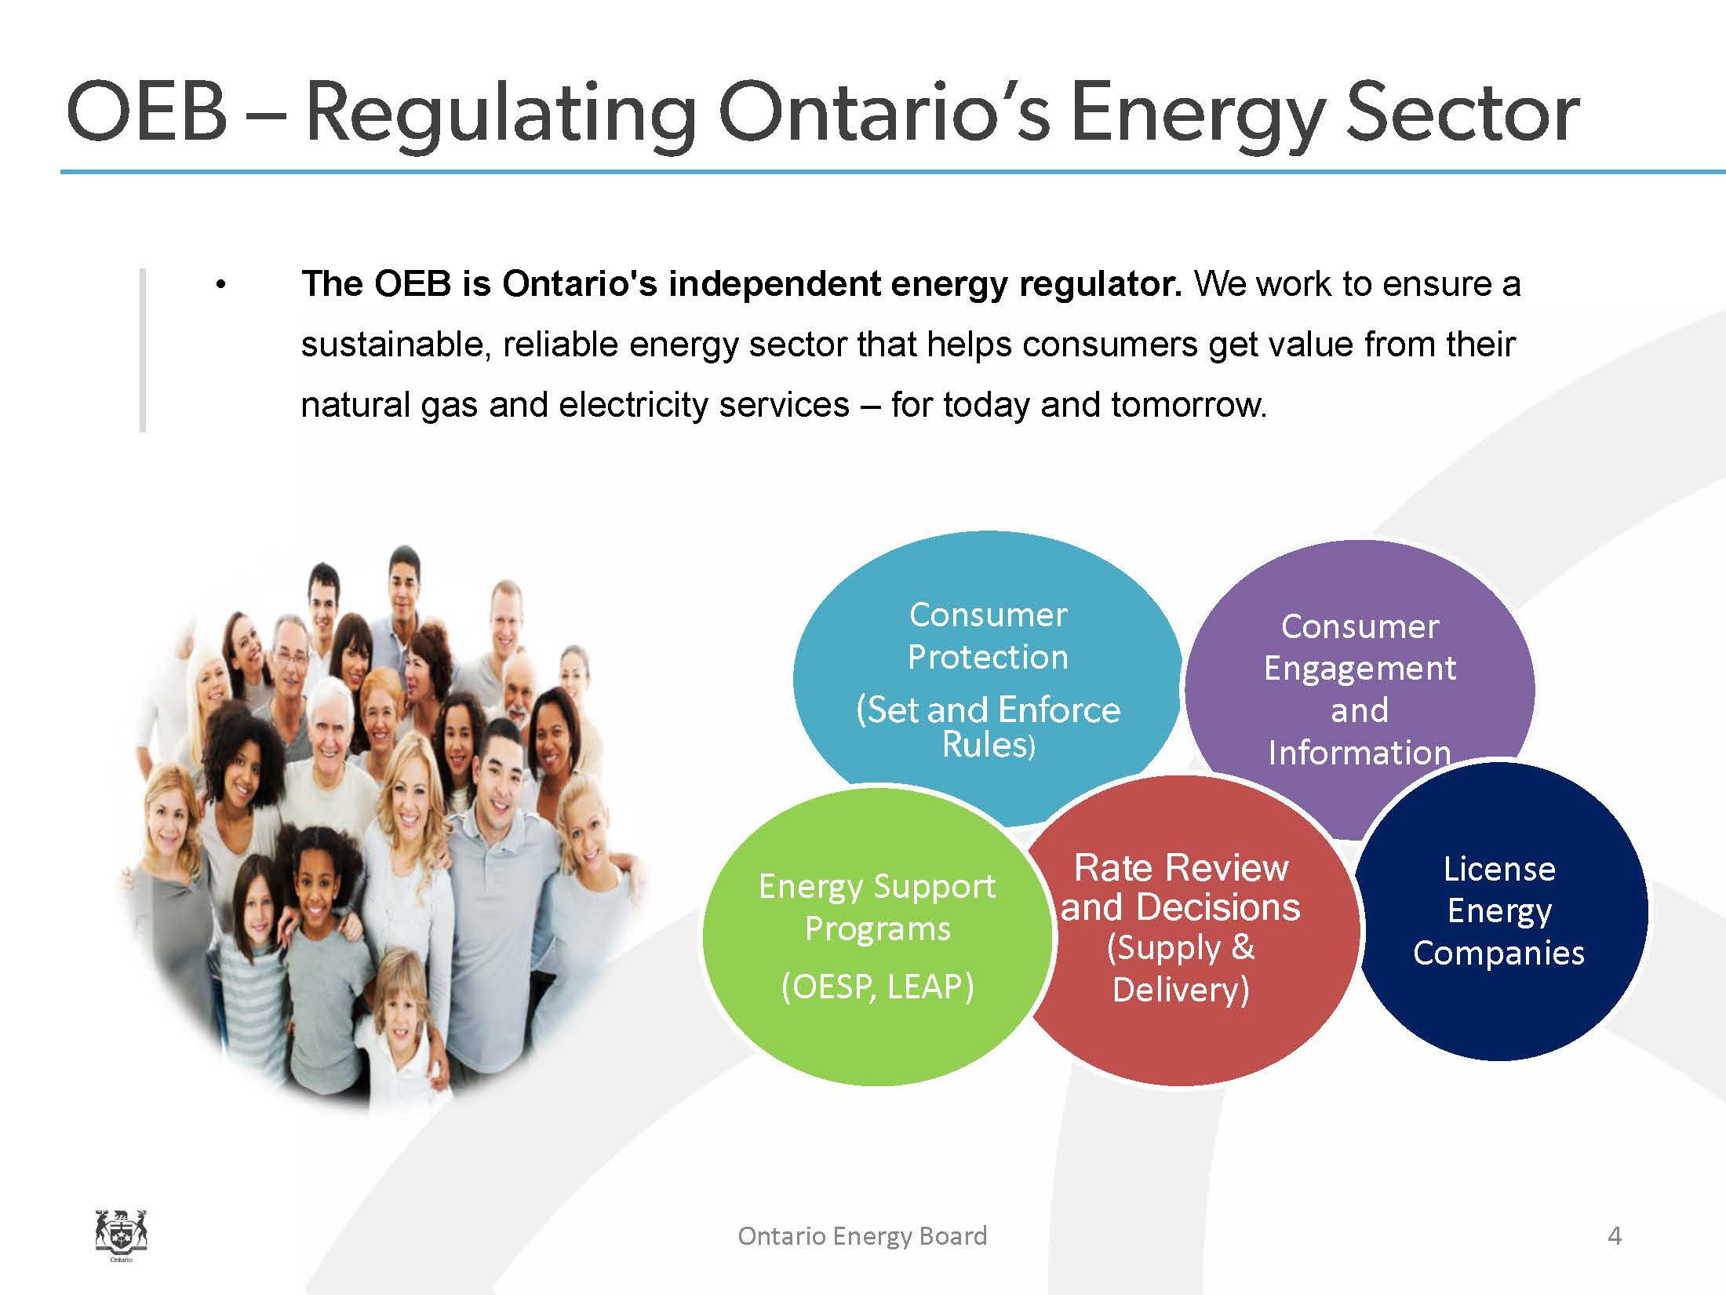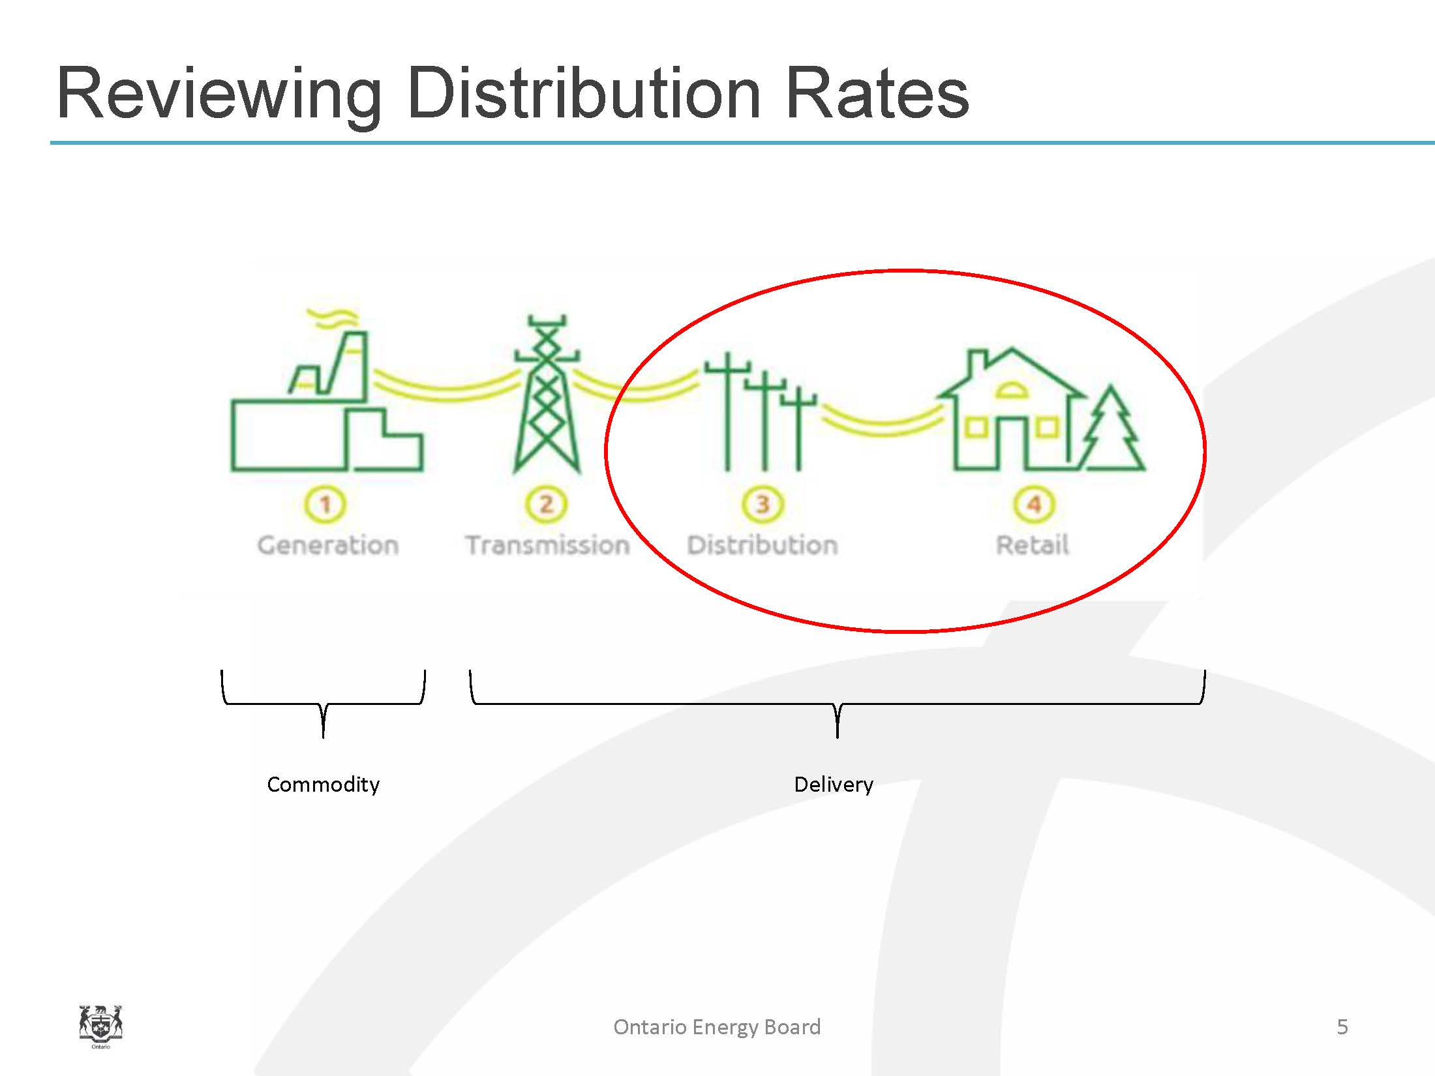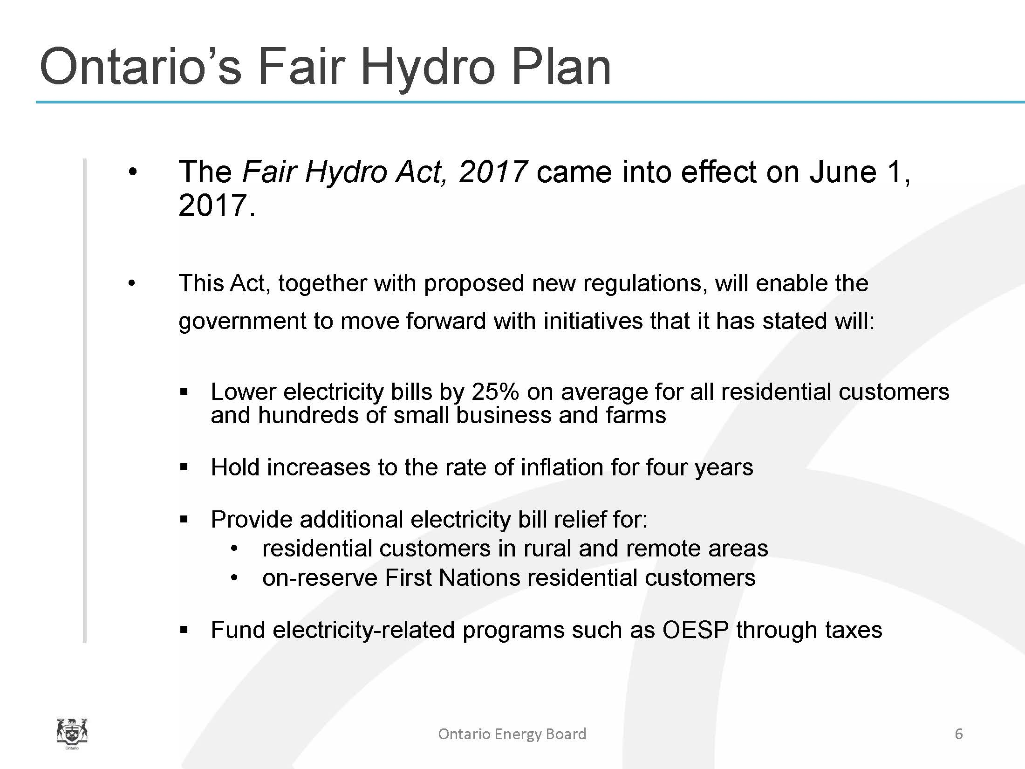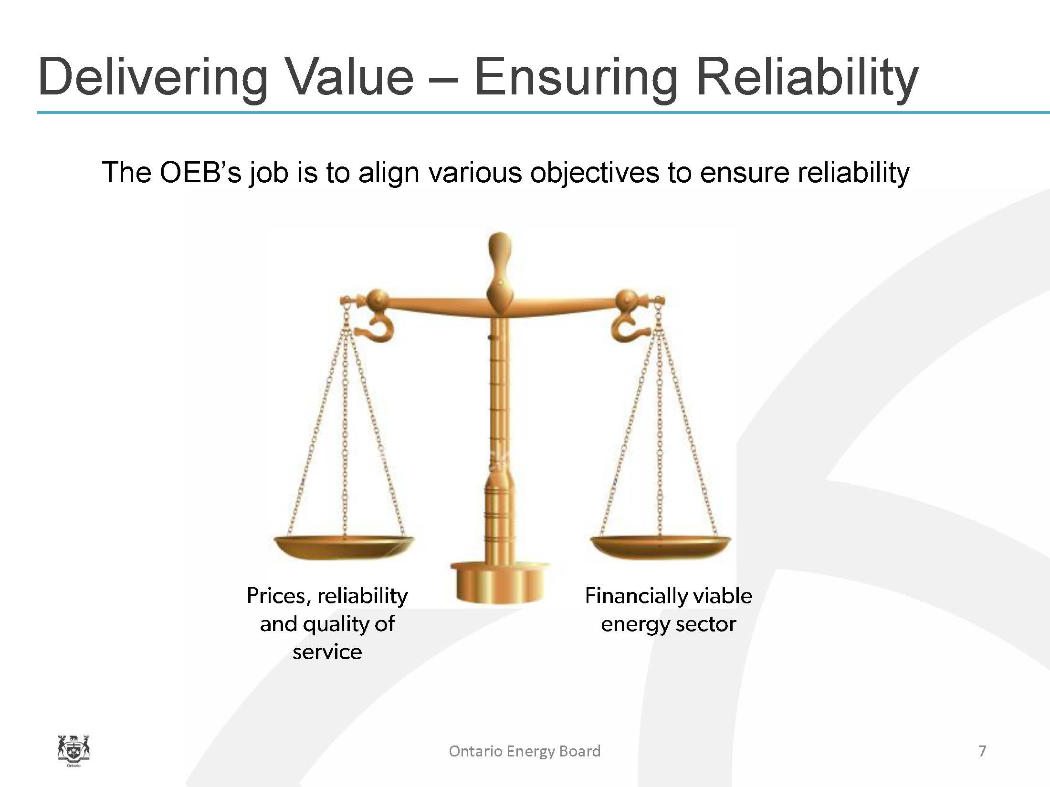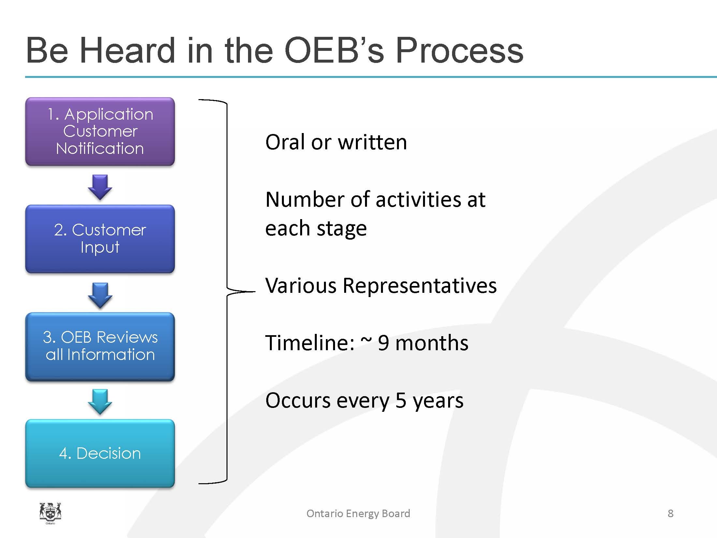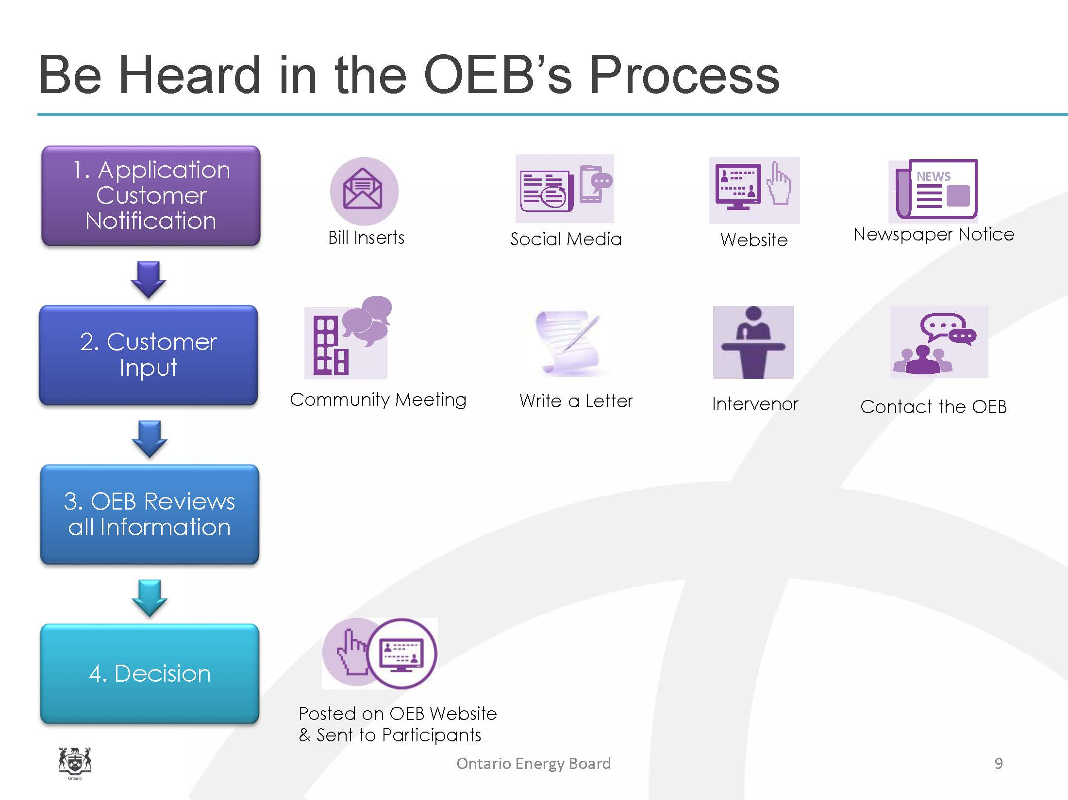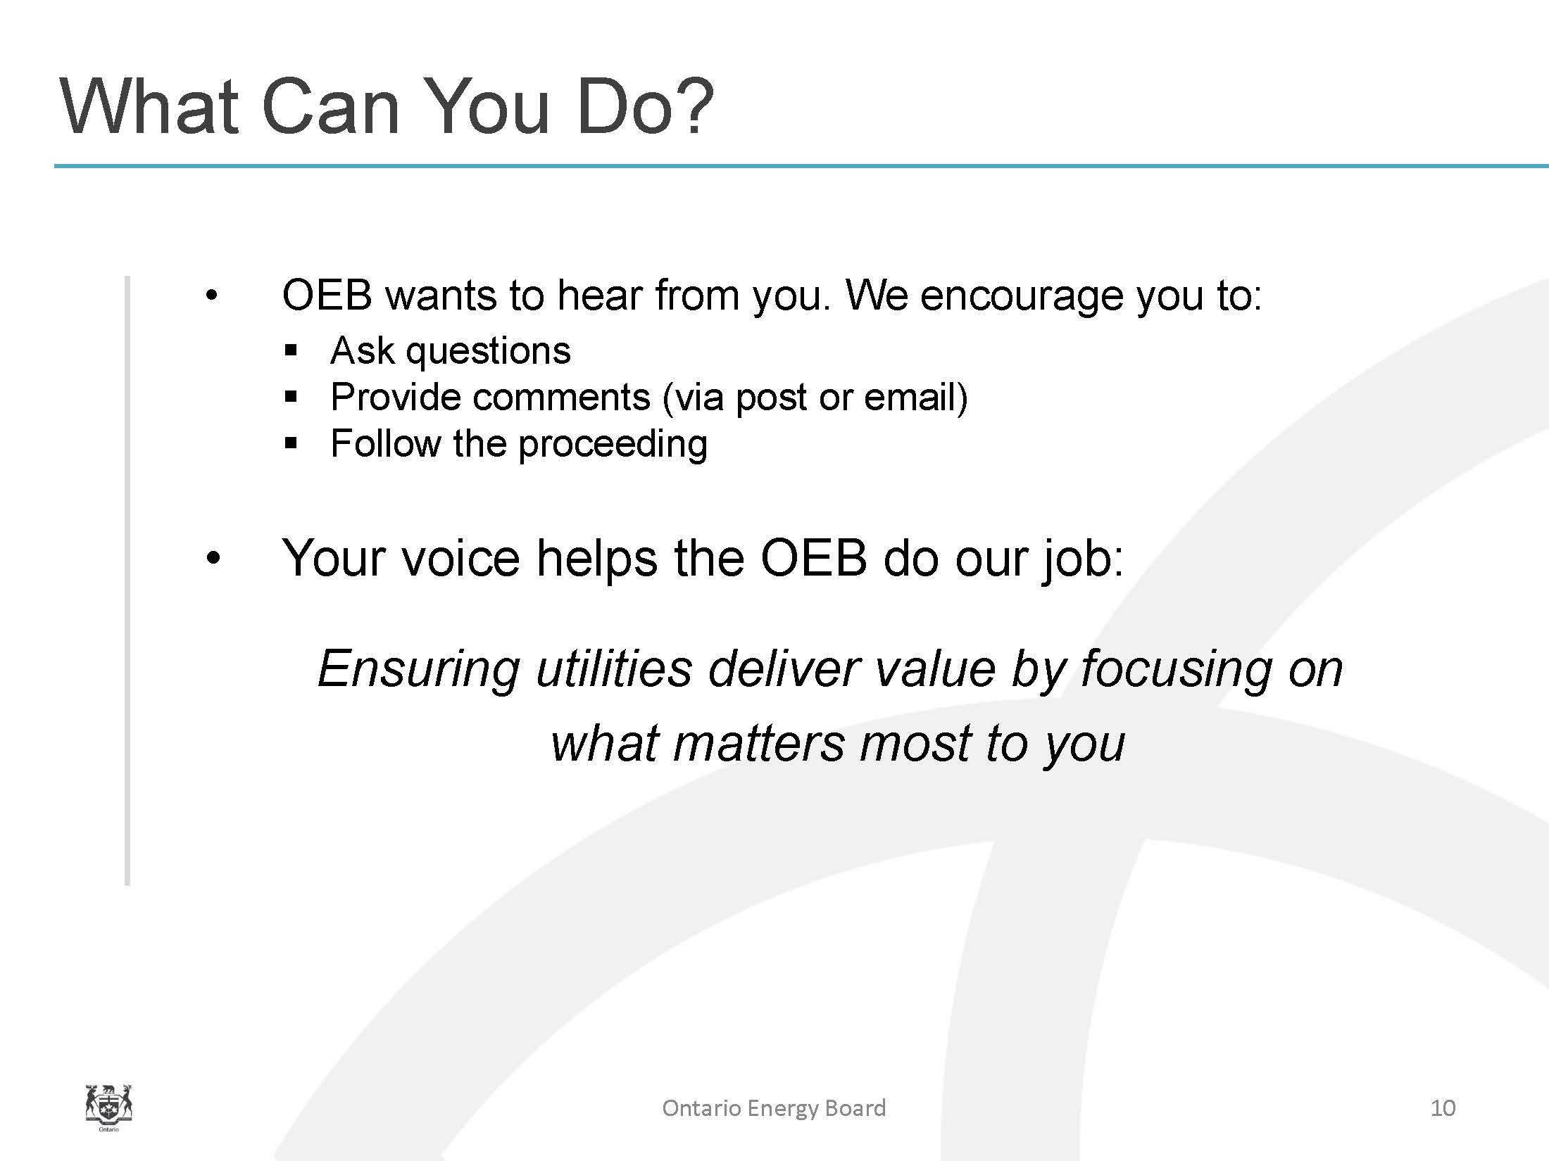

SCHEDULE B
essex powerlines corporation Presentation
essex powerlines corporation
EB-2017-0039
february 8, 2018
