**Appendix A**

# GA Methodology Description

# Questions on Accounts 1588 & 1589[1]

**NOTE:** Questions shown in **BLACK.** Answers shown in **BLUE**. Charts may be shown in black.

1. **In booking expense journal entries for Charge Type (CT) 1142 and CT 148 from the IESO invoice, please confirm which of the following approaches is used:**
2. CT 1142 is booked into Account 1588. CT 148 is pro-rated based on RPP/non-RPP consumption and then booked into Account 1588 and 1589 respectively.
3. *CT 148 is booked into Account 1589. The portion of CT 1142 equaling RPP minus HOEP for RPP consumption is booked into Account 1588. The portion of CT 1142 equaling GA RPP is credited into Account 1589.*
4. If another approach is used, please explain in detail.

**Niagara-on-the-Lake Hydro uses approach B**

1. **Questions on CT 1142**
   1. **Please describe how the initial RPP related GA is determined for settlement forms submitted by day 4 after the month-end (resulting in CT 1142 on the IESO invoice).**

**Refer to Appendix 2B**

* 1. **Please describe the process for truing up CT 1142 to actual RPP kWh, including which data is used for each TOU/Tier 1&2 prices, as well as the timing of the true up.**

**Refer to Appendix 2C**

* 1. **Has CT 1142 been trued up for with the IESO for all of 2017?**

**Yes**

* 1. **Which months from 2017 were trued up in 2018?**

**None**

* 1. **Have all of the 2017 related true-up been reflected in the applicant’s DVA Continuity Schedule in this proceeding?**

**Yes**

* 1. **Please quantify the amount reflected in the DVA Continuity Schedule, and the column where it is included.**

**Credit to account 4705 in the amount of $525,938 is included in the DVA Continuity Schedule in Sheet 2a column BD – Transactions Debit/(Credit) during 2017.**

1. **Questions on CT 148**
2. **Please describe the process for the initial recording of CT 148 in the accounts (i.e. 1588 and 1589)**

**Refer to Appendix 2B**

1. **Please describe the process for true up of the GA related cost to ensure that the amounts reflected in Account 1588 are related to RPP GA costs and amounts in 1589 are related to only non-RPP GA costs.**

**Refer to Appendix 2C**

1. **What data is used to determine the non-RPP kWh volume that is multiplied with the actual GA per kWh rate (based on CT 148) for recording as expense in Account 1589 for initial recording of the GA expense?**

**The initial amount recorded in account 1589 is the total GA (excluding Class A customers) less Estimated RPP GA**

1. **Does the utility true up the initial recording of CT 148 in Accounts 1588 and 1589 based on estimated proportions to actuals based on actual consumption proportions for RPP and non-RPP?**

**Yes**

1. **Please indicate which months from 2017 were trued up in 2018 for CT 148 proportions between RPP and non-RPP.**

**None**

1. **Are all true-ups for 2017 consumption reflected in the DVA Continuity Schedule under 2017.**

**Yes**

1. **Please quantify the amount reflected in the DVA Continuity Schedule, and the column where it is included.**

**Debit to account 4707 in the amount of $678,907.98 is included in the DVA Continuity Schedule in Sheet 2a column BD – Transactions Debit/(Credit) during 2017.**

1. **Questions regarding principal adjustments and reversals on the DVA Continuity Schedule:**

Questions on Principal Adjustments - Accounts 1588 and 1589

1. **Did the applicant have principal adjustments in its 2018 rate proceeding which were approved for disposition?**

**Yes**

1. **Please provide a break-down of the total amount of principal adjustments that were approved (e.g. true-up of unbilled (for 1589 only), true up of CT 1142, true up of CT 148 etc.).**

**1588**

**2016 Adjustments**

1. True-up of unbilled revenue for Dec 2016: ($237,386.16).
2. Estimate for impact of 2016 IESO Notice of Dispute (NOD): ($6,947.29)
3. Adjust 2015 NOD from estimate to settlement amount: $12,445.39
4. Adjust 2016 NOD from estimate to settlement amount: ($892.44)

**Total 2016 Principal Adjustments**: -$237,386.16 - $6,947.29 + $12,445.39 - $892.44 = -$232,780.50

**2015 Adjustments**

1. Estimate for impact of 2015 NOD: ($35,790.65)

**1589**

**2016 Adjustments**

1. True-up of unbilled revenue for Dec 2016: $231,902.02
2. Estimate for impact of 2016 NOD: ($125,029.94)
3. Adjust 2015 NOD from estimate to settlement amount: $64,312.16
4. Adjust 2016 NOD from estimate to settlement amount: $2,822.86
5. Remove legal fees related to NOD included in balance: ($5,042.37)
6. Adjustment for billing error in July 2016: $72,099.66
7. Adjustment for Generation Estimates provided to IESO: $35,661.43

**Total 2016 Principal Adjustments**: $231,902.02 - 125,029.94 + 64,312.16 + $2,822.86 - $5,042.37 + $72,099.66 + 35,661.43 = $276,725.82

**2015 Adjustments**

1. Estimate for impact of 2015 NOD: ($435,410.61)
2. **Has the applicant reversed the adjustment approved in 2018 in its current proposed amount for disposition?**

**1588**

Yes, the total 2016 amount of $232,780.50 and 2015 amount of $35,790.65 are reversed in 2017 for a total of $268,571.15.

**1589**

No, the amounts related to Generation Estimates are not reversed in 2017. At the conclusion of our Cost of Service application NOTL Hydro will undertake a historical review of generation estimates provided to IESO to determine the total impact.

All other amounts were reversed. 2016 amount of ($241,063.39) (total $276,724.82 less Generation Estimates $35,661.43) and total 2015 amount of $435,410.61 for a total of $194,347.22

1. **Please provide a breakdown of the amounts shown under principal adjustments in the DVA Continuity Schedule filed in the current proceeding, including the reversals and the new true up amounts regarding 2017 true ups.**

**1588**

**2017 Adjustments**

1. Reversal of True-up of unbilled revenue for Dec 2016: $237,386.16
2. Reversal of Estimate for impact of 2016 IESO Notice of Dispute (NOD): $6,947.29
3. Reversal of Adjustment for 2015 NOD from estimate to settlement amount: ($12,445.39)
4. Reversal of Adjustment 2016 NOD from estimate to settlement amount: $892.44
5. Reversal of Estimate for impact of 2015 NOD: $35,790.65

**Total 2017 Principal Adjustments:** $237,386.16 + $6,947.29 - $12,445.39 + $892.44 + $35,790.65 = $268,571.15

**1589**

**2017 Adjustments**

1. Reversal of True-up of unbilled revenue for Dec 2016: ($231,902.02)
2. Reversal of Estimate for impact of 2016 NOD: $125,029.94
3. Reversal of Adjustment for 2015 NOD from estimate to settlement amount: ($64,312.16)
4. Reversal of Adjustment for 2016 NOD from estimate to settlement amount: ($2,822.86)
5. Reversal of legal fees related to NOD included in balance: $5,042.37
6. Reversal of Adjustment for billing error in July 2016: ($72,099.66)
7. Reversal of Estimate for impact of 2015 NOD: $435,410.61
8. Adjustment for Generation Estimates provided to IESO 2017: $42,891.11

**Total 2017 Principal Adjustments:** -$231,902.02 + 125,029.94 - 64,312.16 - $2,822.86 + $5,042.37 - $72,099.66 + 435,410.61 + 42,891.11 = $237,237.33.

1. **Do the amount calculated in part d. above reconcile to the applicant’s principal adjustments shown in the DVA Continuity Schedule for the current proceeding? If not, please provide an explanation.**

**Yes**

1. **Please confirm that the principal adjustments approved for disposition in 2018 were not recorded in the applicant’s GL as adjustments (they would be recorded as OEB approved dispositions in the GL and shown as such on the DVA Continuity Schedule under 2018).**

**Confirmed**

# Appendix 2A – RPP Settlement

**Determine Estimated RPP kWh for the reporting month**

**Actual amounts consumed by RPP customers for the reporting month are not available at the time that the 1598 submission is due to the IESO. Due to this fact, NOTL Hydro estimates RPP consumption by applying a scaling factor to the kWhs billed to RPP customers in the reporting month. This is calculated as follows:**

1. **Scaling Factor**
   1. ‘Totalized Meter Data with losses for MMP’ reports for each day are downloaded from the IESO Reports website. Daily information is consolidated for NOTL Hydro’s 2 transformer stations to determine the Total Grid Supplied Consumption.
   2. Actual Embedded Generation for the month is added to the Total Grid Supplied Consumption to determine the Total System Consumption for the reporting month.



* 1. The total kWhs billed for all customers (RPP and non-RPP) for the reporting month is obtained from NOTL Hydro’s Harris Northstar billing system. The Total System Consumption / Total Billed kWh = Scaling Factor



1. **Energy billed for the reporting month to RPP customers (kWh) in Block 1 and 2 for conventional meters OFF/MID/ON PEAK periods for smart meters are obtained from Northstar. Since these are the billed amounts and not the actual consumption for the month, the scaling factor is applied to estimate the RPP Block 1 & 2 and ON/OFF/MID Peak consumption for the reporting month.**



**Determine Estimated Weighted Average Price for the reporting month**

1. **At the time of submission, pricing is normally available in Northstar for the first 19 – 22 days of the reporting month.**
   1. For the period that pricing is available in Northstar an estimate of the IESO invoice is generated utilizing a 3rd party software provided by Kinetiq. This software uses NOTL Hydro’s load, net system load shape and pricing for the period to determine IESO Charge Type 101 – Net energy market settlement for non-dispatchable load. In the example below, pricing in Northstar was available up to and including June 21, 2018. Therefore the estimate invoice cover the period from June 1 – 21, 2018.



1. **For the remainder of the reporting month when pricing is not available in Northstar pricing is determined using the following method:**
   1. kWhs are obtained from the ‘Totalized Meter Data with losses for MMP’ reports mentioned above and Ontario Zone HOEP On Peak and Off Peak prices are obtained from the Daily Market Summary reports available on the IESO website. A sample of the Daily Market Summary is provided below.

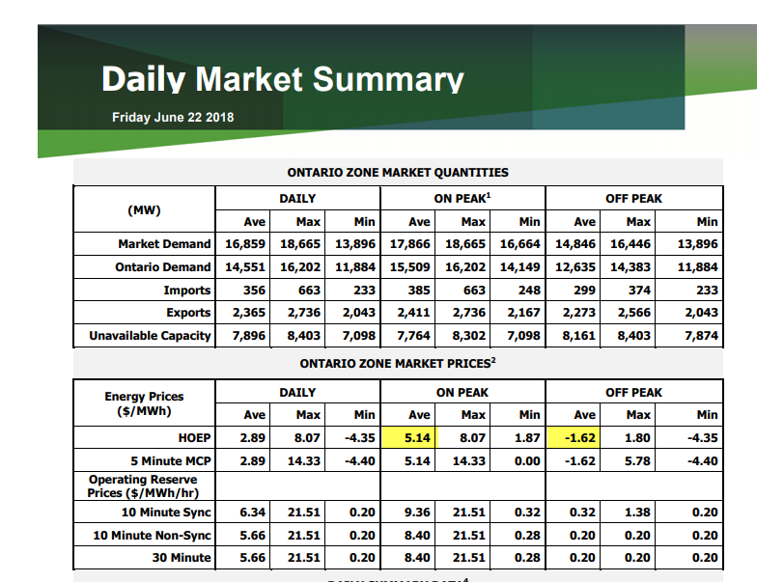

* 1. For the purpose of determining the Net energy market settlement for non-dispatchable load for each day that pricing is not available it is assumed that 75% of the consumption is at the ON Peak price and 25% is at the OFF peak price.



* 1. The amount found on Line 101 of the estimated invoice plus the daily total cost estimate are used as the estimate of the commodity cost for the month purchased from the grid. This amount is then divided by the Grid Supplied Consumption to arrive at the weighted average price for the month.



1. **Since the actual Global Adjustment rate for the month is not available at the time of the submission, the 2nd Estimate of the Global adjustment rates for Class B customers for the month is used for estimating RPP cost of power. The rate is obtained from the IESO website.**

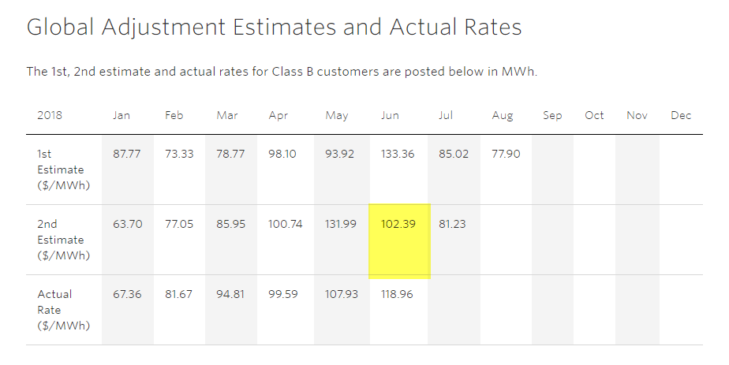



**Estimate and submit RPP Variances**

The estimated/scaled RPP energy consumption is multiplied by the RPP rates to estimate the amount NOTL Hydro will receive from RPP customers for the reporting month.



The estimated/scaled RPP energy consumption is multiplied by the estimated weighted average price and GA 2nd estimate to determine the total cost of power.



The differences between dollars received and cost for each of blocks 1 and 2 for conventional meters and OFF/MID/ON PEAK periods for smart meters are the RPP variances submitted to the IESO in the Form 1598.



**Determine Accounting Entries**

When the IESO invoice for the reporting month is received, an accounting entry is made to reflect the components of the total RPP variance amount in Charge Type 1142. For each of blocks 1 and 2 for conventional meters and OFF/MID/ON PEAK periods for smart meters, the entry to OEB Account 4705 is to reflect passing on to the IESO the RPP dollars received by NOTL Hydro from customers less NOTL Hydro’s energy cost at the weighted average price. The entry to Account 4707 is to reflect NOTL Hydro’s energy cost at the GA rate for non-RPP customers.





**Appendix 2c - 1598 True-up Process**

1. The true-up process is completed once all billings for the reporting period have been processed through the billing system. The last billings for 2017 were completed in mid-February 2018. While the true-up was competed in 2018 all entries were booked in 2017.
2. Actual billed usage data and weighted average price is extracted from the NOTL Hydro’s Northstar Reporting Database using SQL Server Management Studio. Data includes:
   1. Read from Date
   2. Read to Date
   3. Billed Days
   4. Usage (kwh)
   5. Rate
   6. Rate Type (Block 1, Block 2, On, Off, Mid Peak)
   7. Weighted Average Price (WAP)
3. The data is consolidated and sorted to determine the following by Rate Type and month of consumption:
   1. kWh consumed (including losses)
   2. RPP amount received
   3. Cost (WAP) amount.
   4. Global Adjustment (GA) Cost is calculated by multiplying kWh consumed is multiplied by the actual GA for each month to determine the total GA attributable to RPP customers
4. Actual settlement amounts are calculated for 4705 and 4707:
   1. 4705 = RPP Received – Cost (WAP)
   2. 4707 = GA Cost
5. The Actual settlement amounts are compared to the monthly 1598 submissions
   1. The variance between the 2 amounts is the True-up entry.

1.