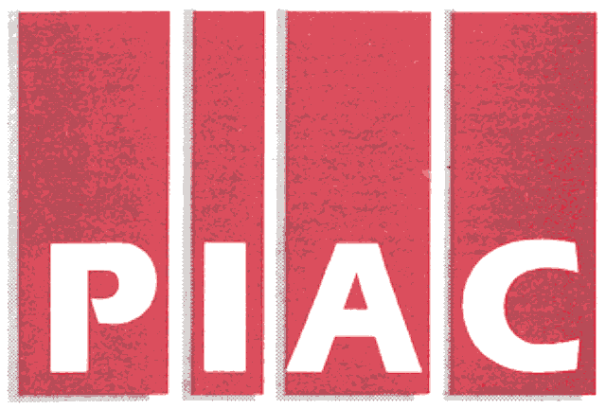October 2, 2006
PUBLIC INTEREST ADVOCACY CENTRE
LE CENTRE POUR LA DEFENSE DE L’INTERET PUBLIC

ONE Nicholas Street, Suite 1204, Ottawa, Ontario, Canada K1N 7B7
Tel: (613) 562-4002. Fax: (613) 562-0007. e-mail: piac@piac.ca. http://www.piac.ca

VIA FAX and E-MAIL
Ms. Kirsten Walli
Board Secretary
Ontario Energy Board
P.O. Box 2319
27th Floor
2300 Yonge Street
Toronto, ON
M4P 1E4

Dear Ms. Walli:

Re: Enbridge Gas Distribution Inc. 2007 Rates Application
EB-2006-0034 - Notice of Intervention
Vulnerable Energy Consumers Coalition (VECC)

We are counsel for VECC in the above noted matter. We are in receipt of the letter of Mr. Stevens of September 28, 2006 on behalf of Enbridge Gas Distribution Inc. (“EGD”) with respect to our proposed intervention in the upcoming Enbridge 2007 Rates proceeding. We understand from his correspondence that the Low Income Energy Network (LIEN) wishes to intervene in this proceeding as well, and that this is a matter of some concern for EGD.

There are two issues raised by Mr. Stevens:

- The grant of intervenor status to VECC
- Eligilibility for an award of costs

Intervenor Status

PIAC has been coordinating the interventions for the organizations associated with VECC since the inception of its coalition, and for similar constituencies at the Ontario Energy Board since the 1980s. The PIAC organizational mandate is primarily directed to providing legal and research services in issues associated with important public services. We have always been cognizant of the number of interests that were represented by intervenors before the Board and endeavored to prevent duplication of effort and cooperate accordingly, particular with other ratepayer representatives. The hundreds of proceedings that have taken place in the OEB in which we have represented vulnerable consumers during this time are testament to the success of our commitment to be efficient, and to add value to the record. We are not aware of any criticism of our interventions as lacking in vigour, value or effect, with respect to the constituencies sought to be represented.

PIAC also carries out research and advocacy activities in addition to its role in facilitating legal services. A cursory perusal of the PIAC organizational web site illustrates the breadth of PIAC’s work particularly in the area of public utilities. We have also had a traditional interest in much of the research and advocacy work undertaken by LIEN in the area of low-income energy conservation, and were pleased to become organizational members at the time of its inception. We are not certain how this modifies our traditional intervention in Enbridge Rate proceedings, but we doubt if it necessarily conveys representational status or complete verisimilitude of interests.

For example the Consumers Council of Canada (CCC) is an organization that includes both utility ratepayers and utilities. On occasion, the individual members are direct intervenors in Board proceedings

Mr. Stevens glosses over the fact that the constituencies represented by VECC and LIEN do differ in composition. For example the Ontario Coalition of Senior Citizens (OCSCO) is a coalition of over 120 senior groups, as well as individual members, across Ontario. OCSCO represents the concerns of over 500,000 senior citizens through its group and individual memberships. OCSCO’s objective is to improve the quality of life for Ontario Seniors.

In conclusion LIEN and VECC represent different interests and the fact the PIAC is a member of LIEN does not in any way diminish PIAC's ability to represent the interests of VECC.

Eligibility for Cost Award

We assume the same necessity to avoid duplication of effort and unnecessary bifurcation of opinion on issues of mutual concern is applicable to LIEN as to other intervenors. We would endeavor to work with LIEN to attempt to avoid circumstances where there are the same “two bites of the same apple” in the manner suggested by Mr. Stevens. We understand that at the end of the day that a responsible intervention is one that adds value, and is deserving of costs recovery.

We would note that VECC advanced the same approach in relation to the LIEN intervention in the recent Union proceedings, where we refrained from participation in the LIEN presentation of its request for special rates.

In the Generic DSM proceeding, VECC took a similar approach to the LIEN concentration on the issue of targeted Low Income DSM Programs. We coordinated with LIEN in advance of the hearing to ensure only one expert was retained with respect to Targeted Low-Income Programs. This evidence was used by all parties and the Board in considering the Issue. However VECC’s counsel felt its interests were best served by taking a different position to LIEN.

We are guided by the words of the Board associated with the adjudication of its cost claim in the recent Union proceeding that:

Intervenors may find that at times they represent constituents that share common interests in general. Costs will not be considered
unreasonable due to duplication so long as the intervenors remain focused on separate issues in a proceeding. All prospective intervenors should be mindful of section 4.03 of the Practice Direction on Cost Awards when submitting their intervention notices.

We would propose to carry out the VECC intervention in this proceeding giving heed to these principles. We suggest the Board accept this approach, and not force a coalition through a joint award of costs as Mr. Stevens advocates.

Thank you.

Yours truly,

Michael Janigan
Counsel for VECC

