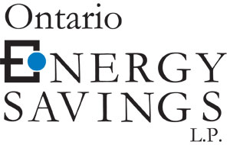
Wednesday, May 30, 2007

Kirsten Walli
Board Secretary
Ontario Energy Board Via Electronic Mail
P.O. Box 2319
2300 Yonge Street, Suite 2700
Toronto ON
M4P 1E4

Dear Ms. Walli,

Re: EB-2007-0606/EB-2007-0615 Enbridge Gas Distribution Inc. and Union Gas Limited Rates for 2008

Ontario Energy Savings L.P. (“OESLP”) is a large retailer of natural gas with affiliates that operate in numerous jurisdictions throughout Canada and the United States. In Ontario, OESLP provides more than 500,000 customers with energy services. As a result, issues set out in this proceeding are directly relevant to OESLP. OESLP wishes to be recognized as an intervenor in the hearing in the English language and will not be seeking an award of costs. OESLP requests an oral hearing. The information for the purposes of service and delivery of documents in the proceeding are outlined below:

Nola L. Ruzycki
Director, Regulatory Affairs
6345 Dixie Road, Suite 200
Mississauga, Ontario, L5T 2E6
Tel: 905-795-4204
Fax: 905-564-6069
Email: nruzycki@energysavings.com

Please contact me should you have any questions or concerns.

Yours truly,
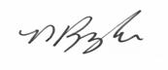

Nola L. Ruzycki
Director, Regulatory Affairs
Tel: 905-795-4204
Fax: 905-564-6069
nruzycki@energysavings.com

c. Patrick Hoey, Enbridge Gas Distribution Inc., patrick.hoey@enbridge.com
Mike Packer, Union Gas Limited, mpacker@uniongas.com

