Westario Power Inc. (Westario Power)
2019 IRM Application
EB-2018-0078
Application Analysis
October 2, 2018
Staff Question #1
Ref: IRM Model Tab 1: Information Sheet

Tab 1 of the Rate Generator Model indicates that the rate year in which Group 1 Accounts were last cleared was 2016. OEB staff notes that Westario Power was approved for disposition in EB-2017-0084 (i.e. the 2018 rate year).
Please confirm if Westario Power agrees and OEB staff will make the necessary correction to the model.
Westario power agrees with the OEB the last approved disposition year was 2018 for the December 31, 2016 balances. Westario Power requests the OEB to please update disposition year accordingly.

Staff Question #2
Ref: IRM Model Tab 3: Account 1580 Variance WMS – Sub-account CBR Class B

This question is related to RRR 2.1.7 filing for account 1580 RSVA – Wholesale Market Service Charge, sub-account CBR Class A and sub-account CBR Class B.
It is noted that the control account 1580 in continuity schedule excludes balances in CBR Class A and CBR Class B; the control account in RRR includes the two sub-accounts’ balances. Therefore, in the Variance column, it is expected to see a variance in cell BV23 only of sub account 1580 Class A plus sub account 1580 Class B and no variance reported in columns BV24 or BV25.

- Please explain the variance in sub account 1580 Class B of ($55,168).

- Please explain the variance in sub account 1580 Class B of ($1,194,211).

- If the balance is incorrect, please update Westario Power’s RRR 2.1.7 and notify your case manager when this is completed.

- Please update the continuity schedule as required.
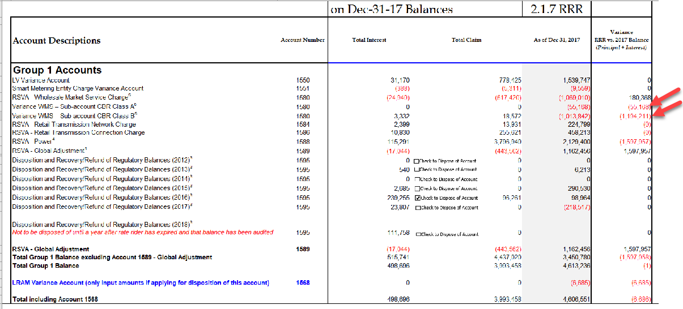
Westario Power has submitted a RRR 2.1.7 revision request. Once this revision has been completed the variances should be eliminated. Revision request as follows:
RRR section 2.1.7 tab Sub-Accounts line items Sub-account CBR class A – Principal, Sub-account CBR class A – Interest, Sub-account CBR class B – Principal, & Sub-account CBR class B – Interest.
Previously submitted:
Sub-account CBR class A - Principal | 1580 | -54,962.00
Sub-account CBR class B - Principal | 1580 | -1,018,421.00
Sub-account CBR class A - Interest | 1580 | -206.00
Sub-account CBR class B - Interest | 1580 | 4,579.00

Correction request:
Sub-account CBR class A - Principal | 1580 | 0.00
Sub-account CBR class B - Principal | 1580 | 175,995.75
Sub-account CBR class A - Interest | 1580 | 0.00
Sub-account CBR class B - Interest | 1580 | 4,372.41

Staff Question #3
Ref: Tab 6.1a GA Allocation – cell D20 Total Non-RPP Class B consumption

OEB staff notes that the total non-RPP Class B consumption on Tab 6.1a, cell D20 shows 160,276,145 kWhs. OEB staff OEB staff is unable to reconcile the data entered in cell D20. Please provide an explanation of the discrepancy. If correction is needed, OEB staff will make the adjustment.

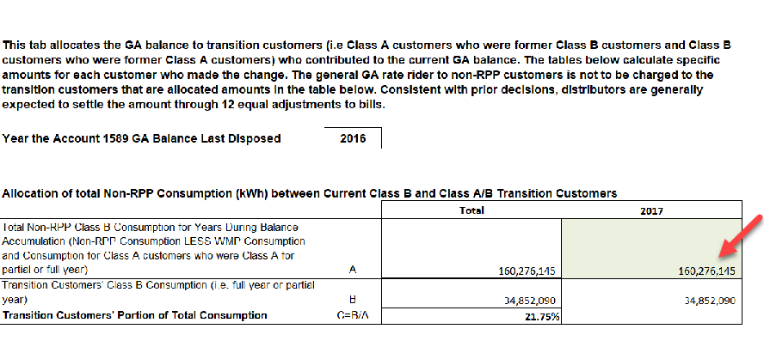

Westario Power is requesting a change to the IRM. 160,276,145 is the uplifted consumption value and 34,852,090 is the unadjusted value. As per the model instructions Westario Power is requesting the value of 160,276,145 be adjusted to its non-adjusted or metered value of 149,790,790. (Please note that Westario’s uplift/adjustment factor at the time of submission was 1.07%.)

Staff Question #4
Ref: Tab 6.1a GA Allocation

Please confirm if the “Year the Account 1589 GA Balance Last Disposed” were last cleared should be 2015 (i.e. In 2017 IRM Application (EB-2016-0113), the OEB approved the disposition of Account 1589, Principal Balance of ($696,807) and Interest Balance of ($10,359).
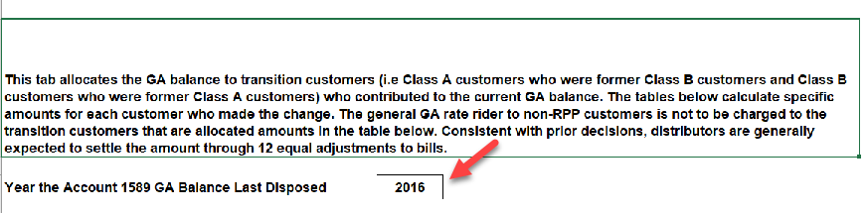

Yes Westario Power’s last disposition was in 2017 for the Balance of December 31, 2015. Westario Power requests the OEB to please update disposition accordingly.

Staff Question #5
Ref: Tab 6.2a CBR B_Allocation
OEB staff notes that the total Class B consumption on Tab 6.2a, cell D 20 of the IRM rate model also shows 160,276,145 kWhs. OEB staff is unable to reconcile the data entered in cell D20. Please provide an explanation for the discrepancy. If correction is needed, OEB staff will make the adjustment.

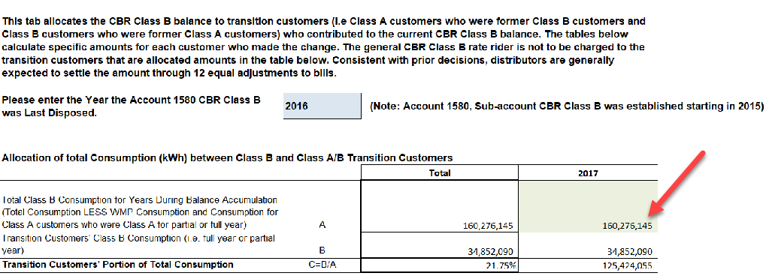

As stated in Question #3, Westario Power is requesting a change to cell D20 in tab 6.1a this change should be carried over to Tab 6.2a.

Staff Question #6
Ref: Settlement Agreement for EB-2017-0084

As part of the settlement agreement for issue 4.2, the Applicant agreed not to dispose of its December 31, 2016 balances in accounts 1588 and 1589. In addition, the Applicant committed to undertake an internal review of its commodity accounts to assess the processes that underpin the accumulation of these balances and to ensure that they are accurate. In addition, the Applicant agreed to explain the results of its internal review at its next rates proceeding.

Accordingly, please explain what the Applicant did to review and validate its processes what were the results of this review? What changes were implemented as a result of this review?

Aside from performing a more detailed monthly analysis, going forward quarterly true-ups will be performed using the OEB’s GA Workform as back-up and confirmation that all costs have been applied correctly.

Here are the results of our internal audit.

Westario has always posted charge type 1142 directly to 1588 and is continuing to do so. Starting in late 2017 Westario changed their Class B GA calculation approach to for booking line charge type 148 from the IESO invoice from an average percentage split to a prorating split based on the prior month’s RPP and non-RPP consumption for Class B consumers. Splits values have and will continue to be booked accordingly into accounts 1588 for RPP and 1589 for non-RPP portion. In prior years GA was calculated on all Class B consumers then a split was based on average percentage ratio of RPP and non-RPP consumers using the average of the prior 2 years. The new methodology provides a smaller and more reasonable true-up variant. The initial split was based on accrued consumption while the true-up values is based on actual billed consumption and will be performed quarterly starting in mid-2018. Unbilled revenue calculation has been scrutinized and edited to enhance the accuracy of the monthly accrual and a true up performed as required on a quarterly basis.

Westario Power submitted the prior year adjustments required in accounts 1588 and 1589 on the GA workform.

Staff Question #7
Ref: DVA Continuity Schedule, Account 1588

With respect to the balance in Account 1588 as at December 31, 2017, given that the variance between RPP revenue and the cost of energy attributable to RPP customers is settled with the IESO on a monthly basis and the Applicant has indicated that all required RPP settlement true-ups for 2017 have been accrued as part of the 2017 ending balance in the DVA continuity schedule, the expectation is that any remaining amounts in account 1588 should be relatively small and close to zero (the difference between amounts billed at the approved total loss factor versus actual system losses for the year).
Accordingly, the Applicant is seeking disposition of approximately $3.7 million in account 1588 as at December 31, 2017. Please explain what the remaining variance in this account pertains to.
After the GA True-up audit Westario Power proceeded to audit RPP Settlement it was determined after review that some of 2016 and 2017 RPP settlement submissions were incorrect. True-up adjustments and reconciliation are in the process of being completed in 2018 and will submitted with 2018 IESO monthly settlement submissions. These true-ups greatly decreased the amount in 1588 therefore Westario Power is not seeking disposition of $3.7 million. Westario Power’s practice is for errors from previous periods be adjusted in month that they were discovered and reflected in the current IESO submission. These errors were discovered after we performed an internal audit on our Account 1588 and 1589.

Staff Question #8
Ref: Responses for Appendix A of the GA Analysis Workform Instructions

The Applicant has provided responses to the questions in Appendix A of the GA Analysis Workform Instructions. :

- The Applicant has not provided a response to Question 2b. Please refer to Question 2b of Appendix A and provide the required information.

Currently Westario updates actual consumption billed on a monthly basis and verifies monthly kWhs back to January 2015. The monthly billed consumption is then calculated based on the difference in price paid by WPI to price charged by WPI to its customer. The difference is calculated for each month as follows. Total Price of Commodity is calculated as paid by WPI to IESO and includes average HOEP charged plus the actual GA rate. This value is then subtracted from the TOU or tiered rate received by WPI. The remaining dollar value is then calculated by the actual billed consumption for that period. This calculation is done for all TOU and Tiered price rates. For the current settlement period an estimate is used based for commodity price, GA is based on the 2nd estimate and consumption is based on a percentage of total load. The following month once all data is available a true-up is performed.

We have determined that CT1142 has not been trued up properly for 2017 and in the process of doing so as a result of our internal audits confirm that that any remaining amounts in account 1588 should be relatively small and close to zero.

- The response provided to 2d indicates that the CT 1142 true-ups are reflected in the DVA continuity schedule, with the exception of the adjustments mentioned in part c. Please confirm that the only adjustments mentioned in part c that have been excluded are “a small amount of billing adjustments that relate to 2017 consumption year”. Also, please provide the dollar value of these billing adjustments that are being referred to.

We are unable to dollarize the billing adjustments referred to in 2c and unable to include these in any true up balances. The net impact is minimal and will be reflected in any settlement amounts required in fiscal year 2018.

- Question 2e requires that you quantify the adjustment specifically related to the CT 1142 true-up that the Applicant has recorded in the “principal adjustment” column of the DVA continuity schedule, accordingly please quantify. Also please break-out the CT 1142 true-up recorded as a principal adjustment in DVA continuity schedule for both 2016 and 2017.

The adjustments related to CT 1142 are treated as transactions in the cost of power account and factored into the monthly adjustment for account 1588. There is no dollar value related to CT 1142 that is reflected in the Principal Adjustments column of the DVA Continuity Schedule. The amounts reflected in the Principal Adjustments column for 2016 and 2017 relate to GA true-ups that should have been recorded in the year but were not, they have been included in the principal adjustments column so that the impact of these missed true-ups are not factored into the disposition rate riders for the year.

- For the response provided for Question 3a, please confirm whether the Applicant initially records the monthly CT 148 charge from the IESO in their G/L prior to receiving the actual invoice (i.e. based on the 2nd GA estimate multiplied by estimated consumption) or does the Applicant only recorded CT 148 in their G/L once the actual invoice from the IESO is received?.

Currently, Westario Power records CT 148 after the IESO invoice has been received.

- In the response provided to Question 3b, the Applicant discusses the CT 148 true-up that is required with respect to the split between RPP and Non-RPP. Is there also an adjustment that is required in order to true-up the estimated GA rate used initially to actual? If not, please explain why it is not required.

The true incorporates both volume and $. Here are the required adjustment required for 2016 and 2017. These adjustments have been added to the DVA schedule under the Principal Adjustments Columns, column AV for 2016 and column BF for 2017.

For 2016 the following is required:
Debit to account 1588 for RPP for $562,353
Credit to account 1589 for Non-RPP for $562,353

For 2017 the following is required:
Debit account 1588 for RPP for $2,160,310
Credit account 1589 for Non-RPP for $2,160,310

- In the response provided fro 3d and 3e, it appears that the applicant indicating that it had not been recording the CT 148 true-up at all for both 2016 and 2017, and then recorded a comprehensive true-up for all of 2016 and 2017 during 2018 (for all 24 months). Please confirm whether this understanding is correct and if not, please clarify what was done.

Westario Power did perform a partial true-up in late 2017 for 2017 but the true-up was too low. A better and more defined true-up was performed in 2018 for both 2016 & 2017.

- In the responses provided for Appendix A, the Applicant has indicated the RPP vs Non RPP split used for the purposes of calculating CT 1142 and for the allocation of CT 148 are initially based on an estimate. Is the same estimate of the RPP vs Non RPP split used for both purposes? Please explain.

No, the estimated split for CT1142 is addressed in the initial Appendix A question 2a and this is different than CT 148 split since the calculation is required on day 4 for CT1142. The CT 148 split is based on actual billed consumption for that month.

- In the response provided to question 4e of the 2017 GA Analysis workform, the Applicant is indicating that the principal adjustments proposed in 4d of Appendix do not reconcile to the DVA continuity schedule. However, upon review of the DVA continuity schedule, it does reconcile for 2016 but doesn’t for 2017. The explanation that is currently provided is not adequate to support why it doesn’t reconcile. Please update as there appears to be a disconnect between the response provided in 4e and what actually got recorded in the DVA continuity schedule as a principal adjustment.

Yes it does reconcile for 2016 and the answer provided in Appendix A regarding 2017 is incorrect. The amount for 2017 true up adjusted in 2018 should be a debit of $2,160,310 to account 1588 and a credit to account 1589 of $2,160,310.

Staff Question #9
Ref: 2016 GA Analysis Workform

- The Applicant has recorded a true-up adjustment of debit $562,353 as adjustment 10 in Note 5 of the GA Analysis Workform
    - Please explain in detail what this true-up adjustment specifically pertains to and accordingly update the explanation provided.
    - Is this true-up comprised of multiple elements (i.e. true-up to the actual GA rate, true-up for actual RPP vs Non RPP split for the purpose of allocating CT 148, true-up of CT 1142 in order to reflect the updated RPP vs Non-RPP split etc). If so, please break-out this balance into its components that are being trued-up
    - The true-up adjustment as recorded is a debit to account 1589. Sufficient explanation has not been provided to support the direction of this adjustment (debit). Please provide this additional information and update the explanation provided in Note 5 to reflect the additional detail.
    - Please provide the supporting calculations for each of the true-up adjustments identified in ii. above.
    - Please confirm that the total true-up adjustment that the Applicant has proposed to record in the “Principal Adjustments” column for 2016 of $562,353 does not form part of the balance in the “Transaction Debit / (Credit) during 2017” column of the DVA continuity schedule (i.e. it wasn’t actually recorded in 2017). When did the Applicant actually record it?

- The amount for CT 148 is allocated in 2016 in the DVA Continuity Schedule based off the estimated split between RPP and non-RPP. If the correction for 2016 had been made in the year the result would have been reallocating $562,353 from account 1589 to account 1588. The result is that 2016’s closing principal balance for account 1589 should be $(856,161) instead of $(1,418,514) and account 1588’s closing balance should be $2,101,194 instead of $2,663,547. Since these adjustments were not recorded until mid 2018 they are not reflected on the DVA continuity schedule.

- The true-up pertains to multiple elements. It is the GA reconciliation from estimate to actual and the split between RPP and Non-RPP customers.

- After the 2016 Workform was completed it was determined Westario Power under estimated the amount of the GA paid for Non-RPP customers and over estimated for RPP customers. Therefore a debit is required to increase 1589 and a credit is required to decrease account 1588 to decrease the effect on RPP customers and increase the effect on Non-RPP customers.

- Total recorded in 2016 for GA Non-RPP based on estimate was $19,785,573.46 but actual value should have been $20,347,926.38 so the NON-RPP customers’ portion was understated by $562,353, therefore a debit is needed to increase the GA NON-RPP portion.

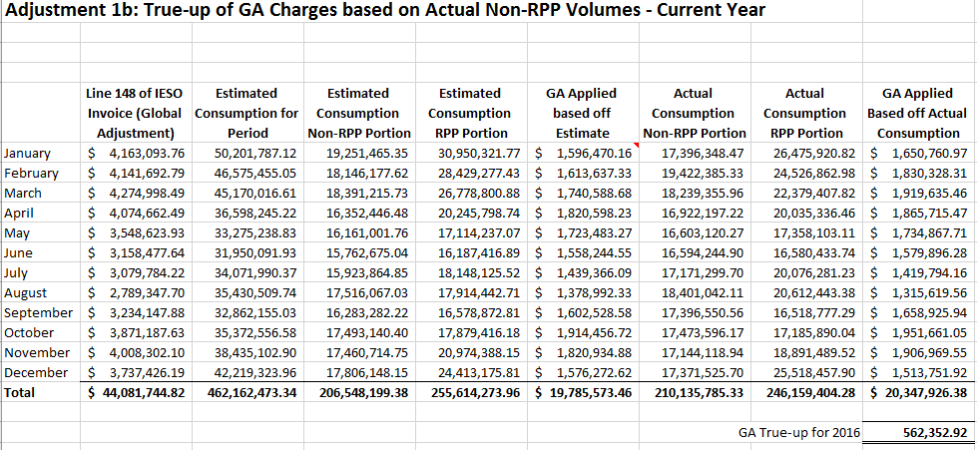

- Westario is confirming that the total true-up adjustment we are proposing in the “Principal Adjustments” column for 2016 of $562,353 does not form part of the balance in the “Transaction Debit / (Credit) during 2017” column of the DVA continuity schedule and is a separate request. The transaction will be posted in 2018.

- The applicant has recorded true-up adjustments for 2a and 2b in Note 5 of the 2016 GA Analysis Workform.
    - Please add explanation that supports the direction of each of these adjustments (i.e. why a debit and a credit are appropriate for 2a and 2b respectively.
    - What months are being accrued for?
    - Please explain how the Applicant has quantified each of these amounts and provide the supporting calculations.
    - Was the amount shown in 2b actually recorded in 2017?
    - Why has the Applicant not recorded the true-up adjustment shown in 2b of Note 5 in the GA Analysis Workform as a principal adjustment for 2016 in the DVA continuity schedule?

- These adjustment are reconciliations for the unbilled revenue. Westario Power accruals on a monthly basis for unbilled revenue. The accruals which these adjustments relate to are do to a fiscal year change so December 2015’s accrual is reversed in 2016 and offset the bills produced in the current for prior consumption period. The difference in this case was $23,051.80 debit between December 2015’s accrual and actual billed for this period in 2016. There is a $231,348.00 credit between December 2016’s accrual and actual billed for this period in 2017. Please see GA Workform Back Up 2016 for calculations. Tab “Adjustment 2a & 2b” has the completed calculations for Non-RPP GA adjustment.

- Westario Power accruals on a monthly basis for unbilled revenue. These adjustments are relate to fiscal year changes and represent December’s accrual being reversed in the following year in January.

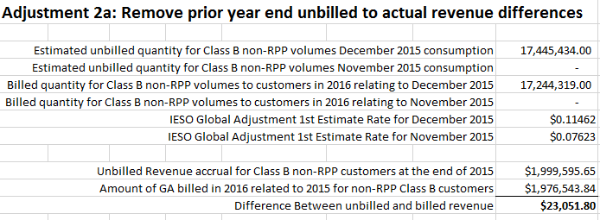

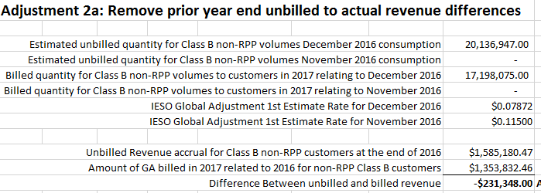

- Yes this amount would have been recorded in 2017 as part of the billed amount in January 2017.

- Since the true-ups was actually recorded in the year that the consumption was billed Westario Power recorded them as part of DVA schedule in the transaction column for that year. In other words if we recorded it in 2016 as a principle adjustment it would have shown as a reversal of the principal adjustment in 2017 so the impact is NIL.

- The applicant has recorded an adjustment of $233,010 to account for the change in customer billing from the 1st estimate to the 2nd estimate.
    - Please provide the calculation that was used to quantify this amount (using the monthly consumption data populated in Note 4 of the GA Analysis Workform).
    - Please confirm that the change in billing from the 1st estimate to the 2nd estimate was done for all rate classes. Was there a lag in doing it for certain rate classes or was it implemented for al rate classes at the same time?

- Westario power used the GA Analysis Workform to calculate the difference. Westario prepared 2 versions of the workform for 2016. Here are the partial workforms and are summary for the difference.

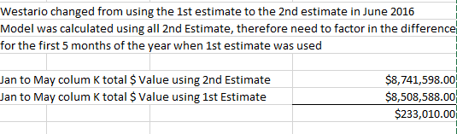

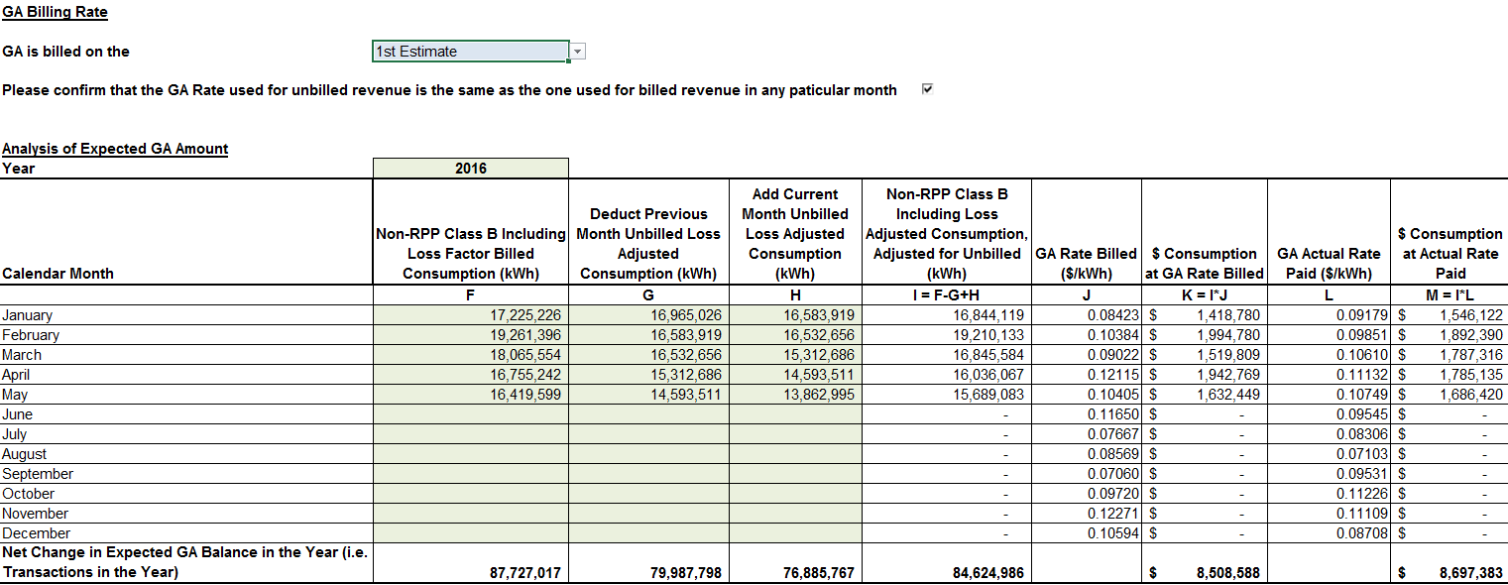

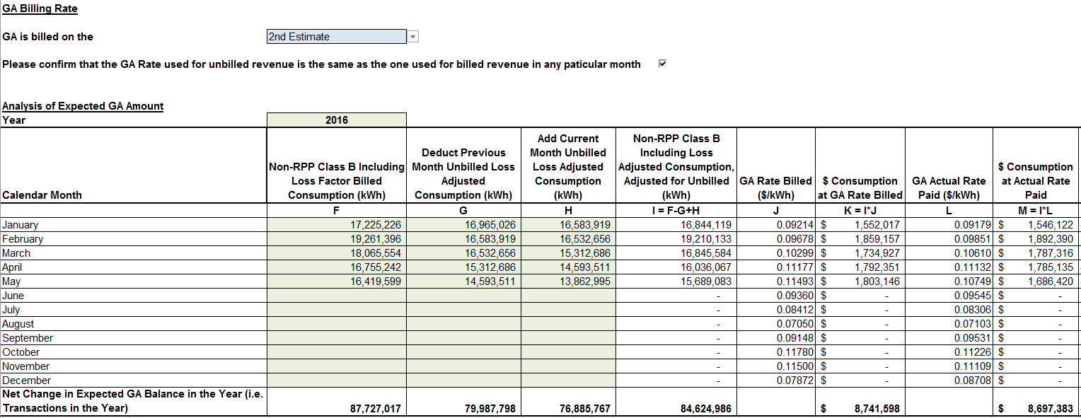

- The implementation occurred for at the same time for all rate classes. Therefore, all rates where effected as of June 1st, 2016.

Staff Question #10
Ref: 2017 GA Analysis Workform

- The Applicant has recorded a true-up adjustment of $2,160,310 as adjustment 1b of Note 5 in the 2017 GA Analysis Workform.
    - Is this true-up adjustment a true-up for the RPP vs Non RPP split only, or is it comprised of multiple elements (i.e. true-up to the actual GA rate, true-up for actual RPP vs Non RPP split for the purpose of allocating CT 148, true-up to CT 1142 in order to reflect the updated RPP vs Non-RPP split etc). If so, please break-out this balance into its components that are being trued-up.
    - In the explanation provided, the Applicant has indicated that in the initial split of the RPP vs Non RPP Class B consumption, all consumption related to its Class A customers was incorrectly included in the figures used to allocate costs to Non-RPP Class B customers, and therefore a significant true-up to account 1589 is required.
      - Please confirm that the above understanding is correct? If not, please clarify.
      - Do the amounts that are now being reallocated to account 1588 as a result of this adjustment mean that there is still a pending settlement adjustment with the IESO that needs to be recorded in account 1588 as well?
      - If so, then quantify this adjustment and reflect it as a principal adjustment against account 1588 in the DVA continuity schedule.
    - The true-up adjustment as recorded is a credit to account 1589 Sufficient explanation has not been provided to support the direction of this adjustment (credit). Please provide this additional information and update the explanation provided in Note 5 to reflect the additional detail.
    - Please provide the supporting calculations for each of the true-up adjustments identified in i. above.
    - Please confirm that this true-up adjustments have actually been recorded by the applicant in 2018.

- The true-up adjustment only pertains to the RPP and Non-RPP split. See calculation in part iv) below

  - This is correct.
  - A pending settlement was required with the IESO at the end of 2017, this has now been settled in 2018. The amount of this true-up was $1,940,236.36.
  - The difference is the result of calculated settlements with the IESO of $4,439,777.61 for 2017 while only $2,499,541.25 was recovered.

- See calculation below in response (iv). The amount for CT 148 is allocated in 2017 in the DVA Continuity Schedule based off the estimated split between RPP and non-RPP which was incorrect and overstated the consumption for Non-RPP Class B customers. The actual split calculation was performed during the GA workform completion process which resulted in a credit to account 1589.

- See calculation below.

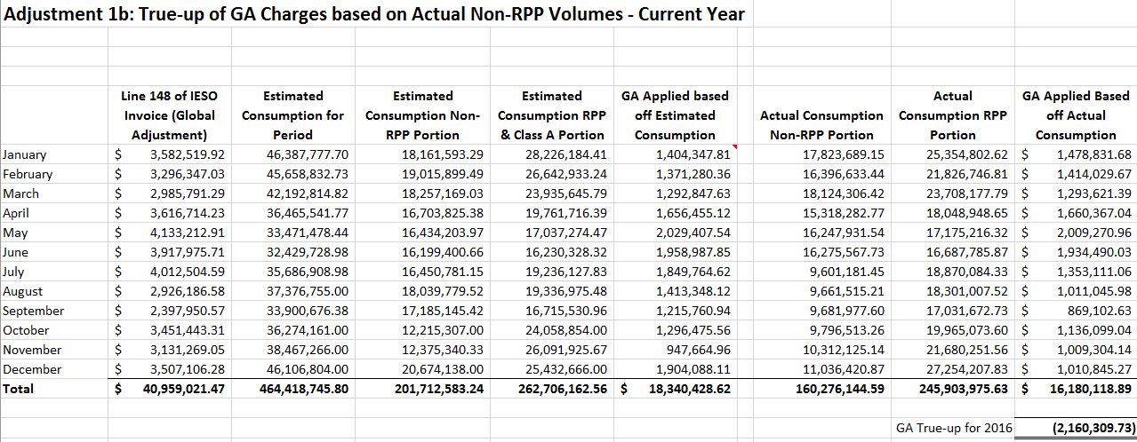

- Yes, the true-up adjustments have been completed in 2018.

- Please explain why the applicant is not proposing to reverse the principal adjustment recorded in the 2016 DVA continuity schedule of $562,353 as adjustment 1a of the 2017 GA Analysis Workform (and as a principal adjustment in the 2017 DVA continuity schedule).

The 2016 true up was not posted in 2017. All required adjustments for true-ups will be posted in 2018, which can be noted on our 2018 Financial Statements when completed.

- The Applicant has proposed a true-up of debit 490,510 as adjustment 9 of the 2017 GA Analysis Workform. It appears from the explanation that was provided that this adjustment is the reversal of a previously recorded true-up that was done incorrectly (and then recorded the correct one as shown in 1b of Note 5 in the 2017 GA Analysis Workform).
    - When the incorrect true-up amount was initially recorded, was it recorded as a credit to account 1589?
    - Was the $490,510 initial true-up actually recorded in 2017 (i.e. it is included in the DVA continuity schedule under the column “Transactions Debit / (Credit) during 2017)?
    - If the answer to ii. above is “yes”, then why is the Applicant not proposing to include this adjustment in the column “Principal Adjustments during 2017” for account 1589 in the DVA continuity schedule?
      - In addition, if the answer to ii. above is “yes”, then why does the Applicant indicate in its response to question 4e of Appendix A from the GA Analysis Workform Instructions, that no true-ups for either 2016 and 2017 were actually recorded in the G/L until 2018.
    - If the answer to ii. above is “no”, then why would this adjustment even appear as a reconciling item in Note 5 of the 2017 GA Analysis workform?

- The initial true-up was recorded as a credit of $490,510 to account 1589.

- Yes, the true-up was recorded in 2017 and is part of the 2017 transactions column.

- This amount should be included in the Principal Adjustments column for 2017. This will reduce the $2,160,310 to $1,669,800. The reason that question 4e indicated true-ups were completed in 2018 is that it was referring to the corrections from 4 d). The $490,510 was recorded in 2017.

- In regards to adjustment 10 proposed in the 2017 GA Analysis Workform:
    - Please provide more detail as to what this adjustment pertains to including detail to support the direction of the proposed adjustment (why a debit to account 1589 is appropriate)?
    - Why was a similar adjustment not proposed as part of the 2016 GA Analysis Workform?
    - Please provide the calculation used to quantify the adjustment amount.
    - Why has the applicant not included this balance as a principal adjustment in the 2017 DVA continuity schedule?
    - Has the Applicant actually recorded this true-up in their books?

        - The adjustment pertains to multiple years of true-up’s related to both long term and short term load transfers. Westario had multiple years of accruals for these load transfers that were finalized in 2017 resulting in all of differences going through in that year.
2013 STLT Adjustment 8,557.21
2014 STLT Adjustment (40,895.75)
2015 STLT Adjustment 6,608.37
2016 STLT Adjustment (10,274.99)
2016 LTLT Adjustment 13,267.86
2017 LTLT (194,804.84)

        - Westario had multiple years of accruals for these load transfers that were finalized in 2017 resulting in all of differences going through in that year.

        - See part i)

        - This balance relates to activity in the GA account and has been included in the transactions for the year, therefore it does not need to be added to the principal adjustment column.

        - Yes this amount has been recorded in Westario Power’s books in 2017.

- The applicant has recorded true-up adjustments for 2a and 2b in Note 5 of the 2017 GA Analysis Workform.
    - Please add explanation that supports the direction of each of these adjustments (i.e. why a debit and a credit are appropriate for 2a and 2b respectively).
    - What months are being accrued for?
    - Please explain how the Applicant has quantified the adjustment amount in 2b and provide the supporting calculations.
    - Was the amount shown in 2b actually recorded in 2018?
    - Why has the Applicant not recorded these true-up adjustments as part of its principal adjustments for 2017 in the DVA continuity schedule?

- These adjustment are reconciliations for the unbilled revenue. Westario Power accruals on a monthly basis for unbilled revenue. The accruals which these adjustments relate to are do to a fiscal year change so December 2016’s accrual is reversed in 2017 and offset the bills produced in the current for prior consumption period. The difference in this case was $231,348.00 debit between December 2016’s accrual and actual billed for this period in 2017. There is a $946,915.82 credit between December 2017’s accrual and actual billed for this period in 2018 since Westario overstated their unbilled for GA for 2017.

- Westario Power accruals on a monthly basis for unbilled revenue. These adjustments are relate to fiscal year changes and represent December’s accrual being reversed in the following year in January.

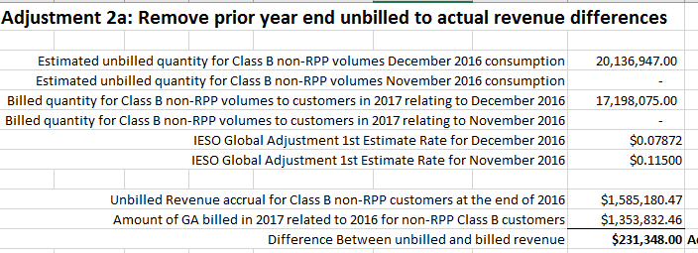

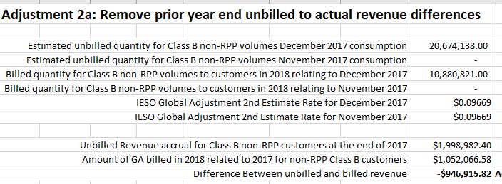

- Yes this amount would have been recorded in 2018 as part of the billed amount in January 2018.

- Since the true-ups was actually recorded in the year that the consumption was billed Westario Power recorded them as part of DVA schedule in the transaction column for that year. In other words if we recorded it in 2017 as a principle adjustment it would have shown as a reversal of the principal adjustment in 2018 so the impact is NIL.

