CNPI – Questions to Applicant
Question 1
Ref. DVA Continuity Schedule and GA Analysis Workform
The applicant has indicated that it has reversed the principal adjustments that it recorded as part of its 2016 DVA disposition balance within the “Transactions Debit/(Credit) during 2017” column of the DVA continuity schedule submitted as part of its current application.
- The “Transactions Debit/(Credit) During 2017” column of the DVA continuity schedule must represent the actual transactions recorded within the Applicant’s G/L. For transparency purposes all principal adjustments, including the Reversal of prior year principal adjustment amounts, must be recorded within the “Principal Adjustments during 2017” column of DVA schedule. Accordingly, please update the DVA continuity to reflect this.

- The reversal of the prior year principal adjustments must also be itemized within the analysis performed within Note 5 of the GA Analysis Workform. Please update the GA Analysis Workform to reflect this.
Question 2
Ref. GA Analysis Workform
With respect to the various adjustments recorded in Note 5 of the DVA continuity schedule (i.e. Adj 1 -10), the applicant provides an explanation for each of the adjustments proposed.
- The explanation for each adjustment does not contain enough information to substantiate the direction, i.e. a debit versus a credit and vice versa. Please update of the explanations to include the sufficient detail so support the direction of each of the adjustments proposed.
Question 3
Ref. Adj. 2b in Note 5 of the GA Analysis Workform
The Applicant has a revenue accrual true-up for the difference between the 1st and 2nd GA rate estimates.
- Please confirm that there is not consumption variance that needs to be accounted for as well between the when the initial accrual that is made at the first GA rate estimate and the 2nd estimate that is used for actual billings made. If so, please quantify the quantity variance impact as well.v

Question 4
Ref. Adj. 8 in Note 5 of the GA Analysis Workform
- Please explain in detail what this adjustment pertains to, and how it was calculated. Has this amount been received in full from the IESO?

- Please confirm that this amount is included as part of the “Transactions Debit/(Credit During 2017” column in the DVA continuity schedule for account 1589.
Question 5
Ref. Adj. 4 in Note 5 of the GA Analysis Workform
- Please provide a description as to how this initial year-end accrual was calculated and what is used to make the true-up to actual?

- Does this accrual relate only to the month of December?

- Please complete the following table to support the quantum of this adjustment (the expectation is that the overall difference should equal the amount of the adjustment, if not, please explain why).

.

- How does the unbilled revenue component of this entry differ from the adjustment recorded in 2b of Note 5 of the GA Analysis workform?
Question 6
Ref. Adj. 9 in Note 5 of the GA Analysis Workform
- Please confirm that this adjustment includes both the January 4th, 2018 settlement with the IESO for November 2017 consumption, and the February 4th, 2018 settlement with the IESO for December 2017 consumption.

- Please also confirm that both settlements noted above were completed using actual consumption data and the actual GA rate for each of the respective months. Please also confirm that because this is the case, there is typically no subsequent true-up required to the CT 1142 that was calculated and recorded for each of these months i.e. due to 1-month time lag in settlements, it is already based on actual data, not estimates).
Question 7
Ref. Note 5 of the GA Analysis Workform and Appendix A, Response 2f
- As part of this response the Applicant has quantified a true-up amount of ($2,558,968) related to CT 1142. Please reconcile this to the true-up adjustments presented in Note 5 of the GA Analysis Workform.

- Please explain why the Applicant is not proposing to record adjustments 3a and 3b from Note 5 of the DVA continuity schedule as part of principal adjustments for account 1589?

Question 8
Ref. DVA Continuity Schedule, Accounts 1595 (2013 and 2015)
Account | Claim Amount
1595 (2013) | (16,059)
1595 (2015) | (145,808)

- CNPI harmonized its rates for Fort Erie, Port Colborne and Gananoque as of January 1, 2017. Please explain why the balances are being socialized and not directed to the appropriate service territories.

Question 9
Ref. Table 2, page 9 of Manager’s Summary
- Table 2 displays the 2019 proposed RTSRs and associated units. Please confirm that the incorrect units were entered for the GS<50, USL and Sentinel lighting classes.

Question 10
Ref: Tab 6.1a GA Allocation – cell D20 Total Non-RPP Class B consumption

Ref: Tab 6.2a CBR B_Allocation – cell D20 Total Class B consumption less WMP

OEB staff is unable to reconcile the data entered in cells D20 in Tab 6.1a and Tab 6.2a. Below is a table that staff prepared showing the “Validation of Data used in class B GA and CBR Allocations”. Staff notes a discrepancy for the 2017 consumption figure that is used in the “GA allocation” and “CBR B Allocation” of 2019 IRM rate model as below.
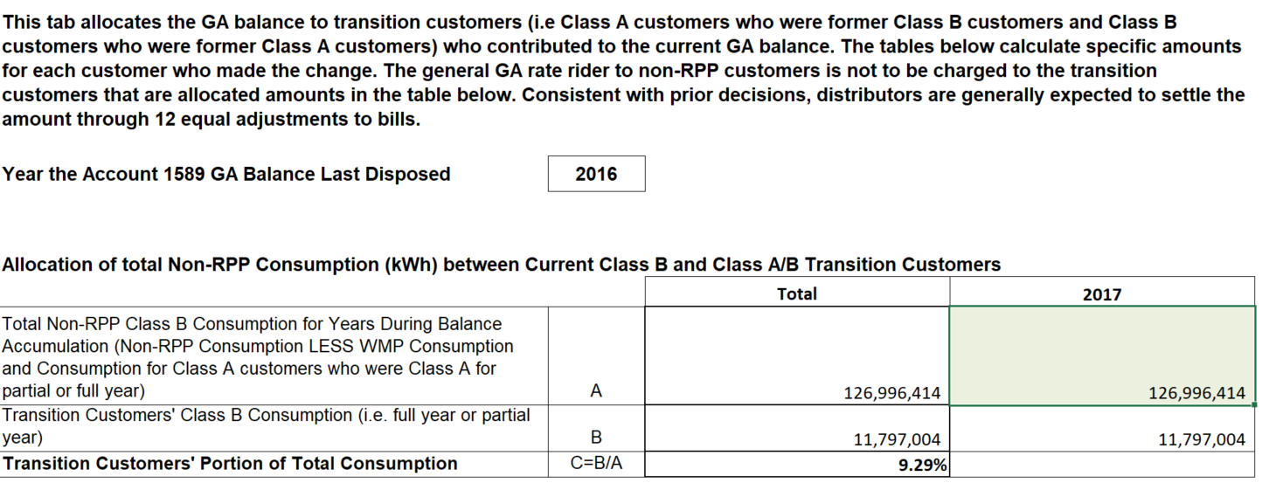
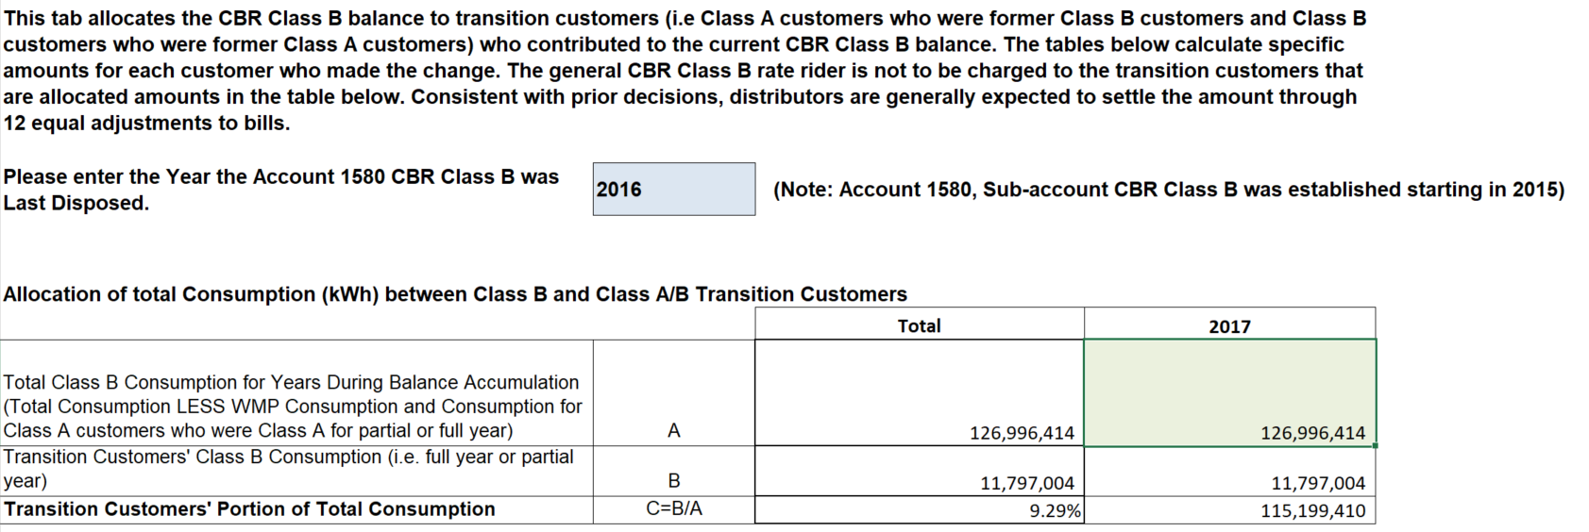

Table 1:
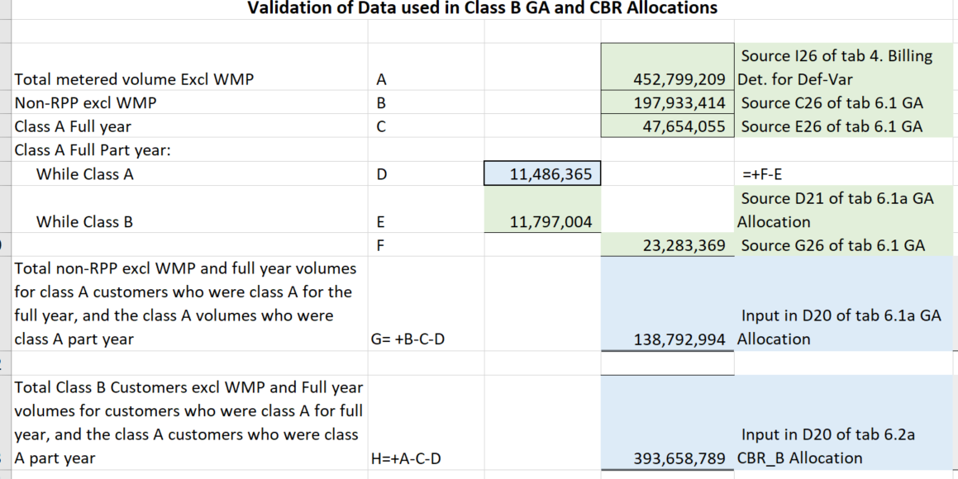
- Please provide an explanation for the discrepancies found in table 1 for the 2017 consumptions.
- Please update the model accordingly if applicable.

