**Waterloo North Hydro Inc. (Waterloo North Hydro)**

**2019 IRM Application**

**EB-2018-0074**

**Application Analysis**

**September 11, 2018**

**Staff Question #1**

**Ref: Tab #3 Continuity Schedule Balances in Account 1580 WMS – Sub-account CBR Class B and RRR filing 2.1.7**

On tab 3 of the 2017 IRM model, it states “Account 1580 RSVA WMS balance inputted into this schedule is to exclude any amounts relating to CBR. CBR amounts are to be inputted into Account 1580, sub-accounts CBR Class A and Class B separately. There is no disposition of Account 1580, sub-account CBR Class A, accounting guidance for this sub-account is to be followed. If a balance exists for Account 1580, sub-account CBR Class A as at Dec. 31, 2017, the balance must be explained.”

OEB staff notes that the control account 1580 in the continuity schedule excludes balances in CBR Class A and CBR Class B; the control account in RRR includes the two sub-accounts’ balances. Therefore, in the variance column, it is expected to see a variance in cell BV23 only (equals the sum of CBR Class A and CBR Class B).

1. If the balance is incorrect, please update Waterloo North Hydro’s RRR filing 2.1.7 and notify your case manager when this is completed.
2. Please make necessary adjustments to the continuity schedule in the 2019 IRM model.

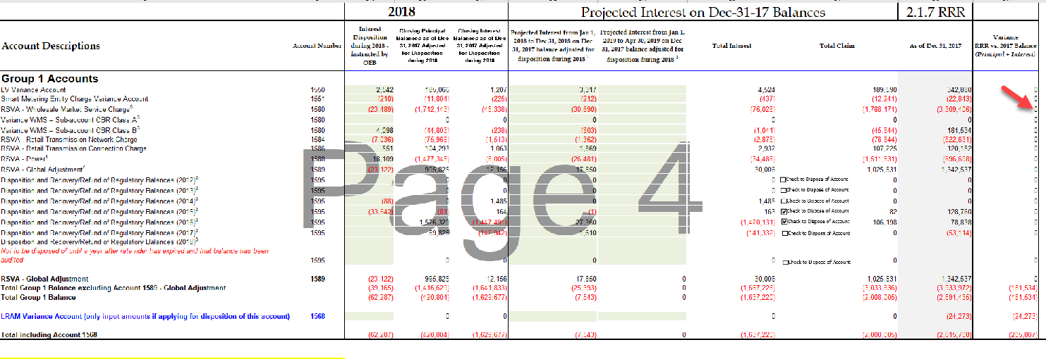

The 2017 RRR filing was correct. The changes have been made in the IRM Model. The net amount in Account 1580 in RRR filing was ($3,309,406). This included ($3,490,940) for WMS alone and $181,534 for WMS – Class B CBR (the balance for WMS – Class A CBR is NIL). Due to this correction in the model there was also a change to the projected interest on the WMS portion. The revised table has been included below.



**Staff Question #2**

**Ref: Cell BT34 from Tab 3. Continuity Schedule has been reproduced below.**

Per Appendix A of the *Chapter 3 Filing Requirements for Electricity Distribution Rate Applications for 2018 Rate Applications,* “Any vintage Account 1595 Sub-Account is to be disposed only once, on a final basis. No further dispositions of these accounts are expected thereafter unless justified by the distributor”.

Ref: A Portion of the Tab 3 Continuity Schedule has been reproduced below.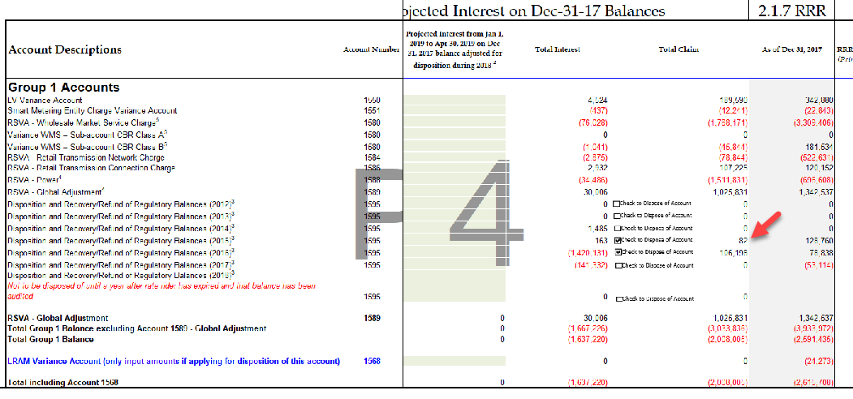

Waterloo North Hydro is requesting disposition of account 1595-2015 debit balance of $82.

1. Please confirm whether Waterloo North Hydro has requested disposition of this sub account previously.

Yes, in the 2018 IRM filing the 2015 balance had been disposed of.

1. When did the rate rider relating to IRM cease?

The 1595-2015 balance ceased April 30, 2016.

1. What audited financial statements did Waterloo North Hydro base this disposition on previously and what does the balance pertain to?

This difference is due to a slight variation between the amount approved to be disposed of and the actual account balance at the end of the year because of a small number of customer bill corrections. The previous amount claimed would have been included on the December 31, 2016 Audited Financial Statements.

1. Please explain why this amount has not been written off.

WNH was under the impression that no balances were to be considered ‘final’ for the 2019 IRM applications and therefore the remaining balance was not written off. WNH has removed the $82 claim and will write off the balance of $83 in the 2018 year.

**Staff Question #3**

**Ref: Tab 6.1a GA Allocation**

**Ref: Tab 6.2a CBR B_Allocation**

OEB staff notes that no data has been entered in cell D20 for Tab 6.1a and Tab 6.2a. Below is a table that staff prepared showing the “Validation of Data used in class B GA and CBR Allocations”.

1. Please confirm If Waterloo North Hydro agrees with the data, if so, staff will adjust the model. If not, please explain.

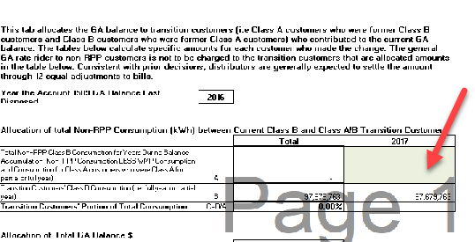

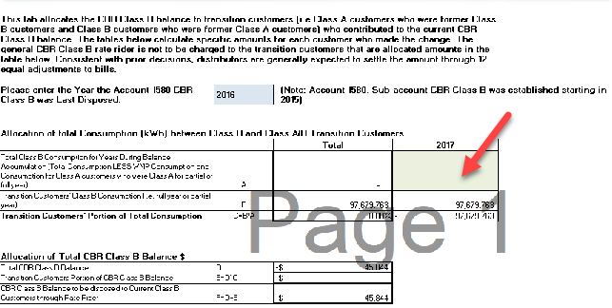



WNH agrees with the numbers attached and have been included in the revised model.

**Staff Question #4**

**Ref: Account 1595 Workform**

OEB staff notes that the amounts inputted in “Principal Balance Approved for Disposition” and “Carrying Charges Balance Approved for Disposition” do not reconcile with the disposition amount approved by the OEB in the 2016 cost of service Decision & Rate Order dated November 26, 2015 (EB-2015-0108).

1. Please provide an explanation for the above discrepancies. If corrections are needed OEB staff will make adjustments.

The 1595 Analysis Workform for 2016 includes Balances Approved for Disposition of Group 1 & Group 2 $2,601,458 and 1589 GA $2,333,935 for a total of $4,935,393. Included in WNH’s 2016 Settlement Agreement was the EDDVAR Model where you can see these same totals (below). The column in the 2019 IRM Model will not add to this total because it does not include Group 2 accounts or Disposition of 2010 and 2011 balances which were disposed of in the 2016 DVAD. If further clarification is needed, please provide where you see the discrepancy.

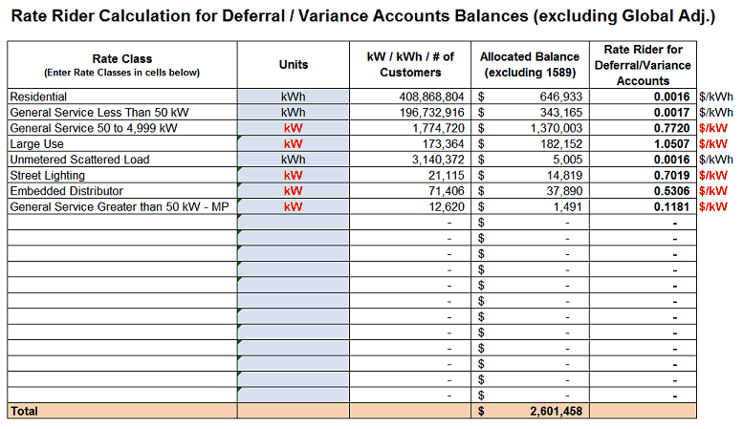

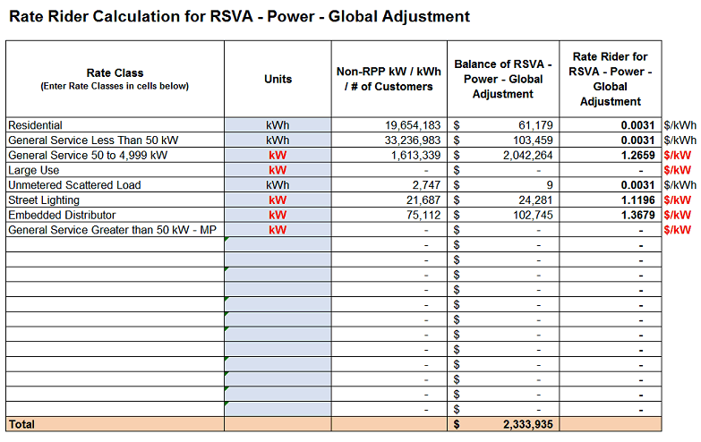

**Staff Question #5**

**Ref: Appendix A – GA Methodology Description – Questions on Accounts 1588 and 1589**

OEB Staff require further clarification on the Applicant’s recording of Charge Types (CT) 1142 and 148 to Accounts 1588 and 1589.

In response to Question 2.a in Appendix A of the GA Analysis Workform Instructions, the Applicant indicated the following:

*“In order to determine the full GA for all customers, Waterloo North Hydro (WNH) multiplies Waterloo North Hydro's total system load (kWh) by the Class B second estimate ($/MWh converted to $/kWh) for the settlement month. The dollar value associated with Class A usage is subtracted from the total Global Adjustment amount to determine the Class B Global Adjustment amount (CT 148). The usage for all non-RPP customers is multiplied by the second estimate to determine the amount of the non-RPP portion of GA (recorded in 1589). The remaining amount must be RPP GA…”*

In addition, in response to Questions 2.b in Appendix A of the GA Analysis Workform Instructions, the Applicant stated:

*“There are no true-ups to usage amounts unless there is a correction on a bill. The error is corrected on the next settlement month after the error has been noted and has not been material in the past.”*

On page 18 of the Manager’s Summary, the Applicant states:

*“WNH performs true-ups in accordance with the accounting guidance provided on May 23, 2017 and reflects RPP settlement true up claims in the year to which such true-up adjustments relate.”*

1. Please confirm that, for the purposes of initial settlement with the IESO, the Applicant bases RPP-related GA costs on the IESO’s 2nd estimate GA prices, as indicated in the first quote above. If not, please explain on what GA price the initial RPP settlement is based on.

Yes, WNH bases RPP-related GA costs on the IESO’s 2nd estimate GA prices.

1. If the above is confirmed, please explain why a true-up is not necessary for the GA price variance, whereby the Applicant would recalculate the amounts payable to (recoverable from) the IESO given the actual GA price for that particular month.

As noted above in WNH’s initial submission it was stated that “There are no true-ups to usage amounts unless there is a correction on a bill.” This may not have been explained properly. WNH does not have true-ups related to Class A and Class B total system load usage. There are two true-ups that are performed: GA price variance true-up (described above) and allocation between Class B RPP and Class B non-RPP usage from the prior month’s accrual (the total usage for Class B will not change).

1. Please confirm that, at the end of a particular target month, the Applicant subtracts the Class A kWh and the Class B Non-RPP kWh billed in that month from the total system load to determine the amount of kWh attributable to Class B RPP customers. If not, please clarify how RPP kWh for a particular settlement month are determined.

Yes, confirmed.

1. If the above is confirmed, please explain how and when the Applicant recalculates the quantities attributable to Class B RPP and Class B Non-RPP customers based on actual consumption, rather than billings in a particular month, as well as how that adjustment is recorded in the general ledgers of the Applicant.

As an example, if the Applicant is initially determining the RPP kWh for June, by subtracting amounts billed to Class A customers in June and amounts billed to Class B Non-RPP customers in June, when is the data available for the Applicant to be able to determine how many kWh were actually consumed by, rather than billed to, Class A and Class B Non-RPP customers during June to perform the quantity-related true-up for CT 1142?

As noted in part B above there is a true up of the allocation between Class B RPP and Class B non RPP in the following month. As an example:

On the 4th business day of a month, WNH completes settlement for the prior month. At this point WNH has usage information on Class A in total, Class B in total as well as the IESO’s second estimate. WNH would take the Class B system load usage and calculate the Class B total dollars using the second GA estimate. WNH would then estimate Non-RPP Class B usage (forecasted) based on prior year’s history usage and multiply the usage by the second estimate to come up with an accrual for August’s Non-RPP Class B amount and the remainder would be August’s RPP Class B amount.

In the following month’s settlement, WNH would take the Actual Class B dollars from the IESO invoice (total of RPP and Non-RPP) and then subtract the actual billing (billed usage multiplied by final rate) for Class B Non-RPP GA. The remainder is the Class B RPP amount which is then subtracted against the prior month’s accrual to become the true-up amount in that month’s settlement. The Class B Non-RPP amount variance (accrual vs. estimate) remains in 1589 until OEB settlement (IRM / COS).

1. The Applicant has indicated that no true-ups are performed in 2017, however, has also acknowledged that true-ups are performed and reflected in the year in which they pertain. Please confirm that the applicant has updated its RPP Settlement true-up procedures consistent with the OEB May 23, 2017 letter regarding the Guidance on the Disposition of Accounts 1588 and 1589. If necessary, please clarify whether or not RPP Settlement true-ups have been performed and recorded during 2017.

In the initial submission it was stated that no true-ups were performed in 2017, however this was meant to be total system usage true-ups. As noted in part B, there are price variance true-ups as well as Non-RPP and RPP allocation true ups monthly. This aligns with WNH’s understanding of the OEB May 23, 2017 letter regarding the Guidance on the Disposition of Accounts 1588 and 1589. The true-ups for price variance and allocation variances were performed and recorded in 2017.

If further clarification is needed, WNH believes that a call may be more appropriate to discuss details.

**Staff Question #6**

**Ref: GA Analysis Workform**

Reconciling item 3b is described as:

*“CR $30K (actual receivable / payable was lower than accrued) related to prior year but recorded in the GL in the current year, therefore, should record CR in current year”*

Please confirm that the applicant intended to state that this amount (a receivable) was related to the current year (2017) but recorded in the GL in the subsequent year (2018), as item 3a already exists to capture amounts pertaining to 2016 but recorded in 2017. If this is not the case, please provide more information on the nature and timing of this adjustment.

OEB’s revision is correct.

**Staff Question #7**

**Ref: GA Analysis Workform**

Waterloo North Hydro’s approved loss factor is 1.0362 and the calculated loss factor from the GA Analysis Workform is 1.0623, a difference of 2.51%. Please explain the difference and revise the GA Analysis Workform as needed.

After review of the GA Workform there was an error in the second table due to an incorrect rolling of the months. A revised workform is attached.