InnPower Corporation
OEB Staff Questions
EB-2018-0045

InnPower Corporation
EB-2018-0045

OEB Staff-1
Ref: IRM Rate Generator Tab 8. STS – Tax Change
OEB staff believes the amount entered for Taxable Capital should be $52,584,820 not $52,820 and the Grossed-up Tax Amount should be $149,534 not $70,535, please confirm. If InnPower does not agree please explain.
OEB Staff-2
Ref: IRM Rate Generator Tab 6. Class A consumption data and Decision and Order EB-2016-0085
On Tab 6. Class A Consumption Data, InnPower has entered the last year CBR Class B was disposed as 2015 but the Decision and Order EB-2016-0065 Page 31 indicates it was last disposed as of December 31, 2016.
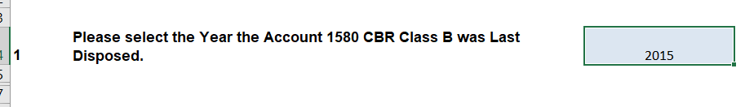
Please confirm this should be changed to 2016, if not please explain.
OEB Staff-3
Ref: IRM Rate Generator Tab 6. Class A Consumption Data
InnPower has indicated on Tab 6. Class A Consumption Data there were no customers who transitioned between Class A and B during the period the Account 1580, sub account CBR Class B balance accumulated.
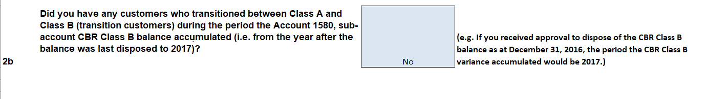
InnPower has also indicted on Tab 6. Class A Consumption Data that it had customers who transitioned between Class A and B during the period the Account 1589 GA balance accumulated.
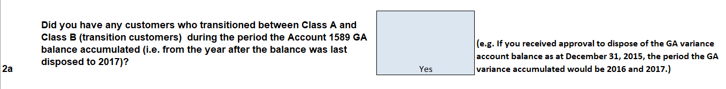
OEB staff believes that both should indicate yes, please explain if you disagree. If you agree please change to yes and fill out the remaining required data at the bottom of spreadsheet.
OEB Staff-4
Ref: Continuity Schedule Tab 3 and Decision and Order EB-2016-0085
InnPower is requesting disposition of accounts 1595-2012, 1595-2013 and 1595-2015. These accounts were just approved for disposition in Decision and Order EB-2016-0085. Please remove the check boxes from your continuity schedule.
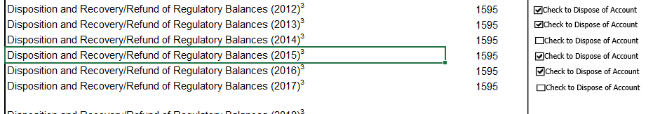
OEB Staff-5
Ref: Continuity Schedule Tab 3 and Decision and Order EB-2016-0085
Please input in Column BE and BJ the amounts disposed of in Decision and Order EB-2016-0085. Without those amounts input the claims are incorrect.
OEB Staff-6
Ref: Continuity Schedule Tab 3
It appears InnPower has Reported its RRR incorrectly for Account 1580 Sub-account CBR Class B. Only the amount allocated the Class B should be reported in this account. The 1580 control account should have the total amount reported and then there would be a variance in this account from the RRR that is equal to the amount reported in the RRR class B.
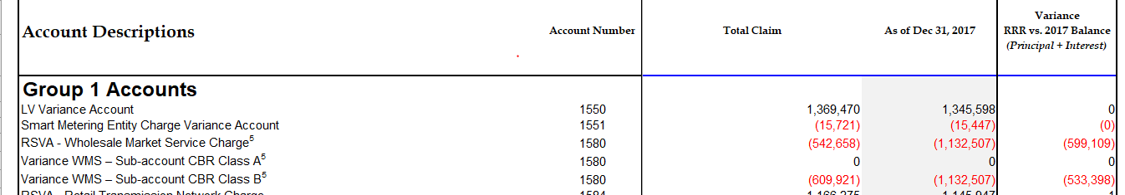
Please refile InnPower’s RRR and review the balances in all the 1580 Accounts and confirm they are correct.

