Entegrus Powerlines Inc. (Entegrus)
2019 IRM Application
EB-2018-0024
Application Analysis
November 7, 2018

Entegrus - Main Rate Zone
Staff Question #1
Ref: Manager’s Summary Attachment C – Entegrus-Main’s IESO Settlement Process
The Applicant has indicated on page 2 of 6:
“Due to cycle billing, this [determining actual consumption] reconciliation process typically happens within three months of the actual customer consumption”
However, on page 3 of 6, the applicant also states:
“Starting in 2016, Entegrus-Main commenced calculating the required December RPP / GA true-up once all volumes and prices were definitively known in January. Entegrus-Main subsequently records the true-up in the general ledger prior to closing the fiscal year”
- Please reconcile the above statements regarding the timeline for when actual consumption data becomes available for a particular month.
- Please explain the source of the actual consumption data and explain how Entegrus-Main obtains all actual December volumes and prices before the end of January.
- Please confirm the date that actual consumption data was retrieved for the month of December 2017, the posting date of the consumption variance true-up adjustments (ie. which day in the general ledger is the true-up adjustment reflected on), as well as the date that the 2017 fiscal year was closed.
- Were there any journal entries made subsequent to closing the 2017 fiscal year that weren’t reflected in 2017? Please quantify applicable entries and update the continuity schedules and GA Analysis Workforms accordingly, in relation to:
  - RPP settlement true ups pertaining to any month prior to 2018 related to GA costs, and/or revenue amounts based on volumes for RPP by TOU or 2 Tier price points and for non-RPP?
  - Differences between the Power or GA Unbilled Revenue vs actual Power or GA revenue billed in January/February relating to any month prior to 2018?
  - Transfers for GA amounts between accounts 1588 and 1589 pertaining to volumes for RPP by TOU or two-tier price points and for non-RPP?
Staff Question #2
Ref: Manager’s Summary Page 13
The Applicant has indicated that during 2017, 24,300,393 kWh were billed to Hydro One Networks Inc. as part of a short-term load transfer arrangement. Furthermore, the Applicant has included this consumption as a Class A customer for the period of July-December 2017.
- Please confirm whether or not Hydro One qualifies as a Class A customer through the ICI program. If not, should Hydro One be treated as a Class B customer? If so, how would this impact Entegrus’ RPP settlements with the IESO? Please provide detail calculations showing the impact to the 2017 RPP Settlements charge type 142/1142 and to accounts 1588 and 1589 if Hydro One was treated as a Class B customer.
- Please confirm whether or not Hydro One has their own customer specific peak demand factor.
- Please confirm what GA rate that Entegrus invoices Hydro One.

Staff Question #3
Ref: GA Analysis Workform, Note 5 Reconciling Items

The Applicant has indicated that an amount of $163,204 has been recorded as a result of differences in Global Adjustment charges from the IESO that pertained to prior periods.
- Please itemize, detail and explain what these adjustments relate to, which month/year these adjustments pertain to and, in the analysis break out the adjustments by year.
- Please confirm whether or not the amount of $163,204 was a credit received from the IESO. If this amount was an additional charge, rather than a credit, please reverse the direction of the reconciling item.
- Please confirm which group of customers that the GA adjustment amount of $163,204 pertains to, RPP or Non-RPP customers.
- Please explain the process for how the Applicant determined what portion of the GA adjustments pertained to RPP customers (and ultimately booked in Account 1588) versus Non-RPP customers (and ultimately booked in Account 1589).
- If any portion of the $163,204 relates to RPP customers and has not been allocated to Account 1588, please record the necessary adjustments in the DVA Continuity Schedule and confirm that Entregrus will settle this amount with the IESO. In addition, please update the GA Analysis Workform to include only the non-RPP portion of the $163,204 in account 1589.
Staff Question #4
Ref: Continuity Schedule – OEB Approved Disposition during 2016

- Provide an explanation for the credit entry in Account 1595 (2016) of $4,003,963.

Staff Question #5
Ref: Continuity Schedule – Principal Adjustments during 2016

- Provide an explanation and justification for what the credit entries in Accounts 1588 and 1589 of $18,303 and $117,104 relate to, respectively.

Staff Question #6
Ref: Continuity Schedule – Principal Adjustments during 2017

- Provide an explanation and justification for what the debit entry in Account 1595 (2017) of $1,371,570 relates to.

Staff Question #7
Ref: Continuity Schedule – Principal Adjustments during 2017

- Provide an explanation and justification for what the debit entries in Accounts 1588 and 1589 of $18,303 and $97,238 relate to, respectively.

Staff Question #8
Ref: Continuity Schedule – Interest Adjustments during 2017

- Provide an explanation and justification for what the debit entries in Account 1595 (2013), Account 1595 (2015) and Account 1595 (2016) of $3,747, $10,460 and $19,221 respectively.
- Provide an explanation and justification for what the credit entry in Account 1595 (2017) in the amount of relates to $6,378.

Staff Question #9
Ref: Continuity Schedule – Interest Disposition during 2018 – instructed by OEB

The amounts entered into column BN do not match the amounts provided in the OEB’s decision and order (EB-2017-0033). Please explain.

Staff Question #10
Ref: 2019 IRM Rate Generator Model, Tab 3, Continuity Schedule

If necessary, with respect to the interrogatory questions asked and answered, provide an updated 2019 IRM rate generator model for Tab 3, continuity schedule.

Staff Question #11

Ref: Tab 6.1a GA Allocation – cell D20 Total Non-RPP Class B consumption
Ref: Tab 6.2a CBR B_Allocation – cell D20 Total Class B consumption less WMP

OEB staff is unable to reconcile the data entered in cells D20 in Tab 6.1a and Tab 6.2a. Below is a table that staff prepared showing the “Validation of Data used in class B GA and CBR Allocations”. Staff notes a discrepancy for the 2017 consumption figure that is used in the “GA allocation” and “CBR B Allocation” of 2019 IRM rate model as below.
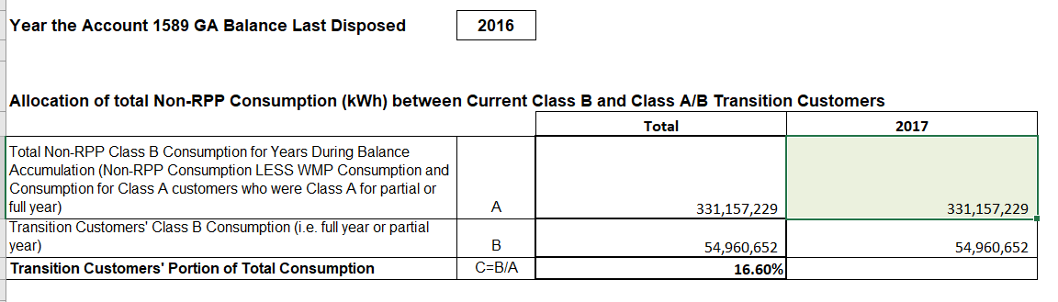

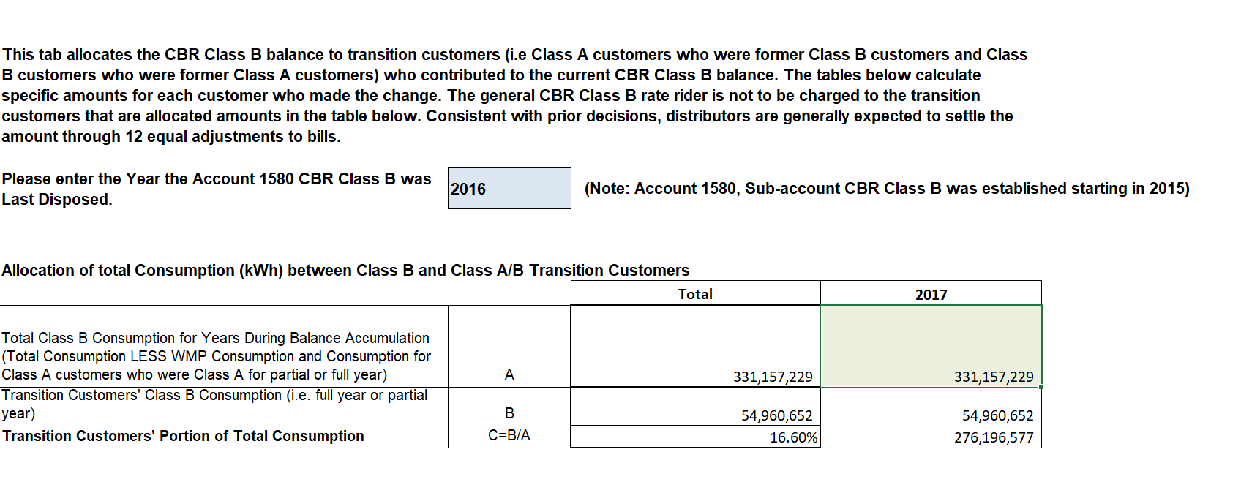

Table 1 – confirmation of 2017 consumptions
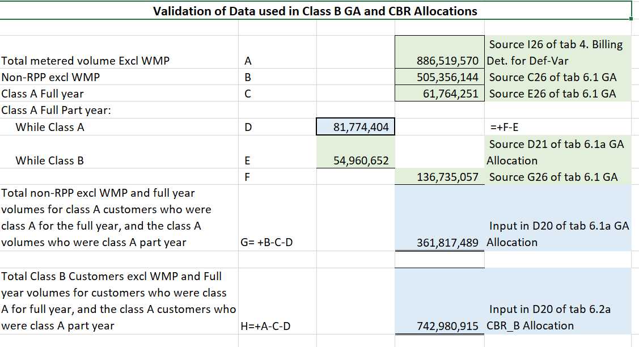
- Using Table 1, please provide a calculation for the 2017 consumptions inputted into the above referenced tabs and explain any discrepancies.
- Please confirm whether or not Entegrus (Main) agrees with the updated quantities per the Table 1 calculations for 2017. If not please explain why Entegrus (Main) believes the values it used in its 2019 IRM Rate Generator Model are appropriate. Otherwise please update the 2019 IRM Rate Generator Model accordingly.

Staff Question #12
Ref: Tab 6 – Customer #18

Please explain why cells F81 and F82 have been left blank.

Staff Question #13
Ref: Tab 8 - Streetlighting

Entegrus Main Rate Zone applied for disposition of a debit balance of $152,720 in lost revenues associated with new CDM program savings in 2016, including persisting savings from 2014 to 2015 in 2016 and carrying charges. Actual conservation savings were compared against Entegrus’ forecasted conservation savings of 7,138,571 kWh included in the load forecast, which was set out in the 2016 cost of service application.

- For the streetlight savings in 2014 and 2015, it appears that the gross demand savings are determined by comparing the billed kW from one month to the previous month.
  - Did Entegrus use the Board-approved load profile to convert 2014 and 2015 energy savings to demand savings?
  - How was the baseline savings determined in 2014 and 2015 for the projects?
  - Please explain how the monthly demand billed kW amounts were determined.
  - Please provide the detailed calculations in excel format to estimate monthly demand billed kW, including the number of installations and replacements and the change in kW billed, pre- and post-installation, in order to determine the baseline kW and demand billed kW.
  - Please confirm whether you have received reports from municipalities that confirm the number of lightbulbs replaced.

- In 2016, the gross kW streetlight savings reductions appear to be determined from actual bills to customers.
  - Did Entegrus use the Board-approved load profile to convert 2016 energy savings to demand savings?
  - Please discuss how you calculated gross kW reduction for the streetlight project.
  - Please provide the detailed calculations in excel format to estimate monthly demand billed kW, including the number of installations and replacements and the change in kW billed, pre- and post-installation, in order to determine the baseline kW and demand billed kW. In particular, please explain why gross kW reduction increased in July and August 2016, and confirm whether savings were appropriately calculated from the baseline.
  - Please confirm whether you have received reports from municipalities that confirm the number of lightbulbs replaced.

- Please confirm appropriateness of the net-to-gross (NTG) ratios to calculate net savings for the 2014, 2015 and 2016 streetlight projects. It appears that a higher NTG ratio applied for the energy savings verified by the IESO for streetlights.

If the NTG ratios are appropriate, please provide the calculations or specific reference source to show support for the assumptions used.

Staff Question #14
Ref: Tab 5 2015-2020 LRAM

- For the rate class allocations in Table 5-a, please confirm accuracy of the -100% allocation of the “Process and Systems Upgrades Initiatives - Project Incentive Initiative” savings to the Standby Power class, while also 100% of these savings are allocated to the GS 50 to 4,999 kW. If this is correct, please confirm the rationale for these allocations.

- Please confirm whether there are missing allocations in cells Z168 and AA 168 of Tab 5, in order for the streetlight savings associated with the retrofit program to be appropriately deducted in the workform.

Staff Question #15
Ref: Tab 6 Carrying Charges
- Please update the Q4 2018 interest rate in Table 6 to reflect the OEB’s most recently approved prescribed interest rate for deferral and variance accounts.

Staff Question #16
- Please file an excel copy of the 2017 Final Results Report for the Entegrus (Main Rate Zone) if available.
- Please file an excel copy of the 2014 Persistence Savings Report for the Entegrus Main Rate Zone.
- Please confirm any changes to the LRAMVA workform in “Table A-2. Updates to LRAMVA Disposition (Tab 2)” and file an updated LRAMVA work form.

Entegrus - St. Thomas Rate Zone
Staff Question #1
Ref: 1595 Analysis Workform

In the 1595 Analysis Workform, the Applicant shows that a significant portion of the residual balance in Account 1595 (2014) pertains to the Residential and General Service 50 to 5,000 kW Rate Classes ($38,965 and $281,369, respectively).
- Please explain the circumstances or events that caused the kWh or kW used in the denominator for the GA rate rider in these customer classes to vary so substantially from the consumption figures in which the rider was applied against.

Staff Question #2
Ref: GA Analysis Workform

In the 2015 GA Analysis Workform, reconciling item 1b in the amount of ($57,067) is described as an adjustment for 2015 that was recorded in the general ledger of 2017. However, the Applicant has recorded an adjustment in reconciling item 1a for $57,067 for 2016.
- Please confirm that this reclassification entry was recorded in the 2017 general ledger.
- If the above is confirmed, please adjust the 2016 GA Analysis Workform to remove the amounts in item 1a, as the 2016 GA transactions do not require a reconciliation for items that did not affect the 2016 general ledger.
- Please confirm that there are no entries made in the 2016 general ledger that pertain to prior years, and that no amount should be reported in item 1a in the 2016 GA Analysis Workform.

Staff Question #3
Ref: GA Analysis Workform

In the 2016 GA Analysis Workform, reconciling item 9 in the amount of ($30,733) is described as an adjustment for interval customers that were billed on final GA rate effective July 1, 2016.
- Please complete the GA Analysis Workform for 2016 for customers that were billed on the 1st estimate only. Note: Reconciling Item 9 of ($30,733) should be removed.

Staff Question #4
Ref: Manager’s Summary, Page 6 of 7

In July 2016, Entegrus - St. Thomas commenced billing General Service > 50 kW interval customers on the IESO published Actual rate, instead of the IESO published 1st Estimate that it bills the other customers in the General Service > 50 kW customer classification. To facilitate appropriate allocation and rate rider calculation of the GA disposition, Entegrus - St. Thomas has treated these 24 customers as Class A customers within the model.
- Please explain why these 24 customers are paying the IESO published actual rate if the O.Reg 429/04 section 16(3) discusses that the same GA rate is to be used for all non-RPP Class B customers within a customer class.
- As of October 2018, are these customers still paying the IESO published actual rate? If not, when will they be switched back to the 1st Estimate?

Staff Question #5
Ref: Tab 3 Continuity Schedule

In section 5.1.7 of the manager’s summary, Entegrus – St. Thomas requested that the CBR balances be transferred to Account 1580 and disposed through a rate rider to all class B customers as Entegrus – St. Thomas did not have any class A customers for the requested disposition period.
OEB staff has transferred the balances in Sub-Account CBR Class B to the 1580 main account.
- Please review the updated model and confirm that OEB staff has updated the continuity schedule correctly.
Staff Question #6
Ref: Tab 3 Continuity Schedule

Explain the credit balance of $485,119 in Account 1595 (2016) under “OEB-Approved Disposition during 2016”.

Staff Question #7
Ref: Tab 3 Continuity Schedule – Account 1588

The total claim for Account 1588 is a credit of $726,025 which is considered significant.
OEB staff notes that a principal adjustment in 2015 was made in the amount of ~$1.77M relating to a reclassification entry booked in 2017 related to 2015 activity.

Please confirm that there were no similar reclassification adjustments required in 2016. If not, please explain the cause of the large credit balance.

Staff Question #8
Ref: Tab 3 Continuity Schedule

For Account 1595(2014) Entegurs St. Thomas has placed values into the OEB-Approved Disposition during 2016 for both principal and interest that do not match up those approved by the OEB in the 2016 Decision and Order (EB-2015-0102). OEB staff is aware that the summation of the principal and interest amounts do match the total claim amount of ($12,806).

For completeness purposes, please replace the amounts in cells AU33 and AZ33 with the OEB Approved amounts outlined on Page 9 of the 2016 Decision and Rate Order (EB-2015-0102).

Staff Question #9
Ref: Tab 3 Continuity Schedule

OEB staff notes that Entegrus – St. Thomas has requested not to dispose of its 2017 Group 1 balances. However, in the “Interest Adjustments during 2017” column, Entegrus – St. Thomas has a series of entries totaling a credit amount of $13,896.
- Please explain.

Staff Question #10
Ref: Updated Manager’s summary page 1 of 7, Single metering configuration error

Entegrus St. Thomas noted that in September 2018 a single metering configuration error was identified relating to the March 2017 installation of an interval meter for a new GS > 50 kW account in the St. Thomas area. Entegrus has assessed that this error has a material impact on the 2017 variance account balances. Due to the error, Entegrus St. Thomas is proposing to dispose of only 2015 and 2016 Group 1 account balances and defer disposition of 2017 balances for its 2020 IRM Application.

- Quantify the impact and discuss how materiality was determined.
- Please explain the extent of the error. Did the error effect all group 1 balances or just particular accounts?

Staff Question #11
Ref: Manager’s summary, 5.1.10 Price Cap Index Adjustment

Entegrus-St. Thomas has used the Rate Generator Model proxy values of 1.20% as the Price Escalator (GDP-IPI), a 0.0% Productivity Factor and the former Group III Stretch Factor Value of 0.30%, as per the Board’s 2017 Benchmarking Update for Determination of 2017 Stretch Factor Rankings. These components result in an interim Price Cap Index of 0.90%.

In August 2018, the Empirical Research in Support of Incentive Rate-Setting: 2017 Benchmarking Update, Report to the Ontario Energy Board was revised. In the revised report, St. Thomas was moved to Group II with a stretch factor value of 0.15%.

OEB staff has updated sheet 16 of the IRM rate generator model.
- Please review the updated model and confirm that OEB staff has updated Sheet 16 correctly.

Staff Question #12
Ref: Tab 6 Carrying Charges

Entegrus St. Thomas Rate Zone applied for disposition of a debit balance of $54,302 in lost revenues associated with new CDM program savings in 2016, including persisting savings from 2013 to 2015 in 2016 and carrying charges. Actual conservation savings were compared against Entegrus’ forecasted conservation savings of 1,492,000 kWh set out in St. Thomas’ 2011 cost of service application and 4,068,000 kWh set out in the 2015 cost of service application.

Please update the Q4 2018 interest rate in Table 6 to reflect the OEB’s most recently approved prescribed interest rate for deferral and variance accounts.

Staff Question #13
Ref: Tab 8 Street lighting (savings being claimed for 2016)

- Did Entegrus St. Thomas use the Board-approved load profile to convert energy savings to demand savings? Please discuss.
- Please explain the methodology to calculate street lighting savings as it uses cumulative gross kW reductions. How was the baseline savings determined?
- Please discuss how you calculated gross kW reduction for the streetlight project. Please provide the detailed calculations in excel format to calculate monthly demand billed kW, including the number of installations and replacements and the change in kW billed, pre- and post-installation, in order to determine the baseline kW, demand billed kW, and the kW reduction.
- Please confirm whether you have received reports from municipalities that confirm the number of lightbulbs replaced.

Staff Question #14

- Please file an excel copy of the 2017 Final Results Report for the Entegrus (St Thomas Rate Zone) if available.
- Please file an excel copy of the 2014 Persistence Savings Report for the Entegrus St Thomas Rate Zone.
- Please confirm any changes to the LRAMVA workform in “Table A-2. Updates to LRAMVA Disposition (Tab 2)” and file an updated LRAMVA work form.

Staff Question #15
Ref: Tab 3-a. Rate Class Allocations
- Please confirm whether the allocation of verified savings was estimated for the two rate zones based on the IESO verified results for Entegrus St. Thomas in 2015 and 2016.
- If yes, please discuss how you determined the breakdown of savings by rate zone. Please provide a table in each of the LRAMVA workforms that outlines the rate zone split of the total savings for each IESO program, where individual rate zone savings were not provided by the IESO.

