Cooperative Hydro Embrun Inc. – 2019 Rates Application (EB-2018-0026)
OEB Staff Questions
September 17, 2018

Question # 1
Ref: Manager’s Summary
The application file number shows EB-2018-0028 in the Manager’s Summary. Please confirm that the application file number is EB-2018-0026.

CHEI Response: CHEI confirms that the application and manager summary should have stated EB-2018-0026

Question #2
Ref: Manager’s Summary, page 14
IRM Model, Tab 7
Cooperative Hydro Embrun did not state the recovery period for its Group 1 Deferral and Variance Accounts in its Manager’s Summary.

- Please confirm that Cooperative Hydro Embrun is proposing a one-year disposition of the Group 1 Deferral and Variance Accounts.
- If the answer to a) is no, please provide an explanation and update Tab 7 of the IRM Model with the correct recovery period.

- CHEI Response: CHEI confirms that it’s proposing to dispose of its balances in one-year.

- CHEI Response: n/a

Question #3 BDO
Ref: IRM Model, Tab 3
The Continuity Schedule does not show the amounts disposed in 2018 for the Group 1 deferral and variance accounts. Please complete columns BM and of the Continuity Schedule (Tab 3) of the IRM Model to show the amounts disposed of during 2018.
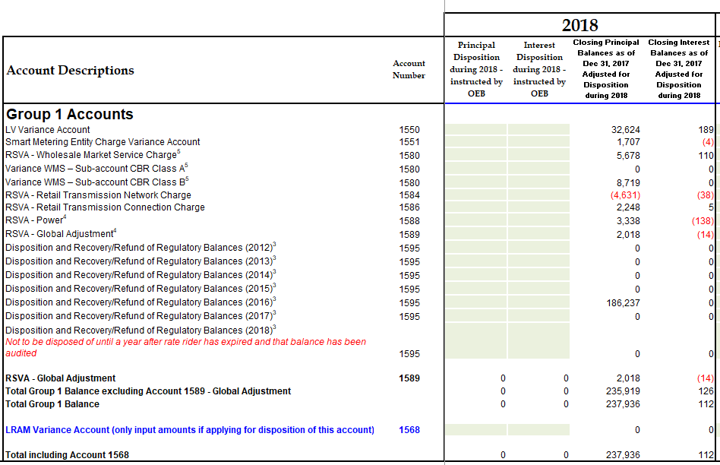

CHEI Response: OEB approved disposition have been transferred from columns BE and BJ to columns BM and BN.
Question # 4
Ref: Manager’s Summary, page 19
Cooperative Hydro Embrun states that because the tax sharing amount of $19 is “marginal”, Cooperative Hydro Embrun proposes to disregard the amount and recalculate it during its 2020 IRM term”. Please confirm that the entire 50/50 sharing amount will be transferred to Account 1595 for disposition at a future date.

CHEI Response: CHEI confirms that the entire 50/50 sharing amount will be transferred to account 1595 for disposition at future date.

Question #5
Ref: IRM Model, Tab 20
Table 1 from Tab 20 of the IRM Model is reproduced below.
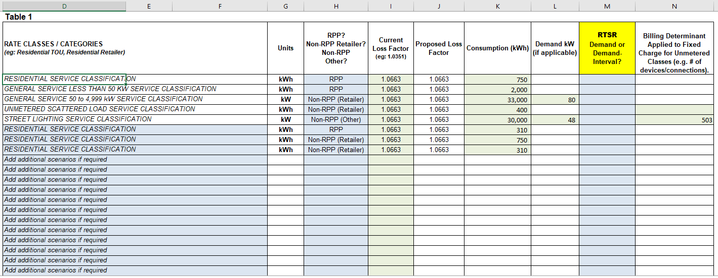

- Please explain why the current loss factor entered is not the same as Cooperative Hydro Embrun’s loss factor in its current (2018) tariff of 1.0749.
- Please update column M in Table 1.

- CHEI Response: CHEI has corrected the loss factor in the model attached to these responses.
- CHEI Response: Column M has been populated in the model attached to these responses.

Question # 6
Ref: Account 1595 Model
IRM Process Updates Q&A issued July 23, 2018 (Q&A #1)
Cooperative Hydro Embrun is not requesting any Sub-account 1595 dispositions, however, the new 1595 model is still required to be filed by all electricity distributors. Please file a copy of the Account 1595 model.

CHEI Response: CHEI confirms that its only balance in 1595 (2016) is not eligible for analysis as one year has NOT passed since the sunset date of the rate rider recovery period and as such, the amounts have not been audited. Therefore 1595 Analysis Workform is not required in this case.

Question # 7
Ref: Revenue-to-Cost Ratio Adjustments Model - Tab 14
IRM Model - Tab 16
OEB staff is unable to reconcile the adjustments in columns M and O of the Revenue-to-Cost Ratio Adjustments model with the adjustments to the monthly fixed charge and distribution volumetric rate adjustments in Tab 16 of the IRM Model.

- Please confirm that the adjustments in the IRM Model are accurate.
- Please file the 2019 version of the Revenue-to-Cost Ratio Adjustments model which was posted on the OEB’s 2019 electricity distribution rates webpage on August 22, 2018. Please ensure that Tab 1 is completed in the updated model.

Revenue-to-Cost Ratio Adjustments Model
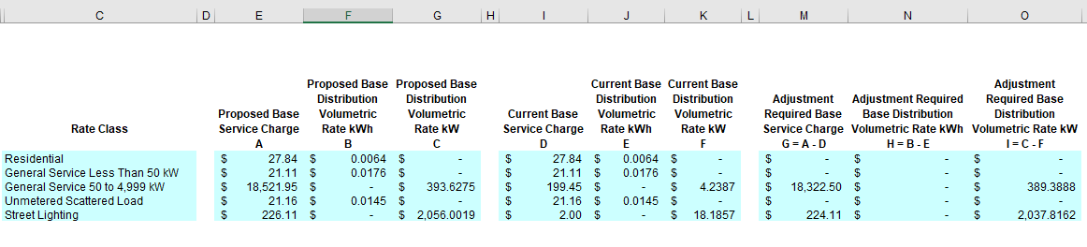

IRM Model
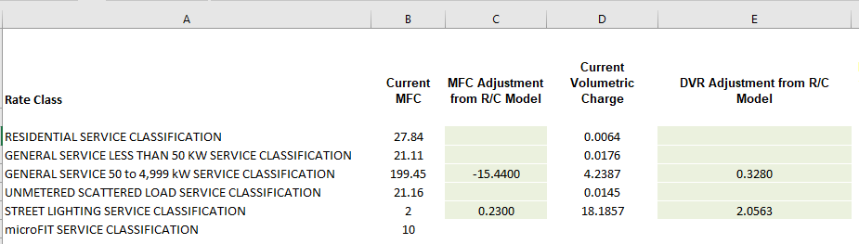

CHEI Response: CHEI confirms that the amounts are accurate as they reconcile with both the model (filed along with these responses) and the Decision and Rate Order.

Question # 8 BDO
Ref: GA Analysis Workform
OEB staff notes that Cooperative Hydro Embrun has complete the GA Workform for the years 2014, 2015, 2016 and 2017. OEB staff notes that balance in Account 1589 as of Dec. 31, 2016 was disposed in Cooperative Hydro Embrun’s 2018 Cost of Service application. Please confirm that Cooperative Hydro Embrun is requesting disposition of the variance accumulated in 2017 only.

CHEI Response: CHEI confirms that the December 31, 2016 was disposes in the CHEI 2018 Cost of Service and is requesting the disposition of the 2017 balance only.

Question # 9
Ref: GA Analysis Workform
Columns G and H in Note 4 of the GA Analysis Workform are incomplete. Please complete columns G and H in Note 4 of the GA Analysis Workform.
CHEI Response: No adjustments are needed for unbilled revenue in columns G and H the customers are billed on a monthly basis from 1st and the last day of the month.

Question # 10 BDO

Ref: GA Analysis Workform
IRM Model, Tab 3
OEB staff notes that the Net Change in Principal Balance in the GA Workform is not consistent with what’s indicated in the Continuity Schedule (cell BG29).

- Please explain why the Net Change in Principal Balance in the GA Workform is not consistent with what’s indicated in the Continuity Schedule (cell BG29).
- Please update the IRM Model and GA Analysis Workform, as required.

CHEI Response: cell C62 in the GA Workform was modified. The cell calculation should have been -14,333 instead of +14,033. With the change the amount match cell BG 29 in the Continuity schedule.

Question # 11
Ref: Manager’s Summary, page 15
Cooperative Hydro Embrun indicated that when completing the RPP vs. market price claim submitted through the IESO portal, it multiplies the amount of kWh’s sold with the estimated power rate and that results in the amount of dollars claimed/paid from/to IESO. Please explain what is meant by the “estimated power rate” and whether this is referring to HOEP only.

CHEI Response: CHEI confirms that (estimated power rate) is refer to HOEP only.

Question #12
Ref: Accounts 1588 and 1589 Questions
For Cooperative Hydro Embrun’s responses to question #3, OEB staff notes that some of the answers are not specifically related to CT 148 but rather CT 1142. For example, the response to question #3(a)(i) appears to be related to the settlement process (i.e., CT 1142). Please file updated responses to question #3, where necessary.
CHEI Response:
#3 (a) -Clarification
CHEI debit the amount charge type 148 from Hydro One Invoice to account 4707(Global Adjustment)

(b) - Clarification
No Global Adjustment amount are recorded in 1588,Global Adjustment is part only of account 1589.

