InnPower Corporation
OEB Staff Questions
EB-2018-0045

InnPower Corporation
EB-2018-0045

InnPower Reply
IPC has undertaken the changes in the 2019 IRM Rate Generator based on the questions put forth by Board Staff and has recalculated the DVA’s and associated Tariff. When reviewing the changes, IPC has adjusted the DVA Proposed Rate Rider Recovery Period to be 24 months from 12 months. IPCV is hereby requesting a 24-month Rate Rider Recovery timeframe.
IPC has made this adjustment to smooth rate increases for our associated rate classed. The 24-month recovery aligns with the EB-2016-0085 timeframe and will end in time for IPC’s bridge year of 2020.

OEB Staff-1
Ref: IRM Rate Generator Tab 8. STS – Tax Change
OEB staff believes the amount entered for Taxable Capital should be $52,584,820 not $52,820 and the Grossed-up Tax Amount should be $149,534 not $70,535, please confirm. If InnPower does not agree please explain.
InnPower Response
IPC has corrected the Taxable Capital amount to be $52,584,820, which has corrected the Grossed Up taxable amount to $149,534.
OEB Staff-2
Ref: IRM Rate Generator Tab 6. Class A consumption data and Decision and Order EB-2016-0085
On Tab 6. Class A Consumption Data, InnPower has entered the last year CBR Class B was disposed as 2015 but the Decision and Order EB-2016-0065 Page 31 indicates it was last disposed as of December 31, 2016.
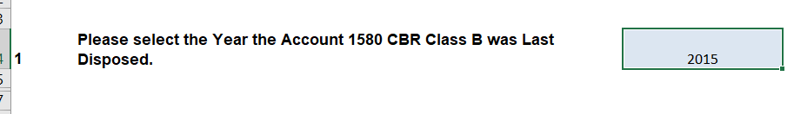
Please confirm this should be changed to 2016, if not please explain.
InnPower Response
IPC has corrected the year to be 2016 on Tab 6. Class A Consumption Data.

OEB Staff-3
Ref: IRM Rate Generator Tab 6. Class A Consumption Data
InnPower has indicated on Tab 6. Class A Consumption Data there were no customers who transitioned between Class A and B during the period the Account 1580, sub account CBR Class B balance accumulated.
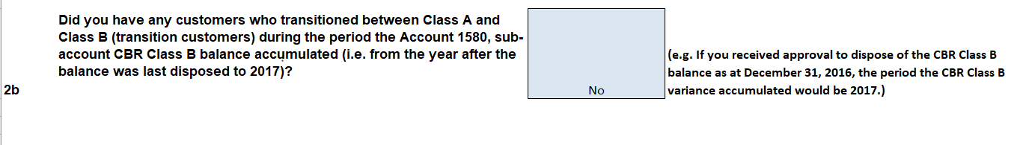
InnPower has also indicted on Tab 6. Class A Consumption Data that it had customers who transitioned between Class A and B during the period the Account 1589 GA balance accumulated.
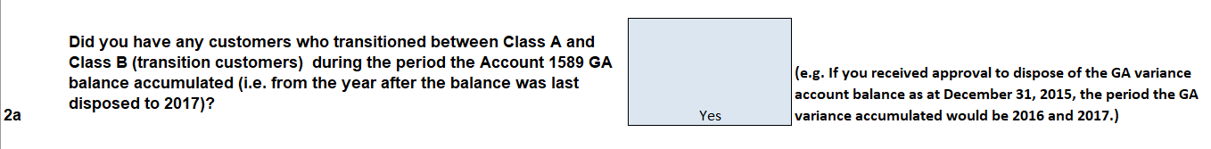
OEB staff believes that both should indicate yes, please explain if you disagree. If you agree please change to yes and fill out the remaining required data at the bottom of spreadsheet.
InnPower Response
IPC has changed the response to “Yes” for 2b. IPC had 1 customer who transitioned from B to A which occurred in 2017. IPC did not have any Class A customers during the entire period since the 1589 GA balance accumulated.
OEB Staff-4
Ref: Continuity Schedule Tab 3 and Decision and Order EB-2016-0085
InnPower is requesting disposition of accounts 1595-2012, 1595-2013 and 1595-2015. These accounts were just approved for disposition in Decision and Order EB-2016-0085. Please remove the check boxes from your continuity schedule.

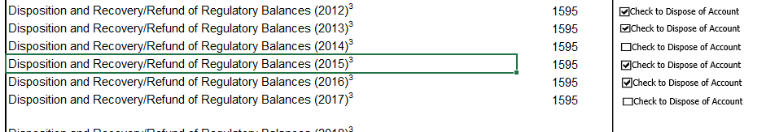

InnPower Response
IPC has removed the check boxes from the applicable DVA’a and has updated the Decision and Order EB-2016-0085 in accordance with OEB Staff-5.

OEB Staff-5
Ref: Continuity Schedule Tab 3 and Decision and Order EB-2016-0085
Please input in Column BE and BJ the amounts disposed of in Decision and Order EB-2016-0085. Without those amounts input the claims are incorrect.
InnPower Response
In discussion with IPC’s Case Advisor, Kelli Benincasa, the amounts disposed of in Decision and Order EB-2016-0085 have been input to Column’s BM and BN. This avoids a RRR discrepancy, but will adjust the overall claim amount,

OEB Staff-6
Ref: Continuity Schedule Tab 3
It appears InnPower has Reported its RRR incorrectly for Account 1580 Sub-account CBR Class B. Only the amount allocated the Class B should be reported in this account. The 1580 control account should have the total amount reported and then there would be a variance in this account from the RRR that is equal to the amount reported in the RRR class B.
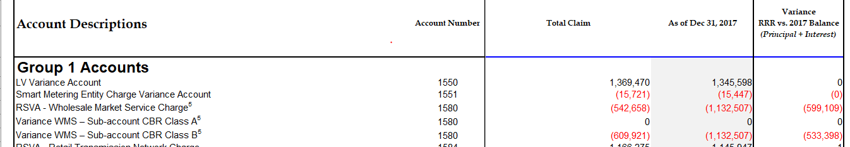
Please refile InnPower’s RRR and review the balances in all the 1580 Accounts and confirm they are correct.

InnPower Response
IPC has reviewed the request with respect to Account 1580. IPC is of the view that the amounts reflected in the sub-account 1580 Class A (principal and interest) are correct. This is due to the fact that IPC undertakes full calendar month billing thus there are no amounts to record in Account 1580 (Class A).
IPC will also issue a correction to Account 1589 which is addressed in the follow up questions on the GA.

