**Northern Ontario Wires Inc. (Northern Ontario Wires)**

**2019 IRM Application**

**EB-2018-0058**

**Application Analysis**

**November 26, 2018**

**Staff Question #1**

**Ref: Rate Generator Model, Tab 3 Continuity Schedule**

The table from Northern Ontario Wires’ 2017 cost of service Decision[1] which identified the principal and interest amounts approved for disposition, is reproduced below.

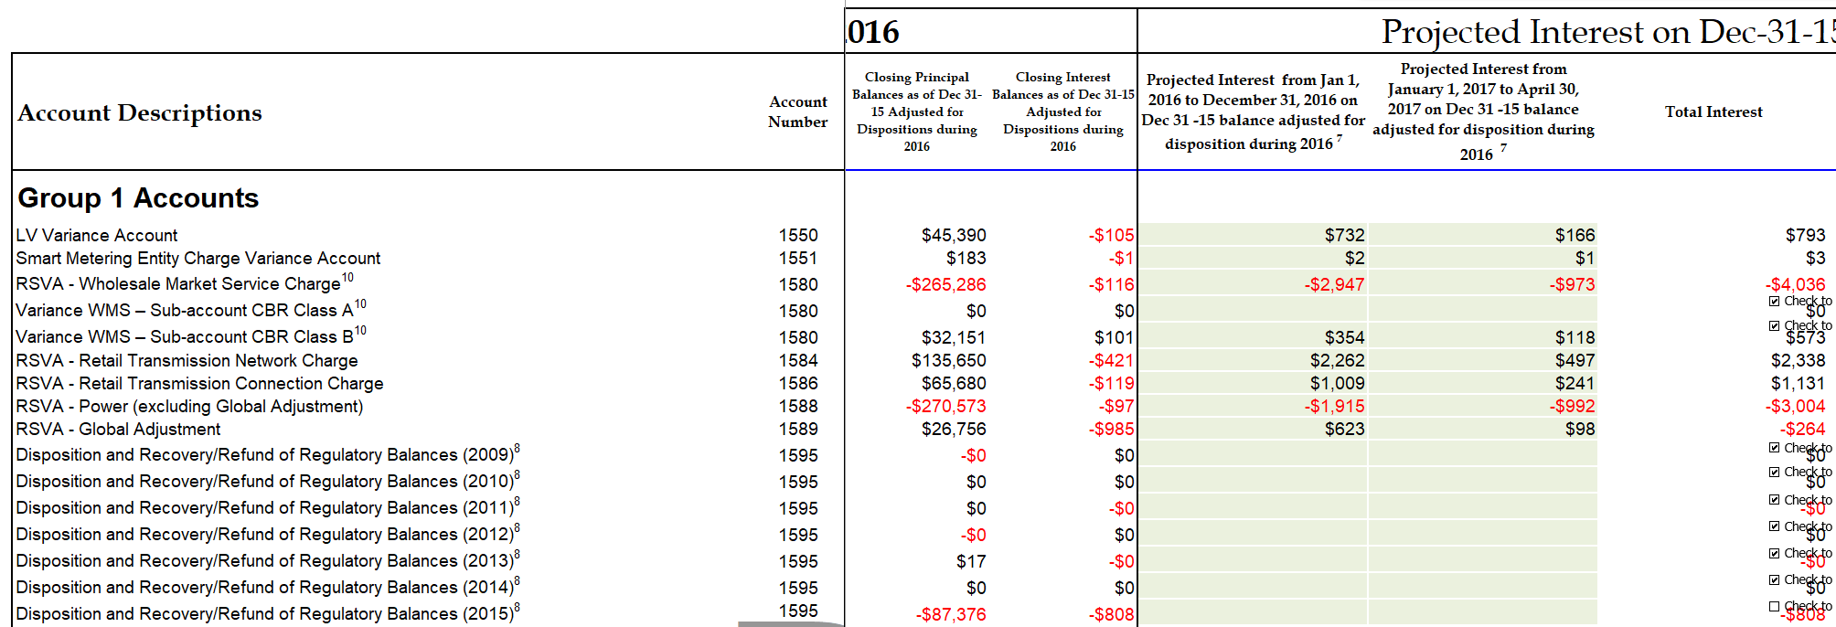

1. OEB staff notes that the “OEB-Approved Disposition during 2017” and “Interest Disposition during 2017 – instructed by OEB” do not reconcile with the approved amounts in the 2017 cost of service Decision in Account 1595 (2015).

Please reconcile the difference. If the input into the Rate Generator Model is an error please provide corrections and OEB staff will make the necessary changes to the model.

*NOW Inc. notes that there is no difference in the OEB approved disposition in 2017. There was no claim for disposition in the 2017 cost of service application or decision in regards to Account 1595 (2015). As noted in the image above, the check to dispose account is not selected for the account in question. The Account 1595 (2015) was disposed in the 2018 IRM Rate Application.*

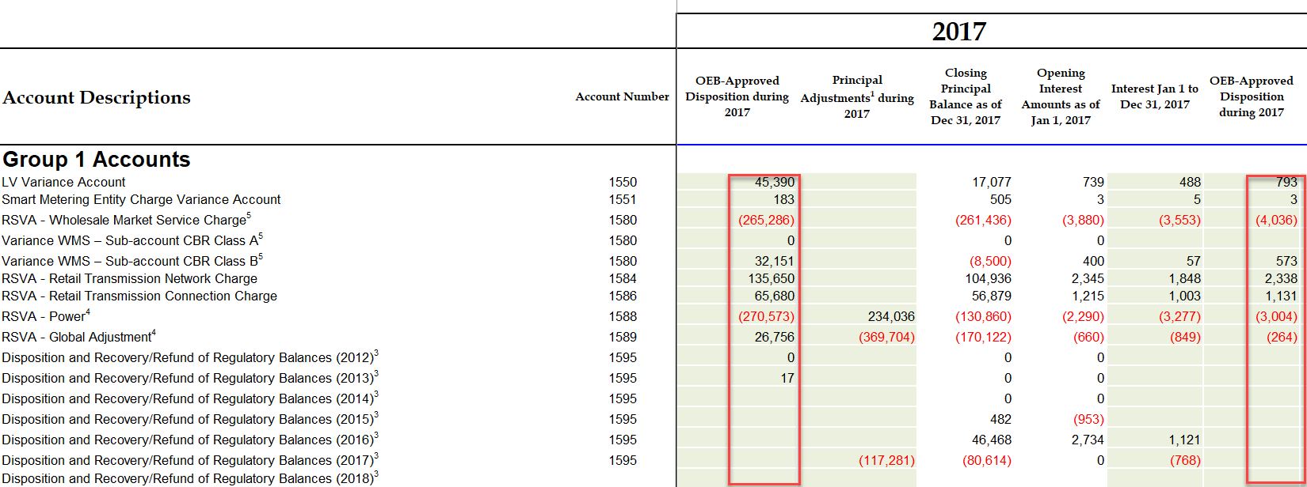

**Staff Question #2**

**Ref: Rate Generator Model, Tabs 6.1a GA Allocation and 6.2a CBR_B Allocation**

OEB staff has done a calculation for the kWh’s entered in Tab 6.1a GA Allocation (i.e. 59,051,612) and Tab 6.2a CBR-B Allocation (110,661,119). Please review the image below and confirm if Northern Ontario Wires agrees with OEB staff’s calculation. If Northern Ontario Wires agrees, please make the necessary corrections to the model.

*NOW Inc. agrees with OEB staff calculations.*

*No amount is included in D20 in Tab 6.2a as a result of Staff Question # 3.*

**Tab 6.1a GA Allocation**

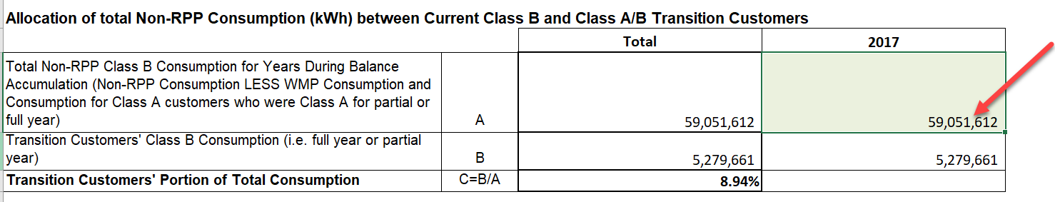

**Tab 6.2a CBR B_Allocation**

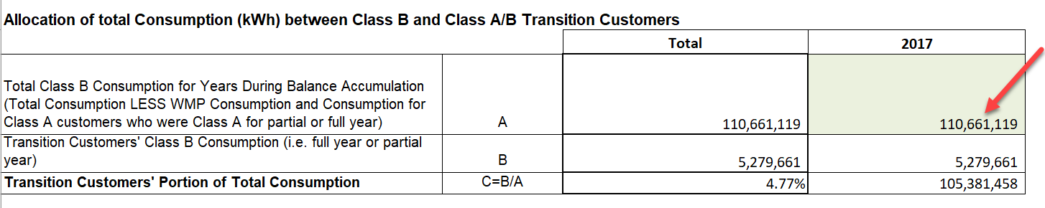



**Staff Question #3**

**Ref: Rate Generator Model, Tab 6.2a CBR_B Allocation**

OEB staff notes that Northern Ontario Wires’ original filing showed immaterial amounts allocated to transition customers for CBR Class B. Therefore a distributor is to transfer the entire OEB-approved CBR Class B amount into the Account 1580 WMS control account to be disposed through the general purpose Group 1 DVA rate riders. OEB staff notes that the Rate Generator Model is designed to automatically do this, however cell D20 on Tab 6.2a should be zeroed out to not show the immaterial allocation.

1. OEB staff has made this change to Northern Ontario Wires’ model and has provided it along with these questions. Please confirm if Northern Ontario Wires agrees.

*NOW Inc. agrees with OEB staff.*

**Staff Question #4**

**Ref: EB-2017-0066 - 2016 GA Analysis Workform; 2017 GA Analysis Workform; 2019 Rate Generator Model**

In the prior year’s GA Analysis Workform (EB-2017-0066), an amount of $77,780 was included as a reconciling item to account for differences in the RPP and Non-RPP proration of GA charges. This adjustment is identified in cell AV29 of the 2019 Rate Generator Model. Further, this amount is also reversed as a credit entry in cell BF29.

1. Please confirm in which fiscal year this adjustment was journalized to the general ledger of Northern Ontario Wires?

*The adjustment was not journalized to the general ledger for NOW Inc. until 2018. As such the Continuity Schedule has been adjusted to remove the reversal in 2017 in BF29 as well as the projected interest balance being updated.*

1. If this adjustment was recorded in fiscal 2017, please explain why a reconciling item in the 2017 GA Analysis Workform is not required, as a credit of $77,780 to reconcile the impact of this adjustment pertaining to 2016. If necessary, please update the GA Analysis Workform accordingly.

*There is no reconciling item required in fiscal 2017 as there in no adjustment recorded in the 2017 general ledger. The reconciling credit of $77,780 will occur in the 2018 GA Analysis.*

1. If the adjustment made in part b) above is entered into the 2017 GA Analysis Workform, the unresolved difference breaches the 1% materiality threshold. Please comment on whether there are other potential reconciling items to consider to explain the unresolved difference.

*As noted in b) the reconciling item is not to be added back in the 2017 GA Analysis as the entry was not recorded in 2017. As a result, the Net Change in Principal Balance in the GL in the 2017 GA Analysis does not include the general journal adjustment which would be offset by the credit reconciling item.*

*Therefore, the unresolved difference remains at $2,543 and below the 1% materiality threshold.*

**Staff Question #5**

**Ref: Application page 7 of 9**

Northern Ontario Wires is proposing to refund its transitional Class A customer from 2017 their attributable GA and CBR amounts as a one-time adjustment rather than twelve equal instalments.

Please indicate in which month Northern Ontario Wires is proposing to issue this refund.

*NOW Inc. is proposing to issue the refund when billing May 2019 consumption which would be on the June 2019 billing.*

**Staff Question #6**

**Ref: Application page 7 of 9; GA Analysis Workform**

Northern Ontario Wires has included a debit adjustment of $252,264 to Account 1588 and a credit adjustment of $252,264 to Account 1589 to account for Class A consumption that was incorrectly factored into the split of GA expenses between RPP and Non-RPP customers.

1. Please provide the supporting calculations for how this number was quantified. Specifically, please show what the RPP/Non-RPP consumption splits were for the affected period(s), how the Class A consumption was determined, and how the correct RPP/Non-RPP splits were calculated.

*See attached image for results of how the $252,264 was quantified. Included in the image are the change in RPP/Non RPP consumption splits, once Class A consumption was removed. The periods impacted were from July to December when NOW Inc. first customer migrated to Class A. The Class A consumption was taken from the Class A customer account and removed from the Non-RPP billed consumption used to calculate the RPP/Non-RPP split. The $252,264 amount was determined by calculating the variance between the consumption splits that include and exclude Class A consumption multiplied by the amount billed by the IESO Type 148.*



1. Please indicate which months these reallocations affect.

*As seen in a) the impacted months are from July to December.*

1. Please indicate in which fiscal year this adjustment was recorded in Northern Ontario Wires’ general ledger.

*The adjustment was recorded in NOW Inc.’s general ledger in 2018.*

1. Please confirm that this reallocation of GA expenses is a correction of prior splits of IESO Charge Type 148 and would not affect the RPP Settlement True-up amounts of Northern Ontario Wires for the months in question.

*NOW Inc. confirms that this reallocation of GA expenses is a correction of prior splits of IESO Charge Type 148 and does not affect the RPP Settlement True-up amounts.*

**Staff Question #7**

**Ref: Application page 7 of 9; GA Analysis Workform**

Northern Ontario Wires indicated that a correction for an IESO bill in December 2017 will result in a credit of $82,113 being received (and has split the credit as $42,452 to Account 1588 and $39,661 to Account 1589).

1. Please indicate when this over-charge was discovered.

*This over-charge was discovered in April 2018.*

1. Please indicate in which fiscal year the credit has been recorded in the general ledger of Northern Ontario Wires.

*The credit has been recorded in the 2018 fiscal year.*

1. At this point, has the IESO acknowledged this error and confirmed that a credit in this amount will be provided to Northern Ontario Wires?

*The IESO has acknowledged the error and have indicated that settlements should have it corrected on the December 2018 invoice.*

**Staff Question #8**

**Ref: Application page 5 of 9; 2019 Rate Generator Model**

In Part 6 of the Application (Global Adjustment) Northern Ontario Wires has indicated:

“TOU Meters are read at month end based on the calendar month. There is no estimate for these meters as actual consumption is provided…Conventional meters are read on the first of the month so no estimation is required.”

In addition, Northern Ontario Wires has indicated:

“As part of the RPP settlement process, NOW Inc. provides estimates to the IESO based on historical consumption and true up the consumption monthly as part of its settlement true up process as described below. The actual data is available in the subsequent month’s billing batches.”

1. Please explain or reconcile the two statements above. Specifically, why is there a need to provide estimates to the IESO initially and true up based on subsequent month’s billing batches, if actual consumption is available prior to the date in which initial RPP settlement amounts are reported to the IESO?

*The statements above referring to no estimate on the meter reads and estimates provided to the IESO are a result of timing, and not estimated figures. The consumption that is read at the end of the month and reported to the IESO is actual consumption data.*

*In the second statement above, the “estimates to the IESO” is in reference to actual consumption data that is from the previous month (Eg. July Filing done in the first four days of August uses actual June consumption.) The true up for June is done and reported in the same July filing which results in a one-month lag on RPP true-ups. This format is done as a result of the timing of data in the NOW Inc. billing system. The actual consumption for the month of filing is only available in the subsequent month’s report.*

1. Please confirm that, with respect to the initial RPP Settlement figures (submitted four days after a particular month-end to the IESO), the only element of RPP Settlement that is based on estimates is the GA rate used (1st or 2nd estimate is used initially) to calculate the GA attributable to RPP customers in that particular settlement month which is subsequently trued up to actual GA rate. If not, please clarify OEB staff’s understanding of which items are being trued up for the purposes of RPP settlement each month.

*NOW Inc. confirms that the only element of the RPP settlement that is based on estimates is the GA rate (first estimate) used to calculate the GA attributable to RPP customers in that particular settlement month which is subsequently trued up to the actual GA rate.*

**Updates to the Rate Generator Model:**

1. Tab 6.2a CBR_B Allocation Staff Question #3 above
2. Tab 20 has been updated to reflect the DRP rate to $36.86.

If you have to make any adjustments to the model, please use the attached version.

1. EB-2016-0096