**Atikokan Hydro Inc. (Atikokan Hydro)**

**2019 IRM Application**

**EB-2018-0018**

**Application Analysis**

**November xx, 2018**

**Staff Question #1**

**Ref: Managers Summary page 5 of 29**

Atikokan Hydro stated in its managers summary that “the tariffs did not reflect the OEB’s most recent charges to the Ontario Electricity Support Program Recipient credit but Atikokan attest Atikokan has been in compliance with order EB-2016-0376”.

1. Please state why Atikokan Hydro included this statement in the Managers Summary

**RESPONSE**

Please disregard this statement in the manager’s summary.

**Staff Question #2**

**Ref: Sheet 3 “Continuity Schedule” is reproduced below**

The table from Atikokan Hydro’s 2017 cost of service Decision[1] which identified the principal and interest amounts approved for disposition, is reproduced below.

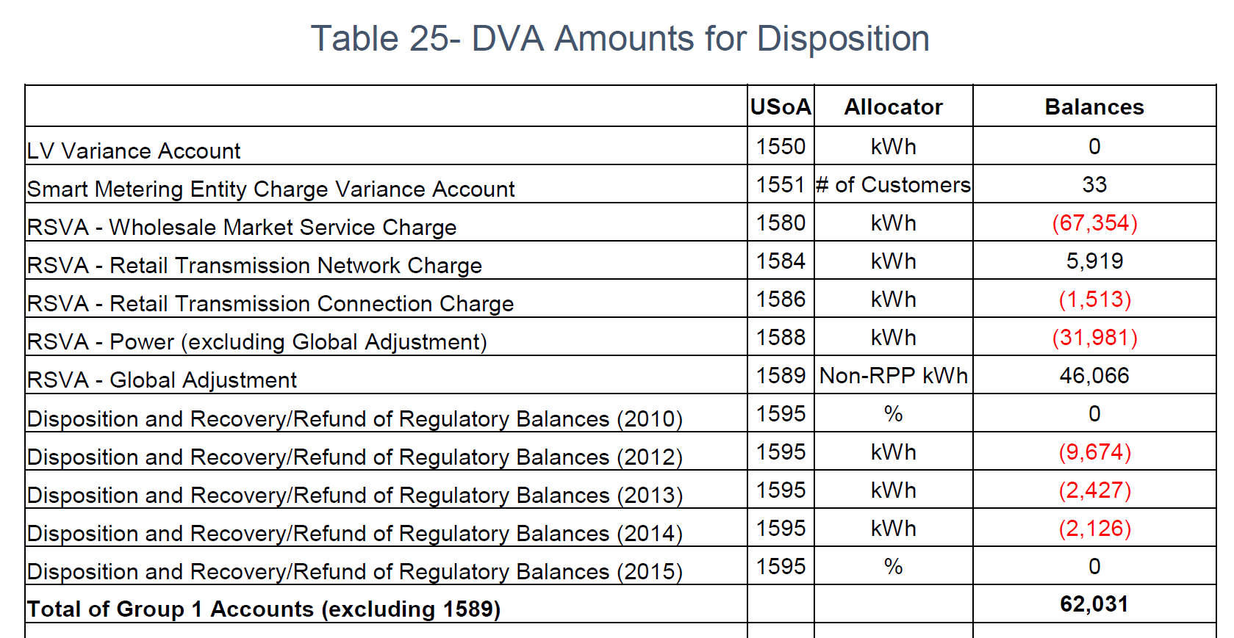

1. OEB staff notes that the “OEB-Approved Disposition during 2017” and interest Disposition during 2017 do not reconcile with the approved amounts in the 2017 cost of service Decision.

Please reconcile differences. If the input into the Rate Generator Model is an error please provide corrections and OEB staff will make the necessary changes to the model.

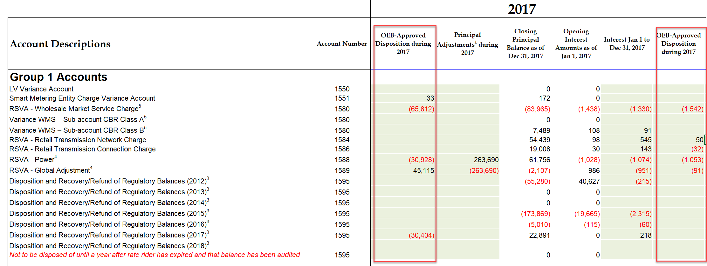

**RESPONSE**

Atikokan inadvertently included the 2017 OEB Principal approved amounts for Account 1584 and 1586 in the column with the ‘Transactions Debit/(Credit) during 2017’.

The Global Adjustment interest amounts for Interest Jan 1 to Dec 13, 2017 and the OEB Approved Disposition during 2017 were reversed. The proposed correction has been made.

The Rate Generator Model should read as follows to address the input errors by Atikokan:



**Staff Question #3**

**Ref: Sheet 3 “Continuity Schedule” is reproduced below**

The table from Atikokan Hydro’s 2018 IRM Decision[2] which identified the principal and interest amounts approved for disposition, is reproduced below.

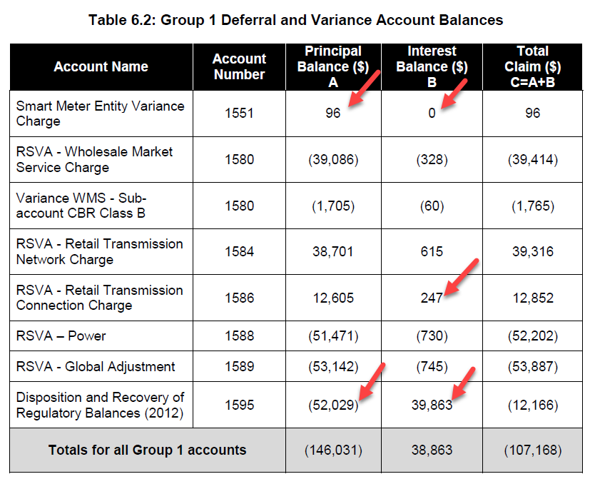

1. OEB staff notes that the “OEB-Approved Disposition during 2018” and “Interest Disposition during 2018 instructed by OEB” do not reconcile with the approved amounts in the 2017 cost of service Decision.

Please reconcile differences. If the input into the Rate Generator Model is an error please provide corrections and OEB staff will make the necessary changes to the model.

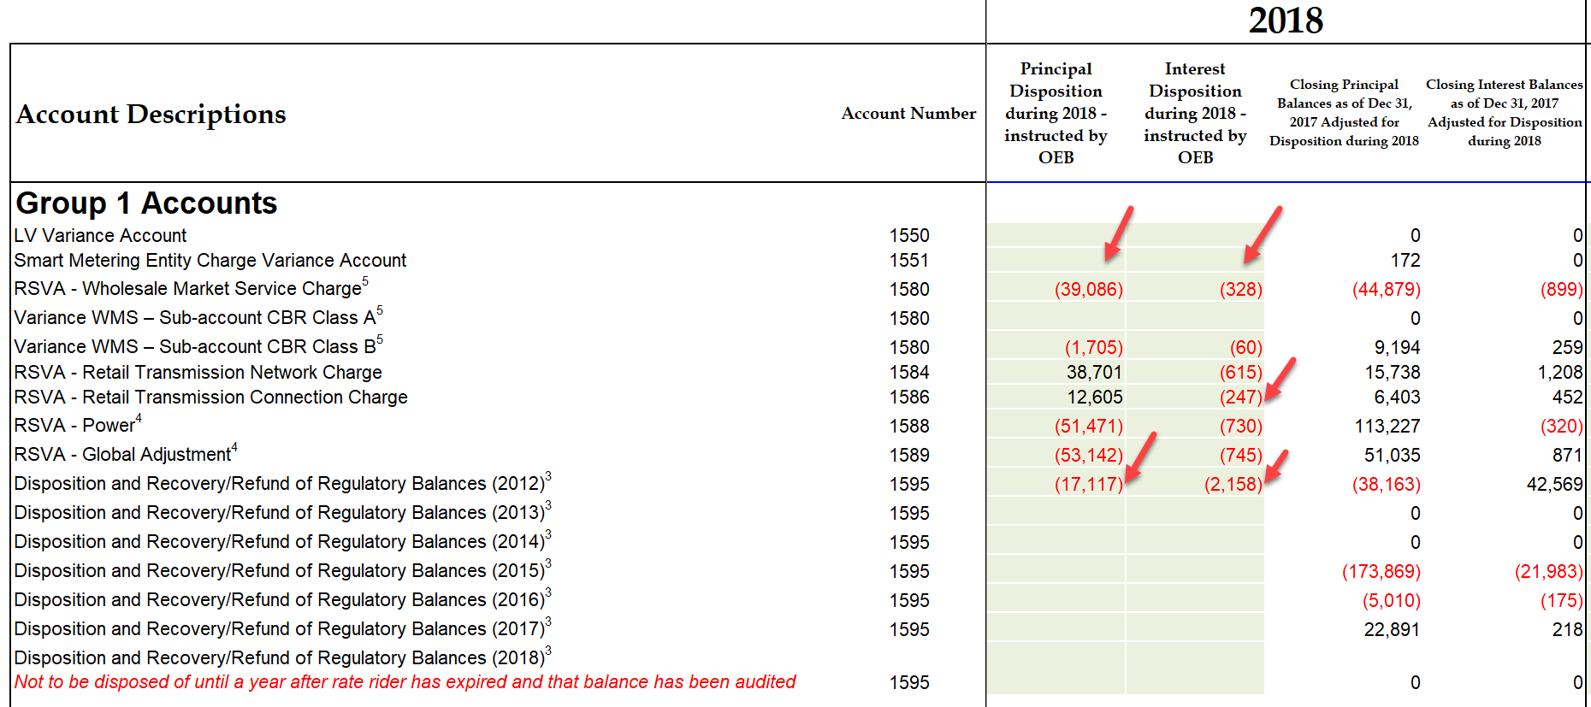

**RESPONSE**

The differences have been reconciled. The Rate Generator Model should read as follows to address the input errors by Atikokan:



**Staff Question #4**

**Ref: Sheet 10 “RTSR Current Rates” is reproduced below**

OEB staff is unable to reconcile the “Non-Loss Adjusted Metered kWh” and “Non-Loss Adjusted Metered kW” for GS 50 to 4,999 kW Service Classification with the reported amounts in Atikokan Hydro’s 2.1.5 RRR.

1. If Atikokan believes the figures entered are correct, please provide an explanation for these discrepancies.
2. If Atikokan Hydro believes these figures needs adjustments, please confirm and OEB staff will update the model with the figures as found in the RRR.

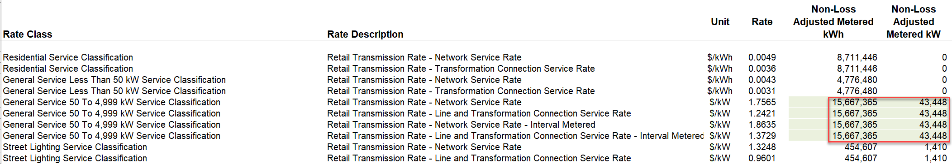

**RESPONSE**

Atikokan agrees with OEB staff. The model should be revised to agree with the RRR.

**Staff Question #5**

**Ref: Application and Evidence, p. 24 of 29**

1. The Applicant indicates that customers are billed on a monthly basis, please clarify if this means that they are billed consumption on a calendar months basis.
2. If the Applicant does not bill consumption on a calendar month basis, then please explain if the Applicant settles with the IESO based on actual billed consumption or based on actual monthly consumption (actual monthly consumption means the actual consumption consumed by the ratepayers for a given month)?

**RESPONSE**

1. Atikokan confirms its customers are billed consumption on a monthly calendar basis.
2. Atikokan settles with the IESO based on a calendar month basis.

**Staff Question #6**

**Ref: Appendix E, Responses to Question 3a and 3b**

The responses provided relate to the initial recording and subsequent true-up of the CT 148 charge from the IESO.

1. Please confirm that the Applicant waits to receive the actual CT 148 charge from the IESO prior to recording an amount in their G/L. No amounts are recorded prior to the receipt of the IESO CT 148 invoice.
2. In the response provide to 3a, the Applicant indicates that the CT 148 charge from the IESO is initially split between accounts 1588 and 1589 by taking the estimated RPP consumption for the month multiplied by the GA estimate for the month, which is then allocated to account 1588, and the residual going to account 1589. Question 3b, then goes on to ask how the Applicant then performs a true-up of this split, however the response provided does not address this process: The description provided in the response to 3b appears to relate to the Applicant’s process to true-up CT 1142, not CT 148.
   1. Given that the applicant initially splits CT 148 from the IESO based on an estimate of RPP consumption and the GA rate, does the applicant then record a true up of this initial split based on the actual consumption and the actual GA Rate.
   2. If yes, please explain this process, detailing when it is done and how the calculations are performed. Also confirm whether all of the CT 148 true-up have been made and recorded as part of the December 31, 2017 balance in Account 1589 per the DVA continuity schedule.
   3. If the Applicant does not true-up its initial split of CT148, please provide a calculation that quantifies the true-up that would be required for 2017.

**RESPONSE**

1. Atikokan confirms, no amounts are recorded into the G/L until the actual CT 148 is received from the IESO
2. a) It does appear Atikokan confused both CT 148 and CT 1142 in responses. CT 148 is split between 1588 and 1589 using actual consumption and the GA rate charged on the IESO bill.
3. Atikokan does not see a required true up for 2017.

**Staff Question #7**

**Ref: GA Analysis Workform, Note 5, Adjustment 9**

The Applicant has proposed a principal adjustment for $263,690 to account for Class A related GA that was recorded in Account 1589.

1. For settlement purposes with the IESO, was the class A consumption properly reported to the IESO? Or was the RPP consumption that was used for settlement purposes inaccurate as a result of the Class A consumption. Please explain.
2. The adjustment proposed by the Applicant reduces Account 1589 and increases Account 1588. Shouldn’t this balance now in Account 1588 be settled directly with the IESO instead of ratepayers since it relates to GA RPP? If the Applicant is of the opinion that no settlement with the IESO is required for this balance, then please explain why.

**RESPONSE**

1. The Class A consumption was properly reported to the IESO. The RPP consumption used for settlement purposes was not inaccurate as a result of the Class A consumption.
2. Atikokan does not believe settlement with the IESO is required for this balance. Atikokan believes the RPP consumption used for settlement is accurate.

1. EB-2016-0056
2. EB-2017-0026