**Niagara Peninsula Energy Inc. (NPEI)**

**2019 IRM Application**

**EB-2018-0054**

**Responses to OEB Staff Questions**

**November 30, 2018**

**Staff Question #1**

**Ref: A portion of Tab 11 – RTSR – UTR & Sub-Tx is reproduced below**

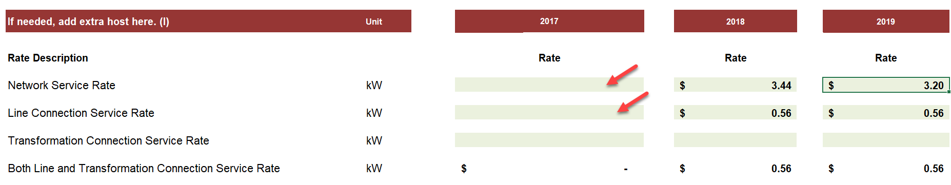

OEB staff notes that the column pertaining to the Extra Host for 2017 – Network Service Rate and Line Connection Service Rate are unpopulated.

1. If the omission of these rates are an error, Board staff will make the relevant

corrections.

Response

In the 2019 IRM Rate Generator Model, the cells for the 2017 Network Service Charge and Line Connection Service Charge pertaining to the Extra Host (Grimsby Power Inc.) are protected, and NPEI was not able to enter these rates. NPEI requests that Board Staff enter the rates for 2017 from Grimsby Power Inc.’s (“GPI’s”) approved Tariff of Rates and Charges effective January 1, 2017 (EB-2016-0073), for GPI’s Embedded Distributor rate class on Sheet 11 as follows: Network Service Rate of $2.8090 per kW in cell F50 and Connection Service Rate of $0.5083 per kW in Cell F52.

NPEI notes that GPI’s 2017 Embedded Distributor Network and Connection Service Charge rates are correctly reflected on Sheet 12.RTSR – Historical Wholesale of NPEI’s 2019 IRM Rate Generator Model and that the correction of the omission on Sheet 11 will have no impact on NPEI’s proposed RTSRs.

**Staff Question #2**

**Ref: Tab 6.1a GA Allocation – cell D20 Total Non-RPP Class B consumption**

**Ref: Tab 6.2a CBR B_Allocation – cell D20 Total Class B consumption less WMP**

OEB staff is unable to reconcile the data entered in cells D20 in Tab 6.1a and Tab 6.2a. Below is a table that staff prepared showing the “Validation of Data used in class B GA and CBR Allocations”. Staff notes a discrepancy for the 2017 consumption figure that is used in the “GA allocation” and “CBR B_Allocation” of 2019 IRM rate model as below.

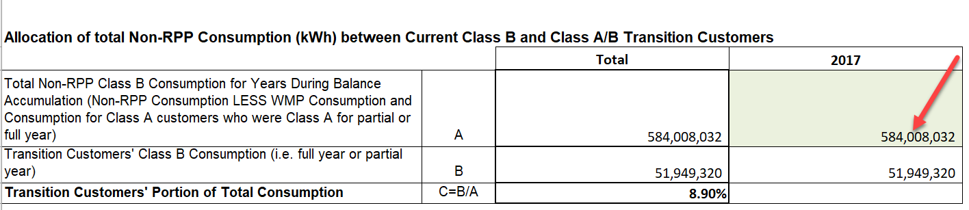

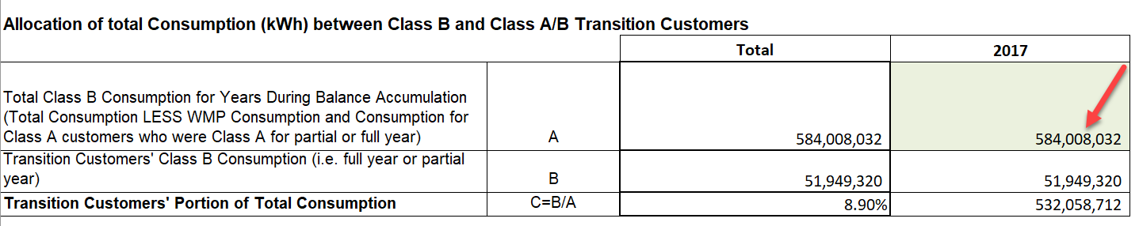



1. Please provide an explanation for the discrepancies.
2. Please update the model accordingly if applicable.

Response

1. In preparing its application, NPEI requested Board Staff to make several revisions to the billing determinants on Sheet 4.Billing Det. For Def-Var of the 2019 IRM Rate Generator Model, relating to Wholesale Market Participation consumption. Subsequent to these revisions, there were references in the formulas on Sheets 6.1a GA Allocation and 6.2a CBR Allocation, which NPEI should have updated but did not. NPEI agrees with the data presented in the table above.
2. NPEI has updated Sheets 6.1a of the 2019 IRM Rate Generator Model to agree with the consumption included in the table above. NPEI has not updated Sheet 6.2a of the model, since these values have been subsequently zeroed out (see Question #3 below).

**Staff Question #3**

**Ref: Rate Generator Model, Tab 6.2a CBR_B Allocation**

OEB staff notes that NPEI’s original filing showed immaterial amounts allocated to transition customers for CBR Class B. Therefore a distributor is to transfer the entire OEB-approved CBR Class B amount into the Account 1580 WMS control account to be disposed through the general purpose Group 1 DVA rate riders. OEB staff notes that the Rate Generator Model is designed to automatically do this, however cell D20 on Tab 6.2a should be zeroed out to not show the immaterial allocation.

1. OEB staff has made this change to NPEI’s model and has provided it along with these questions. Please confirm if NPEI agrees.

Response

NPEI agrees with this change.

**Staff Question #4**

**Ref: 2019 Rate Generator Model Tab 3; 2018 Rate Generator Model Tab 3 (EB-2017-0063)**

OEB staff notes that the Closing Principal Balances as of December 31, 2016 (in the current application) do not reconcile with the OEB-approved closing Principal Amounts as of December 31, 2016 (from EB-2017-0063) in Account 1588. Specifically the following discrepancies are noted:

|  |  |  |  |
| --- | --- | --- | --- |
|  | Current Application | EB-2017-0063 | Difference |
| Transactions Debit/(Credit) during 2016 | ($588,623) | ($363,759) | ($224,864) |
| Principal Adjustments During 2016 | Nil | ($55,378) | $55,378 |
| Closing Principal Balance as of Dec 31, 2016 | ($3,320,224) | ($3,150,738) | ($169,486) |

OEB staff further notes that the difference pertains to an amount of $169,486 for an RPP Settlement Claim recorded in the 2017 general ledger, which pertained to 2016 transactions.

1. Please confirm that the Applicant agrees that the 2016 figures require adjustment. If so, please adjust the 2016 principal transactions, principal adjustments, and closing December 31, 2016 principal balances to match the OEB-approved amounts presented in EB-2017-0063. If not, please explain the Applicant’s position.
2. Please confirm that the 2017 transactions (Column BD) include the $169,486 charge type 1142 from 2016, as referenced above.
3. If above part b) is not confirmed, and the 2017 transactions column was already manually adjusted for this amount, please update the 2017 transactions column so that it matches the total dollar amounts recorded in the Applicant’s 2017 general ledger.
4. Please adjust the projected carrying charges and total claim for Account 1588, if as a result of making the change requested in parts a) and/or c) above, the closing Principal Balance as of December 31, 2017 has changed.

Response

1. NPEI confirms that the discrepancy of $169,486 in the closing 2016 balance of Account 1588 relates to an RPP settlement claim recorded in the general ledger in 2017. This amount was approved for disposition in NPEI’s 2018 IRM Rate Application (EB-2017-0063). NPEI agrees that this amount should be included as a Principal Adjustment in 2016. NPEI has revised the DVA Continuity Schedule to include this adjustment.
2. NPEI confirms that the 2017 transactions amount in column BD includes the CT 1142 of $169,486 related to 2016 consumption.
3. Not applicable.
4. NPEI has adjusted its Rate Generator Model to reflect the adjustment made in part a).

**Staff Question #5**

**Ref: 2019 Rate Generator Model Tab 3; Application Page 21 of 144; 2017 GA Analysis Workform**

In its application, NPEI states that an amount of ($1,627,844) for RPP Settlement was included as a principal adjustment to Account 1588, as this amount related to December 2017 transaction but was recorded in the 2018 general ledger.

1. Please confirm if Charge Type 148 from December 2017 was also posted in the general ledger in January 2018? If so, why is a similar adjusting entry not required in the principal adjustments for 2017, as well as in the 2017 GA Analysis Workform?
2. Was Charge Type 148 from December 2017 allocated to Accounts 1588 and 1589 based on actual consumption in that month for Non-RPP and RPP customers?

Response

1. Charge type 148 from the December 2017 IESO invoice was posted in the general ledger in December 2017. For charge type 148, there is no one-month lag.
2. Charge type 148 from December 2017 was allocated as follows:

Beginning in February 2017, NPEI bills all non-RPP Class B customers using actual GA rates. Therefore, the GA billing to non-RPP class B customers should not result in any variance in Account 1589 RSVA – Global Adjustment. As a result of this, NPEI’s procedure for allocating CT 148 is:

1. Each month, after the monthly unbilled revenue accrual is posted, NPEI determines the total amount of non-RPP Class B GA revenue that has been recorded for the month.
2. NPEI records a portion of IESO Charge Type 148 Class B Global Adjustment Settlement Amount to Account 4707 Charges – Global Adjustment that exactly offsets the revenue amount determined in step 1). Unbilled revenue is reversed in the following month thereby any differences relating to the apportioning in Charge Type 148 is accounted for in the following month.
3. The amount determined in step 2) is subtracted from the total of IESO Charge Type 148 Class B Global Adjustment Settlement Amount. The remaining amount of charge type 148 is recorded in Account 4705 Charges – Power Purchased.

**Staff Question #6**

**Ref: Table 11 – Components of Account 1589 RSVA – GA**

Please confirm that as of the year ended December 31, 2017, the amount of GA revenue accrued (billed and unbilled) for Class B Non-RPP customers was the same as the amount of GA charged to those same customers and that no variance exists in the account for any billing activity after January 2017.

Response

NPEI confirms that as of the year ended December 31, 2017, the amount of GA revenue accrued (billed and unbilled) for Class B Non-RPP customers was the same as the amount of GA charged to those same customers. NPEI confirms no variance exists in the account for any billing activity after January 2017.

**Staff Question #7**

**Ref: Table 14 – GA Allocation to Transition Customers; Transition Customers Individual GA Amounts**

NPEI has proposed to allocate a portion of the Account 1589 GA balance to those customers who transitioned from Class B to Class A as of July 1, 2017. The purposes of allocating the GA balance to transition customers is to recognize that they had only contributed to the GA balance for part of the year and should not be allocated the full amount. The key aspect of cost causality that underlies this treatment is that a portion of the GA balance accumulated during the first six months of the year, and that another portion accumulated in the latter six months.

In NPEI’s case, since all Class B Non-RPP customers were billed on actual GA rates effective February 2017 (no variance recorded in Account 1589 from July 1, 2017 to December 31, 2017), and since there were no Class A customers prior to July 1, 2017, transition customers contributed to the GA variance on an equal basis as those customers who remained as Class B for all of 2017 (ignoring the $24,815 attributable to specific customers billed at 1st estimate in January).

1. Please confirm that the circumstances described above is accurate. If not, please clarify OEB staff’s understanding of NPEI’s transactions during 2017.
2. If the above is confirmed, please explain why transition customers for 2017 should not be treated the same as all other Non-RPP Class B customers, and should be charged the general rate rider based on the ($99,554) amount calculated in Table 11 of the Application.
3. If NPEI agrees with OEB staff’s position, please confirm and OEB staff will adjust the Rate Generator Model so that no amount of the GA Balance is allocated to transition customers (who will instead be charged the general GA rate rider based on a total balance of ($99,554)). If NPEI disagrees with OEB staff’s position, please explain why the method proposed in the Application, as filed, is more appropriate.

Response

1. NPEI confirms that the circumstances described above are accurate.
2. The premise of the transition customer allocation in the model is that Account 1589 accumulates throughout the entire year. The model automatically creates Sheet 6.1a once it is indicated that customers transitioned between Class B and Class A in cell C21 on Sheet 6. NPEI populated Sheet 6 Class A Consumption Data and 6.1a GA Allocation in the 2019 IRM Rate Generator model in accordance with the Filing Requirements and model instructions, which resulted in the proposed allocation to the transition customers. Upon review NPEI agrees that, in NPEI’s case, since the Account 1589 balance relates entirely to consumption when there were no Class A Customers, it is appropriate to treat the transition customers the same as all other Non-RPP Class B customers.
3. NPEI confirms that it agrees with OEB Staff’s position, and requests that Staff adjust NPEI’s Rate Generator Model so that no amount of the GA balance is allocated to transition customers, who will be instead charged the general GA rate rider based on a total balance of ($99,554).

**Staff Question #8**

**Ref: Section 3.2.5.2.7 Description of Accounting Methods and Transactions**

OEB staff notes that, for the purposes of allocating Charge Type 148 to Accounts 1588 and 1589 (initially Accounts 4707 and 4705), NPEI subtracts the amount of GA revenue (billed and unbilled) for the month from the total of Charge Type 148, with the remainder being deemed RPP-related GA costs.

OEB staff notes that this methodology will result in any difference between approved and actual loss factors being entirely allocated to non-RPP customers.

1. Please present a table, showing the monthly amounts of CT 148 allocated to Account 1589 based on NPEI’s existing methodology, as well as what the CT 148 allocation would be to Account 1589 had it been based on the percentage of Non-RPP consumption out of total consumption.
2. If the total amounts calculated in part a) above are material, please transfer the difference between Accounts 1588 and 1589, accordingly. If the amounts are immaterial, please state so.

Response:

In NPEI’s case, because there is no variance in Account 1589, there would be no resulting difference in anything relating to a loss factor in Account 1589. Hence, any difference between approved and actual loss factors would be allocated to all customers (RPP and Non-RPP) because the difference is entirely accounted for in Account 1588 RSVA Power.

**Staff Question #9**

**Ref: LV Variance Account; Rate Generator Model Tab 3**

OEB staff notes that the balance of NPEI’s USoA account 1550 is significant. The balance being requested for disposition is $856,391. This balance represents the principal and interest transactions from 2017 plus forecasted interest to April 30, 2019.

Please provide an explanation for the large size of the account balance. If practicable, provide a quantitative analysis for amounts paid and amounts collected that reconciles this large balance.

Response

The balance of Account 1550 – LV Variance proposed for disposition of $856,391 consists of Principal of $836,172 and Carrying Charges of $20,219. The table below shows the details of the Principal component of this balance:



NPEI’s Board-approved LV rates were last updated in NPEI’s 2015 COS Rate Application (EB-2014-0096). The balance in Account 1550 that accumulated during 2017 is partly due to increases in Hydro One’s approved rates for its Sub-Transmission rate class since NPEI’s last COS application. The total amount of LV charges that NPEI was billed by Hydro One during 2017 was $967,102, versus $617,364 in 2014, an increase of $349,738.

Another factor that contributed to the Account 1550 balance is that, in 2016, the OEB approved an Embedded Distributor rate class for Grimsby Power Inc. (“GPI”) which applies to NPEI. Prior to 2015, NPEI was a customer of Niagara West Transformation Corporation (“NWTC”), a licensed transmitter. NWTC had a Board-approved Transformation Connection Transmission rate of $1.77/kW. NPEI recorded the charges from NWTC in Account 4716 – Charges Connection. In the EB-2014-0344 Decision and Order, issued March 26, 2015, the Board approved the amalgamation of GPI and NWTC, and deemed the NWTC transmission assets to be GPI distribution assets. The Board also approved GPI to continue to charge NPEI the NWTC transmission rate of $1.77/kW until GPI’s next rebasing.

In the Decision and Order in GPI’s 2016 COS Rate Application (EB-2015-0072), the Board approved an Embedded Distributor rate class for GPI, which applies to NPEI. Since that time, GPI’s monthly invoice to NPEI includes charges for Retail Transmission Rates – Network (recorded in Account 4714 Charges – Network), Retail Transmission Rates – Connection (recorded in Account 4716 Charges – Connection), Monthly Service Charge and Distribution Volumetric Charge (both recorded in Account 4750 Charges – LV).

The total amount of LV charges that NPEI was billed by GPI during 2017 was $383,372.