Hearst Power Distribution Company Limited
OEB Staff Questions
EB-2018-0038
December 28, 2018

Hearst Power Distribution Company Limited (Hearst Power)
EB-2018-0038
Follow-Up Questions

Staff Question-1
Ref: Heart Power Responses to OEB Staff Questions Round #1_iv Dec. 14 (Spreadsheet Tab #11) and Response to Staff Question 11

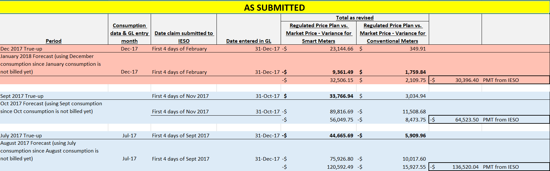

Hearst Power has stated the following:
Hearst Power reviewed all submission to the IESO in relation to account 1588 two items were identified as erroneous:
- Data entry error on true-ups: Incorrect data was entered in one box on each of the true-ups completed in July and Sept 2017.
- The inclusion of the estimated billing 1588 power variance account for January 2018: Every month, the settlement form submitted to the IESO regarding the 1588 variance account includes a monthly forecast/estimation for the current month AND a monthly with true-up for the previous month, all under a single claim. Once the monthly claim is submitted to the IESO, the amount is received as one payment, it is entered in our Accounting General Ledger under only one month. We now realized that this in incorrect and the single claim should be accounted in two separate entries in our GL; the forecast in one month and the true-up in the previous month. A revision is required to remove the forecast for January 2018 enter in December 2017.

For all above revisions, please refer to the excel spreadsheet for more details. Revisions to the RRR filings and the IRM model will be required once we receive final adjustments from the IESO.
- With respect to item 1 above, please describe the nature of the data entry error on true-ups completed in July and September 2017.
  - Are the July and September errors related to Class A consumption reporting with the IESO?
Hearst Power: No

  - If the answer to part i. is “yes”, please describe how it impacts Account 1588.
Hearst Power: N/A

  - What is the dollar value of the error related Class A currently reflected in Account 1588?
Hearst Power: N/A

  - If this error is related to July and September true-up, was the true-up completed in 2018?
Hearst Power: The final/corrected true-up was completed in November 2018, when the discrepancies were identified. This error can be quantified as $33,083.11 which is to be credited from account #1588 as an adjustment entry.

    - If the true-up was completed in 2017, why does Hearst Power believe that it needs to be corrected?
Hearst Power: Hearst Power believes it needs to be corrected as incorrect values were entered during the true-up process which resulted in an incorrect true-up.

- With respect to item 2 above, please clarify what Hearst Power means by “forecast/estimation for the current month”. Does the current month mean the month that just passed? For example would the “current month” be December for the settlement form completed on January 4th?
Hearst Power: Further to our discussion with OEB staff on Dec 27, more specifically the discussion with Ms. Rajvinder Sabharwal, Hearst Power would like to re-state item #2 to order modify and better align its statement with its excel spreadsheet and having received and acknowledge the OEB comments. The item #2 re-statement is the following:
- The inclusion of the December true-up in the January preliminary report to the IESO: Every month, the settlement form submitted to the IESO regarding the 1588 variance account includes a monthly forecast/estimation for the current month AND a monthly with true-up for the previous month, all under a single claim. Once the monthly claim is submitted to the IESO, the amount is received as one payment, it is entered in our Accounting General Ledger under only one month. We now realized that this in incorrect and the single claim should be accounted in two separate entries in our GL; the forecast in one month and the true-up in the previous month. A revision is required to remove the December true-up in the January 2018 preliminary statement.

The December 2017 true-up included in the January 2018 preliminary statement can be quantified at $22,794.95 which is to be credited from account #1588 as of December 31st, 2017.

- Please quantify the amount included in the balance for disposition in Account 1588 that relates to the error related to item 1 and item 2 separately.
Hearst Power:
Item #1 - $33,083.11 to be credited from account 1588 in 2017
Item #2 - $22,794.95 to be credited from account 1588 in 2017

Staff Question-2
Ref: Rate Generator Model, Various Tabs

OEB staff has made the following edits to Hearst Power’s Rate Generator Model based on its responses to the initial OEB staff questions:

- Removed LRAMVA allocation by rate class on Tab 4
- Checked off box on Tab 4 re: RRR reconciliation as per response to staff question 3
- Adjusted # in cell D20 as per response to staff question 4
- Changed tax impact to $10,182 as per response to staff question 6
- Updated tax rate to 15% as per response to staff question 6
- Updated price escalator to 1.5%
Please review the updated Rate Generator Model and bill impacts provided with these questions and confirm Hearst Power’s acceptance of the updated model. If any further edits are required throughout the remainder of this proceeding, please ensure to make them to this version of the model.

Hearst Power:
Hearst Power is in agreement with the statement included in Staff Question-2 above.

https://www.oeb.ca/industry/applications-oeb/electricity-distribution-rates/2019-electricity-distribution-rate#updates Announced November 23, 2018

