Thunder Bay Hydro Electricity Distribution Inc.

OEB Staff Questions

EB-2018-0069

**Thunder Bay Hydro Electricity Distribution Inc. (Thunder Bay Hydro)**

**EB-2018-0069**

**OEB Staff-1**

**Ref: Tab 6.1a GA Allocation and Tab 6.2a CBR B_Allocation**

OEB staff has done a calculation for the kWh’s entered in Tab 6.1a GA Allocation and Tab 6.2a CBR B_Allocation. Please review below and confirm Thunder Bay Hydro agrees with OEB staff’s calculation and OEB staff will update the model for Tab 6.2a CBR B_Allocation, if not please explain why. OEB staff confirms Tab 6.1a GA Allocation is correct.



**OEB Staff-2**

**Ref: Tab 6.2a CBR_B Allocation and Tab 6.2 CBR B**

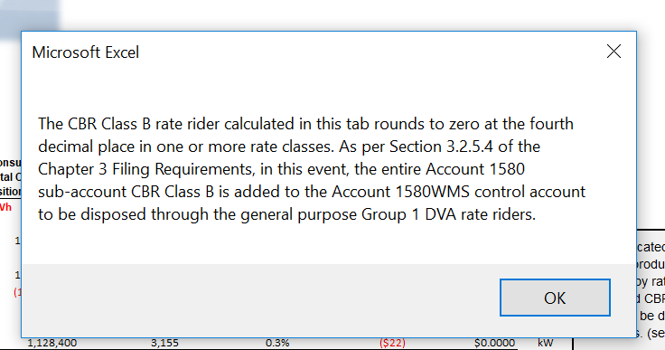

The message above pops up on Tab 6.2 CBR B, therefore the amount in Account 1580 Variance WMS – Sub-account CBR Class B will roll up into Account 1580WMS control account. OEB staff will remove the kWh’s entered in cell D20 of Tab 6.2a CBR B_Allocation.

**OEB Staff-3**

**Ref: Tab 3 Continuity Schedule**

Thunder Bay Hydro is requesting disposition of Account 1595-(2015), the residual balance of this account was already previously disposed in 2018. As per instructions on Tab 3 Continuity Schedule residual balances are only to be disposed of once, see cell C53 and below.



Please provide an explanation for requesting to dispose of the residual balance a second time or request OEB staff remove the check mark to dispose of the Account 1595-(2015) balance of $1,625.

**OEB Staff – 4**

**Ref. Appendix A: GA Methodology Description**

In the response provided to Question 2, Thunder Bay Hydro describes how it performs its monthly settlements with the IESO. In a particular, the utility states that it uses a monthly average of kWh and the second estimate GA rate for purposes of completing its initial settlement.

1. It is not clear from the response provided in Question 2b that the utility then trues-up its initial settlement for both the RPP kWh (to actual RPP kWh) and the GA rate (to the actual GA rate for the month that was settled). Please confirm that this is the case, and if not, please explain why.
2. Please indicate the frequency in which the utility performs the above true-ups (i.e. in the month after initial settlement, quarterly, etc).
3. Please confirm that Thunder Bay Hydro meant the 4th quarter in the response provided to Question 2d.

**OEB Staff I – 5**

**Ref. Appendix A: GA Methodology Description**

In the response provided to Question 2, Thunder Bay Hydro describes how it initially records its monthly CT 148 charge from the IESO.

1. Please confirm whether Thunder Bay Hydro initially records an estimate of the CT 148 charge prior to the receipt of the actual invoice, or does the utility wait for the actual invoice to come in before it actually records anything in their G/L (and accrues the invoice to the appropriate period).

**OEB Staff – 6**

**Ref. GA Analysis Workform.**

1. Please ensure that cell C62 of Note 5 in the GA Analysis Workform agrees to the 2017 transactions per for Account 1589 per the DVA continuity schedule.
2. Please provide further explanation as to the nature of reconciling item 8 that is presented in Note 5 of the GA Analysis Workform including details as to how it represents a difference between the expectation calculated in Note 4 and what actually got recorded by the utility in Account 1589 during 2017.
   1. Please also provide details as to how the amount of the reconciling item was quantified.
   2. Please also explain why Thunder Bay has not proposed to record this reconciling item as a principal adjustment to their December 31, 2017 balance in Account 1589 in the DVA continuity schedule.
3. Thunder Bay Hydro has recorded an adjustment in 2a of Note 5 to account for the difference between unbilled revenue for December 2016 and what actually got billed subsequently in January 2017. Please quantify what this difference would be for the December 2017 unbilled revenue accrual and what actually got billed in January 2018 and record it as reconciling adjustment 2b in the GA Analysis Workform. If the utility is indicating that there is no difference that would need to be accounted for, then please explain why that would be the case.