**Peterborough Distribution Inc. – 2019 IRM Application (EB-2018-0067)**

**OEB Staff Questions**

**January 24, 2019**

**Question # 1**

**Ref: IRM Model, Tab 1**

In the Decision and Rate Order issued for Peterborough Distribution’s 2018 rates (EB-2017-0266), the Group 1 DVA accounts balances as of December 31, 2016 were disposed of. Therefore, the rate year associated with this disposition should be 2018. In tab 1 of the IRM model, Peterborough Distribution selected 2017 as the rate year in which the Group 1 accounts were last cleared. Please confirm if the rate year should be corrected to 2018.

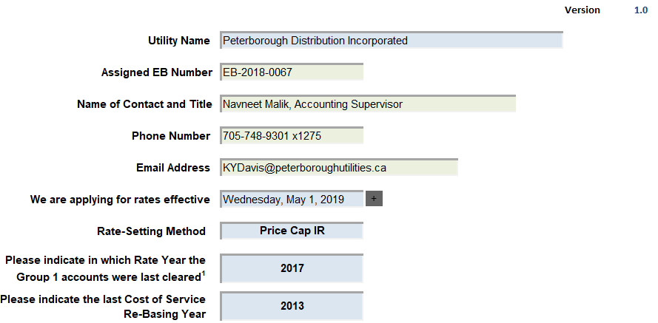

**Question # 2**

**Ref: Manager’s Summary, page 9**

The tax amount of $61,605 does not meet the minimum amount to generate a rate rider. Please confirm that the entire 50/50 sharing amount will be transferred to Account 1595 for disposition at a future date.

**Question #3**

**Ref: IRM Model, Tab 3**

Tab 3 of the IRM Model shows two interest adjustments for 2017 and variances in the same amount in relation to Account 1595 (2015 and 2016). Please explain the nature of these adjustments and the resulting variances.

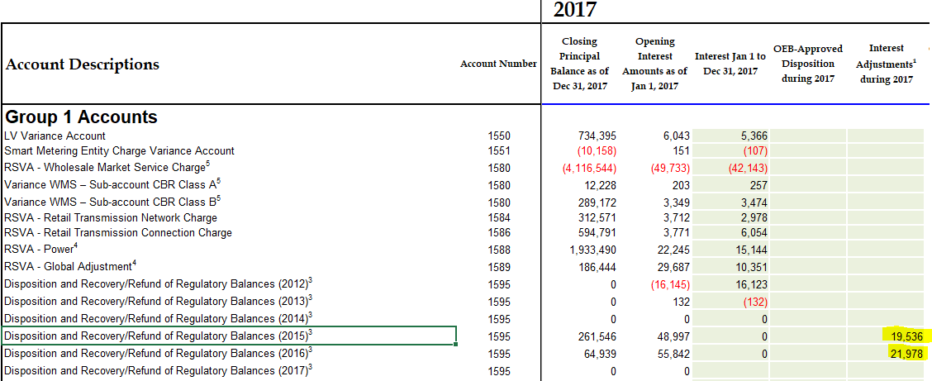

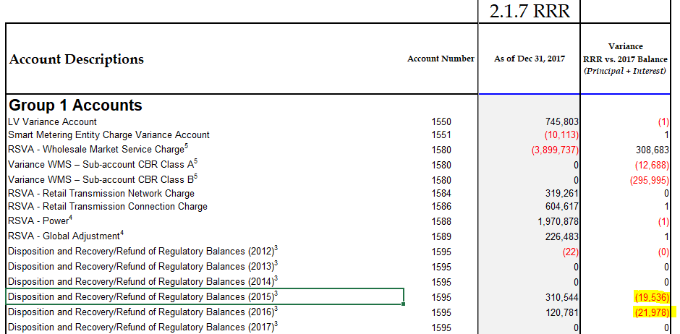

**Question #4**

**Ref: Account 1595 Workform**

The balance in Account 1595 (2015) shows a variance of greater than 10%. Please provide a detailed explanation including the underlying causes of the material balance in the “additional notes and comments” box of the workform.

**Question #5**

**Ref: Appendix A GA Methodology Questions**

In the responses provided to Question 2, Peterborough Distribution describes its RPP settlement process and subsequent true-up of those settlements.

1. Peterborough Distribution indicates that it performs a true-up of its RPP settlement two months after the initial submission. Please confirm that this means, for example, that the settlement of the month of December consumption would take place on January 4th. Then the subsequent true-up to actual of the settlement of the month December consumption would take place on Peterborough Distribution’s March 4th settlement with the IESO (2 months later).
2. Please confirm when Peterborough Distribution performs its RPP settlement true-up, it includes both the true-up to actual RPP consumption and the true-up to the actual GA rate, and both of these true-ups are done at the same time. For example, using the December 2017 RPP consumption settlement with the IESO, please confirm that both the true-up to actual December 2017 RPP consumption and the true-up to the actual December 2017 GA rate were both done on the March 4th, 2018 settlement with the IESO. If they are not being done at the same time, please provide further detail as to when each of the true-ups are performed
3. Peterborough Distribution has indicated that it has not recorded the true-ups for November and December 2017 settlements with the IESO in its DVA continuity schedule. However it appears that Peterborough Distribution has quantified those true-ups in Note 5 of its GA Analysis workform. Please indicate which adjustments from note 5 of the GA Analysis Workform represent the November and December 2017 RPP settlement true-ups. Please provide the true-up amount broken down by month.

**Question #6**

**Ref: GA Workform, Note 5, adjustments 1a, 1b and 8**

Peterborough Distribution has recorded several adjustments in the GA Analysis workform that it has described as RPP settlement adjustments.

1. Given that Peterborough Distribution has indicated that it uses Approach A in its response to Question 1 of the Appendix A GA Methodology questions, please explain why RPP settlement adjustment true-ups would impact account 1589 when no amounts related to RPP customers are recorded to this account?
2. Based on how Peterborough Distribution records its transactions to Accounts 1588 and 1589, as described in the Appendix A responses, shouldn’t all RPP settlement true-up adjustments only impact Account 1588? Please explain.

**Question #7**

**Ref: Appendix A GA Methodology Questions**

Question 3 of Appendix A requires Peterborough Distribution to describe how it initially records its CT148 charge from the IESO and whether the initial recording of that charge is based on estimate that would require a true-up at a later date. It appears that the responses provided by Peterborough Distribution do not address these requirements.

1. On or about the 15th of every month, Peterborough Distribution receives an invoice from the IESO that includes a charge for CT 148 Global Adjustments. Does Peterborough Distribution wait for the actual invoice from the IESO to come in before it records any amounts related to CT 148 in their G/L? Please explain
2. If the charge is initially estimated before the invoice is received, please explain when that estimate is made and how the estimate is quantified.
3. As part of its response to Question 1 of Appendix A Peterborough Distribution has indicated that it splits its CT 148 between accounts 1588 and 1589. Given that actual consumption for a particular month is not known at the time the CT 148 charge is received, the initial split between accounts 1588 and 1589 is based on an estimate. When is the true-up to the actual split performed? Please describe how that true-up is calculated.
4. Please quantify what the CT 148 true-up was for November and December 2017 and explain the journal entry that is recorded in the G/L in order to capture this true-up.
5. What period was the true-up of November and December 2017 CT 148 recorded in?

**Question #8**

**Ref: IRM Model, Tab 3**

1. As part of Peterborough Distribution’s last IRM application (EB-2017-0266), the OEB approved principal adjustments to Peterborough Distribution’s DVA continuity schedule in the amount debit $1,425,806 and credit $1,493,039 to Accounts 1588 and 1589 respectively. These principal adjustments are not reflected in the DVA continuity schedule submitted by Peterborough Distribution and therefore the continuity schedule does not represent what the OEB had approved in that proceeding. Please update the December 2016 closing balances in Accounts 1588 and 1589 within the DVA continuity schedule submitted as part of the current application, to reflect as principal adjustments during 2016, the amounts that had been approved as principal adjustments in that proceeding.
2. For 2017, please record the reversal of these 2016 principal adjustments in the principal adjustments during 2017 column of the DVA continuity schedule.