Greater Sudbury Hydro Inc. – 2019 Rates Application (EB-2018-0034)
OEB Staff Questions
January 30, 2019

Question #1
Ref: IRM Model, Tab 1
In Greater Sudbury Hydro’s 2018 rates application (EB-2017-0042), the Group 1 DVA accounts balances as of December 31, 2016 were not disposed of since the balances did not exceed the pre-set disposition threshold. Therefore, the rate year associated with this disposition should be 2017, which was the last time the Group 1 accounts were disposed of. In tab 1 of the IRM model, Greater Sudbury Hydro selected 2018 as the rate year in which the Group 1 accounts were last cleared. Please confirm if the rate year should be corrected to 2017.

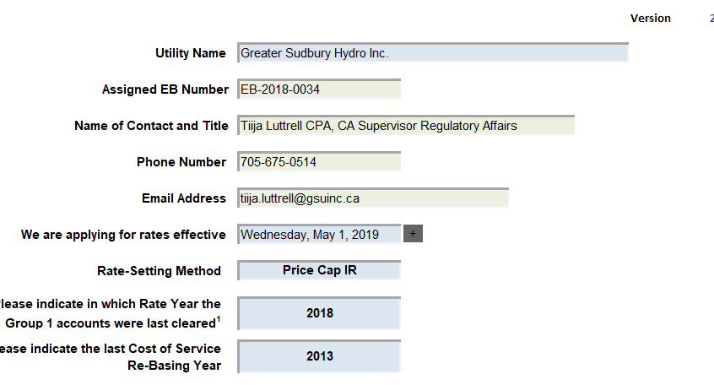

Question #2
Ref: 2019 IRM Application, Tab 2 (LRAMVA Threshold) of LRAMVA workform
2009 Decision and Order, EB-2008-0230, pp. 7-8
Greater Sudbury Hydro applied for disposition of a debit balance of $668,660 in lost revenues associated with new CDM program savings between 2012 and 2016 and carrying charges.

In the LRAMVA claim as filed, there are no forecast savings in 2012, and as a result, the full impact of lost revenues in 2012 is claimed. However, in the 2009 Decision and Order, EB-2008-0230, it appears that 2.618 GWh was quantified as the CDM manual adjustment to the 2009 load forecast.
- Please confirm whether the 2009 approved load forecast had in fact included 2.618 GWh to compensate for the reduction in CDM.
- If a) is confirmed, please discuss the appropriateness of not applying 2.618 GWh as the forecast savings in 2012 to determine the 2012 lost revenue impacts. As is currently filed, the full impact of 2012 lost revenues is claimed as there are no forecasted savings for 2012.

Question #3
Ref: LRAMVA workform
- If Greater Sudbury Hydro made any changes to the LRAMVA work form as a result of its responses to question 2, please file an updated LRAMVA work form.
- Please confirm any changes to the LRAMVA workform in response to the above LRAMVA question in “Table A-2. Updates to LRAMVA Disposition (Tab 2)”.

Question #4
Ref: IRM Model, Tab 3
In the continuity schedule for 2016, Greater Sudbury Hydro has input an interest adjustment for Account 1589 as highlighted below. Please explain this adjustment.

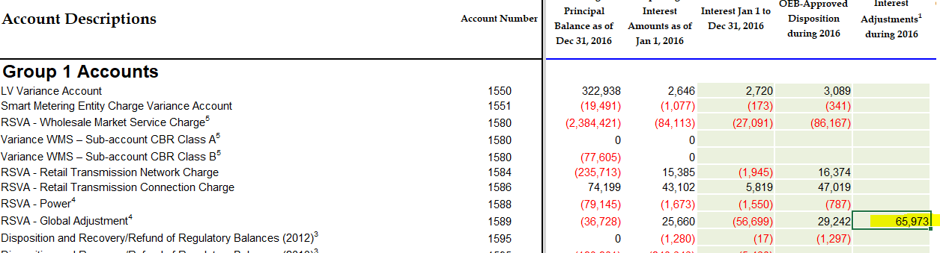

Question #5
Ref. Attachment 4, Question 2
This question requests certain information regarding the recording and true-up of the monthly CT 1142 charge from the IESO related to its RPP settlements.
- Please confirm whether OEB staff’s understanding of Greater Sudbury Hydro’s IESO settlement process is correct. The initial RPP settlement with the IESO for a given month uses estimates for RPP consumption, the GA rate, and the WAP. On a quarterly basis, Greater Sudbury Hydro will true up each of these estimated components of the IESO settlement, to actual. If any of the above is not correct, please clarify as needed.
- Greater Sudbury Hydro has indicated in its responses to question 2 that it has trued up its IESO settlements for Q4 of 2017 as part of its February 2018 settlement and accrued these true-ups as part of its December 31, 2017 balance as presented in the DVA continuity schedule. In the response to 2f, Greater Sudbury Hydro has quantified the net true-up for Q4 2017. Since the GA RPP gets recorded in account 1589 it means a portion of CT 1142 gets credited to account 1589, and the portion related to RPP-HOEP gets recorded in account 1588. With respect to the Q4 true-up, please breakdown the total net true up provided in 2f between the portion that got recorded to account 1588 (and indicate whether debit or credit) and the portion that was recorded to account 1589 (and indicate whether debit or credit). If the true-up was only recorded to one account, please explain why that would be appropriate.

Question #6
Ref. Attachment 4, Question 3
The questions request certain information regarding the recording of the monthly CT 148 charge from the IESO.
- In the 3a, it is not clear from that response whether Greater Sudbury Hydro waits for the actual Global Adjustments charge (CT 148) on the monthly IESO invoice to come in before it records any amounts in its G/L with respect to CT 148? Or does Greater Sudbury Hydro initially estimate the monthly global adjustments charge in advance of receiving the invoice and then true it up once the actual CT 148 IESO invoice comes in. Please explain.
- In regards to response 3g, if Greater Sudbury Hydro initially records all of CT 148 to account 1589, as stated in its response to question 1, then it is not clear as to why there would be a true-up adjustment that reclassifies global adjustment costs between accounts 1588 and 1589 when Greater Sudbury Hydro does not record any global adjustment costs (CT 148) to account 1588 in the first place. Please explain the nature of the adjustment that is recorded in response 3g and why it is necessary.

Question #7
Ref. 2016 and 2017 GA Analysis Workforms, Note 4 and Note 5
- In Note 4 of both the 2016 and 2017 GA Analysis Workforms, please confirm that the balances presented in column F of the table represent actual consumption billed for each particular month (actual consumption means the billing for consumption that was consumed in that particular month only and contains no overlap of months)
- Does Greater Sudbury Hydro estimate and record unbilled GA Revenue for the month of December? If no, please explain why Greater Sudbury Hydro does not need to accrue for unbilled GA Revenue for December.
- If the above is yes, then has Greater Sudbury Hydro compared its unbilled GA Revenue accrual for December 2017 consumption, with the actual revenue that ended up being billed in January 2018 (related to December 2017)?
- If the above is yes, please indicate what that delta is. If Greater Sudbury Hydro has not done the comparison, then please quantify as part of its response to this question.

Question #8
Ref. 2016 and 2017 GA Analysis Workform, Note 5
Please confirm that for Greater Sudbury Hydro’s December 2017 class A consumption, the utility has accrued the related GA cost and GA revenue on the basis (i.e. GA revenue = GA cost) to ensure that no amounts related to class A customers is being picked up in account 1589. If they do not equal, please quantify what the delta between the two is.

Question #9
Ref. 2016 GA Analysis Workform, Note 5
- The sum of cell C62 and C73 must equal the Transaction debit / (credit) during 2016 as presented in the DVA continuity schedule. As currently presented it does not. Therefore, please adjust accordingly.
(Note that you do not need to present the approved disposition during the year in the GA Analysis Workform. Instead, C62 should just be populated with the balance in the “Transactions debit / (credit) during 2016” column of the DVA continuity schedule.)
- Please provide the calculation used to quantify adjustment 7 in Note 5 of the 2016 GA Analysis Workform.
- Please explain the nature of adjustment 9 and why it should be presented as a debit in the reconciliation in Note 5. Was this amount accrued as part of the 2015 DVA balances that were approved for disposition by the OEB?

Question #10
Ref. 2017 GA Analysis Workform, Note 5
- Please provide the calculation used to quantify adjustment 7 in Note 5 of the 2016 GA Analysis Workform.
- Greater Sudbury Hydro refers to differences between the IESO posted GA and the GA rate per the IESO invoice as the source of a reconciling item in Note 5. Please explain what the differences between the IESO invoice and the posted rate relate to. Please further explain how Greater Sudbury Hydro quantified the impact of this difference and provide the calculation. Finally, please also explain why presenting the adjustment as a credit balance in the reconciliation is appropriate.

Question #11
Ref. DVA Continuity Schedule, Account 1588
Greater Sudbury Hydro is seeking disposition of approximately $438K (credit) in account 1588. Given that Account 1588 accumulates the variance between the RPP revenue and the cost of energy and gets settled directly with the IESO on a monthly basis, the expectation is that any remaining amounts in account 1588 would be relatively small and close to zero (primarily comprised of the difference between amounts billed at the approved total loss factor versus actual system losses for the year). Based on the above expectation, please explain what comprises the balance in account 1588 as at December 31, 2017 (or confirm that it is in fact only the accumulation of the loss factor differences for the two years that remains in this account).

