Synergy North Corporation.
OEB Staff Questions
EB-2018-0069

Synergy North Corporation (Thunder Bay Rate Zone )
EB-2018-0069

OEB Staff-1
Ref: Follow up to Response Staff question 3
Synergy North provided the following response to staff question 3.
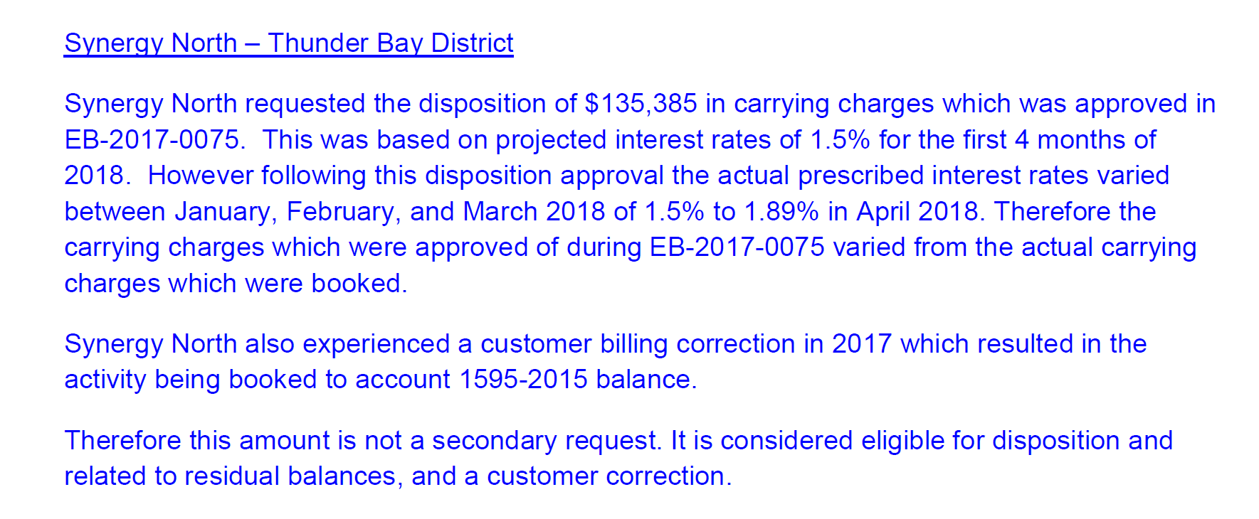
The OEB expects the distributor to absorb the differences in interest rates approved for disposition regardless of whether they are a debit or credit balance. The OEB also expects distributors to only seek disposition once of the 1595 sub-accounts. The balance of $1,625 in Account 1595-2015 is considered nominal.
Given the above OEB guidance please confirm if Synergy North agrees to withdraw its request to dispose of Account 1595-2015.

