March 12, 2019

Ontario Energy Board
P.O. Box 2319
27th Floor, 2300 Yonge Street
Toronto, Ontario
M4P 1E4

Re: Lakeland Power Distribution Ltd. 2019 Cost of Service Application, EB-2018-0050

Dear Ms. K. Walli:

Lakeland Power Distribution Ltd. (LPDL) is scheduled to file its Settlement Proposal in regard to EB-2018-0050 on March 14th, 2019.

The Parties continue to use best efforts to work towards a potential settlement of the issues in respect of the application, however LPDL is requesting that the deadline to file the Proposal be extended to March 22nd, 2019 to allow for more time for the Parties to work through the settlement process.

Respectfully Submitted,
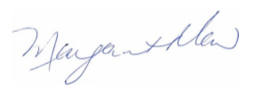
Margaret Maw
Chief Financial Officer
Lakeland Power Distribution Ltd.

CC: John Vellone and Bruce Bacon, Borden Ladner Gervais LLP
Mr. Andrew Pride
Intervenors of record in EB-2018-0050

