Waterloo North Hydro Inc.
OEB Staff Questions
EB-2019-0071

Waterloo North Hydro Inc.
EB-2019-0071

Staff Question-1
Ref: Managers Summary, Page 8
Waterloo North explained the variance of ($495,997) between the requested amount and the RRR 2.1.7 for Account 1588 RSVA-Power as below:
WNH completed a review of this account in 2019. Due to the current process for
settlement it was determined that there is a price variance that had not been truedup with the IESO in 2017 and 2018. This will be resolved for 2019 and future years due to the transition to the new 1588/1589 account rules set out by the OEB. It was determined that the true-up required for 2017 was $1,193,281. In WNH’s 2019 application $398,902 had been adjusted as this was the amount of variance that could be determined at that time. This leaves of a remainder of $794,379 to be adjusted in the 2020 application. The same process was completed for the 2018 year. The variance for 2018 was $(298,382). This accounts for the difference of $495,997. See Table 2.7a – 2017 & 2018 True-Up Adjustments for the details.

Table 2.7a provides the breakdown of the variance $ into months of 2017 and 2018. A note in Table 2.7a states that
WNH currently submits 1598 settlement based on billed usage. The true up value calculated in these tables represents the difference between the amount we submitted for 1598 and the actual usage for the settlement month. The actual HOEP and GA rates were used in calculating the difference. The settlement
data was pulled directly from our submissions and the consumption was pulled from our billing system.

- Please explain the differences in terms of methodology between the 2017 true-up of $398,902 that was included in 2019 application and the current true-up for 2017 that results in an additional true-up amount of $794,379.
- Based on the note provided in Table 2.7a, please confirm that the current true-up is a true-up of both usage and price.
- Please explain why the true-up does not impact Account 1589 Global Adjustment.
- Please provide the supporting calculations in excel including usages and prices of each months for the monthly true-up variances $ in 2017 and 2018.

Staff Question-2
Ref: Attachment B GA Analysis Workform & Appendix A Responses, Pages 2&3
Waterloo North provided the following answer to question 11. b) for the true-up process for CT 1142 as below:
In account 1588 RSVA power for 2017 and 2018 true-ups between TOU / Tier
1 & 2 prices have been calculated and discussed in section 2.7 of the IRM
application. This has been corrected annually since the review of the 2019 IRM application however this process is being amended under the new accounting guidance methodology and will be reviewed monthly on a go forward basis.

- Please elaborate on the statement that “this process is being amended under the new accounting guidance methodology” and identify the main differences between the current process and the process that is being amended.

Staff Question-3
Ref: Attachment B GA Analysis Workform & Appendix A Responses, Pages 2&3
Waterloo North explained in question 10 b) that:
CT 148 is booked into Account 1589. The portion of CT 1142 equaling RPP minus HOEP for RPP consumption is booked into Account 1588. The portion of CT1142 equaling GA RPP is credited into Account 1589.

Waterloo North explained in question 11 a) that:
In order to determine the full GA for all customers, Waterloo North Hydro
(WNH) multiplies Waterloo North Hydro's total system load (kWh) by the
Class B second estimate ($/MWh converted to $/kWh) for the settlement
month. The dollar value associated with Class A usage is subtracted from the
total Global Adjustment amount to determine the Class B Global Adjustment
amount (CT 148). The usage for all non-RPP customers is multiplied by the
second estimate to determine the amount of the non-RPP portion of GA
(recorded in 1589). [Emphasis added]

Waterloo North answered in question 12 a) that:

As noted above in 2a) In order to determine the full GA for all customers,
Waterloo North Hydro (WNH) multiplies Waterloo North Hydro's total system
load (kWh) by the Class B second estimate ($/MWh converted to $/kWh) for
the settlement month. The dollar value associated with Class A usage is
subtracted from the total Global Adjustment amount to determine the Class B
Global Adjustment amount (CT 148). This is recorded in 1589. The RPP
portion of GA is removed from 1589 as noted above and included on CT 1142. [Emphasis Added]

- Please explain what exactly is recorded in Account 1589 for the GA expense? Please choose from the answers below:
- CT 148 on the IESO invoice – RPP portion of GA that is submitted on the IESO RPP claim form
- Total System Load (kWh) X GA 2nd estimate rate – Class A GA $ - RPP portion of GA that is submitted on the IESO RPP claim form
- [Total System Load (kWh) – Class A volume (kWh) – RPP volume (kWh)] x GA 2nd estimate rate
- Others – please explain in details.

If the answer above for the GA expense is not i), please explain why Waterloo North does not use the total GA expense on the IESO invoice to allocate the RPP and Non-RPP portions of the GA.
Staff Question-4
Ref: Rate Generator Model, Tab 3 – Continuity Schedule
OEB staff notes that there was a formula error in the IRM Rate Generator Model posted on the OEB’s webpage.

On tab 3 the formula for cell BM41 is =Sum(BM39,BM40) - BM37. The last portion of the formula (i.e. – BM37) is an error.

OEB staff has made the necessary correction to the Rate Generator Model and provided it along with these questions.

Please confirm Waterloo Hydro’s acceptance of the revised model.

Staff Question-5
Ref: Rate Generator Model, Tab 4 – Billing Det. for Def-Var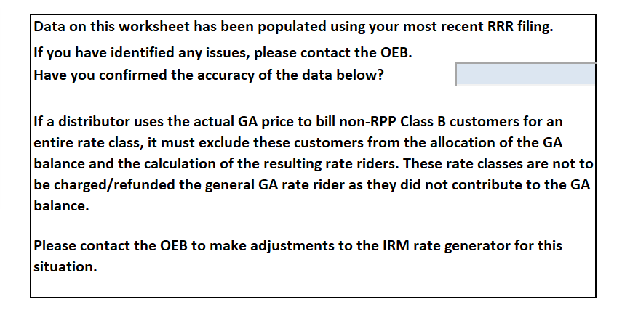
Please confirm Waterloo Hydro has confirmed the accuracy of the data on Tab 4 – Billing Det. for Def-Var. Once confirmed please update Tab 4.

Staff Question-6
Ref: Managers Summary, Page 6
Managers Summary, Page 14
Rate Generator Model, Tabs 11 – RTSR – UTR’s & Sub-Tx and
12 – RTSR – Historical Wholesale
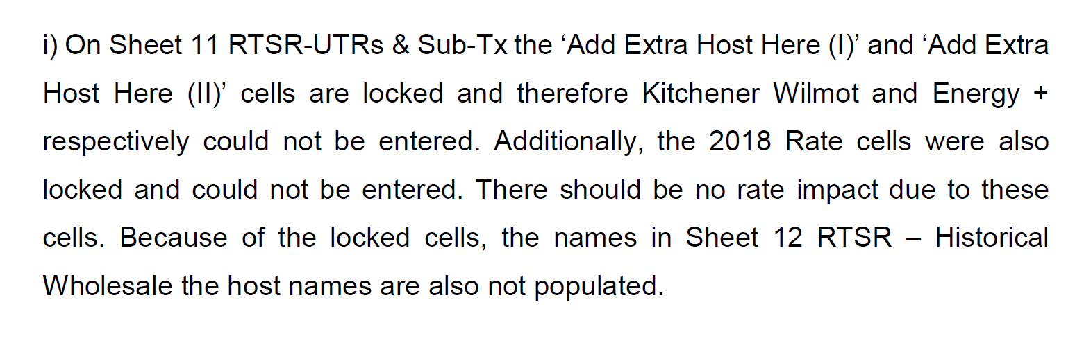
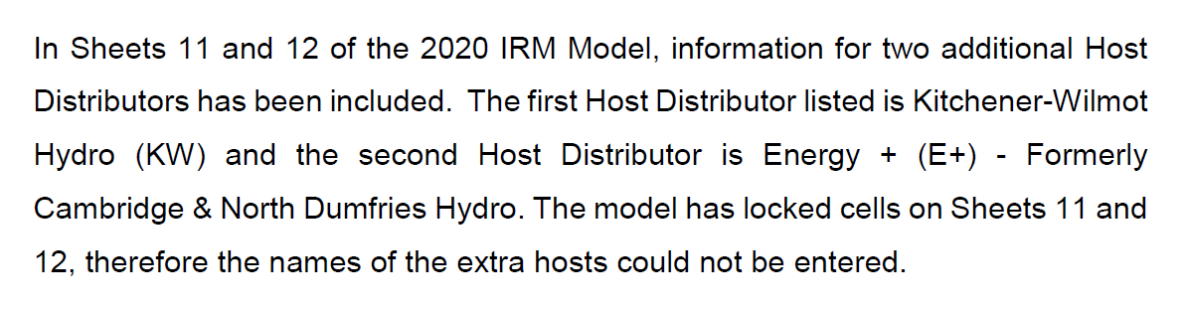OEB staff have unlocked the cells on Tabs 11 – RTSR – UTR’s & Sub-Tx and 12 – RSTR – Historical Wholesale, please update the IRM Rate Generator model accordingly.

Staff Question-7
Ref: Managers Summary, Page 6
Rate Generator Model, Tab 20 – Bill Impacts
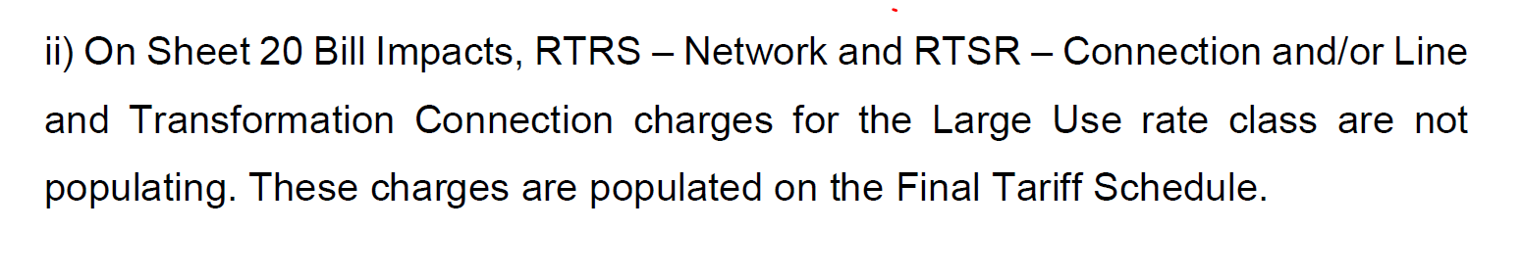
OEB staff have updated cell M33 to Demand – Interval from Interval for the Large Use Service Classification, please confirm this is correct. The RTSR – Network and RTSR – Connection and/or Line and Transformation Connection charges are now populating in the Bill Impacts Tab.

Staff Question-8
Ref:
Rate Generator Model, Tab 20 – Bill Impacts
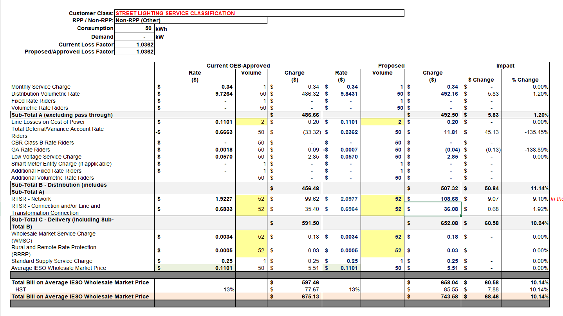
Has Waterloo Hydro considered requesting the DVA rate rider disposition period be over 24 months for the Street Lighting rate class, in order to mitigate the bill impact of greater than 10%?

