Canadian Niagara Power Inc. (Canadian Niagara Power)
2020 IRM Application
EB-2019-0024
Application Analysis
September 12, 2019

Staff Question #1
Ref: A portion of Sheet 3 “Continuity Schedule” is reproduced below

The table from Canadian Niagara Power’s 2018 IRM Decision which identified the principal and interest amounts approved for disposition, is reproduced below.
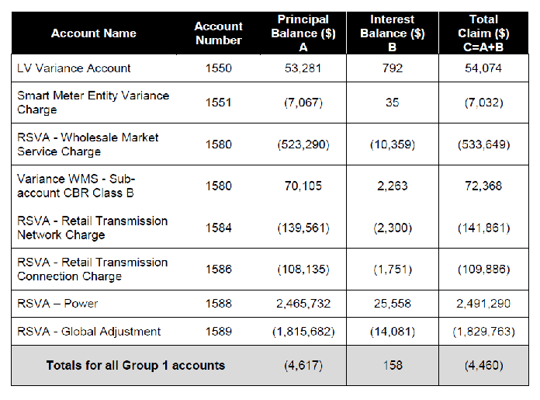

- OEB staff notes that the “OEB-Approved Disposition during 2018 (Cells BJ23 & BJ25) do not reconcile with the approved amounts in the 2018 IRM decision.
Please reconcile differences. If the input into the Rate Generator Model is an error please provide corrections and OEB staff will make the necessary changes to the model.
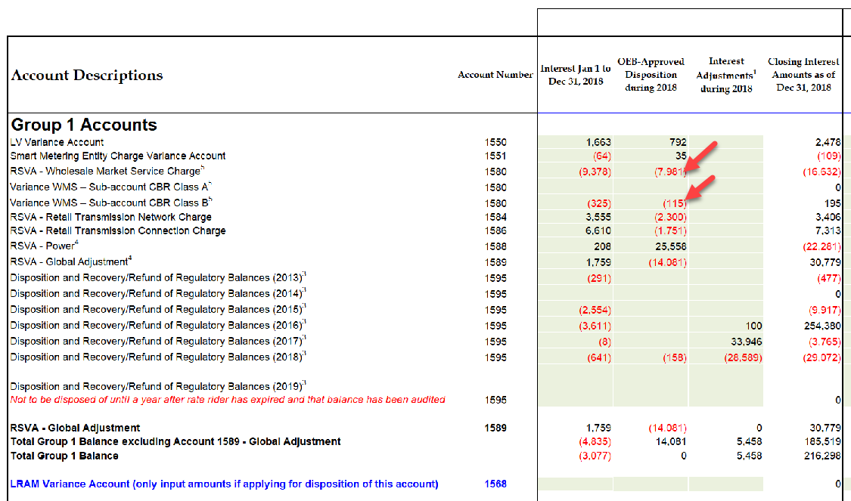

CNPI Response

- Due to an input error into the schedule, please adjust Cell BI23 to (11,756), cell BJ23 to (10,359), BI25 to 2,053 and BJ25 to 2,263. This will not change the closing interest amounts as of Dec 31, 2018 for both rows of the model. The adjusted amounts will then agree to the 2018 IRM decision.

Staff Question #2
Ref: GA Analysis Workform – Note 3 – GA Billing Rate

Please explain why Canadian Niagara Power is not using the same GA Rate used for unbilled revenue as the one used for billed revenue in any particular month.

CNPI Response

Please refer to ‘Unbilled Accrual Class A and B Customers’ section within the Application, which can be found on Page 14 of 17. For greater clarity, due to the tight financial reporting deadlines, billing for the month ceases prior to the end of the month such that the unbilled report can be run, analyzed, and financially posted on a timely basis. Given that the 2nd GA estimate is not yet available at the time the first unbilled report is run, the 1st GA estimate is therefore applied to all non-interval customer unbilled estimates.

Staff Question #3
Ref: A portion of Sheet 3 “Continuity Schedule” is reproduced below
Account 1595 (2016) Adjustments:
- Please provide explanation to the “Principal Adjustments during 2017” of $42,496 and “Interest Adjustments during 2017” of ($42,496) entered in Account 1595 (2016).

- Please provide explanation to the “Principal Adjustments during 2018” of ($100) and “Interest Adjustments during 2018” of $100 entered in Account 1595 (2016).

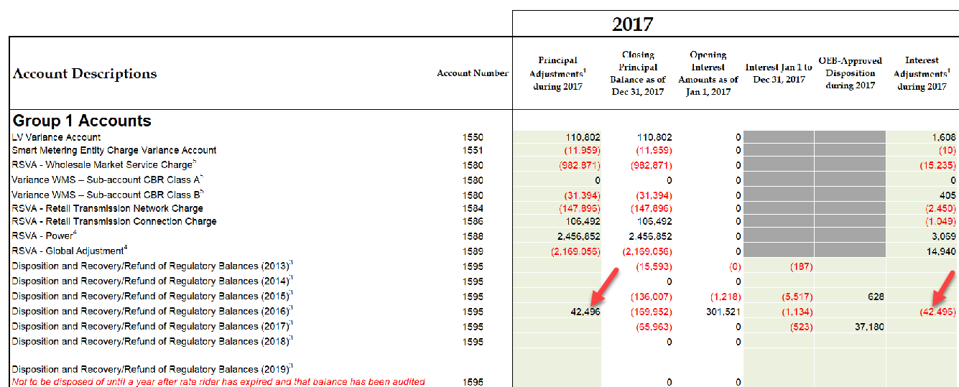

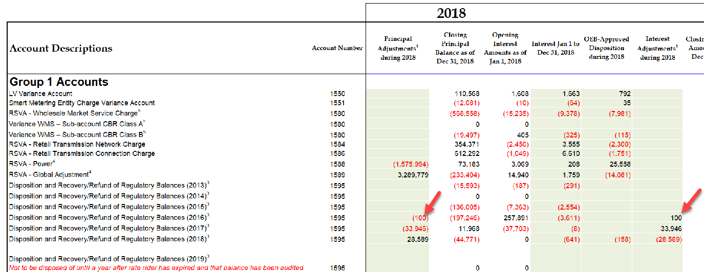

CNPI Response

- In accordance with ‘Appendix A: Application of Recoveries in Account 1595’ in the Chapter 3 filing requirements version dated July 20, 2017, these amounts reflect the drawdown of a portion of the interest balance transferred to 1595, which is to only occur after the principal has been fully drawn down on. Given that a more recent version of the Chapter 3 filing requirements is silent on this topic, CNPI has continued to follow this guidance.

- The same comment as a) above.

Staff Question #4
Ref: Manager’s Summary p.15
At the above reference, Canadian Niagara Power states that it is still reviewing the February 21, 2019 standardized accounting guidance with respect to the accounting for Accounts 1588 and 1589. It further indicates that as of the submission date, no material adjustments have been noted, but a full review was not yet complete.
- Is Canadian Niagara Power seeking final disposition of its 2017 and 2018 Group 1 DVA account balances as part of the current application?

- Is the response to the above is yes, the OEB will only consider a utility’s request for final disposition of its Group 1 DVA account balances once it has confirmed that the February 21, 2019 OEB accounting guidance has been fully implemented and all resulting material adjustments have been recorded.

Accordingly, please provide a status update with respect to the implementation of the OEB’s February 21, 2019 accounting guidance related to Accounts 1588 and 1589, including a summary and explanation of any adjustments to both 2017 and 2018 that results from the implementation.

- Have the above referenced adjustments been reflected within the amounts being sought for disposition as part of the current proceeding? If not, please explain why.

- If in the above response the utility has indicated that the OEB’s February 21, 2019 accounting guidance is not fully implemented as of the date of these IR responses, please explain why full implantation has not yet occurred given that the guidance is effective from January 1, 2019. Please also provide details as to the level of work that is left to complete and when the utility expects to complete this work by.
CNPI Response

- Yes. In contemplating CNPI’s responses in b) to d) below, CNPI is still seeking final disposition of 2017 and 2018, as differences in 2017 and 2018 have been quantified as being immaterial in c) below.

- CNPI will have the OEB’s February 21, 2019 accounting guidance related to Accounts 1588 and 1589, fully implemented by the end of 2019. As of August 31, 2019, CNPI has implemented a substantial portion of the guidance including the calculations for the RPP settlements process. This has been completed retroactively to January 1, 2019 and the differences calculated were submitted to the IESO in CNPI’s August 2019 submission (by 4th business day of September), as well as reflected in the DVA account balances. CNPI has also performed a recalculation of 2017 and 2018 RPP settlement amounts, and the differences have been quantified in the table below. As of August 31, 2019, CNPI also updated its month-end unbilled estimates to better align with the guidance.

The remaining month-end “process” related implementation of the accounting guidance has been delayed due to system implementation timing limitations, but CNPI will ensure that all 1588, 1589, 4705 and 4707 2019 year-end RRR filing reported balances will be reflective of the new guidance; hence why CNPI is requesting final disposition of its 2017 and 2018 Group 1 DVA account balances as part of the current application.

As part of its review of the OEB’s February 21, 2019 accounting guidance related to Accounts 1588 and 1589, CNPI noted that the RPP settlements approach outlined in the guidance varied slightly from the RPP settlements that CNPI had been historically completing and reporting. For example, all GA amounts calculated in the RPP settlements process that were part of charge type 142/1142 on IESO invoices, had been posted to OEB 4707/1589 instead of 4705/1588. Also, all Class B Global Adjustment amounts in charge type 148 on IESO invoices had been posted to OEB 4707/1589, instead of posting the RPP portion of Class B to 4705/1588. Additionally, CNPI historically used the average weighted price obtained from an independent 3rd party database, rather than following the exact calculation methodology prescribed in the guidance. Finally, the kWhs used in the RPP settlements process was based on billed loss adjusted kWhs, rather than ensuring that the aggregate of RPP and non-RPP kWhs agreed to total system load for the period being settled.

CNPI has quantified the variance between CNPI historically reported values as presented in the DVA balances within this application, and the amounts calculated in accordance with the OEB’s February 21, 2019 accounting guidance related to Accounts 1588 and 1589. The table below outlines a summary of the adjustments that would need to be considered, for each of 2017 and 2018, in the 1588 and 1589 accounts:

Year | Account | Adjustment Dr (Cr)
2017 | 1588 | $29,008
2017 | 1589 | ($39,002)
2018 | 1588 | $114,209
2018 | 1589 | ($33,293)

- Using the materiality calculation of 0.5% of annual GA and Cost of Power costs outlined in the Accounts 1588 and 1589 Q&A’s released July 11, 2019, CNPI has not made any further adjustments to the DVA balances sought for recovery in this proceeding. Materiality was calculated in the table below:

Year | Account | 2.1.7 RRR $ Amount Filed | 0.5% Materiality Calc | Variance in b) Above | Conclusion
2017 | 4705 – COP | $28,867,683 | $144,338 | $29,008 | Immaterial, no DVA adj required
2017 | 4707 - GA | $18,993,669 | $94,968 | ($39,002) | Immaterial, no DVA adj required
2018 | 4705 – COP | $29,490,087 | $147,450 | $114,209 | Immaterial, no DVA adj required
2018 | 4707 - GA | $16,006,362 | $80,032 | ($33,293) | Immaterial, no DVA adj required

- Please see b) above. Although the guidance has been substantively implemented as of August 31, 2019, the remaining month-end “process” related implementation of the guidance has been delayed due to system implementation timing limitations. Full implementation will occur by the end of 2019, with 2019 year-end balances in 1588 and 1589 being in compliance with this new guidance.
Staff Question #5
Ref: GA Analysis Workform

- As part of the GA Analysis Workform, Canadian Niagara Power has recorded as adj. 2b an amount of debit $203k related to the understatement of the accrual for December 2018 unbilled revenue. OEB staff believes that it should be presented as credit of $203K since it is supposed to be a true-up related to the understatement of the December 2018 unbilled revenue accrual. If Canadian Niagara Power believes that presenting it as a credit adjustment in the GA Analysis Workform is not accurate, then please explain why. Otherwise, please update the GA Analysis Workform and the DVA continuity schedule accordingly.

- Also the supporting explanation that was provided for the above amount within the GA Analysis Workform appears to relate to only 103K of the total adjustment. If this is a typo then please update accordingly. Otherwise, please explain what the remaining 100k relates to.

- The explanat5ion provided for Adj. 13 within the GA Analysis Workform seems to only provide detail regarding 43K of the total $132K adjustment. If this is a typo, then please update accordingly. Otherwise, please provide the explanation relating to the remaining 90K.

- Canadian Niagara Power does not have an adjustment in the GA Analysis Workform to remove 2018 GA balances related to Class A customers (other than the reversal of the 2017 principal adjustment). If Canadian Niagara Power believes that an adjustment for 2018 is not required, then please explain why that is the case.

CNPI Response

- The explanation for 2b should be corrected to read: $203k relates to the overstatement of the December unbilled revenue accrual of the current year and billed actual (DR to be recorded in DVA in current year), therefore, should record the DR in current year. The GA Analysis Workform has been updated.

- Please see a) above. This was a typo and that the explanation should read $203k. The GA Analysis Workform has been updated.

- The explanation for Adj. 13 should be corrected to read: Difference in Class B GA for IESO purchases accrued at December of current year and actual GA charged on IESO invoice. $132k relates to the understatement of the December IESO payable accrual (DR to be recorded in DVA in current year), therefore, should record the DR in current year. The GA Analysis Workform has been updated.

- In 2018, CNPI aligned its unbilled revenue Class A accrual amounts with the amount it accrued under IESO charge type 147 (Class A GA). Therefore, no adjustment for 2018 is required.

EB-2017-0031

