Festival Hydro Inc.
OEB Staff Questions
EB-2019-0035

Festival Hydro Inc.
EB-2019-0035

Staff Question-1
Ref: IRM 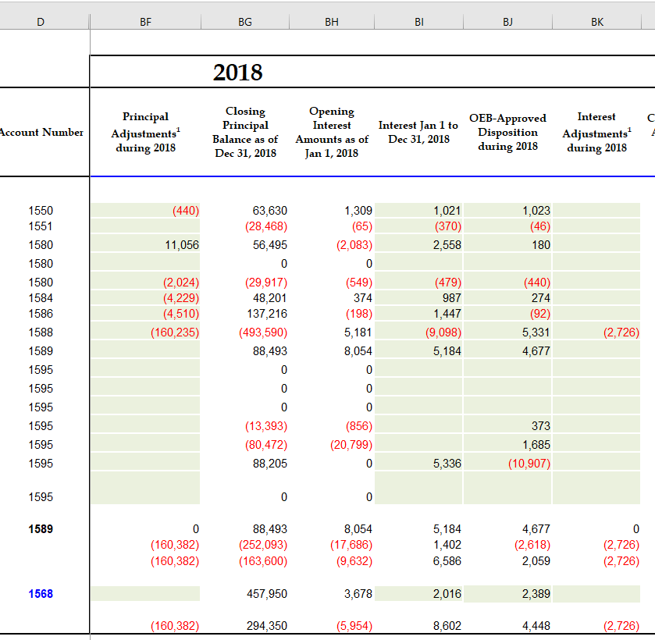

Rate Generator Model – Tab 3 Continuity Schedule

- Please explain the reason for the adjustments in column BF, for accounts 1550, 1580, 1584 and 1586.

- Please confirm there have been no adjustments to previously disposed of balances.

Staff Question-2
Ref: Managers Summary – Page 9
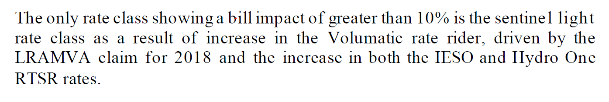
Has Festival Hydro considered requesting the LRAMVA rate rider disposition period be over 24 months for the sentinel light rate class, in order to mitigate the bill impact of greater than 10%?

Staff Question-3
Ref: Rate Generator Model, Tab 3 – Continuity Schedule
OEB staff notes that there was a formula error in the IRM Rate Generator Model posted on the OEB’s webpage.

On tab 3 the formula for cell BM41 is =Sum(BM39,BM40) - BM37. The last portion of the formula (i.e. –BM37) is an error.

OEB staff has made the necessary correction to the Rate Generator Model and provided it along with these questions.

Please confirm Festival Hydro’s acceptance of the revised model.

Staff Question-4
Ref: Manager’s Summary, p. 6
Festival Hydro indicates that it has implement the OEB’s guidance related to the accounting for accounts 1588 and 1589 as outlined in the OEB’s February 21, 2019 letter to distributors.

- As part of its previous IRM application (EB-2018-0032), Festival Hydro’s audited 2017 Group 1 DVA account balances were approved for interim disposition by the OEB. The intent of the interim disposition was to allow Festival Hydro to go back and update the 2017 balances in accounts 1588 and 1589 once the OEB had issued its standardized guidance on the accounting for these accounts (i.e. the Feb 21, 2019 guidance). In the evidence filed for the current proceeding, Festival Hydro has confirmed that it has implemented the OEB’s guidance from January 1, 2018, but it is not clear whether it went back and quantified the impact of the new guidance on its 2017 balances as well. Please confirm whether Festival Hydro has implemented the February 21, 2019 OEB accounting guidance to its 2017 balances in accounts 1588 and 1589.

- If the response to the above is yes, was there an adjustment to the 2017 balances as a result of the implementation. If so, please explain the nature and amounts of each of the 2017 adjustments.

- Are the 2017 adjustments included as part the principal adjustments that have been recorded against account 1588 in the DVA continuity schedule of the current proceeding (i.e. the credit $162,961)? If not, please explain why they have been excluded and please update the DVA continuity schedule accordingly.

- If Festival Hydro has gone back to its 2017 Group 1 DVA account balances and implemented the OEB’s February 21, 2019 accounting guidance, is Festival Hydro seeking OEB approval for final disposition related to its 2017 Group 1 DVA account balances as part of the current proceeding?

Staff Question-5
Ref: IRM Rate Generator Model - Tab 3 – Continuity Schedule
Festival Hydro has recorded a principal adjustment of credit $162,961 against account 1588 related to the implementation of the OEB’s February 21, 2019 guidance. Festival Hydro has indicated that the adjustment relates to the 2018 settlements for embedded generation.
- Please explain the issue that has given rise to this adjustment (i.e. what wasn’t Festival doing before that it is now doing).

- Please explain why the adjustment only impacts account 1588, but no impact on account 1589.

Staff Question-6
Ref: GA Analysis Workform
Festival Hydro has completed a GA Analysis Workform in support of its disposition of the 2018 balance in account 1588.
- Please quantify the impact of the difference between the approved loss factor and the actual loss factor for 2018. If the balance is material, please include it as a reconciling adjustment in the GA Analysis Workform (adjustment 7 in the GA Analysis Workform).

- Please confirm that all GA revenues associated with Class A customers have been accrued on the same basis as the IESO costs accrued for those customers, and that no balances pertaining to Class A customers are represented in the closing amounts of Account 1589.

- In the final rate generator model from EB-2018-0032, there is a principal adjustment of credit $52,979 that is recorded against the closing 2017 balance of account 1589. Please explain why Festival Hydro is not proposing to reverse that principal adjustment as part of the closing 2018 balance in account 1589 in the current proceeding. If it needs be recorded as part of the disposition of the 2018 balance in account 1589, then please update the DVA continuity schedule and the GA Analysis Workform to reflect this adjustment.

Staff Question-7
Ref: Participation and Cost Report (filed July 22, 2019)
It appears Festival Hydro has filed another version of the Participant and Cost Report to support its 2018 CDM savings included in the LRAMVA.
Please re-file the Participation and Cost Report made available by the IESO, which includes unverified 2018 program results and a tab titled “LDC Progress” that contains CDM savings results in 2015 to 2018.

Staff Question-8
Ref: Application, p. 7
2019 Decision (EB-2018-0032), Tariff of Rates and Charges
In the application, Festival Hydro notes that it continues to carry a balance of $10,235 from the 2016 disposal and requests that the balance be rolled into the approved 2020 1595 rate rider.
- Please confirm:
  - Festival Hydro was approved disposition of a residual balance of ($14,489) in Account 1595 (2016) in the 2019 IRM proceeding and it was disposed of through the 2019 DVA rate riders.
  - Festival Hydro continues to carry a remaining residual debit balance of $10,235 from the 2016 disposal that is solely related to the LRAMVA balance.

- Please explain how the residual debit balance of $10,235 was derived, and show calculations.

- Please discuss why Festival Hydro believes it is appropriate to transfer a residual balance from 1595 (2016) sub-account to the 1595 (2020) sub-account, considering the residual balance is related to the 2016 vintage year and should only be cleared once.

Staff Question-9
Ref: Tabs 5 and 8 of LRAMVA workform
In Tab 8 of the LRAMVA workfrom, Festival Hydro provided the following explanation under the “Street Lighting Process and Methodology” section:
All past Retrofit Streetlighting projects do not contribute Peak Demand Savings, as verified in the IESO list of historical projects. Therefore, no Peak Demand Savings were subtracted from previous Retrofit years as a result of removing street lighting projects from the Retrofit Program. Similarly, no Energy Savings were subtracted from previous Retrofit years because the municipalities that undertook these projects are all General Service 50 to 4,999 kW customers, which are billed on kW, not kWh. Removing Energy Savings from the Retrofit program in the years the streetlighting projects were completed without reallocating the rate class distributions for these years would incorrectly reduce the total 'Actual CDM Savings' in these years allocated to the General Service < 50 kW rate class, which is billed on kWh. Additionally, making changes to the Retrofit Energy Savings to reflect streetlighting projects would have no impact on General Service 50 to 4,999 kW customers, as 'Actual CDM Savings' for this rate class is calculated in kW, not kWh. (emphasis added)

- Based on the description provided in Tab 8, please confirm that the energy savings from the 2015, 2016 and 2017 saveOnEnergy retrofit programs (per Tab 5 of the LRAMVA workform) include kWh savings from street light projects.

- If question a) is confirmed, please show how there would be a misallocation of savings to the GS<50 kW class (incorrectly reducing total actual savings allocated to the GS<50 kW class) if the kWh savings from street light projects were removed from the saveOnEnergy retrofit program.

- Please re-calculate the LRAMVA balance, with the kWh savings from street light upgrades excluded from the 2015, 2016 and 2017 saveOnEnergy retrofit program. Please file another version of the LRAMVA workform showing this revision in Tab 5 of the LRAMVA workform.

Staff Question-10
Ref: Tab 8 of LRAMVA workform
Festival Hydro provided detailed tables, in the LRAMVA workform, showing the difference between pre- and post- billed demand to calculate street light savings. However, in the application, Festival Hydro did not include information on the eligibility of the street light savings claimed, as noted in the Addendum to section 3.2.6 of the Filing Requirements.
- In the detailed project tables (#1 to 5) with pre- and post-billed demand data broken down by bulb retrofitted or replaced, please confirm that the upgrades in each table were implemented as one-time upgrades, as of the completion date (noted in parenthesis in the table name). If the total billed demand for the pre- and post-installation tables represent upgrades that happened during the year and ended as of the completion date, please indicate why the upgrades/retrofits could not be broken down by the specific month of the upgrade.

- In the Summary tables, please clearly explain how the monthly billed kW amounts (in column c) relate to the persistence calculations (the latter of which are used for lost revenue calculations), and how the billed kW amounts relate to the kW amounts that are documented in the detailed project tables (to the left hand side of the Summary table).

- Please confirm that the street light upgrades represent only incremental savings attributed to the municipality’s participation in the IESO’s CDM program. If there are savings that are not attributable to the participation in IESO’s program, please remove the savings attributable to other non-IESO programs.

- Please confirm that the energy savings associated with street light upgrades from the 2015 saveOnEnergy retrofit program have been removed. If not, please explain.

- Please confirm that Festival Hydro has received reports from the municipality that validates the number and type of bulbs replaced or retrofitted through the IESO program.

Staff Question-11
Ref: Tab 6 of LRAMVA workform
Festival Hydro’s LRAMVA balance is inclusive of carrying charge amounts to June 30, 2019, but it should have been calculated up to January 1, 2020.
Please confirm that the projected carrying charges in Tab 6 of the LRAMVA workform have been updated to December 31, 2019.

Staff Question-12
- If Festival Hydro made any changes to the LRAMVA work form as a result of its responses to the above LRAMVA questions, please file an updated LRAMVA work form, the revised LRAMVA balance requested for disposition, and a table summarizing the revised rate riders.

- Please confirm any changes to the LRAMVA workform in response to these LRAMVA questions in “Table A-2. Updates to LRAMVA Disposition (Tab 2)”.

