

|  |  |  |  |
| --- | --- | --- | --- |
| **Document ID:** | PC-7 | **Author(s)**  **and Project Manager:** | **Samantha Tam** |
| **Issue:** | **1.0** | **Sponsor:** | **David Short** |
| **Effective Date:** | **June 7, 2019** | **Project ID:** | **442** |

**Purpose**

The project charter formally authorizes the initiation of a project and gives the project manager authority to apply organizational resources to the project activities, and gains the commitment of resource managers and stakeholders. The Project Charter acts as the contract between the project manager and project sponsor. The Project Charter is flexible and scalable to address the size and nature of a particular project or program. The Project Charter can be used by the project manager to gain approval for the full project cost, timeline and resources or can be evolved (through subsequent versions) to seek approval for one or more phases of the project. During the planning phase the project team refines the project’s goals and scope and determines the project cost and schedule through a number of activities including, analysis, design and procurement. The outcome of the planning phase will be documented in the Project Plan.

The Project Charter includes a description of the business needs, describes how the project will address them, and is an instrument for gaining stakeholder agreement about the vision and goals. The Project Charter:

* Establishes high-level goals or objectives for the project;
* Shows alignment of the project to enterprise strategy, goals and priorities;
* Identifies key stakeholders, both internal and external;
* Identifies the scope, schedule and cost for the overall project and the detailed scope, schedule and cost to complete the planning phase of the project;
* Identifies the overall project delivery approach;
* Identifies potential risks, quality assurance activities and controls, as well as assumptions and constraints;
* Establishes the Project Steering Committee; and
* Initiates project monitoring and controls.

# Project Executive Summary

The Transitional Capacity Auction (TCA) project will meet an emerging need for additional committed capacity in Ontario beginning in the summer of 2020 and will be designed to satisfy this near-term reliability need until at least winter 2024/2025. The TCA enables an effective transition to the execution of the first Incremental Capacity Auction (ICA) – expected in Q4-2022 to meet capacity needs starting summer 2025. The TCA will also seek to improve certain reliability aspects of the rules TCA participants must follow as the IESO will be relying on these resources to balance supply and demand. TCA is required to enable additional resources as Demand Response (DR) participants alone will not be able to satisfy Ontario’s future capacity need.

Like the ICA, the TCA will use a competitive and transparent platform to acquire capacity while providing the best value for Ontario consumers by evolving the Demand Response Auction (DRA). This will be done by enabling new resource types as well as including some key ICA design features. New participation is expected to come from existing generators who are coming off contract and available capacity-backed imports from other markets.

By evolving the DR Auction and taking advantage of the early design work of the ICA, TCA project costs will be minimized. In addition, the TCA project will create learning opportunities (design and implementation) for auction participants and IESO’s ICA team. These lessons learned will increase the effectiveness of the development and execution of the ICA.

The TCA project is in alignment with IESO’s priority as outlined in Peter Gregg’s January 2019 speech[1] to the Ontario Energy Network, specifically:

“In December, we will run an auction to meet capacity needs for 2020. Our goal is to have that auction and subsequent auctions build on the current demand response auction including allowing more resource types to compete. This would provide generators whose contracts are expiring over the next few years an opportunity to compete in our electricity market and help meet emerging capacity needs.”

The TCA project will be conducted in two phases in order to incrementally increase auction participation and incorporate new design features starting in the 2020 summer commitment period:

* TCA **Phase 1** will enable dispatchable, non-committed[2] generators in addition to current Demand Response (DR) participants for the December 2019 TCA, with capacity delivery for the summer 2020 and winter 2021 commitment periods.
* TCA **Phase 2** will enable additional resources, factoring project effort against capacity value, for subsequent TCAs starting Q2-2020. TCAs are likely to take place approximately semi-annually. This will include enhancement to the capacity qualification process and enabling imports and self-schedulers participants.

The total estimated cost for both phases of the work, without contingency, is $7.38M. This includes an incremental cost to the IESO of approximately $1.6M in external vendor costs and approximately $2.5M in IESO labour (five FTEs). All other costs are expected to be composed of re-allocated IESO labour. A detailed breakdown is shown in the table below

|  |  |  |  |  |  |  |  |
| --- | --- | --- | --- | --- | --- | --- | --- |
|  | Phase 1 | | | Phase 2 | | | Grand Total |
|  | Cost | Contingency (20%) | Total | Cost | Contingency  (40%) | Total |
| Operating Expense | $0.62M | $0.12M | $0.75M | $1.34M | $0.54M | $1.88M | $2.62M |
| Capital | $1.05M | $0.21 | $1.26M | $4.37M | $1.75M | $6.12M | $7.37M |
| **Total** | **$1.67M** | **$0.33M** | **$2.00M** | **$5.71M** | **$2.28M** | **$8.00M** | **$10.00M** |

**The Project Charter is seeking approval for the range of project costs as listed below:**

* **Capital: $5.42M to $7.37M**
* **Operating: $1.96M to $2.63M**
* **Total Project Cost: $7.38M to $10.00M**

**The project is expected to complete by September 30, 2021. To address the level of uncertainty we are requesting an additional 9 months of time contingency which would extend the project to June 30 2022.**

**Project costs and schedule will be reviewed at the completion of the planning phase and the Project will seek appropriate Project Steering Committee and IESO Board approvals for any changes that exceed the upper ranges listed here.**

The estimated percentage of TCA work that is directly transferrable to ICA work is approximately 30%. This estimate includes capital work related to enabling imports, auction engine, a portion of the work to create forms to support the auction and quality assurance work.

As the TCA project progresses, it will assess various design feature alternatives in order to meet the objectives of this project. In carrying out this assessment the project will consider the enduring value of the change/enhancement, the complexity of the design and implementation, and the benefit to the IESO, participants and market efficiency to achieve the optimal outcome.

The inaugural list of critical risks for the TCA project is as follows:

* Lack of stakeholder support due to expanded resource participation in the auction, more stringent market rules vs market manual requirements, and compressed timelines for engagement;
* Limited IESO human resources;
* If ICA go-live is delayed, lack of capability to support new build (i.e. out of scope for TCA) that might be required to meet our 2025+ capacity needs; and

More details and additional risks are noted in the subsequent section of this Project Charter.

# Business Needs and Project Goals

There is an immediate need to develop and implement a mechanism to acquire capacity[3] in order to mitigate an emerging capacity supply gap expected to begin in 2020 and increase significantly in 2023 when OPG’s Pickering A station retires and the current contract for OPG’s Lennox GS expires.

The IESO believes that a capacity auction is the most effective way to meet Ontario capacity needs for the next decade:

* For the next decade, Ontario needs capacity and not energy. That is, the type of resources required to meet Ontario capacity needs over the next decade are resources that will run infrequently during short periods of highest demand or when the system experiences short term challenges
* Ontario’s capacity need varies through time. As a result, a capacity acquisition mechanism that avoids locking in and using the wrong resources is preferred. Over the past decade, long term contracts locked-in Ontario to limited flexibility and therefore large costs:
  + We observed that the Ontario system was overbuilt as demand decreased.
  + For long stretches of time, baseload generation exceeded baseload demand leading to reliance on exports and other mitigation measures to balance supply and demand.
  + Procurements did not acquire the optimal mix of generation, as they provided large amounts of energy but not enough flexibility.
  + Contracted resources were protected from market rule changes and didn’t always support system operability – leading to protracted contract amendment discussions (e.g. wind dispatch) or unnecessary costs (e.g. gas generators with high minimum outputs increased hydro spill).
* There is much uncertainty in near-term capacity requirements: potential changes to the Industrial Initiative (ICI), conservation, nuclear refurbishments etc will likely change capacity needs. Annual capacity auction allows us to adjust requirements year-to-year as information improves.

As a result, in the near term, we expect that a Capacity Auction will be effective at acquiring lower cost resources to meet Ontario capacity needs: re-contracting existing resources, imports, demand response, uprates of existing generators etc.

The goal of the TCA project is to competitively acquire sufficient additional capacity to meet Ontario’s capacity needs identified by the IESO’s Resource Planning[4] team that occurs between summer 2020 and winter 2024/2025, and as such provide a transitional mechanism for participants to participate in the ICA once available.

Failure to implement the TCA project will result in:

* Insufficient capacity starting summer 2020 to winter 2024/25 – potentially causing a reliability issue; or
* The need for long-term contracts or short-term Reliability Must Run Contracts which are less competitive (i.e. less benefits to rate payers) and lack flexible compared to markets[5] which will increase ratepayer costs. This will also increase the risk by affecting stakeholder confidence, reduce competition, and negatively impact the success of ICA and its ability of the IESO to attract participation in the execution of capacity auctions.

## Benefits Expected

The benefits of this project include:

1. Addressing Ontario capacity requirements reliably and cost-effectively in the period before the ICA is available;
2. Preparing the IESO and participants for the transition to a comprehensive, transparent, competitive capacity acquisition mechanism where the target capacity is based on a reliability need; enabling a transition for market participants and the IESO to the ICA allowing lessons learned for the incremental capacity auction implementation; and
3. Limiting the change of existing business and processes by leveraging the existing DR Auction framework of rules, manuals and tools.

The project is expected to deliver a conservatively calculated net benefit of approximately $180M (2019, NPV 5%) compared to traditional contract procurement over 5 years of the TCA.

In developing the financial benefit for the TCA, the analysis used a number of sources of information:

1. Information from “A Benefits Case Assessment for the Market Renewal Project”[6] as well as information from the 2019 MRP Business Case.
2. Internal projections on expected MWs to meet resource adequacy and resource assurance needs.
3. The benefit range was derived from comparing expected costs between the ‘low’ auction price and the ‘low’ contract price scenarios, and the between the ‘high auction price and the ‘high contract price scenarios. The average of the two resulting NPV values was used as the benefit minus the TCA cost of implementation.
4. An estimate of future capacity auction clearing prices, where the market clearing price reflects the number of MWs required:
   * In general terms, clearing prices in an auction will reflect the cost of acquiring sufficient resources to meet at least the target capacity
   * In developing representative pricing, the latest DR auction prices were used as a reasonable starting point and then prices were incremented using a ‘high’ and ‘low’ price scenario to develop a sensitivity for potential savings:
     1. In the low price scenario, auction clearing prices were incremented by 10% and 7% in the first 2 years and then by 25% and 47% in the last two respectively.
     2. In the high price scenario, auction clearing prices rise by 10% to 25% year over year.
   * In both scenarios, forecasted prices increase more dramatically in 2023 and then again 2024 due to higher capacity needs. In 2023, imports, and other resources are expected to compete with Lennox, while in 2024, a new build price was included.
5. In the “but for” contracting cases it is assumed that MWs are procured through targeted procurements, and again a ‘low’ price and ‘high’ price scenario were developed:

* In the ‘low’ price scenario, additional DR is contracted at a 15% discount to those procured under the DR3 program. Lennox GS is re-contracted at a modest premium to existing prices to reflect remediation work necessary to keep the plant operating. Needs in 2024 are met at the cost of a single cycle gas turbine (low case).
* The ‘high’ price scenario has RFP prices steady until 2021 followed by modest increases for 2022 and 2023 with a jump in pricing for 2024 due to the assumed new build of a combined cycle gas turbine (high case).
* In both cases it is assumed that an RFP is issued in 2020 and the resource comes into service (or returns to service if it is off contract) in 2024.

1. In all scenarios, an annual 2.5% inflation adder was included.

In conducting the analysis, a conservative assessment has been taken. Specifically, a number of sources of potential benefits have been omitted including:

* No benefits from existing DR auction (i.e. target MW are reduced by ~750 MW) as it is assumed that the DR auction could continue to acquire similar quantities to what cleared in December 2018. As such, this calculation only considers incremental capacity above the 750 MW.
* No integration benefits from implementing the Single Schedule Market in 2022.
* Auction attracts modest uprates (3% of fleet, versus 7-10% considered achievable) to existing output of the current installed capacity in Ontario.
* Auction prices rise from current levels and more than double to attract a combustion turbine or existing gas asset to clear the TCA.
* Modest levels of imports consistent with Planning/Operations assumptions
* No reduction of benefits for the “but for” procurement case from locking-in resources that subsequently are not required
* The “but for” procurement case assumes the IESO can procure DR at lower rates than under DR3 ($90,000 MW-yr versus $104,000 MW-yr)

There is some additional sensitivity in developing the above calculation as the majority of the benefits accrue in the latter 2 years of the TCA when significant MWs are needed to meet system needs. Should the TCA be less effective, or an RFP more effective than expected then the potential benefits would be reduced. However, the experience from other jurisdictions and from Ontario is that once an annual auction mechanism is in place it has consistently exceeded expectations in its ability to attract low cost capacity resources that were previously not in the market.

Detailed benefit calculations are show in Appendix C.

Upon completion of the TCA Project the following business objectives are expected to be achieved:

| Business Objective ID | Component | Business Objective | |
| --- | --- | --- | --- |
| 1 | Phase 1 | Enable dispatchable, non-committed generators to participate in TCA and to deliver capacity to meet May 2020 to April 2021 capacity need. | |
| 2 | Phase 2 | Improve the capacity qualification process, as well as, enable:   * system-backed imports, * resource-backed imports, * up rates and remaining uncontracted plant capacity, and * self-scheduling resources   to participate in TCAs and to deliver capacity to meet May 2021 to April 2025 capacity need. |

## Measures for Business Objectives

TCA project business objectives will be measured as follow:

| Business Objective Measure ID | Business Objective # | Procedure for Measures (identify how the performance will be measured) | Measured when and by whom? |
| --- | --- | --- | --- |
| 1 | 1 | Transitional Capacity Auction is successfully implemented and operated to acquire the required target capacity through 2019 TCA. | December 2019 – ongoing for each auction – Director, Power System Assessments |
| 2 | 1 | Dispatchable, non-committed generators are able to participate in December 2019 TCA. | December 2019 – ongoing for each auction – Director, Power System Assessments |
| 3 | 1,2 | All the processes, tools and rules are successfully implemented to enable successful auction participants to deliver the capacity obligation secured through TCA. | December 2019 – ongoing for each auction – Director, Power System Assessments |
| 4 | 2 | Transitional Capacity Auctions are successfully implemented and operated to acquire the required target capacity through 2020-2021 TCAs. | December 2020 – ongoing for each auction – Director, Power System Assessments |
| 5 | 2 | Participants are able to offer system-backed import capacity into the 2020 TCA | June 2020 [TBC]– ongoing for each auction – Director, Power System Assessments |
| 6 | 2 | Participants are able to offer resource-backed import capacity into the 2020 TCA | Dec 2020 [TBC]– ongoing for each auction – Director, Power System Assessments |

# Project Overview

The following sections will describe project scope, high level impact assessment, timeline, cost, and resource need.

## Project Scope

The scope of TCA is outlined in the following table. Up-to-date scope listing is found on TCA SharePoint site: <http://intranet/collaboration/Projects/TCA/SitePages/Home.aspx>, TCA_Scope.xls

This project will only seek to enable resources that can currently participate in the IESO’s energy market. If other initiatives of the IESO enable new entrants then the TCA may seek to incorporate these entrants into the auction as appropriate.

Phase 1 scope includes design and implementation changes to enable dispatchable, Noncommitted generators to participate in TCA, and provide an incremental improvement to the reliability aspects of TCA participants.

Phase 2 scope includes design and implementation changes to:

* Enable system-backed imports
* Enable resource-backed imports
* Enable other resources as appropriate
* Phase in appropriate ICA design elements, including enhancement to capacity qualification process

## High Level Assessment of Impacted Business Processes, Systems and Governing Documents

### Processes

**Phase 1**

|  |  |
| --- | --- |
| Process | Impact |
| Qualify Capacity | Update the process to allow participants to specify the type of resource (generator vs. load) that will deliver the capacity that may be secured through the auction |
| Record Equipment | Update the process to create a task for Contract Management group to verify that the selected generator resources do not have any active contracts within the commitment period. |

**Phase 2 – TBD: To be updated in later version of Project Charter**

|  |  |
| --- | --- |
| Process | Impact |
|  |  |
|  |  |

### Systems

**Phase 1**

|  |  |
| --- | --- |
| Solution | Impact |
| Online IESO | 1. Rename all occurrences of “Demand Response Auction” to “Transitional Capacity Auction” 2. Allow generation participants to submit authorization requests to become an auction participant 3. Allow Auction participants to specify the type of resource during qualification process that will deliver the capacity 4. Allow generator participants to associate generator resources to a capacity obligation, if required 5. Implement business rules to allow participants to associate only the previously selected resource types to be associated with a capacity obligation 6. Implement new tasks for Contract Management to ensure that the selected generator resources do not have any active contracts within the commitment period. |
| Post Auction Reports | Add additional information related to generator resources in the post auction report |
| Commercial Reconciliation System (CRS) | Enable generation, modify availability charge and update capacity charge |

**Phase 2 - TBD: To be updated in later version of Project Charter**

|  |  |
| --- | --- |
| Solution | Impact |
| Demand Response Auction Tool (Matlab) | Add constraints for zonal min as a downward sloping curve. |
|  |  |
|  |  |

### Governing Documents

**Phase 1**

| Market Rules Chapter, Section | Impact |
| --- | --- |
| Chapter 7, Section 18 Demand Response Auction | Rename section to Transitional Capacity Auction  Change references from Demand Response Auction to Transitional Capacity Auction |
| Chapter 7, Section 18.1 Purpose of Demand Response Auctions | Change references from Demand Response Auction to Transitional Capacity Auction |
| Chapter 11 Definitions | Change references from Demand Response Auction to Transitional Capacity Auction  Change definition of commitment period  Add definition for obligation period |
| Chapter 2, Section 2.1.1..10 | Update the list of classes of market participants to by changing “demand response auction participants” to “capacity auction market participants” |
| Chapter 7, Section 18 (throughout) | Change references from Demand Response Auction to Transitional Capacity Auction  Change references from demand response auction participant to capacity auction participant |
| Chapter 7, Section 18.2.2 Participation in Demand Response Auctions | Language added to differentiate between requirements for demand response providers and generators |
| Chapter 7, Section 18.5 Demand Response Auction Parameters | Change references from Demand Response Auction to Transitional Capacity Auction |
| Chapter 7, Section 18.6 Demand Response Auction Parameters | Change references from Demand Response Auction to Transitional Capacity Auction |
| Chapter 7, Section 18.2.3 | Change references from Demand Response Auction to Transitional Capacity Auction |
| Chapter 2, section 5B | Change references from Demand Response Auction to Transitional Capacity Auction |
| Chapter 2, Section 5.1 | Change references from Demand Response Auction to Transitional Capacity Auction |
| Chapter 2 Appendices | Change references from Demand Response Auction to Transitional Capacity Auction |
| Chapter 7, S. 19 Demand Response Market Participants with Demand Response Capacity Obligations | Change references from Demand Response Auction to Transitional Capacity Auction in19.1.2, add that dispatchable, non-committed resources can register |
| Chapter 7, S. 19.6 (New) | Create a new section that describes the Eligibility Requirements for Generators with a Capacity Obligation |
| Chapter 7, Section 18.9 Demand Response Capacity Obligation Transfers | Change references from Demand Response Auction to Transitional Capacity Auction |
| Chapter 2, Section 3 | No changes anticipated |
| Chapter 3, Section 6.3 | Events of default |

**Phase 2 - TBD: To be updated in later version of Project Charter**

|  |  |
| --- | --- |
| Market Rules Chapter, Section | Impact |
|  |  |
|  |  |
|  |  |

**Phase 1**

| Market Manuals | Title | Impact |
| --- | --- | --- |
| MM 1.1, Section 2 | Participant Authorization, Maintenance & Exit | Replace use of "Demand Response" and update description (if required). |
| MM 1.2, Section 6 | Facility Registration, Maintenance and De-registration | Update DR section to include any generation specific registration requirements and replace use of "Demand Response". For 2020 and beyond, registration changes might be required but operational experience from 2019 change will provide greater clarity on the overall need. |
| MM 12 | Demand Response Auction | 1) Replace use of "DR/Demand Response"  2) Updates to reflect changes in the Registration process and Settlements (Charges, non-performance factor update) for enabling generation  3) Update demand curve elements description (Target Capacity Calculation, Zonal Min. Treatment)  4) Review and update DR timelines (if required)  5) Add criteria for capacity obligation transfer from the IM 12.1  6) Update buy-out process timeline and eligibility, if applicable |
| MM 7.3, Section 4.2.4 | Outage Management | Include test activation requirements for generation resources. |
| MM 2 Part 2.1 Section 5.3 | Dispute Resolution | Remove SIA requirement for DR participants. No SIA is required to participate in TCA (since physical resources participating in TCA should have already have gone through the connection assessment process). |
| MM 2 Part 2.1 Section 8.4.2 | Dispute Resolution | Remove SIA requirement for DR participants. No SIA is required to participate in TCA (since physical resources participating in TCA should have already have gone through the connection assessment process). |
| MM 4.2 Section 2.4.1 | Submission of Dispatch Data in the Real-Time Energy and Operating Reserve Markets | For 2019, update to include generation resources. |
| MM 7.4 Section 3, 3.1 | IESO-Controlled Grid Operating Policies | Mentions demand response for availability forecast. Add/Update with "capacity/auctioned capacity". |
| MM5 Part 5.4 | Prudential Support | Replace use of "DR/Demand Response" |
| MM 5.5 | Physical Markets Settlement Statements | 1) Replace use of "DR/Demand Response"  2) Add charges for generation resource |
| IM 12.1 | Demand Response Auction | 1) Replace use of "DR/Demand Response"  2) Update group names as per organization chart  3) Update templates and descriptions as per updated process  4) Update timelines for Settlements and IT related work |

**Phase 2 – TBD: To be updated in later version of Project Charter**

|  |  |  |
| --- | --- | --- |
| Market Manuals | Title | Impact |
|  |  |  |
|  |  |  |
|  |  |  |
|  |  |  |

## Out of Scope

The following items are out of scope for the entire TCA project:

* Market rule, market manual, and system changes to enabling participation of new entrants in the IESO–administered markets
* Pre-auction capacity verification for individual resources as part of capacity qualification.
* Work related to minimum hour of dispatch.
* Seasonal co-optimization within the auction engine.
* Rebalancing auctions in between TCA auctions.
* Enabling participation in the auction by new-build generation facilities.
* Delisting processes for existing generators.
* Enhancing performance obligations, assessment and non-performance implications.

## Overall Project Timeline

**TCA Schedule Phase 1:**



Phase 1 schedule: March 01 2019 to December 31 2019

Phase 1 schedule contingency: Jan 1, 2020 to Apr 30, 2021 (when commitment period starts)

**TCA Schedule Phase 2:**



Phase 2a (Jun 2020 auction) schedule: April 01, 2019 to Dec 31, 2020

Phase 2a (Jun 2020 auction) schedule contingency: Jan 2021 to May 2021 (when commitment period starts)



Phase 2b (Dec 2020 auction) schedule: Q3 2019 to Q3 2021

Phase 2b (Dec 2020 auction) schedule contingency: Q4 2021 to Q2 2022 (when commitment period starts)

## Cost

The estimated cost breakdown of the project is presented in table below:

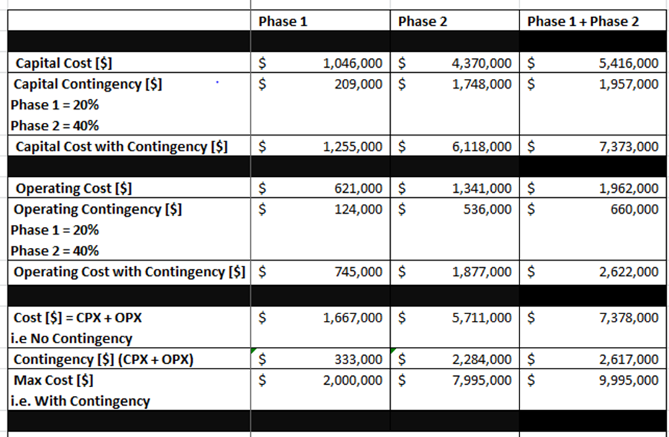

## Key Resource Needs

The following identifies the key resources required to support the project in 2019. An updated 2019 resource plan along with an estimated 2020 resource plan will be provided as a part of the Project Plan.

List of resources required and names identified, if any:

* Accenture Contract Services (CRS)
* CD – Business Lead (Imports) [Dina Shoukri]
* CIM - Solution Analyst (Online IESO)
* Connection Assessments - SME
* Contracts – SME [Emanuel Movchovitch]
* Customer Stakeholder & Community Engagement – SME [Dale Fitzgerald]
* EC – Business Analyst [Esther Kim-Reece, Sunil Maniyappan, Mike Poznanski]
* Finance
* IT – Appian Developer (Reports)
* IT – Appian Developer [Jin Lee, Rachel Zhao]
* Legal [James Hunter, Julie Bedford]
* MACD SME
* PAO:M&TI – SME [Shilpan Desai]
* Market Rules – SME [Robert Doyle]
* Market Settlements – SME [Jonathan Paredes, Karan Ujla]
* ICA [Danielle D’Souza, Angeli Jaipargas, Michael Falvo, Mohamed Ahmed]
* MRP QA SME [Joseph Rampersad]
* Operations Integrations - SME
* PAO:MF&I SME
* PAO:PSL SME
* Planning [Anna Lafoyiannis]
* Project Manager [Samantha Tam]
* Procurement SME
* RMSS – Solution Analyst [Rob Sinclair]
* Vendor:Brattle
* Operational Assessments – Manager [Jessica Tang]

## Approval Detail for the Current Project Charter

### Timeline

The funds requested in the current version of the Project Charter are to be used from now until Dec 2019.

Key milestones are outlined in Section 3.4.

### Cost

Please see Section 3.5.

### Resources

Please see resource details from Section 3.6.

# Key Stakeholders (Internal and External)

Stakeholders include:

• D - Direct Customer Stakeholder Group(s): Direct customer stakeholder groups receive the benefit or harm of the change initiative.

• I - Indirect Customer Stakeholder Group(s): Indirect customer stakeholder groups are once removed from the direct impact of a change. They are noted when it is possible they will experience an indirect benefit or harm resulting from the change initiative. This impact should be considered during Analyze and Design.

• M - Manager Stakeholder(s): Listed by job title, manager stakeholders have the authority to authorize the addition, change or removal of processes, systems, or governing documents.

• B - Builder Stakeholder Group(s): Listed by group, builder stakeholders are those who provide the resources to do the work to implement the change

A stakeholder group can belong to both Customer and Builder groups.

Table 1. Key Stakeholder list

| Stakeholder | Stakeholder Role | How They Are Affected or How They Are Participating |
| --- | --- | --- |
| Power System Assessments | Direct Customer Stakeholder Group | 1. Qualify Capacity 2. Acquire Capacity 3. Conduct Auction 4. Monitor Capacity Readiness 5. Market facing documentation 6. Manage Enrolment Request 7. Authorize Market and Program Participation (Auction Participant) 8. Manage Enrolment Request to Authorize for the Physical Market (Auction Market Participant) 9. Register Facilities (both physical and virtual facilities)    1. Physical Generator Facility; 10. Market facing documentation |
| Market Operations – Market Forecasts & Integration | Direct Customer Stakeholder Group | 1. Determine in-market capacity available for planning horizon 2. Utilize available in-market capacity for day-ahead commitment 3. Outage/Unavailability of TCA resources 4. Market facing documentation |
| Market Operations – System Operations | Direct Customer Stakeholder Group | 1. Utilize available in-market capacity for dispatch scheduling to manage reliability 2. Confirm or adjust available in-market capacity as part of ex-post activity 3. Market facing documentation |
| Market Settlements | Direct Customer Stakeholder Group | 1. Settle payments, set-offs, clawbacks, cost recovery 2. Create new charge types to facilitate settlement of payments, set-offs and cost recovery as required 3. Market facing documentation |
| Meter Data Management | Direct Customer Stakeholder Group | 1. Register Revenue Meter Installation for Generator facilities 2. Market facing documentation |
| Finance & Treasury | Direct Customer Stakeholder Group | 1. Determine Auction Deposit 2. Collect, track, disburse deposit as required 3. Set Prudential Support for Capacity market participation 4. Market facing documentation |
| Information Technology & Services | Direct Customer Stakeholder Group | 1. Publish pre auction and post auction reports as required 2. Modify applications as required |
| MACD | Direct Customer Stakeholder Group | 1. Monitor for patterns of non-compliance and anomalies for cleared capacity, in-market capacity, and settlement amounts 2. Enforce non-compliance |
| Customer Outreach | Direct Customer Stakeholder Group | 1. New market participants to train 2. Potentially increase in the volume of work as a result of new participants |
| Customer Response | Direct Customer Stakeholder Group | Training Capacity Market Participants (energy market participation, Online IESO tool, accessing reports site, produce training materials etc.) |
| IT Service Desk | Direct Customer Stakeholder Group | Support new CMPs who are using external facing IESO systems |
| Auction participants | Direct Customer Stakeholder Group | Participate in pre-auction, auction and post-auction activities and deliver capacity obligation in the real time energy market during the commitment period |
| Markets | Direct Customer Stakeholder Group | Establish and lead design work |
| IESO Market Participants | Direct Customer Stakeholder Group | Changes may create direct impacts |
| Local Distribution Companies | Indirect Customer Stakeholder Group | 1. Cleared capacity participants may request measurement data from LDCs 2. Aggregators may request acknowledgement from LDCs regarding location of demand response contributors |
| Director Planning and Assessments | Manager Stakeholder | 1. Manage Enrolment Request 2. Authorize Market and Program Participation 3. Qualify Capacity (TBC) 4. Acquire Capacity (TBC) 5. Conduct Capacity Auction 6. Register Facility 7. Establish import limits, when appropriate |
| Director Market Operations | Manager Stakeholder | 1. Plan Operations 2. Direct Short-Term Operations |
| Director Settlements | Manager Stakeholder | 1. Settle Markets and Programs |
| Director MACD | Manager Stakeholder | 1. Detect Non-Compliance 2. Enforce Non-Compliance |
| Director, Finance, Corporate Controller & Treasury, | Manager Stakeholder | 1. Set Prudential Support 2. Set and Collect Auction Deposit |
| Director Business Solutions | Manager Stakeholder | 1. Operate Technology 2. Publish Reports |
| Director, Corporate & Regulatory Affairs | Manager Stakeholder | 1. Deliver Marketplace Training 2. Corporate communications and customer service |
| TCA Design Manager | Builder Stakeholder | Project Design Lead |
| Enterprise Change | Builder Stakeholder | Project Manager |
| Customer Information Management | Builder Stakeholder | Solution Analyst |
| Technology Support | Builder Stakeholder | Technical Analyst, Technical Specialists, Database administrators |
| Business Solutions | Builder Stakeholder | Solution Analysts, Solution Specialists, Developers |
| Business Analysis Services | Builder Stakeholder | Business Analyst |
| Market Registration | Builder Stakeholder | Process subject matter experts |
| Power System Assessments | Builder Stakeholder | Process subject matter experts |
| Market Operations | Builder Stakeholder | Process subject matter experts |
| Market Settlements | Builder Stakeholder | Process subject matter experts |
| Meter Data Management | Builder Stakeholder | Process subject matter experts |
| Treasury and Finance | Builder Stakeholder | Process subject matter experts |
| Stakeholder and Public Affairs | Builder Stakeholder | Process subject matter experts |

# Project Governance Structure

Project Steering Committee approves TCA project decision

| Member Name | Title | Representing |
| --- | --- | --- |
| Leonard Kula | VP Planning, Acquisition and Operations/COO | Planning, Acquisition and Operations, Market Renewal |
| Alex Foord | VP Information & Technology Services/CIO | Information & Technology Services |
| Mike Lyle | VP Legal Resources and Corporate Governance | Legal |
| Barbara Anderson | VP Corporate Services/CFO | Finance |
| Terry Young | VP Policy, Engagement and Innovation | External Stakeholders |
| Glenn McDonald | Director MACD | Market Assessment & Compliance |

# Delivery Approach

Due to a need for a commitment of resources as early as 2020, the DR Auction will evolve in a phased approach:

**Phase 1:** Add dispatchable, non-committed generators to current eligible DR participants for the December 2019 TCA for a 2020/2021 commitment period. Agile development method will be used for registration tool (i.e. OnlineIESO) changes while all other tool development will be done using waterfall method.

**Phase 2:** Add additional resources and design features factoring project effort against capacity value. There will likely be more than one set of design changes spread out over multiple auctions within Phase 2. Agile development method will be used for registration tool (i.e. OnlineIESO) changes while all other tool development will be done using waterfall method.

**External Communication:**

* Phase 1 and 2 design documents will be used for documenting official design decisions made. Market Rules and Market Manuals will be the enduring official documents detailing the changes.
* Interim design discussions could be discussed at TCA SE, SAC and DRWG
* Written stakeholder feedback from design documents review and stakeholder meetings will be reviewed, and IESO response to stakeholder feedback will be posted.

**Internal Communication:**

Decisions made are communicated internally:

* Project sponsor informs ELT biweekly as needed
* Business lead informs managers and directors regularly
* Project team meets with ICA project team biweekly. Items discussed and decisions made are documented
* Project sponsor, business lead and project manager meet monthly with PSC. Meeting minutes are documented.

# Assumptions, Constraints and Potential Risks

## Project Assumptions

1. For Phase 1, new eligible participants are limited to non-committed and non-regulated dispatchable generators
2. Adequate IESO internal resources and support.
3. No “showstoppers” from external/internal stakeholders.
4. Design maturity can be reached to start writing business requirements in March/April 2019 and supporting IT tool development beginning no later than mid-May

## Project Constraints

1. First auction for Phase 1 is December 2019

## Potential Project Risks and Mitigation Actions

Table 2: Risk Summary

| **Risk ID** | **Risk Description** | **Initial Risk Level** | **Mitigation Tasks** | **Mitigation Tasks Implemented**  **(Yes/No)** | **Mitigated Risk Level** |
| --- | --- | --- | --- | --- | --- |
| R001c | Compressed timelines for stakeholder engagement affect the quality of the overall design considerations needed to develop a robust TCA. | Critical | Additional time and cost have been added to the project. Some inefficiency is acceptable given reliability needs and the evolving nature of the TCA project. Issues discovered may be corrected in a future auction. | Yes | High |
| R001d | Stakeholder lacks understanding on the capacity need requirements for 2020 and the urgency to implement auction mechanism by end of 2019 Q4 leads to slow stakeholder buy in. | Critical | Executive outreach is used to build relationships and understand areas of concern and support.  Stakeholder engagement to provide SE plan to ensure participation from affected participants and consideration of their input. | Yes | High |
| R005 | IESO human resources are limited. | Critical | Reflect this project priority properly and communicate human resourcing need as early as possible. Mitigated by formal project ranking and it is approved in the 2019 Project Portfolio. | Yes | Medium |
| R015 | Gaps in design due to aggressive timeline | High | Accepted for Phase 1. For Phase 2, if gaps are identified subsequently prioritize design requirements and roll them into the following TCAs as appropriate. | Yes | High |
| R016 | Gaps in testing due to aggressive timeline | High | Work with IT QA to come up with Project QA plan. Plan and prioritize rework for later project phases. | Yes | Medium |
| R019 | IT tool changes are delayed. | High | Limit and prioritize scope as required. | Yes | Medium |
| R023 | If lCA go-live is delayed, TCA does not support new build and might cause reliability issue. | Critical | Continue to work with ICA team to look for implementation of more advanced ICA design features in TCA if ICA project schedule is at significant risk. | Yes | High |
| R025 | Stakeholder engagement (SE) for Design will not be completed before tool development begins. If there are showstoppers from SE there will be rework and project delay. | High | Accepted due to compressed timeline. If showstoppers are encountered go-live date could be delayed. | No (Accepted Risk) | High |
| R028 | Phased in approach means that the first auctions may not have the needed transparency, certainty and competition that the ICA would have, reducing both short-term and long-term efficiency | High | IESO to make strong commitment that capacity auctions are main procurement tool and continuous evolution of auctions is a must | Yes | Medium |
| R029 | Neighbouring jurisdictions may not provide sufficient or timely support for capacity imports, limiting the amount of import capacity available and reducing TCA effectiveness. | High | Develop strategy of working with ISO/RTOs, as well as stakeholders in neighbouring jurisdictions | Yes | Medium |
| R030 | There might not be enough capacity to meet the increased target capacity requirement. | High | Develop transparent plan for enabling resources to understand potential and timing considerations | Yes | Medium |
| R031 | Certain processes/features will likely have to be manual/more opaque. This might cause:   * Potential stakeholder pushback with compliance if it is not specified in market rules and manuals * Processes/features might be open to policy influence if they are not codified in market rules | High | Will continue re-evaluate process/features and make required changes as Phase 2 evolves. | Yes | Medium |
| R032 | Government policy development/changes may result in significant political risk to the viability of the auction and reduce risk appetite of investors in Ontario | High | Proactive government strategy needed; narrative and quantitative analyses needed to support that IESO’s approach will deliver lowest cost outcome | Yes | Medium |
| R033 | Timing between auction and MRP Energy coming into service may result in risks to participants. This is related to the revenue uncertainty due to the changeover from the current market to the renewed energy market. | High | Cannot be mitigated and accept risk. TCA to continue working with MRP team. | No | High |
| R034 | Phased in approach will mean changing framework and rules, reducing certainty. This adds risks to Market Participants as they are uncertain when or how they can optimally participate in TCA and thus the auction may not provide the appropriate business environment to enable and expand auction participation. | High | ICA HLD will provide the vision and direction for comprehensive auction. Ensure lessons learned are outlined and discussed transparently and built into the processes; need clear work plan for the next few years to give clarity and confidence through the transition | Yes | Medium |
| R035 | Transitional approach may not yield sufficient revenues for existing assets, resulting in shutdowns, and reducing future liquidity | High | Accept risk. Will continue to work with demand curve parameters. | No (Accept Risk). | High |
| R037 | TCA is unable to meet objectives, eroding ICA support. | High | See all documented risks and mitigation tasks. | Yes | Medium |

# Change Controls

Changes in the project that will impact/exceed tolerance levels for objectives, time and cost will be managed through the formal Project Change Management Process resulting in a Project Exception Report. The Project Exception Report, if approved, will result in the re-baselining of the project. Refer to the Project Exception Report for reference and additional details.

# Appendix A: NPV Analysis and Cash Flow

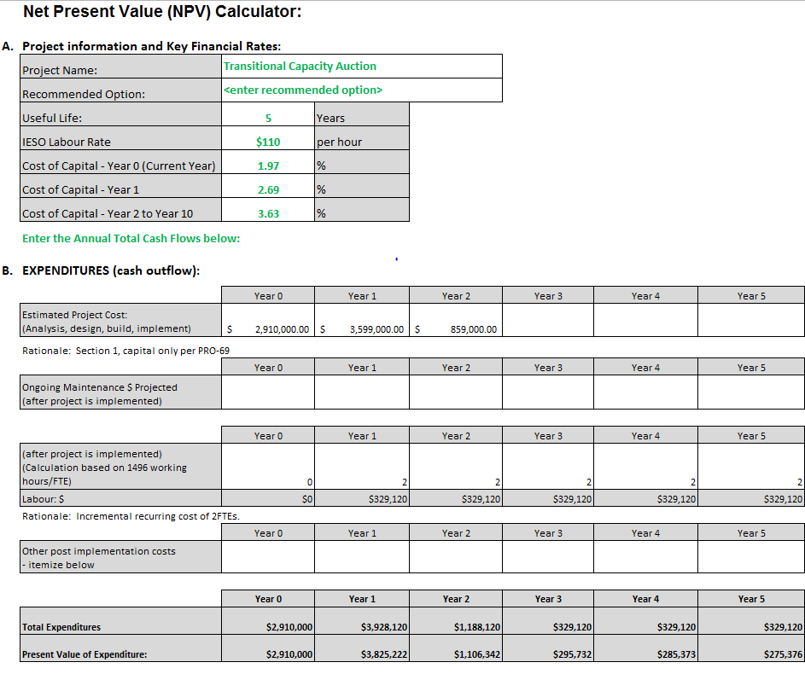

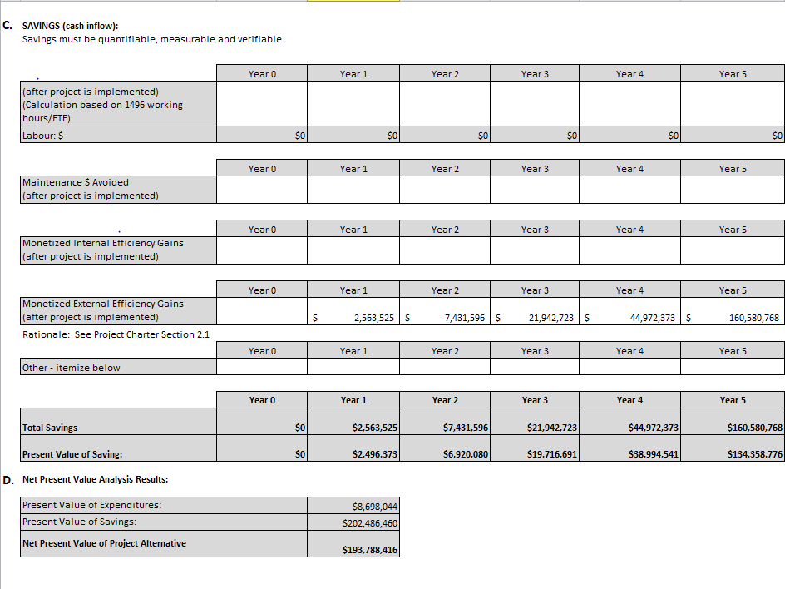

# Appendix B: Capacity Need

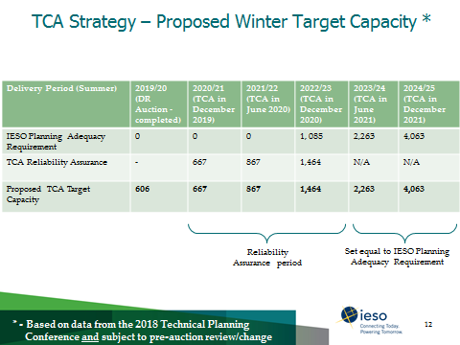[7]

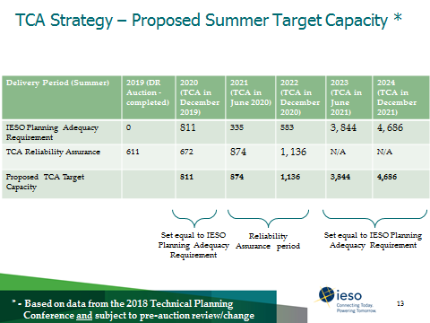[8]

**Appendix C: Benefits**

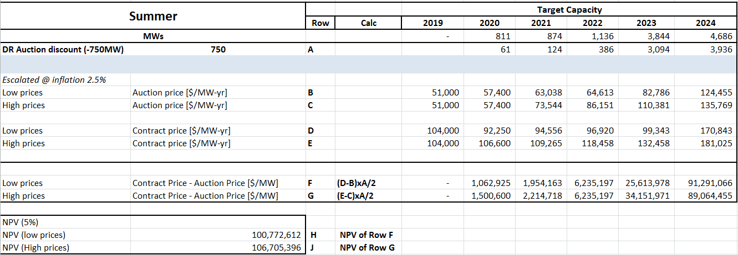

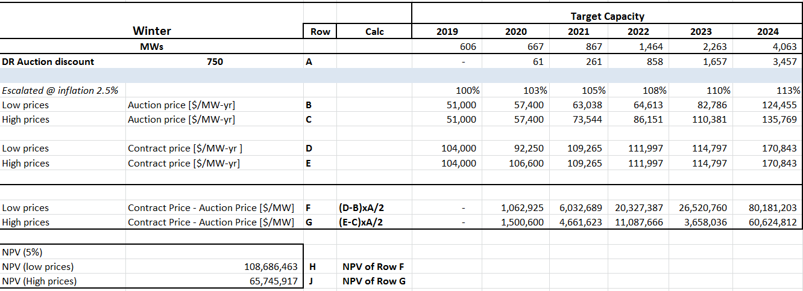

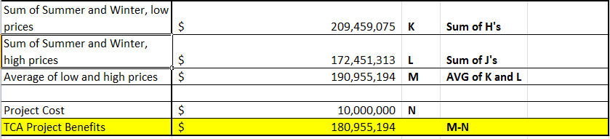

**Document Control**

Authors:

|  |  |
| --- | --- |
| Prepared By | Role |
| *Samantha Tam | Project Manager |
| Sunil Maniyappan | Business Analyst |

Project Management Adherence Review:

|  |  |
| --- | --- |
| Reviewed By | Role |
| Anil Agrawal | PMO Project Support |

Financial Review:

|  |  |
| --- | --- |
| Reviewed By | Role |
| Anthony Martinello | Director, Finance, Corporate Controller & Treasury |
| *Barbara Anderson | VP – Finance & CFO and Project Steering Committee Member |

Content Reviewers:

|  |  |
| --- | --- |
| Reviewed By | Role |
| Jessica Tang | Business Lead |
| Daniela Sabatini | Manager, Change Delivery |
| Nicholas Ingman | Director, Enterprise Change |
| Gordon Drake | Manager, Business Analysis Services |
| Lia Kosic | Director, Financial Planning and Analysis |
| Ioan Agavriloai | Director, Power System Assessments |
| Chuck Farmer | Director, Resource Planning |
| Dave Robitaille | Director, Market Operations |
| Jeannette Briggs | Director, Settlements |
| Bill Pettitt | Director, Business Solutions |
| Jessica Savage | Director, Corporate & Regulatory Affairs |
| Leonard Kula | Project Steering Committee Member |
| Alex Foord | Project Steering Committee Member |
| Mike Lyle | Project Steering Committee Member |
| Terry Young | Project Steering Committee Member |
| Glenn McDonald | Steering Committee Member, Director MACD |

Approvals:

|  |  |
| --- | --- |
| Approved By | Role |
| *David Short | Project Sponsor |
| *Peter Gregg | President & CEO (On behalf of the Board) |
| IESO Board | IESO Board |

* Indicates who will approve in Citadel.

Distribution List

|  |  |
| --- | --- |
| Name | Organization |
| Citadel | IESO |
| PMO | IESO |
| Finance | IESO |

Document Change History

|  |  |  |
| --- | --- | --- |
| Issue | Reason for Issue | Date |
|  |  |  |

References

| Document Title | Document ID |
| --- | --- |
| Approved Project Portfolio |  |
| *Project Roles and Responsibilities* | *GDE-309* |

Related Documents

| Document Title | Document ID |
| --- | --- |
|  |  |

**– End of Document –**

1. http://ieso.corp.int/inside-the-ieso/peter-gregg-speaks-ontario-energy-networking
2. Non-committed is defined as “Resources that are not –in whole or in part - rate-regulated, contracted to the IESO, contracted to the OEFC, or obligated as a resource backed capacity export to another jurisdiction during the entire duration of a given Commitment Period”, per [Transitional Capacity Auction Phase I Design Document](http://www.ieso.ca/-/media/Files/IESO/Document-Library/engage/mocn/Transitional-Capacity-Auction-Draft-Phase-I-Design.pdf?la=en) published externally.
3. Capacity is the capability to generate electricity (or to reduce the consumption of electricity through demand response) when needed:

   Capacity is essential to be able to manage the changing demand on the system both from hour-to-hour and between seasons.

   A reliable system has adequate capacity committed to meet peak demands under various system conditions including extreme weather.

   Acquiring capacity essentially covers the portion of costs to build and/or maintain resources while the energy market covers the costs of a resource to actually run and provide energy.
4. See Appendix B
5. See “A Benefits Case Assessment for the Market Renewal Project” by The Brattle Group, [here](https://www.google.com/url?q=http://www.ieso.ca/-/media/Files/IESO/Document-Library/engage/me/Benefits-Case-Assessment-Market-Renewal-Project-Clean-20170420.pdf&sa=U&ved=0ahUKEwj46I2Txt3gAhUU0IMKHfMKCOwQFggFMAA&client=internal-uds-cse&cx=002629981176120676867:kta9nqaj3vo&usg=AOvVaw3dO68446gkwQM6jr9dq5eA)
6. Same, [here](https://www.google.com/url?q=http://www.ieso.ca/-/media/Files/IESO/Document-Library/engage/me/Benefits-Case-Assessment-Market-Renewal-Project-Clean-20170420.pdf&sa=U&ved=0ahUKEwj46I2Txt3gAhUU0IMKHfMKCOwQFggFMAA&client=internal-uds-cse&cx=002629981176120676867:kta9nqaj3vo&usg=AOvVaw3dO68446gkwQM6jr9dq5eA)
7. Slide 12, “[Transitional Capacity Auction Draft Phase I Design](http://www.ieso.ca/-/media/Files/IESO/Document-Library/engage/mocn/mocn-20190418-TCS-draft-phase1-design.pdf?la=en)” TCA Stakeholder engagement presentation to be held on April 18, 2019.
8. Slide 13, “[Transitional Capacity Auction Draft Phase I Design](http://www.ieso.ca/-/media/Files/IESO/Document-Library/engage/mocn/mocn-20190418-TCS-draft-phase1-design.pdf?la=en)” TCA Stakeholder engagement presentation to be held on April 18, 2019.