Renfrew Hydro Inc.
OEB Staff Questions
EB-2019-0065

Renfrew Hydro Inc.
EB-2019-0065

OEB staff Question-1
Ref: 1595 Analysis Workform – Tab 1595 - 2012
- Please confirm that Tab 1595 – 2012 was selected in error and that Tab 1595 – 2015 should have been selected, if not please explain.
- If confirmed, please fill out tab 1595 – 2015. This will allow OEB staff to reconcile the amounts to the continuity schedule on Tab 3 of IRM Rate Generator Model.

OEB staff Question-2
Ref: IRM Rate Generator Model – Tab 12 RTSR – Historical Wholesale
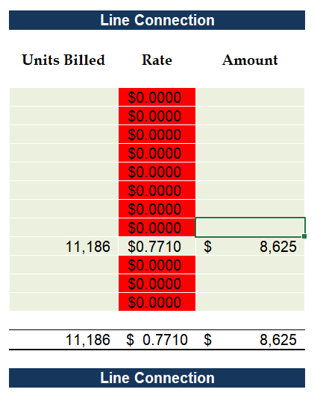
Please confirm Renfrew Hydro was not supplied by Hydro One Stewartville M3 express feeder during the month of September and the Cobden 23M2 feeder delivered power to Renfrew Hydro, if not please explain.

OEB staff Question-3
Ref: Rate Generator Model, Tab 3 – Continuity Schedule
OEB staff notes that there was a formula error in the IRM Rate Generator Model posted on the OEB’s webpage.

On tab 3 the formula for cell BM41 is =Sum(BM39,BM40) - BM37. The last portion of the formula (i.e. –BM37) is an error.

OEB staff has made the necessary correction to the Rate Generator Model and provided it along with these questions.

Please confirm Renfrew Hydro’s acceptance of the revised model.

OEB staff Question-4
Ref: GA Analysis Workform, Tab – GA 2017
Please explain the variance between the calculated loss factor of 1.1073 in the GA Analysis Workform and the approved loss factor of 1.0810, for year 2017.

OEB staff Question-5
Ref: Rate Generator Model, Tab 4 – Billing Det. for Def – Var
As per Section 3.2.5 of the 2019 Filing Requirements for Electricity Distribution Rate Applications, an applicant may elect to dispose of the Group 1 account balances below the threshold. OEB staff notes that Renfrew Hydro does not does not meet the threshold test of .0010 -/+, on Tab 4 of the rate generator model but has not disposed of their DVA balances since the 2017 rate year. There are three years of undisposed balances.
- In order to avoid intergenerational inequities would Renfrew Hydro be willing to dispose on an interim basis of all Deferral and Variance Account balances?
- If yes, please change Cell C29 to yes on Tab 4 and fill out the new tabs that appear.

OEB staff Question-6
Ref: Tab 5 of LRAMVA workform
Renfrew Participation and Cost Report
Please confirm that Renfrew Hydro is not seeking to recover the 2018 unverified demand savings, as well as the 2017 unverified savings adjustments, as part of its LRAMVA claim.

