Festival Hydro Inc.

OEB Staff Questions

EB-2019-0035

**Festival Hydro Inc.**

**EB-2019-0035**

**Staff Question-1**

**Ref: IRM** 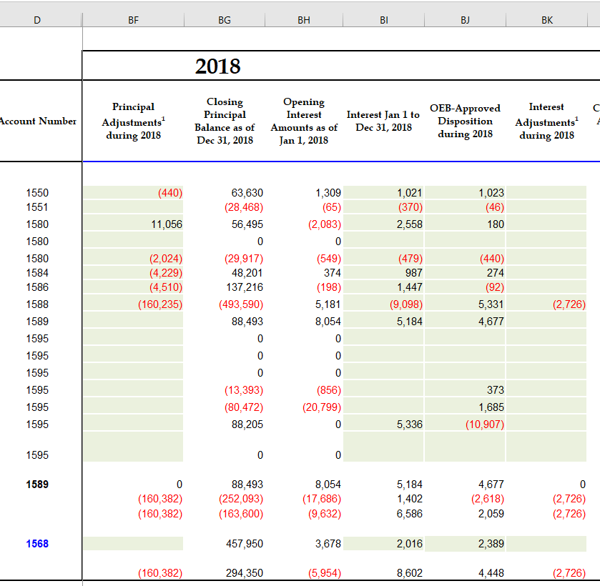

**Rate Generator Model – Tab 3 Continuity Schedule**

1. Please explain the reason for the adjustments in column BF, for accounts 1550, 1580, 1584 and 1586.

The principle adjustments in the 2017 continuity schedule for 1550, 1580, 1584, 1586 are entries to true-up unbilled revenue. Festival adjusts Dec revenue by posting journal entries to true up unbilled revenue in March of the following year once the fiscal years billings are complete. Festival updated the continuity schedule to include these adjustments under the “Transactions Debit/ (Credit) during 2018” column.

1. Please confirm there have been no adjustments to previously disposed of balances.

Festival confirms there have been no adjustments to previously disposed of balances.

**Staff Question-2**

**Ref: Managers Summary – Page 9**

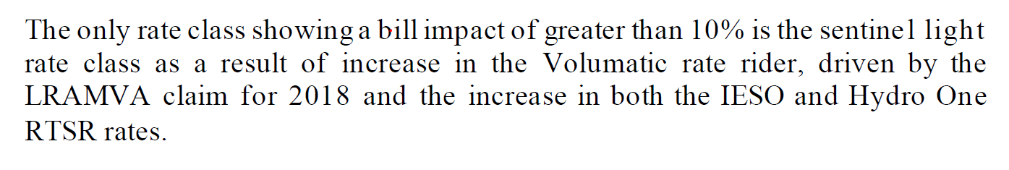

Has Festival Hydro considered requesting the LRAMVA rate rider disposition period be over 24 months for the sentinel light rate class, in order to mitigate the bill impact of greater than 10%?

Festival did not consider this given that the rate class is just slightly over 10% at 10.6% and for consistency, wherever possible, Festival requests to apply the same rate riders over the same time frame for all rate classes.

**Staff Question-3**

**Ref: Rate Generator Model, Tab 3 – Continuity Schedule**

OEB staff notes that there was a formula error in the IRM Rate Generator Model posted on the OEB’s webpage.

On tab 3 the formula for cell BM41 is =Sum(BM39,BM40) - BM37. The last portion of the formula (i.e. –BM37) is an error.

OEB staff has made the necessary correction to the Rate Generator Model and provided it along with these questions.

Please confirm Festival Hydro’s acceptance of the revised model.

Festival accepts revised model.

**Staff Question-4**

**Ref: Manager’s Summary, p. 6**

Festival Hydro indicates that it has implement the OEB’s guidance related to the accounting for accounts 1588 and 1589 as outlined in the OEB’s February 21, 2019 letter to distributors.

1. As part of its previous IRM application (EB-2018-0032), Festival Hydro’s audited 2017 Group 1 DVA account balances were approved for interim disposition by the OEB. The intent of the interim disposition was to allow Festival Hydro to go back and update the 2017 balances in accounts 1588 and 1589 once the OEB had issued its standardized guidance on the accounting for these accounts (i.e. the Feb 21, 2019 guidance). In the evidence filed for the current proceeding, Festival Hydro has confirmed that it has implemented the OEB’s guidance from January 1, 2018, but it is not clear whether it went back and quantified the impact of the new guidance on its 2017 balances as well. Please confirm whether Festival Hydro has implemented the February 21, 2019 OEB accounting guidance to its 2017 balances in accounts 1588 and 1589.

Festival reconciled all 2017 and 2018 settlement amounts with the RPP settlement amount included on the IESO invoices. Festival then utilized the OEB model and for each of the 24 months, updated the tables for the initial settlement and any subsequent true ups to determine the balance under the OEB model, versus the actual amount that Festival submitted for settlement and true ups. The resulting annual differences are as noted in the table below. Festival found no material differences in 2018. As Festival’s revised settlement process, utilizing calendar month smart meter data and rolling true ups on a two-month lag was implemented in May 2017, the analysis performed for 2017 did show a material difference as per the table below. Festival also adjusted the true up process in 2019 to allow for a price true up the month after settlement, and a usage true up the following month to ensure the new guidance was implemented. Festival’s general ledger remains open long enough after year end to allow for a final true up of unbilled revenue and the accrual of subsequent months settlement true ups relating to the fiscal year being closed.



Based on the information above, Festival recovered a material amount greater than the actual settlement amount calculated under the new methodology from the IESO on RPP settlement in 2017. As such, the commodity variance account balance would have been overstated by this amount. We have made a principal adjustment in our continuity schedule to credit 1588 by $75,170.

Festival requests based on this adjustment, and the fact that the 2018 difference is immaterial, that the 2017 balance be disposed of in final as part of this rate proceeding.

1. If the response to the above is yes, was there an adjustment to the 2017 balances as a result of the implementation. If so, please explain the nature and amounts of each of the 2017 adjustments.

There was no adjustment made to the 2017 balances as a result of implementing the OEB guidance in 2019.

1. Are the 2017 adjustments included as part the principal adjustments that have been recorded against account 1588 in the DVA continuity schedule of the current proceeding (i.e. the credit $162,961)? If not, please explain why they have been excluded and please update the DVA continuity schedule accordingly.

See responses above.

1. If Festival Hydro has gone back to its 2017 Group 1 DVA account balances and implemented the OEB’s February 21, 2019 accounting guidance, is Festival Hydro seeking OEB approval for final disposition related to its 2017 Group 1 DVA account balances as part of the current proceeding?

Festival is seeking final approval of both 2017 and 2018 Grp 1 DVA account balances as part of this proceeding.

**Staff Question-5**

**Ref: IRM Rate Generator Model - Tab 3 – Continuity Schedule**

Festival Hydro has recorded a principal adjustment of credit $162,961 against account 1588 related to the implementation of the OEB’s February 21, 2019 guidance. Festival Hydro has indicated that the adjustment relates to the 2018 settlements for embedded generation.

1. Please explain the issue that has given rise to this adjustment (i.e. what wasn’t Festival doing before that it is now doing).

Starting in January 2018 Festival had a formula error when calculating embedded generation settlement values. The formula was adding the cost of power price and solar contract price together rather then subtracting.

1. Please explain why the adjustment only impacts account 1588, but no impact on account 1589.

As the error had no impact on non-RPP balances, account 1589 was not impacted.

**Staff Question-6**

**Ref: GA Analysis Workform**

Festival Hydro has completed a GA Analysis Workform in support of its disposition of the 2018 balance in account 1588.

1. Please quantify the impact of the difference between the approved loss factor and the actual loss factor for 2018. If the balance is material, please include it as a reconciling adjustment in the GA Analysis Workform (adjustment 7 in the GA Analysis Workform).

The actual loss factor differential is slightly above our materiality so has now been included on the revised GA work form submitted.

1. Please confirm that all GA revenues associated with Class A customers have been accrued on the same basis as the IESO costs accrued for those customers, and that no balances pertaining to Class A customers are represented in the closing amounts of Account 1589.

Confirm that all the GA revenues associated with Class A customers have been accrued on the same basis as the IESO costs accrued and are not included in account 1589.

1. In the final rate generator model from EB-2018-0032, there is a principal adjustment of credit $52,979 that is recorded against the closing 2017 balance of account 1589. Please explain why Festival Hydro is not proposing to reverse that principal adjustment as part of the closing 2018 balance in account 1589 in the current proceeding. If it needs be recorded as part of the disposition of the 2018 balance in account 1589, then please update the DVA continuity schedule and the GA Analysis Workform to reflect this adjustment.

The rate generator model from our 2019 IRM shows in column AV of the continuity schedule the original adjustment for $52,979 to the 2016 balance and then the 2017 adjustment was to reverse for this.

**Staff Question-7**

**Ref: Participation and Cost Report (filed July 22, 2019)**

It appears Festival Hydro has filed another version of the Participant and Cost Report to support its 2018 CDM savings included in the LRAMVA.

Please re-file the Participation and Cost Report made available by the IESO, which includes unverified 2018 program results and a tab titled “LDC Progress” that contains CDM savings results in 2015 to 2018.

New version of the Participation and Cost report is for March 15, 2019 and has been attached. The project list Festival provided with the original LRAMVA submission included additional unverified projects settled from March 15 – March 31, 2019, with a completion date in 2018. These savings were added to the Participation and Cost report amounts for 2018.

**Staff Question-8**

**Ref: Application, p. 7**

**2019 Decision (EB-2018-0032), Tariff of Rates and Charges**

In the application, Festival Hydro notes that it continues to carry a balance of $10,235 from the 2016 disposal and requests that the balance be rolled into the approved 2020 1595 rate rider.

1. Please confirm:
   1. Festival Hydro was approved disposition of a residual balance of ($14,489) in Account 1595 (2016) in the 2019 IRM proceeding and it was disposed of through the 2019 DVA rate riders.

Yes, Festival had a residual balance of ($14,489) in Account 1595 (2016) in the 2019 IRM Application that was approved for disposal.

* 1. Festival Hydro continues to carry a remaining residual debit balance of $10,235 from the 2016 disposal that is solely related to the LRAMVA balance.

Festival reviewed the request and has determined the remaining balance requested to be transferred to the 2020 1595 rate rider is only $4,609.50. The $10,235 balance was made up of $4,609.50 relating to 2015 LRAM (2017 Disposition) and $5,625.96 relating to 2016 LRAM (2018 Disposition). As the 2016 LRAM (2018 Disposition) did not complete billing until Feb 2019 we will request its remaining balance be transferred in our 2021 application.

1. Please explain how the residual debit balance of $10,235 was derived and show calculations.

See answer above. Festival requests the balance of $4,609.50 be transferred to the 2020 1595 rate rider.



1. Please discuss why Festival Hydro believes it is appropriate to transfer a residual balance from 1595 (2016) sub-account to the 1595 (2020) sub-account, considering the residual balance is related to the 2016 vintage year and should only be cleared once.

See answer above. The residual balance of $4,609.50 is from 2015 LRAM (2017 Disposition) and completed billing in Feb 2018.

**Staff Question-9**

**Ref: Tabs 5 and 8 of LRAMVA workform**

In Tab 8 of the LRAMVA workfrom, Festival Hydro provided the following explanation under the “Street Lighting Process and Methodology” section:

All past Retrofit Streetlighting projects do not contribute Peak Demand Savings, as verified in the IESO list of historical projects. Therefore, no Peak Demand Savings were subtracted from previous Retrofit years as a result of removing street lighting projects from the Retrofit Program. Similarly, no Energy Savings were subtracted from previous Retrofit years because the municipalities that undertook these projects are all General Service 50 to 4,999 kW customers, **which are billed on kW**, not kWh. Removing Energy Savings from the Retrofit program in the years the streetlighting projects were completed without reallocating the rate class distributions for these years would **incorrectly reduce** the total 'Actual CDM Savings' in these years allocated to the **General Service < 50 kW rate class, which is billed on kWh**. Additionally, making changes to the Retrofit Energy Savings to reflect streetlighting projects would have no impact on General Service 50 to 4,999 kW customers, as 'Actual CDM Savings' for this rate class is calculated in kW, not kWh. **(emphasis added)**

1. Based on the description provided in Tab 8, please confirm that the energy savings from the 2015, 2016 and 2017 saveOnEnergy retrofit programs (per Tab 5 of the LRAMVA workform) include kWh savings from street light projects.

Yes, the Retrofit energy savings (kWh) for years 2015, 2016 and 2017 include the energy savings from the Streetlighting projects implemented in those years.

1. If question a) is confirmed, please show how there would be a misallocation of savings to the GS<50 kW class (incorrectly reducing total actual savings allocated to the GS<50 kW class) if the kWh savings from street light projects were removed from the saveOnEnergy retrofit program.

The portion of savings attributable to each rate class is determined by dividing the list of projects by customer and determining the portion of the savings generated by projects completed by each rate class. In this step the Streetlighting projects were properly identified as resulting from the Streetlighting rate class and were excluded from the GS < 50kW and GS 50-4,999 kW split. The percentages of Retrofit savings calculated as being generated by each of the two rate classes are correct.

Festival should have removed the energy savings (kWh) resulting from the Streetlighting projects from the total Retrofit verified energy savings in the 2015, 2016 and 2017 years. The total kWh attributed to the GS <50kW incorrectly included a portion of the Streetlighting project energy savings. The lost revenue recovery for the GS 50-4,999kW rate class is based on kW. Since there were no demand savings (kW) for Streetlighting projects the lost revenue recovery for the GS 50-4,999kW rate class was calculated correctly.

Festival has created another version of the LRAMVA workform showing the revision in Tab 5. Rows 59, 308 and 492 were added to reduce the energy savings attributed to GS <50kW rate class by the amount of streetlighting energy savings in 2015, 2016 and 2017.

1. Please re-calculate the LRAMVA balance, with the kWh savings from street light upgrades excluded from the 2015, 2016 and 2017 saveOnEnergy retrofit program. Please file another version of the LRAMVA workform showing this revision in Tab 5 of the LRAMVA workform.

Festival has revised the LRAMVA workform.

**Staff Question-10**

**Ref: Tab 8 of LRAMVA workform**

Festival Hydro provided detailed tables, in the LRAMVA workform, showing the difference between pre- and post- billed demand to calculate street light savings. However, in the application, Festival Hydro did not include information on the eligibility of the street light savings claimed, as noted in the Addendum to section 3.2.6 of the Filing Requirements.

1. In the detailed project tables (#1 to 5) with pre- and post-billed demand data broken down by bulb retrofitted or replaced, please confirm that the upgrades in each table were implemented as one-time upgrades, as of the completion date (noted in parenthesis in the table name). If the total billed demand for the pre- and post-installation tables represent upgrades that happened during the year and ended as of the completion date, please indicate why the upgrades/retrofits could not be broken down by the specific month of the upgrade.

The retrofit details are provided upon completion of the project. The upgrades are not broken down by the month they were commissioned. Festival is only aware of the project start and completion dates, which have been provided.

1. In the Summary tables, please clearly explain how the monthly billed kW amounts (in column c) relate to the persistence calculations (the latter of which are used for lost revenue calculations), and how the billed kW amounts relate to the kW amounts that are documented in the detailed project tables (to the left hand side of the Summary table).

The persistence values show no degradation in savings based on the IESO’s analysis of persisting savings for these measures. There are other reductions in the billed kW due to additional decommissioning of inefficient fixtures. These reductions are unrelated to the IESO projects. The kW savings from the detailed project tables were the drivers for the Gross kW reduction on the billed amount.

1. Please confirm that the street light upgrades represent only incremental savings attributed to the municipality’s participation in the IESO’s CDM program. If there are savings that are not attributable to the participation in IESO’s program, please remove the savings attributable to other non-IESO programs.

Festival confirms that streetlighting upgrades represent only incremental savings attributed to the municipality’s participation in the IESO CDM program.

1. Please confirm that the energy savings associated with street light upgrades from the 2015 saveOnEnergy retrofit program have been removed. If not, please explain.

Festival has removed the energy savings associated with streetlight upgrades from the 2015, 2016 and 2017 Save on Energy retrofit program.

1. Please confirm that Festival Hydro has received reports from the municipality that validates the number and type of bulbs replaced or retrofitted through the IESO program.

Festival validates the number of, and type of bulbs replaced or retrofitted through the IESO program.

**Staff Question-11**

**Ref: Tab 6 of LRAMVA workform**

Festival Hydro’s LRAMVA balance is inclusive of carrying charge amounts to June 30, 2019, but it should have been calculated up to January 1, 2020.

Please confirm that the projected carrying charges in Tab 6 of the LRAMVA workform have been updated to December 31, 2019.

Festival has updated the projected carrying charges.

**Staff Question-12**

1. If Festival Hydro made any changes to the LRAMVA work form as a result of its responses to the above LRAMVA questions, please file an updated LRAMVA work form, the revised LRAMVA balance requested for disposition, and a table summarizing the revised rate riders.

Festival has revised the LRAMVA workform.

1. Please confirm any changes to the LRAMVA workform in response to these LRAMVA questions in “Table A-2. Updates to LRAMVA Disposition (Tab 2)”.

Festival added the changes to the LRAMVA workform in “Table A-2”.