Lakefront Utilities Inc.
OEB Staff Questions
EB-2019-0050

Lakefront Utilities Inc.
EB-2019-0050

Staff Question-1
Ref: 2020 IRM rate generator model, Tab 1
Pre-amble:
Lakefront Utilities provided the following responses in Tab 1. OEB staff has boxed in red the responses that require clarification:
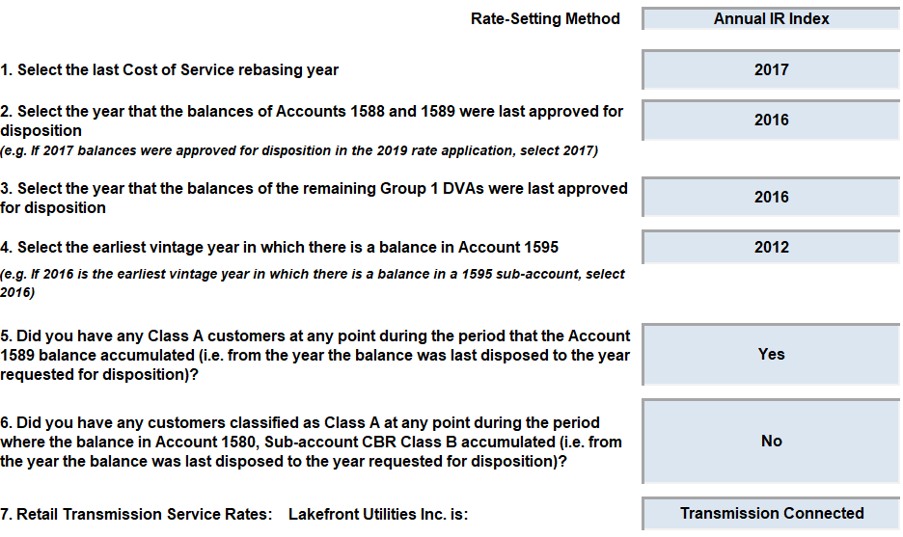
Questions:
- Please revise the rate setting option to “Price Cap” as it is currently showing “Annual IR Index”.

- The following questions relate to questions 2 and 3:
Please explain why Lakefront Utilities selected “2016” as the last year in which Accounts 1588/1589 and remaining Group 1 balances were disposed.

This appears to be inconsistent with past OEB decisions for Lakefront Utilities, summarized as follows:

  - In the 2017 COS proceeding (EB-2016-0089), group 1 DVA balances were disposed as of December 31, 2015.
  - In the 2018 IRM proceeding (EB-2017-0057), Lakefront Utilities withdrew the request to dispose of its 2016 group 1 DVA balances. A third party audit on Account 1588/1589 balances up to December 31, 2017 (including 2016 and 2017 balances) was required to be submitted in the next rates proceeding.
  - In the 2019 IRM proceeding (EB-2018-0049), the OEB did not approve the disposition of group 1 DVA balances as of December 31, 2017 and ordered a second audit to confirm accuracy of Account 1588/1589 balances.

If “2016” was provided in error, please confirm whether the selection should be “2015”. If not, please explain.

- Lakefront Utilities’ response to question 6 confirms that there were no Class A customers during the period in which Account 1580 balances accumulated. However, Lakefront Utilities provided 2017 Class A consumption for partial year Class A customers in Tab 6.2a of the IRM rate generator model. Please review accuracy of the selection to question 6 in Tab 1.

- Please confirm whether Lakefront Utilities’ selection as a “transmission connected” distributor was correct, as OEB staff understands the distributor is fully embedded in Hydro One’s distribution system.

Staff Question-2
Ref: 2020 IRM rate generator model, Tab 6 (Class A consumption)
Application, Section 3.2.5.2, p. 21
Pre-amble:
OEB staff identified the following issues with respect to the classification of transition customers and the presentation of full-year Class A volumes in Tab 6.
- There are discrepancies in the classification of customer #9 in Tables 3-a and 3-b.
- It is unclear whether customer #11 was a transition customer in 2017 or 2018.
- Table 3-b requires full-year Class A volumes to be aggregated by rate class and not by customer.
Questions:
- For customer #9, please confirm whether this customer is classified under the “GS 50 to 2,999 kW” or “GS 3,000 to 4,999 kW” rate class. In Table 3-a, customer #9 is classified under “GS 50 to 2,999 kW”, but in Table 3-b, it is shown as “GS 3,000 to 4,999 kW”. Please confirm the correct rate classification for customer #9 and revise Tables 3-a and 3-b, accordingly.

- In the application, Lakefront Utilities stated it had 10 customers that transitioned from Class B to A for global adjustment in 2017. There was no mention of any customers that transitioned in 2018.

  - Please clarify whether customer #11 was a transition customer in 2018. If yes, please provide the Class B volumes for the periods: January to June 2017, July to December 2017, and January to June 2018 in Table 3-a.
  - If customer #11 was not a transition customer in 2017 or 2018, please explain why it was included in Table 3-a.
  - Please correct the class a/b selections for customer #11 in Table 3-a.

- Please review the response provided in cell 487 of Tab 6 and populate the full-year 2018 Class A volumes (kWh and kW) by rate class in Table 3-b.

- As Lakefront Utilities indicated it had 10 transition customers in 2017, please provide the respective 2016 volumes for these transition customers in Tab 6 of the IRM rate generator. Please also confirm that the 2016 data provided in Tab 6 is consistent with RRR filings.

Staff Question-3
Ref: 2020 IRM rate generator model, Tab 6.2a (CBR)
Pre-amble:
In Tab 6.2a, Lakefront Utilities did not provide data in Cell E19 “total consumption, less WMP” for the 2017 year. However, RRR 2.1.5 shows 235,405,060 kWh for 2017.
An extract is re-produced below:
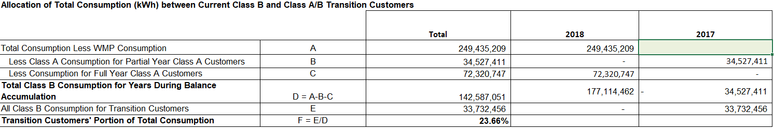
Questions:
- Please confirm whether 2017 kWh volumes should be 0 (Cell E19 of Tab 6.2a) boxed above, when RRR 2.1.5 shows 235,405,060 kWh. Please update the rate generator model accordingly.
- If Tab 6.2a should include 2016 kWh volumes based on your response to Question-1 c) above, please provide the volume data and confirm that the 2016 volumes entered into the green shaded cells are consistent with RRR filings.

Staff Question-4
Ref: 2020 IRM rate generator model, Tab 12 (RTSR Historic)
Pre-amble:
In Tab 12, it appears that Line Connection and Transformation Connection revenues were switched, as the historic sub-transmission RTSR rates were highlighted in red.
An extract is re-produced below:
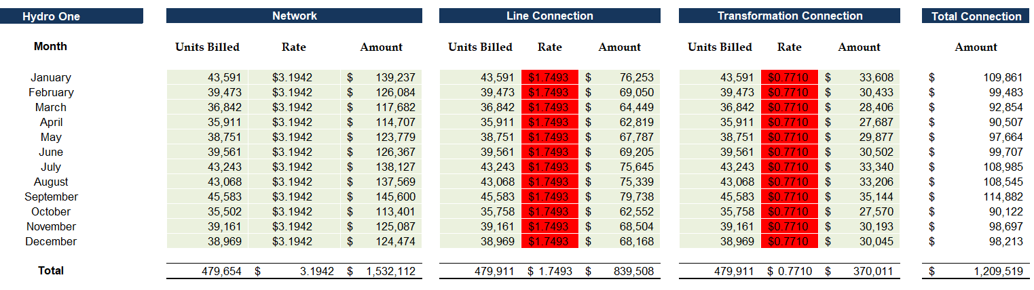
Question:
Please revise the entries for Line Connection and Transformation Connection, and confirm that the rates calculated are consistent with Hydro One Sub-transmission rates billed for the respective periods.

Staff Question-5
Ref: 1595 workform, Tab 2016
EB-2016-0089, Settlement Proposal 2017 COS EDDVAR Model, Tab 2 (DVA Continuity Schedule)
Pre-amble:
OEB staff identified the following issues in Tab 1595 (2016):
- The residual balance from both components of the 1595 (2016) account balance: 1) total group 1 balance (excluding 1589) and 2) account 1589 (GA) have exceeded 10% of the approved amounts for disposition. However, the supporting tables populated in step 3 only relate to the riders to recover group 1 DVA balances.
- The rate rider “RSVA – Global Adjustment” was not selected (in step 2).
- Lakefront Utilities explains that its billing system revenues agree with the total rate rider dollars collected and returned. However, there is a significant difference between actual and forecast load in calculating the GA rider for the GS 3,000 to 4,999 kW rate class, which raises questions regarding the accuracy of either the billing determinants used to calculate the rate riders or the actual billing determinants for this specific rate class.
Questions:
- Please confirm that Lakefront Utilities recovered the Account 1589 GA balance through a separate rate rider. If yes, please confirm whether the “Group 1 DVA account (excluding GA) – non WMP” rate rider (per step 2) was selected in error.

An extract from step 2 showing the rate rider selection of “Group 1 DVA account (excluding GA) – non WMP” is boxed below:

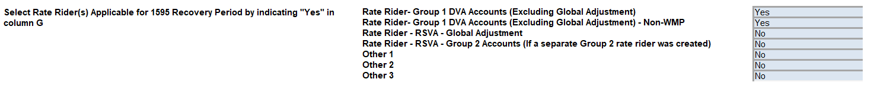
Please revise the rate class selection to “RSVA – Global Adjustment” as appropriate, and re-populate the table in step 3.

- In the step 3 tables for both rate rider groups, actual billed consumption was 40,390 kW for the GS 3,000 to 4,999 kW class in 2016. However, forecast consumption for the GS 3,000 to 4,999 kW class was approved to be 80,916 kW to dispose of the group 1 DVA balance (excluding GA) and 80,896 kW to dispose of the GA balance in 2016.

An extract of the step 3 tables from 1595 (2016) is re-produced below:

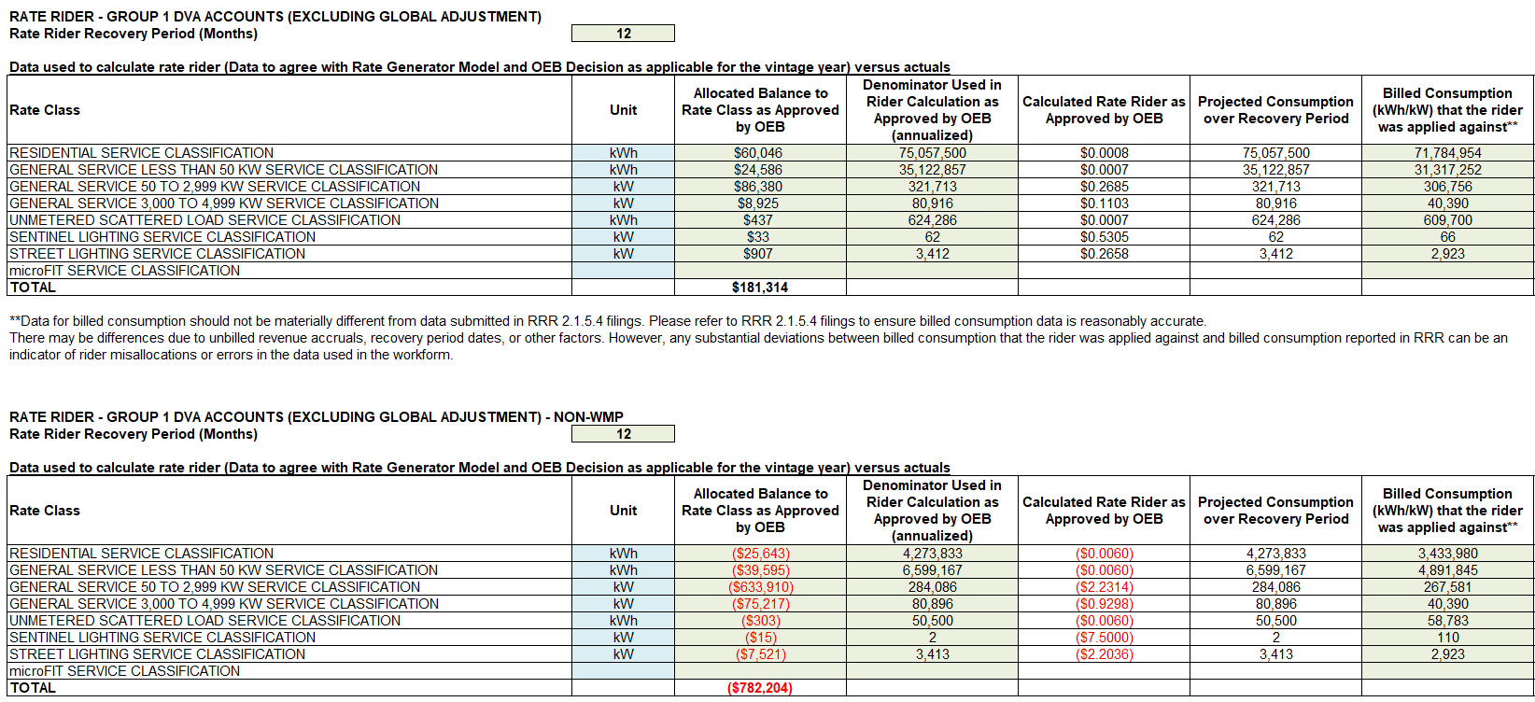

- Please explain why the 2016 actual billed consumption for the GS 3,000 to 4,999 kW class was significantly lower than originally forecast for each of the two rate riders.

Staff Question-6
Ref: Application, p. 20
1595 workform, Tab 2012
EB-2011-0250, Decision and Order, Proposed Settlement Agreement, p. 43 of 104
EB-2016-0089, Settlement Proposal 2017 COS EDDVAR Model, Tab 2 (DVA Continuity Schedule)
Pre-amble:
Lakefront Utilities is seeking to dispose of its residual debit balance of $99,264 from the 1595 (2012) account balance. As noted in the application, Lakefront Utilities seeks to dispose of this residual balance in 1595 (2013) as the IRM rate generator model did not include the applicable line for 2012.
Although the residual balance is within +/-10% of the approved balances for disposition, OEB staff seeks clarification on the accuracy of the principal amounts included in the 1595 (2012) workform.
An extract of 2012 approved amounts by rate class is shown in the 2017 COS EDDVAR model:
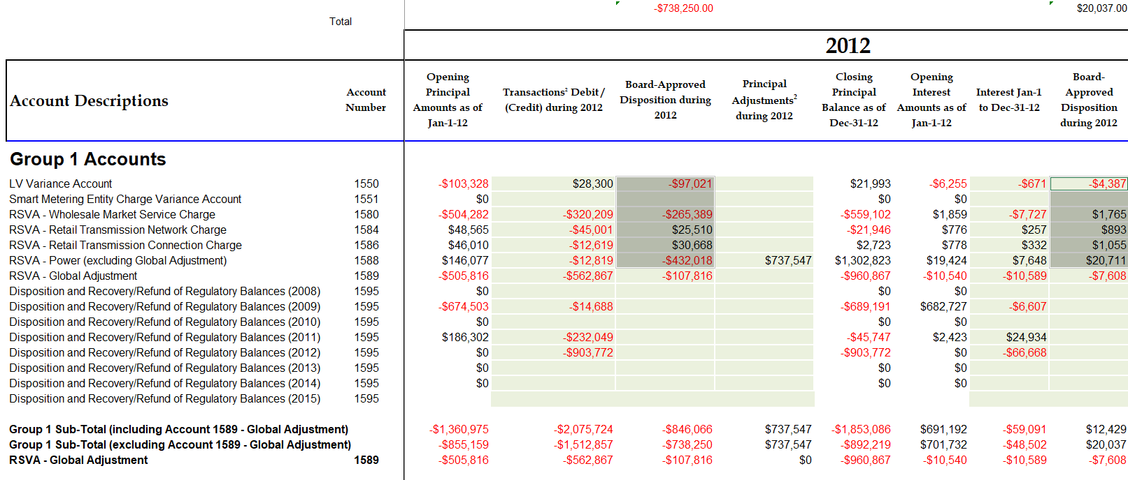
An extract of the entries in 1595 (2012) are shown below:
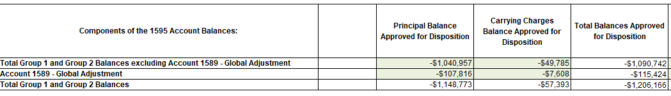
Questions:
- Please confirm whether there were explicit approvals in the 2012 COS Settlement Agreement (EB-2011-0250) on the principal and carrying charges by account. If yes, please provide the specific reference and list the approvals by account.

- For the principal and interest balances entered into 1595 (2012):
- Please confirm accuracy of the approved amounts entered into the 1595 (2012) workform.
- Please reconcile the approved balances in the 1595 (2012) workform to what was approved by account.

Staff Question-7
Ref: 2020 IRM rate generator, Tab 20 (Bill impacts)
Pre-amble:
In the bill impact tab, the RTSR rate changes for all rate classes exceed 4% from the previous year. As indicated in Tab 20, an explanation should have been provided in the application.
Question:
Please explain the cause for the RTSR rate increases by rate class, and quantify the reasons for the increase.

Staff Question-8
Ref: Manager’s Summary
In light of the fact that Lakefront Utilities indicated that it has fully implemented the OEB’s February 21, 2019 accounting guidance for Accounts 1588 and 1589, please confirm whether it is seeking approval for final disposition of its 2018 Group 1 DVA balances (which is an accumulation of the following years’ balance in 2016, 2017, and 2018) as part of the current proceeding.

Staff Question-9
Ref: Manager’s Summary, p. 22
Pre-amble:
Lakefront Utilities confirms that it has implemented the OEB’s February 21, 2019 accounting guidance related to Accounts 1588 and 1589. It further indicates that a review of the historical balances, results of the review, and adjustments had occurred in 2017 during Lakefront Utilities’ special purpose audit.
Questions:
- Please explain how Lakefront Utilities was able to ensure that it had fully implemented the OEB’s February 21, 2019 accounting guidance during its 2017 special purpose audit, when this accounting guidance was not available at that time.

- With respect to the process Lakefront Utilities employed in order to implement the OEB’s February 21, 2019 accounting guidance:

  - Please confirm that Lakefront Utilities went back to each transaction and RPP settlement that was completed in each of 2016, 2017 and 2018 and compared how those transactions were recorded at that time, under the existing methodology, to how they would have been recorded had they used the OEB’s February 21, 2019 accounting guidance.

  - If not, please explain how Lakefront Utilities ensured that it appropriately implemented the OEB’s February 21, 2019 accounting guidance across each month in 2016, 2017, and 2018.
  - Please provide the analysis that was used to quantify the adjustments required to 2016, 2017 and 2018 as a result of implementing the OEB’s February 21, 2019 accounting guidance.

- Is Lakefront Utilities confirming that the only adjustments that were required to the balances in Accounts 1588 and 1589 for 2016 and 2017 (as a result of implementing the OEB’s February 21, 2019 accounting guidance) is limited to the adjustments presented in Baker Tilly’s special purpose audit report?

- What year were the adjustments from the special purpose audit actually recorded in Lakefront Utilities’ G/L?

- As the adjustments in the Baker Tilly special purpose audit report only relate to 2016 and 2017, were any adjustments required to 2018 as a result of implementing the OEB’s February 21, 2019 guidance? If so, please provide the amount of each adjustment and also explain the nature of such adjustments.

- Have the adjustments that relate to 2018 been reflected in the DVA continuity schedule provided in the current proceeding? If so, please indicate where they have been included.

Staff Question-10
Ref: GA Analysis Workform (Tabs 2016, 2017 and 2018)
Pre-amble:
For transparency purposes, the GA Analysis Workform submitted in the current year must correspond with the DVA continuity schedule.
Questions:
Please update each year of the GA Analysis Workform to reflect the following:
- Cell C62 in 2016 GA Analysis Workform, and Cell C64 in 2017 and 2018 GA Analysis Workforms must correspond to the transaction during the year as per the DVA continuity schedule. As they currently do not, please update accordingly.

- Audit adjustments recorded as principal adjustments in the DVA continuity schedule should be presented as such in the GA Analysis Workform of each year. Please update accordingly.

- The reversal of the above principal adjustments should be recorded in the GA Analysis Workform in the year in which these adjustments were actually booked in Lakefront Utilities’ G/L.

- In the GA Analysis Workform, Lakefront Utilities has proposed certain principal adjustments (such as the unbilled revenue accrual adjustment), however they do not appear to be reflected in the DVA continuity schedule. Please explain why they have been excluded. If they should be reflected in the DVA continuity schedule, please update accordingly.

- With respect to the unbilled revenue accrual differences (i.e Adjustment 2b in the GA Analysis Workform for each year), please provide an explanation in the space provided beside Adjustment 2b (for each year) that explains whether the year-end unbilled revenue accrual for the particular year was over- or understated.

- Please quantify and explain the difference between Lakefront Utilities’ actual system loss factor and the approved loss factor for 2016, 2017, and 2018.

- It is not clear why Adjustment 9 in each of the 2016, 2017 and 2018 GA Analysis Workforms are presented as reconciling adjustments between the OEB’s expected GA calculation (in Note 4 of the GA Analysis Workform) and the actual GA for each year (Cell C62 for 2016 GA Analysis Workform, Cell C64 in the 2017 and 2018 GA Analysis Workforms). Please explain.

Staff Question-11
Ref: Appendix 4: GA Methodology Description
- Lakefront Utilities has not populated the tables in question 1 of the appendix. OEB staff believes that once the utility addresses OEB staff questions 6 and 7 above, there will be amounts that need to be populated within these tables. Please update accordingly.

- In the response provided to question 11 (i.e. questions on CT 1142), Lakefront Utilities has indicated that they settle with the IESO based on actual consumption that it pulls from Northstar:

    - Does Lakefront Utilities bill consumption on a calendar month basis?

    - Is Lakefront Utilities indicating that its Northstar system is capable of providing actual consumption for a particular month (RPP and Non-RPP) by the fourth day following the month end (i.e. all of January’s actual consumption is known by the fourth day of February).

    - Lakefront Utilities indicates that although it settles on actual consumption, it still performs a monthly true-up, but the resulting amounts are immaterial. Does Lakefront Utilities still record these monthly true-ups in its G/L? If no, please provide each monthly true-up for 2018.

    - What was the true-up that was required related to Lakefront Utilities’ December 2018 settlement with the IESO?

- In the response provided to question 12 (i.e. questions on CT 148), please clarify the following:
- Does Lakefront Utilities initially accrue an amount in its G/L for CT 148 prior to the receipt of the actual invoice from the IESO? Please explain.

- Is Lakefront Utilities indicating that the monthly CT 148 charge from the IESO is split between RPP and Non-RPP using actual consumption for the particular month from Northstar?

Staff Question-12
Ref: All models filed with 2020 IRM application
- Based on Lakefront Utilities’ response to the above questions, please re-file all applicable models, workforms, reports and/or appendices to reflect the updates.

- Please summarize all updates to the application, model(s) and/or reports submitted in this proceeding.

