Hydro Hawkesbury Inc.
OEB Staff Questions
EB-2019-0042

Hydro Hawkesbury Inc.
EB-2019-0042

Staff Question-1
Ref: Tab 3 of IRM Rate Generator (cells BM 37 and BM 41)
IRM Rate Generator Model – Staff Revised (attachment)

Pre-amble
An extract of the balance in 1595 (2019) of Tab 3 is re-produced below:
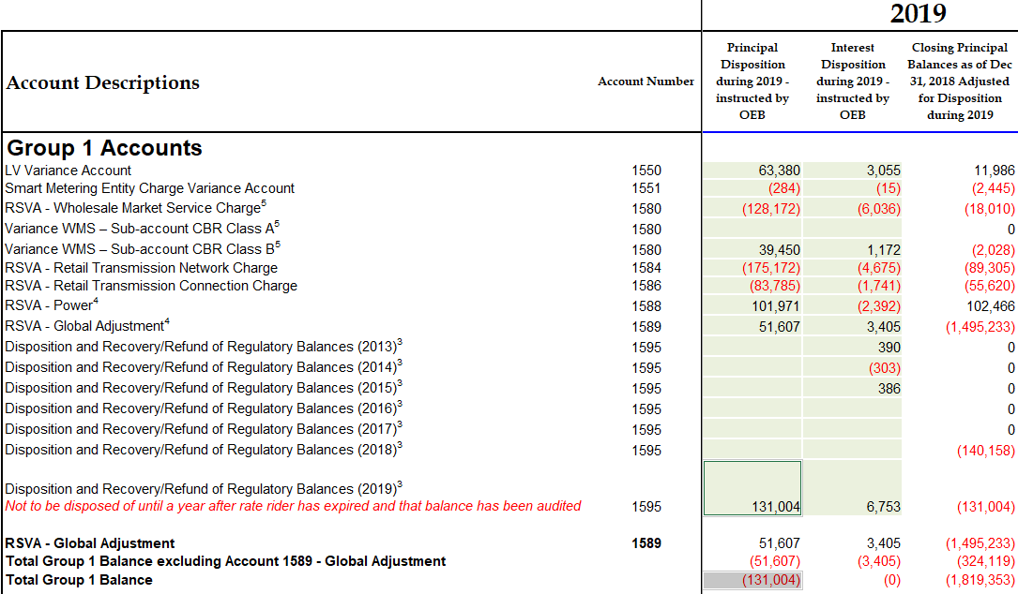
In the updated IRM rate generator attached, the formula in Tab 3 cell BM 41 was corrected by OEB staff, as the original formula did not capture the total group 1 balance correctly. Given the formula change, it raises question on whether the amounts originally entered for disposition in 1595 (2019) are correct.
Questions
- Please confirm whether a debit balance of $131,004 has been transferred into Account 1595 (2019). Based on the updated IRM rate generator attached, please review accuracy of:
  - the amount entered in Account 1595 (2019) in Tab 3, cell BM 37
  - total group 1 balance of 0 in Tab 3, cell BM 41

Staff Question-2
Ref: Application, p. 13
Tab 3 of IRM Rate Generator (cells BV 23 and BV 25)

Pre-amble
In the application, Hydro Hawkesbury states that the Class B Account 1580 WMS CBR sub-account balance should have been $37,755 and ($150,546) in the control Account 1580 WMS. Based on the 2.1.7 RRR column of the DVA continuity schedule, it appears that these amounts were not included in RRR as of December 31, 2018.
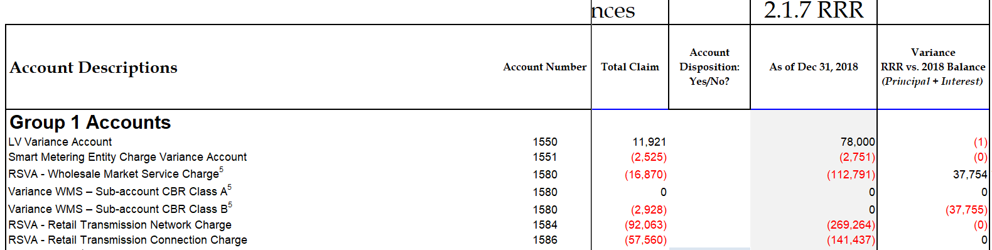
Questions
- Please explain why there is a 0 balance in its 2.1.7 RRR filing for Class B Account 1580 WMS CBR sub-account when Hydro Hawkesbury notes that there should have been a debit balance of $37,755 in 2.1.7 RRR. Why would the 2.1.7 RRR balances for Account 1580 not reflect all transactions as of December 31, 2018?

- Please update the 2.1.7 RRR balances for the control Account 1580 WMS and the Class B Account 1580 WMS CBR sub-account as of December 31, 2018 as required. Please submit a revision request to the OEB’s Performance Analytics & Reporting group and notify the case manager when the RRR amendment is complete.

Staff Question-3
Ref: Application, p. 16
Tab 6 of IRM Rate Generator (Table 3-b)
GA Analysis Workform

Pre-amble
In the application, Hydro Hawkesbury states that it has 1 or 2 class A customers when providing settlement information to the IESO. In Tab 6 of the IRM rate generator, there is one transition customer in 2018.
In Tab 6, Hydro Hawkesbury entered 12,502,583 kWh for class A consumption in 2018. However, in the GA analysis workform, non-RPP class A consumption is 15,041,117 kWh based on the data extracted from RRR.
Questions
- Please clarify the circumstances in which Hydro Hawkesbury has one or two class A customers. Please confirm accuracy of the information in Table 3-a.

- Please explain why there is a discrepancy of 2,538,534 kWh (15,041,117 kWh minus 12,502,583 kWh) in class A consumption between its RRR filing and Tab 6 of the IRM rate generator. Please confirm the correct number and check whether the class A volumes submitted in RRR as of December 31, 2018 require updating.

Staff Question-4
Ref: Application, p. 14
1595 Analysis Workform
Tab 3 of IRM Rate Generator

Pre-amble
In the application, Hydro Hawkesbury is proposing not to dispose of its 1595 balances, as the total balance of all accounts in 1595 is $473 and is too immaterial to dispose. Therefore, Hydro Hawkesbury has not populated the 1595 Analysis Workform.

In the DVA Continuity Schedule, Hydro Hawkesbury has not included the residual balances from Account 1595 sub-accounts 2013, 2014 and 2015 as part of the disposition of its group 1 DVA balances.

Question
- Please confirm that Hydro Hawkesbury is planning to write off the residual debit balances for Account 1595 vintage years 2013, 2014 and 2015 due to the immateriality of the residual balances.

Staff Question-5
Ref: Application, pp. 25-26
Hydro Hawkesbury 2018 Scorecard (accessible via OEB website)
Pre-amble
In 2018, Hydro Hawkesbury had under-earned by -13.10% based on an achieved ROE of -4.10% and a deemed ROE of 9.00%. Hydro Hawkesbury attributes the under-earnings to the following two reasons:
- Refund of the cost of the substation in 2018 due to the over-collection of $253K since its 2014 COS application (one-time event)
- Over-statement of cost of power by $9M due to the regression methodology established in its 2018 COS application, which Hydro Hawkesbury states will create a discrepancy between deemed and actual financial indicators
Questions
- Given that cost of power is overstated by $9M compared to actual, please discuss whether Hydro Hawkesbury foresees any regulatory or financial viability issues during the IRM years until its next rebasing. Please discuss in the context of Hydro Hawkesbury’s current financial position.

- Please elaborate on the tools or systems that Hydro Hawkesbury has in place to ensure that its capital and operational spending are in line with revenues.

Staff Question-6
Ref: Tab 11 of IRM Rate Generator (UTRs)
Pre-amble
In the 2020 column under the “Uniform Transmission Rates (UTR)” section on Tab 11 of the IRM rate generator, the 2019 Uniform Transmission Rates approved for Network, Line and Transformation Connection Service costs (EB-2018-0326) were carried over in 2020. OEB staff notes that the 2020 UTR column should have reflected the latest uniform transmission rates approved in EB-2019-0164.
Question
- Please confirm whether Hydro Hawkesbury agrees with the updates on the 2020 UTRs in the staff revised version of the IRM rate generator attached.

Staff Question-7
Ref: Application, pp. 13-14
Pre-amble
At the above reference, Hydro Hawkesbury confirms that it is in compliance with the OEB’s February 21, 2019 accounting guidance related to Accounts 1588 and 1589 and that no adjustments were required as a result of the implementation of this accounting guidance.
Questions
- As a result of confirming that it has implemented the OEB’s February 21, 2019 accounting guidance, please confirm whether Hydro Hawkesbury is seeking final (as opposed to interim) disposition of its 2018 audited Group 1 DVA account balances as part of the current proceeding.

- Please confirm whether Hydro Hawkesbury is also seeking final disposition related to its December 31, 2017 audited Group 1 DVA account balances, which were approved for disposition by the OEB on an interim basis as part of Hydro Hawkesbury’s 2019 IRM application.

- In regards to the implementation of the OEB’s February 21, 2019 accounting guidance, please confirm that Hydro Hawkesbury has assessed this new accounting guidance against each RPP settlement it had completed in both 2017 and 2018, and that no adjustments were required as a result.

- Hydro Hawkesbury indicates that it did not report any adjustments related to the implementation of the OEB’s February 21, 2019 accounting guidance because it settles using actual numbers. In the context of the OEB’s February 21, 2019 guidance, it prescribes that a utility settle its consumption for a particular month on the fourth day of the following month (i.e. December consumption is settled on January 4th) using best available data.

  - Is Hydro Hawkesbury confirming that actual consumption quantities are available for RPP settlement purposes by the fourth day of the following month (i.e. actual December consumption is available by January 4th)?

  - If the response above is no, then please explain how Hydro Hawkesbury is confirming that it has implemented the OEB’s February 21, 2019 accounting guidance when it has not complied with the prescribed accounting for RPP settlements.

- In the response provided to question 2 of the Appendix A – GA Methodology Description, Hydro Hawkesbury indicates that it follows methodology b) with respect to recording CT 148 (i.e. CT 148 is booked into Account 1589, the portion of CT 1142 equalling RPP – HOEP for RPP consumption is booked into account 1588, and the portion of CT 1142 equalling GA RPP is credited into Account 1589).

- In the context of the OEB’s February 21, 2019 accounting guidance, please explain how Hydro Hawkesbury is confirming that it is in compliance with this guidance when the guidance prescribes the use of methodology a) from question 2 of the Appendix A – GA Methodology Description.

Staff Question-8
Ref: GA Analysis Workform (cell C64)
Tab 3 of IRM Rate Generator Model (cell BD 29)
Pre-amble
Hydro Hawkesbury has completed and submitted the OEB’s GA Analysis Workform in support of its disposition of Account 1589. In cell C64 of the GA Analysis Workform, Hydro Hawkesbury has presented a credit balance of $104,114.
Questions
- The balance in cell C64 of the GA Analysis Workform must correspond with the “Transactions debit/(credit) during 2018” column for Account 1589 as per the DVA continuity schedule in the Rate Generator Model. Accordingly, please update the GA Analysis Workform as it currently does not match the balance in the DVA continuity schedule.

- If Hydro Hawkesbury believes that the current balance in cell C64 of the GA Analysis Workform is correct, please explain why.

Staff Question-9
Ref: GA Analysis Workforms (filed in 2019 and 2020 IRM proceedings)
Tab 20 of IRM rate generator, column I (current loss factor)
Pre-amble
In the 2018 GA Analysis workform submitted on record in this proceeding, cell K59 shows that the calculated loss factor was 1.0781 based on 2018 non-RPP class B volumes. In the 2017 GA Analysis workform submitted previously in the 2019 IRM proceeding, cell F57 shows that the calculated loss factor was 1.0567 based on 2017 non-RPP class B volumes.
The calculated loss factor of 1.0781 in the 2018 GA Analysis Workform based on 2018 non-RPP class B volumes also appears relatively high in comparison with the approved loss factor of 1.0509 (for secondary metered customers).
Questions
- Please explain why the calculated loss factor was 1.0781 in the 2018 GA Analysis Workform is significantly higher than the approved loss factor of 1.0509 for secondary metered customers.

Please provide the supporting analysis to explain how the calculated loss factor of 1.0781 (shown in the 2018 GA Analysis Workform) is reasonable compared to the applicant’s approved loss factor.

Staff Question-10
Ref: All models filed with 2020 IRM application
- Based on Hydro Hawkesbury’s response to the above questions, please re-file all applicable models, workforms and/or appendices to reflect the updates.

- Please summarize all updates to the application, model(s) and/or appendices submitted in this proceeding.

